Reduced Shedding of Surface Mesothelin Improves Efficacy of Mesothelin Targeting Recombinant Immunotoxins

Prince Awuah¹, Tapan K. Bera¹, Messan Folivi^{1,3}, Oleg Chertov², and Ira Pastan¹
¹Laboratory of Molecular Biology, Center for Cancer Research, National Cancer Institute, National Institutes of Health, Bethesda, MD; ²Cancer Research Technology Program, Leidos Biomedical, Inc., Frederick, MD
³Current address: Meharry Medical College, School of Medicine, Nashville, TN

SUPPLEMENTARY FIGURE

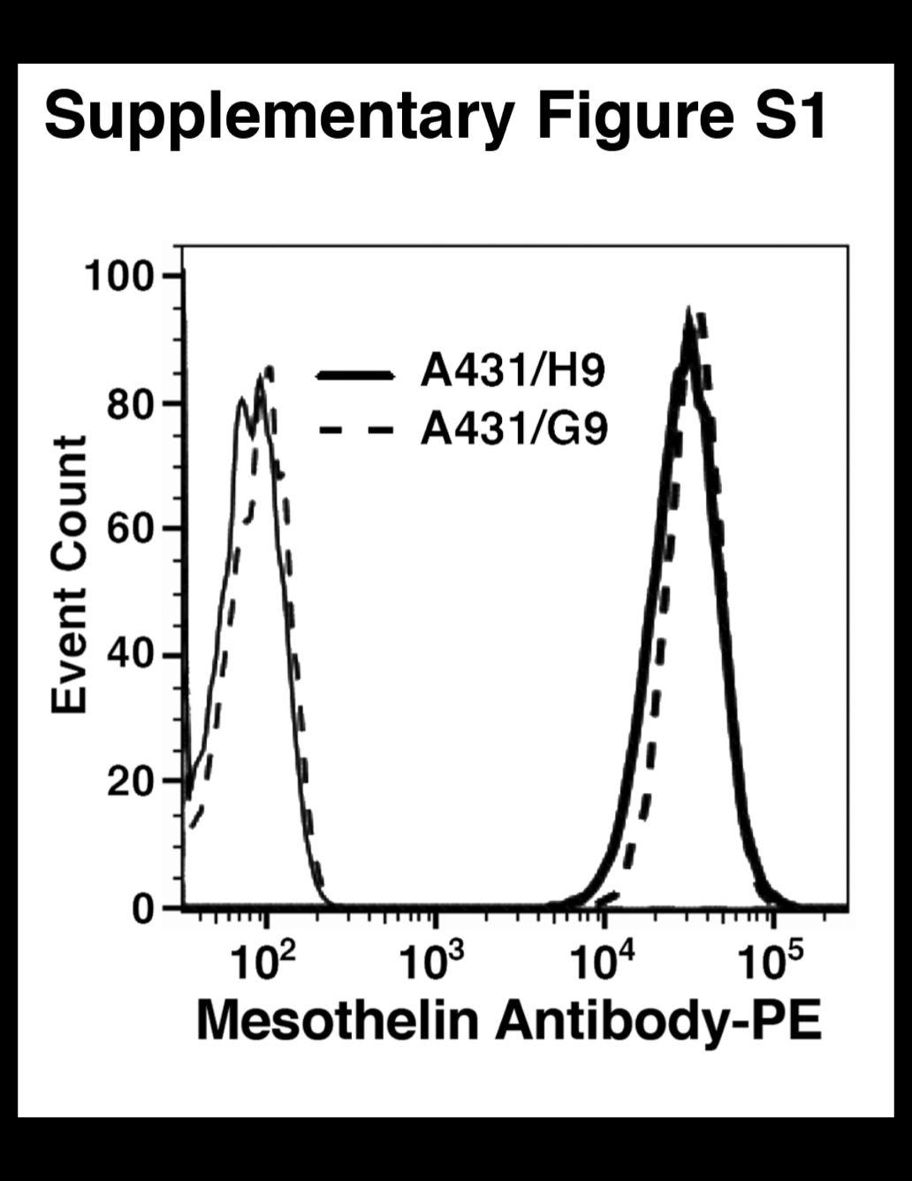

Flow cytometry analysis using 5 μg/ml of MSLN
antibody showing that wild-type and TACE mutant
cells express similar levels of surface MSLN. Cells
were plated on day 1 and the following day cells
were trypsinized, washed, and processed for flow
cytometry analysis.

