Supplementary Information

Targeted Drug Delivery with an Integrin-Binding Knottin-Fc-MMAF Conjugate Produced by Cell-Free-Protein Synthesis

Nicolas V. Currier^{1,*}, Shelley E. Ackerman^{2,*}, James R. Kintzing², Rishard Chen³, Maria Filsinger Interrante², Alexander Steiner³, Aaron K. Sato³ and Jennifer R. Cochran^{2,4}

¹Divsion of Pediatric Hematology/Oncology, Stanford Medical School, ²Department of Bioengineering, Stanford University, ³ Sutro Biopharma, Inc., South San Francisco, CA, ⁴Department of Chemical Engineering, Stanford University

*These authors contributed equally

To whom correspondence should be addressed:
jennifer.cochran@stanford.edu
Shriram Center for Bioengineering and Chemical Engineering
443 Via Ortega, Room 356
Stanford, CA 94305-4125
Phone: (650) 724-7808
Fax: N/A

Supplementary Figure 1. Standard curves for quantification of cellular integrin expression. The Quantum Simply Cellular kit from Bangs Laboratories was used for quantitative analysis of cellular integrin expression. Five populations of Quantum Simply Cellular microspheres, one of which was a non-binding “blank”, were used with increasing levels of Fc-specific capture antibody. Channel values for each population were used to compute a regression associating fluorescence to number of surface receptors (assuming monovalent binding of antibody to integrin receptor; use of a secondary antibody results in an approximate quantification). A lot-specific QuickCal template provided by Bangs Laboratories was used for regression fit and calculation. For α_{v}β₃ and α₅ integrins, fluorescently labeled primary antibodies were used, while a secondary antibody was required for measurement of α_{v}β₅ expression. Therefore, α_{v}β₅ expression levels can only be considered semi-quantitative.

Supplementary Figure 2. Competition binding to U87MG tumor cell surface integrins. Varying concentrations of CTRL-Fc-MMAF were incubated with AF488-labeled 2.5F peptide monomer and allowed to compete for binding to integrin receptors expressed on the surface of U87MG cells. The fraction of AF488-2.5F bound to the cell surface is plotted versus the concentration of knottin-Fc. Data shown is the average of triplicate values and error bars represent standard deviation.

Supplementary Figure 3. Inhibition of tumor cell proliferation. U87MG, A2780 and MB-468 cells were incubated with varying concentrations of 2.5F-Fc-MMAF, and CTRL-Fc-MMAF. Cell viability at 120 hr was assessed by measuring the absorbance resulting from CCK8 reagent at λ=450 nm and is reported as the percent inhibition relative to untreated cells.

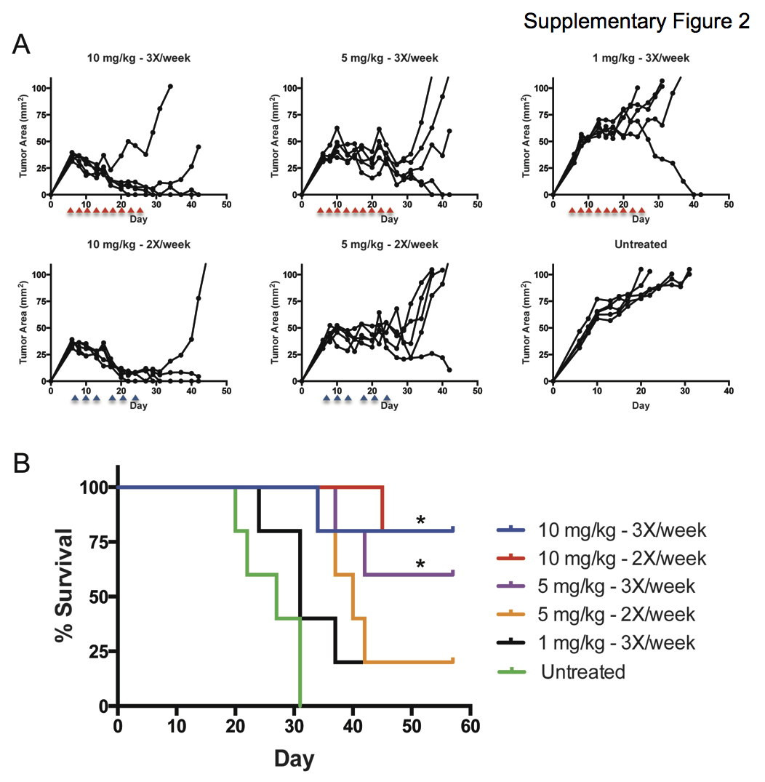

Supplementary Figure 4. Growth inhibition of subcutaneous U87MG tumors implanted into Nu/Nu mice. Dose-response of 2.5F-Fc-MMAF administered: 10 mg/kg twice weekly, 10 mg/kg three times a week, 5 mg/kg twice weekly, 5 mg/kg three times a week, or 1 mg/kg three times a week compared to an untreated control. Tumor areas for each group are shown in A, and Kaplan-Meier survival curves are shown in B. Blue arrows (twice weekly) and red arrows (three times weekly) indicate days of compound administration over a three week period. Day is defined as day post tumor inoculation.
*p=0.0189 (10 mg/kg 3X/2X vs. Untreated); *p=0.0189 (5 mg/kg 3X/2X vs. Untreated. Not significant: 1 mg/kg 3X vs. Untreated (p=0.6748); 10 mg/kg 3X vs. 10 mg/kg 2X (p.>0.99); 5 mg/kg 3X vs. 5 mg/kg 2X (p>0.99).

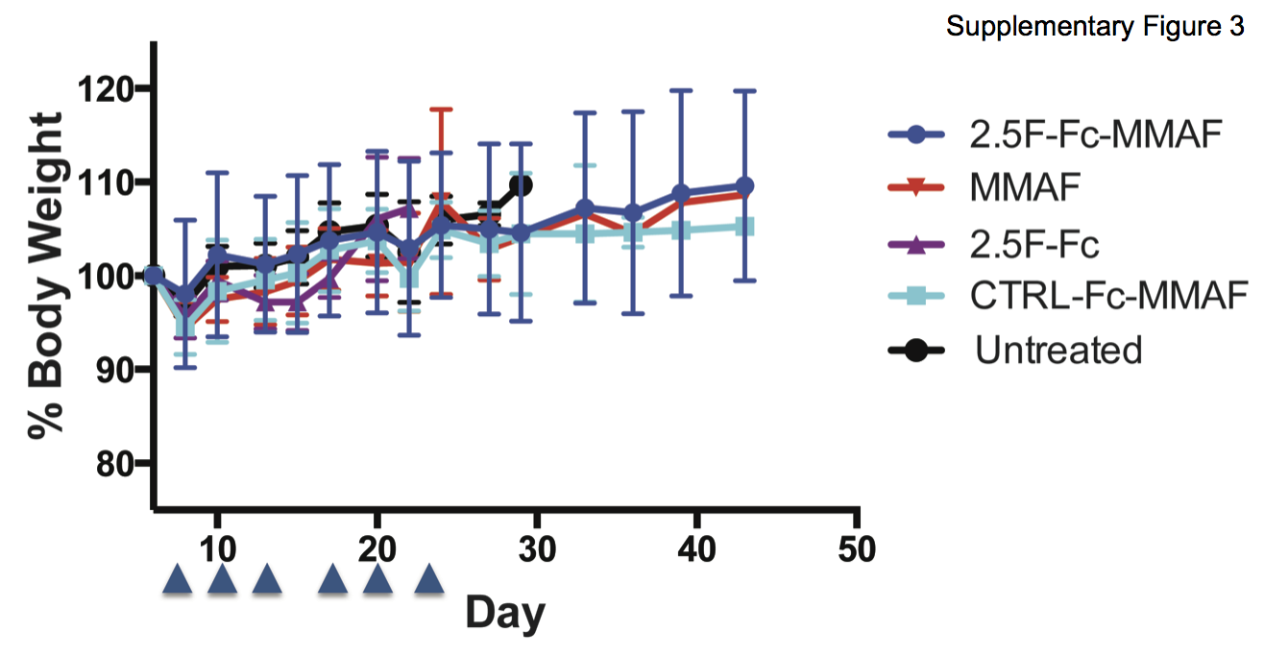

Supplementary Figure 5. Weight monitoring. Weight was measured on untreated control mice or mice dosed 10 mg/kg twice weekly with: 2.5F-Fc-MMAF, CTRL-Fc-MMAF, 2.5F-Fc, or molar equivalent (0.24 mg/kg) of MMAF. Blue arrows indicate days of compound administration over a three week period. In these experiments MMAF = DBCO-PEG-MMAF and day is defined as day post tumor inoculation.

