RG7386, a novel tetravalent FAP-DR5 antibody, effectively triggers FAP-dependent, avidity-driven DR5 hyperclustering and tumor cell apoptosis
Brünker et al Supplementary Results 5
- Supplementary Figure 4 and associated figure legend

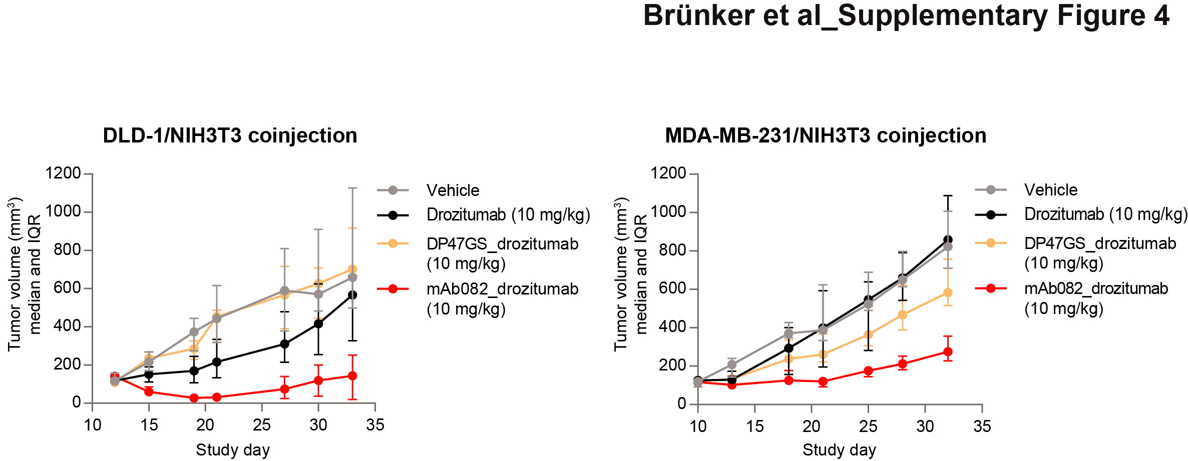
Figure S4. Related to Figure 4. FAP-drozitumab BsAb induces tumor growth inhibition in vivo. Analysis of tumor growth inhibition in a DLD-1/NIH3T3 and MDA-MB-231/NIH3T3 co-injection mouse models in response to the FAP-DR5 BsAb mAb082_drozitumab or drozitumab coupled to the non-targeting DP47GS IgG (median tumor volume and IQR).

