RG7386, a novel tetravalent FAP-DR5 antibody, effectively triggers FAP-dependent, avidity-driven DR5 hyperclustering and tumor cell apoptosis
Brünker et al Supplementary Results 4
- Supplementary Figure 3 and associated figure legend

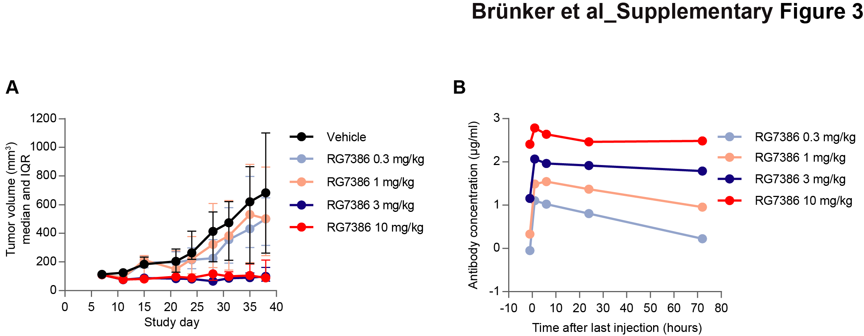Figure S3. Characterization and optimization of RG7386 dosing in vivo. (A) RG7386 dose optimisation was investigated in the DLD1/NIH3T3 co-injection mouse model. Animals were treated once weekly (i.v.) with the indicated concentrations of RG7386 (median tumor volume and IQR; n = 9 animals per group). (B) RG7386 pharmacokinetics data was obtained in the same model at the indicated time points (mean antibody concentrations are shown). Serum was collected 1 h before the last RG7386 injection and at 1, 6, 24, and 72 h after the last injection. Two mice were analysed for each time point and group. RG7386 serum levels were measured with a generic anti-human Fc ELISA.

