RG7386, a novel tetravalent FAP-DR5 antibody, effectively triggers FAP-dependent, avidity-driven DR5 hyperclustering and tumor cell apoptosis
Brünker et al Supplementary Results 3
- Supplementary Figure 2 and associated figure legend
- Supplementary Table 4

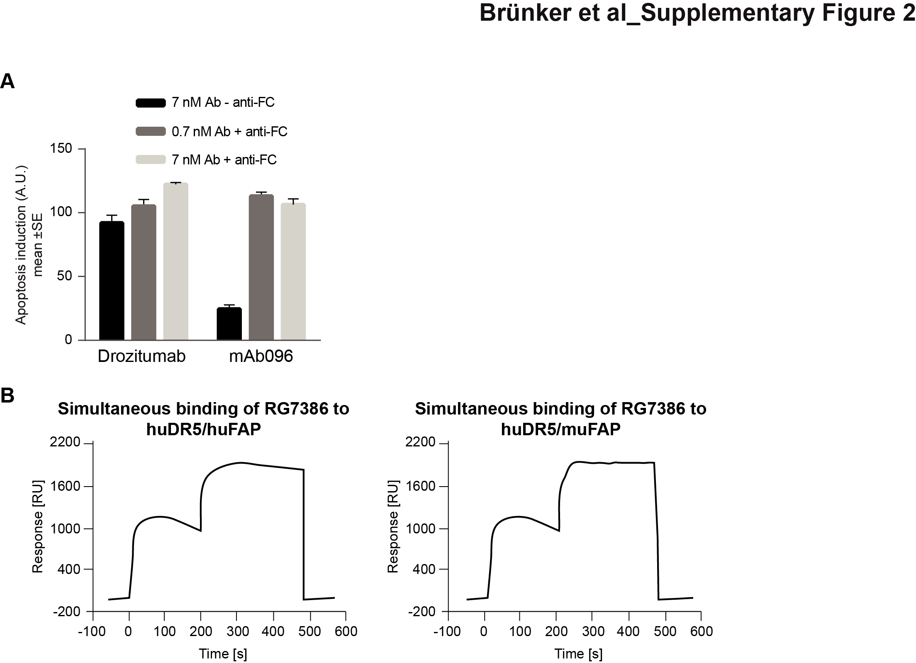
Figure S2. Related to Figure 3. In vitro characterization of the FAP-DR5 BsAb RG7386. (A) Comparison of crosslinking-independent apoptotic activities of drozitumab and the novel DR5 agonistic antibody mAb096 (used in the RG7386 bispecific molecule) in MDA-MB-231 cells. (B) Simultaneous binding of RG7386 to huDR5 followed by huFAP or muFAP recombinant proteins assessed by surface plasmon resonance.

 | Binding to FAP KD (nM) | Binding to DR5 KD (nM)
Human | 0.52 | 1.9
Cynomolgus monkey | N.D. | 0.63
Specificity of individual Ab clones | mAb082:  No binding to huDPP-IV (CD26, closest FAP homologue) | mAb096:  No binding to huDR4, DcR1/2, OPG

Table S4. Characterization of RG7386 binding avidities. RG7386 binding to FAP and DR5 was determined in a TagLite binding assay. HuDPP-IV: human dipeptidyl peptidase IV; DcR: decoy receptor; OPG: osteoprotegerin.

