RG7386, a novel tetravalent FAP-DR5 antibody, effectively triggers FAP-dependent, avidity-driven DR5 hyperclustering and tumor cell apoptosis
Brünker et al Supplementary Results 1
- Supplementary Figure 1 and associated figure legend
- Supplementary Tables 1 and 2

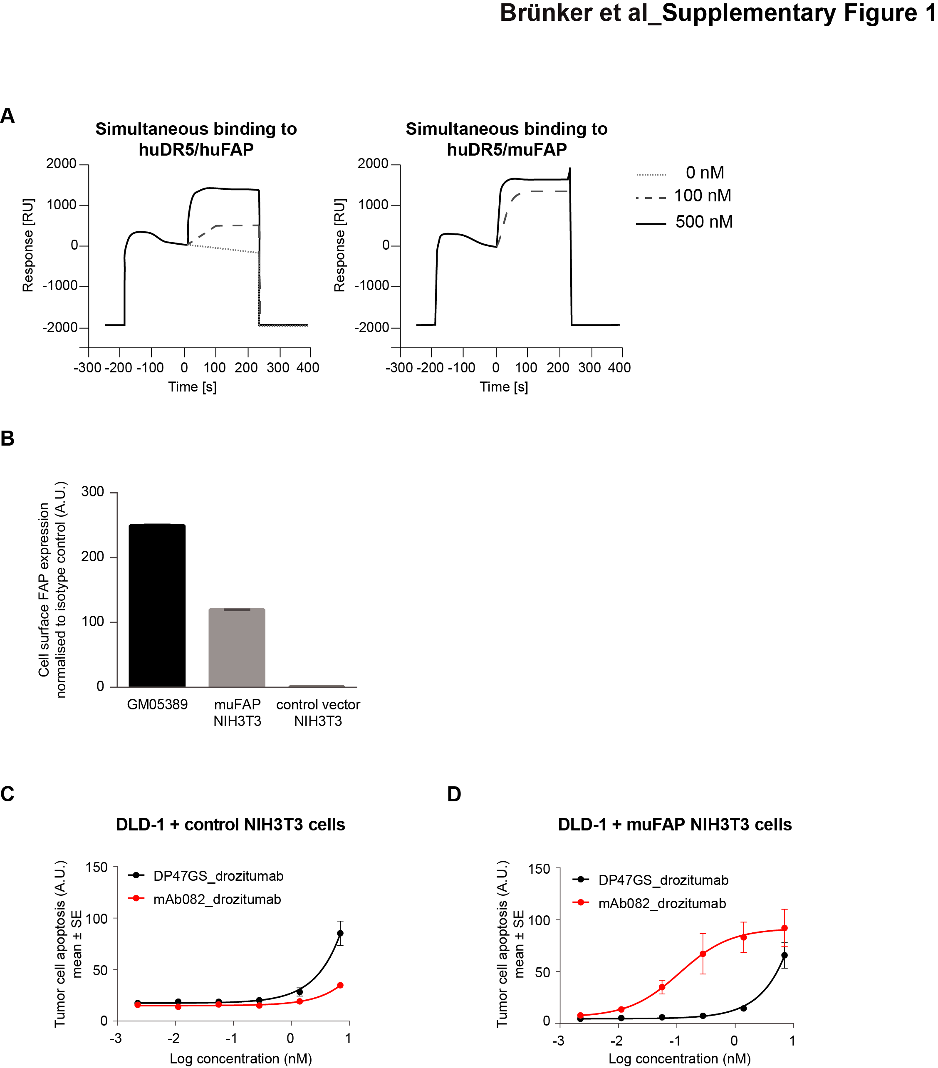

Figure S1. Related to Figure 1. Characterization of FAP-drozitumab BsAbs and anti-tumor efficacy in the presence of FAP-expressing fibroblasts in in vitro co-culture models. (A) Simultaneous binding of mAb007_drozitumab to huDR5 followed by huFAP or muFAP recombinant proteins was assessed by surface plasmon resonance at the indicated antibody concentrations. (B) FAP cell-surface expression in GM05389 human fibroblasts and in NIH3T3 cells following stable transfection of muFAP was assessed by flow cytometry using fluorescently-labeled mAb082 anti-FAP antibody. (C-D) Analysis of DLD-1 tumor cell apoptosis in the presence of control-transfected (C) or stable muFAP-expressing NIH3T3 fibroblasts (D) in response to the FAP-DR5 BsAb, mAb082_drozitumab, or drozitumab coupled to the non-targeting DP47GS IgG (N.D. = not determined).

 | Binding to huDR5 Ki (nM)* | Binding to huFAP Ki (nM)**
mAb082_drozitumab VHCL | 2.1 | 0.32
mAb007_drozitumab VHCL | 1.58 | 0.53
mAb007_drozitumab VLCH1 | 1.43 | 5.96
mAb007_drozitumab 2+1 | 1.99 | 8.56

Table S1. BsAb binding to DR5 and FAP antigens. Binding avidities of FAP-drozitumab bispecific molecules to DR5 and FAP was analyzed in cells expressing human DR5 (huDR5) or huFAP extracellular domains using a TagLite competition assay. * Drozitumab: 0.98 nM, ** anti-FAP mAb007: 0.61 nM and anti-FAP mAb082: 0.29 nM.

 | Apoptosis induction EC50 values (nM)
 | MDA-MB-231 cells - fibroblasts | MDA-MB-231 cells + fibroblasts
Drozitumab alone | 15.2 | 11.06
Drozitumab + anti-Fc | 0.14 | 0.33
mAb082_drozitumab VHCL | 25.4 | 0.09
mAb007_drozitumab VHCL | 4.46 | 0.014
mAb007_drozitumab VLCH1 | 3.4 | N.D
mAb007_drozitumab 2+1 | 11.17 | 0.57

Table S2. Anti-tumor efficacy of FAP-drozitumab bispecific molecules is FAP-dependent. EC50: half-maximal effective concentration; N.D.: value not determined

