Linalool-incorporated nanoparticles as a novel anticancer agent for epithelial ovarian carcinoma

Hee Dong Han¹, Young-Jae Cho^{2,3}, Sung Keun Cho⁴, Yeongseon Byeon¹, Hat Nim Jeon¹, Hye-Sun Kim⁵, Byoung-Gie Kim², Duk-Soo Bae², Gabriel Lopez-Berestein^{6,8,9}, Anil K. Sood^{7,8,9}, Byung Cheol Shin⁴, Yeong-Min Park¹, and Jeong-Won Lee^{2,3}

Supplementary Fig. 1

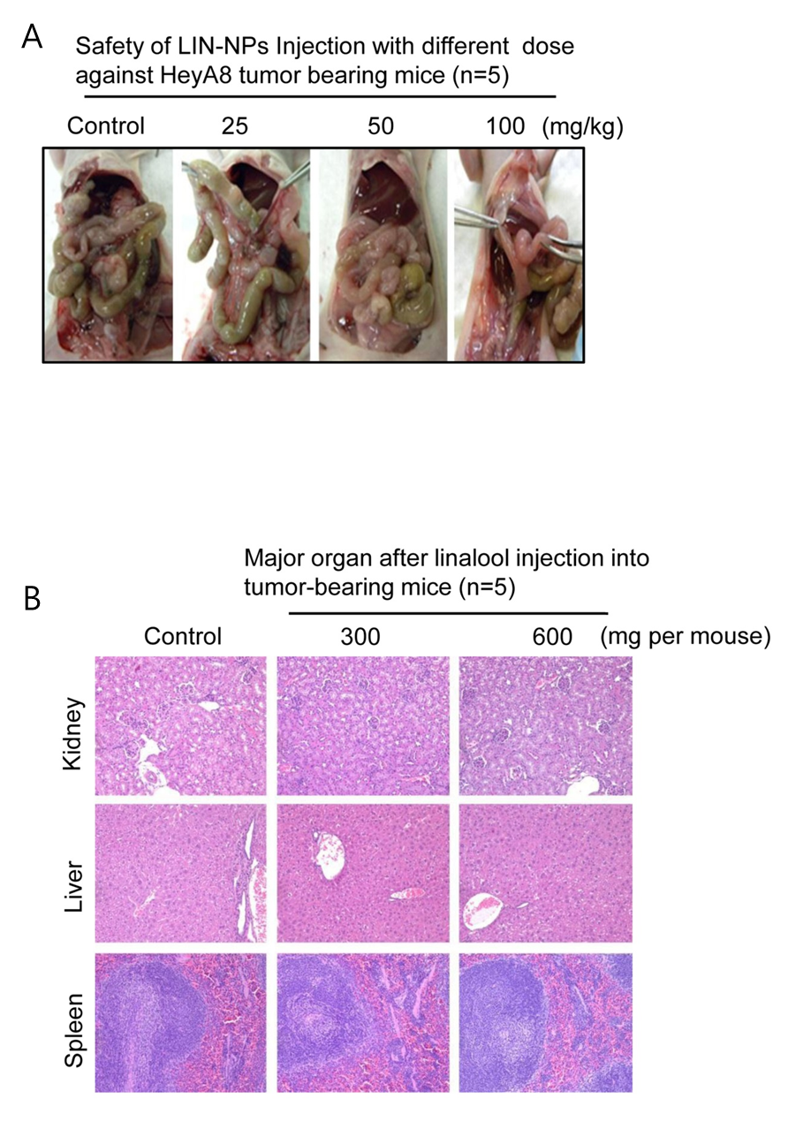

Supplementary Figure 1. Safety and toxicity in mouse after treatment of linalool with different dose.

