Supplementary Figure S2 Additional clustering data
Uitdehaag et al. Cell panel profiling reveals conserved therapeutic clusters and differentiates the mechanism of action of different PI3K/mTOR, Aurora kinase and EZH2 inhibitors

Figure S2A. Hierarchical clustering tree showing that replicate measurements (red brackets) cluster together. Clustering parameters as described in the text. Due to the presence of replicates, the order of the compounds is different than Fig. 3, although clusters are maintained.

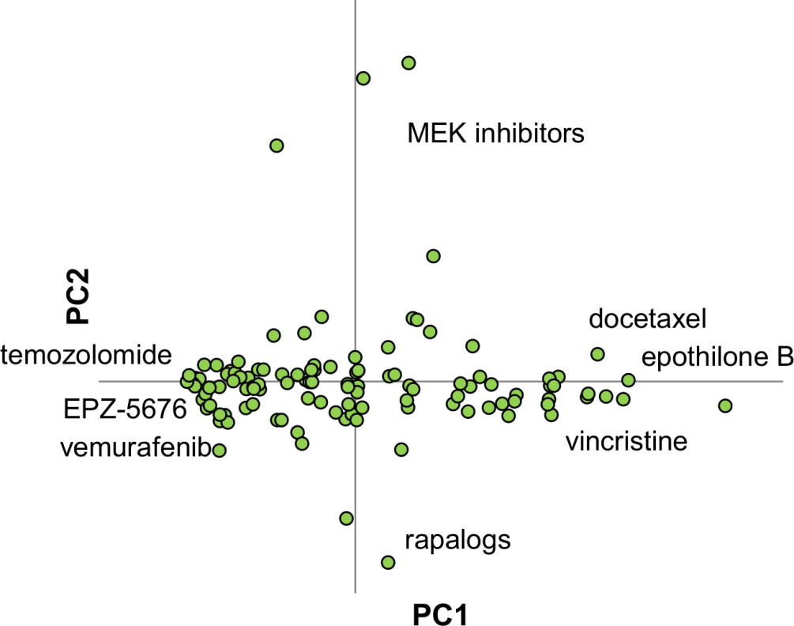

Figure S2B. Principal component analysis of all ¹⁰log IC₅₀ cell profiling data. First and second principal components are displayed (PC1 and PC2). The PC1 axis shows a continuous scattering of compounds, with very potent ones on the right, and least potent ones on the left. PC2 is further analyzed in Fig. 4I.

