**Supplementary Figure S1 Additional reproducibility data**

Uitdehaag *et al.* Cell panel profiling reveals conserved therapeutic clusters and differentiates the mechanism of action of different PI3K/mTOR, Aurora kinase and EZH2 inhibitors

|  |  |  |  |  |  |  |
| --- | --- | --- | --- | --- | --- | --- |
| **dataset** | **assay** | **no. cell lines** | **reference**  **compound** | **no.**  **data points** | **σ range** | **overall σ** |
| Oncolines | cell proliferation | 44 - 66 | doxorubicin | 264 | 0.05 - 0.61 | 0.14 |
| NCI-60 | cell proliferation | 60 | doxorubicin | 134,220 | 0.23 - 0.64 | 0.48 |
| Kalliokoski *et al*.(30) | PDE3 | 1 | cilostamide | > 1000 | 0.17 | 0.17 |
| Kalliokoski *et al*.(30) | PDE4D | 1 | rolipram | > 1000 | 0.22 | 0.22 |

**Figure S1A.** Variation of replicate IC50s in high-throughput profilings. For Oncolines, statistics are based on six doxorubicin profilings. The standard deviations (σ) of 10logIC50s were calculated per cell line (column ‘σ range’), then averaged over all 44 cell lines (overall σ). Data were compared to the 2238 doxorubicin replicates in the NCI-60 panel, and two highly standardized PDE3 and PDE4 activity assays (30), to benchmark IC50 reliability from panel screening. Statistics on other large panels could not be calculated as replicate data were unavailable.



**Figure S1B**. IC50s of replicates vary less when cell lines grow faster. The y-axis displays the standard deviations of paired differences between replicates (10logIC50). Every black dot indicates one cell line and summarizes data from 20 replicates (see also Fig. 1C).



**Figure S1C**. IC50 variation is not caused by variation in cell growth. The y-axis displays the standard deviations of paired differences between replicates (10logIC50). The x-axis displays the observed standard deviations of the cell doubling rates, a measure of cell growth rate. Every black dot indicates one cell line and summarizes data from 20 replicates (see also Fig. 1C).



**Figure S1D**. The Pearson correlation between replicates decreases when there is more time between them. Every black dot represents one replicate pair (see also Fig. 1C).

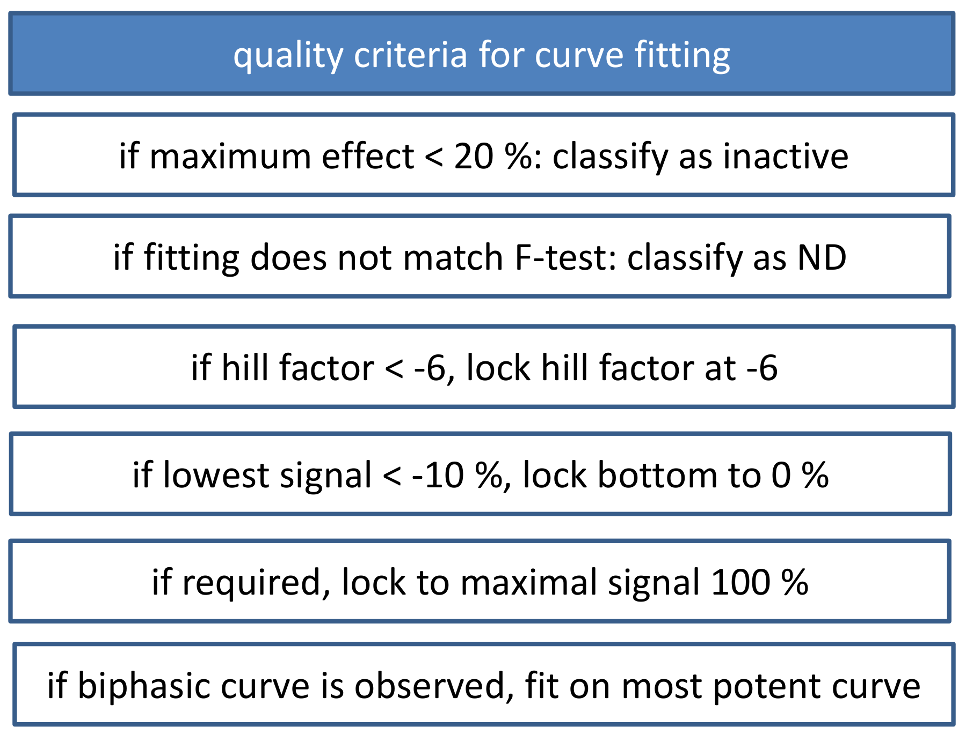

**Figure S1E**. Criteria for curve fitting applied in generating IC50 data.

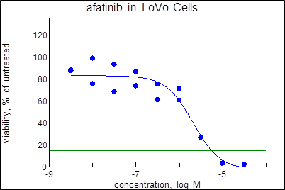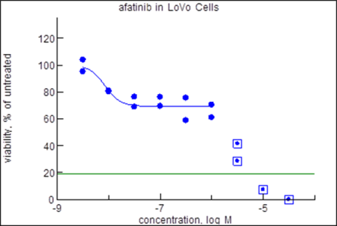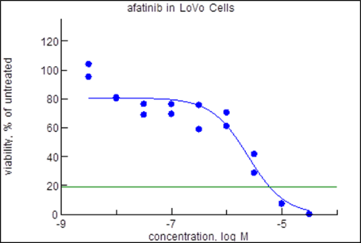

**Figure S1F**. Variations in curve fitting arising from a biphasic curve. Left: data of replicate no. 1. Middle: original fit of replicate no. 2. Right: reinterpretation of replicate no. 2.

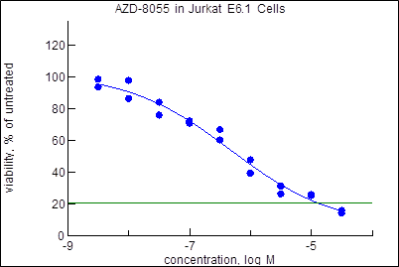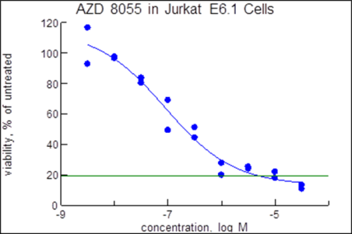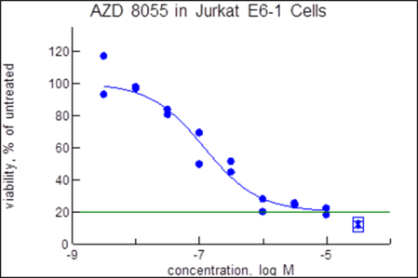

**Figure S1G**. Variations in curve fitting arising from variations in maximal signal. Left: data of replicate no. 1. Middle: original fit of replicate no. 2. Right: reinterpretation of replicate no. 2.

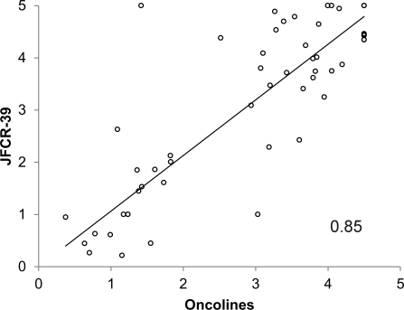 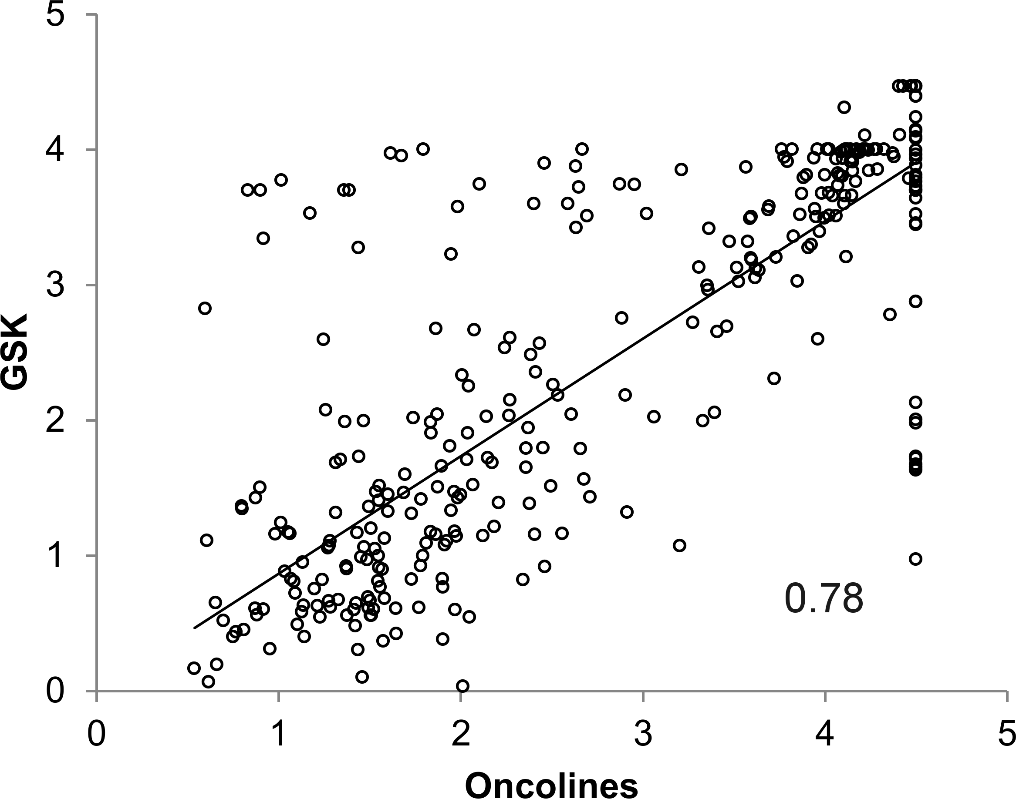 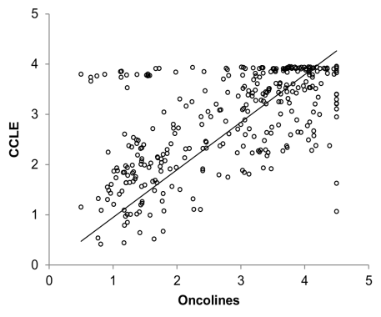

**Figure S1H** IC50s of our data set compared to IC50s in other cell line profiling experiments. Left: Data from JFCR-39 (Nakatsu *et al*., ref. 6). Middle: Data from Greshock *et al.*, ref. 13). Right: Data from Barretina *et al*., ref. 10). All data were converted to 10logIC50 (nM), which are the units of all x- and y-axes. Data from JFCR-39 (left) are GI50. Numbers in panels indicate Pearson correlations between the data.