Supplementary (s) Figure legends
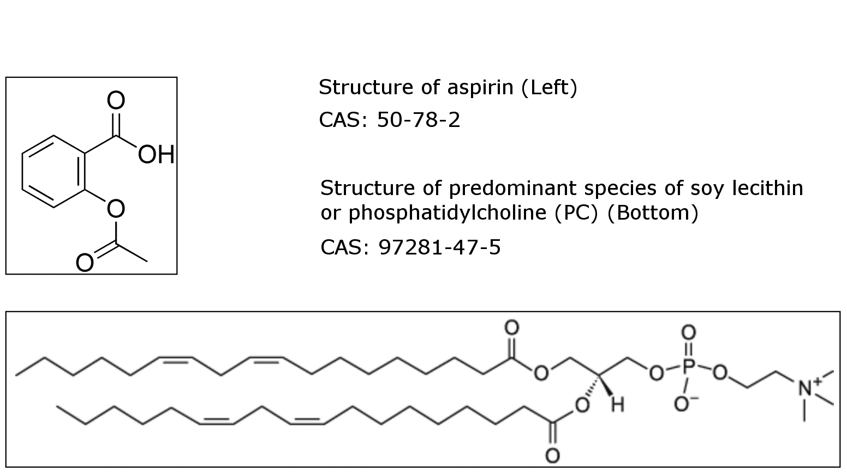

Figure S-1. Chemical structures of aspirin and the predominant phospholipid in soybean phosphatidylcholine (PC).

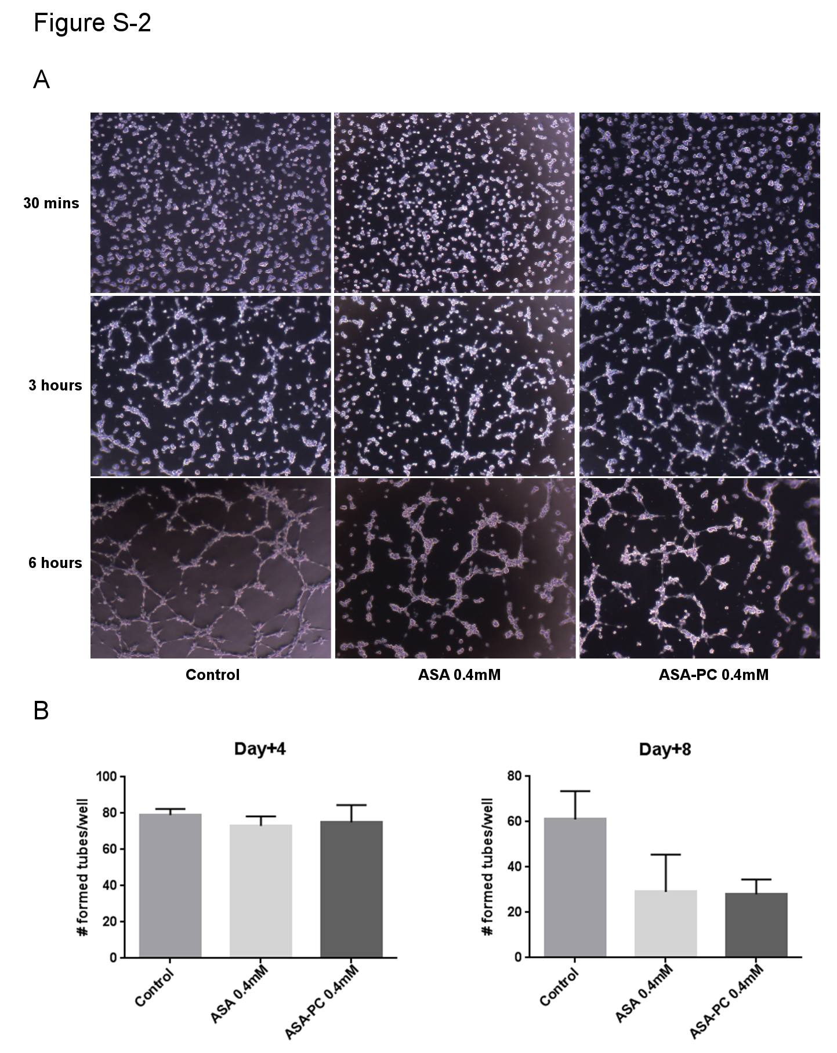
Figure S-2. Evaluation of the effects of aspirin-PC and aspirin on tube-formation (measured under microscopy over a 6-hr period), as an index of their possible anti-angiogenic action on human umbilical vein endothelial cells (HUVECs) RF24 after the cells were incubated in medium containing the aspirin test formulations (at an aspirin dose of 0.4 mM) for either 4 or 8 days prior to the 6hr tube formation assay. (A) micrograph demonstrating tube-formation over 6 hr study period. (B) Quantitation of tube formation by counting number of formed tubes/well. It can be appreciated that although no effect was observed at 4-days, there was trend that both agents reduced tube formation at 8-days.

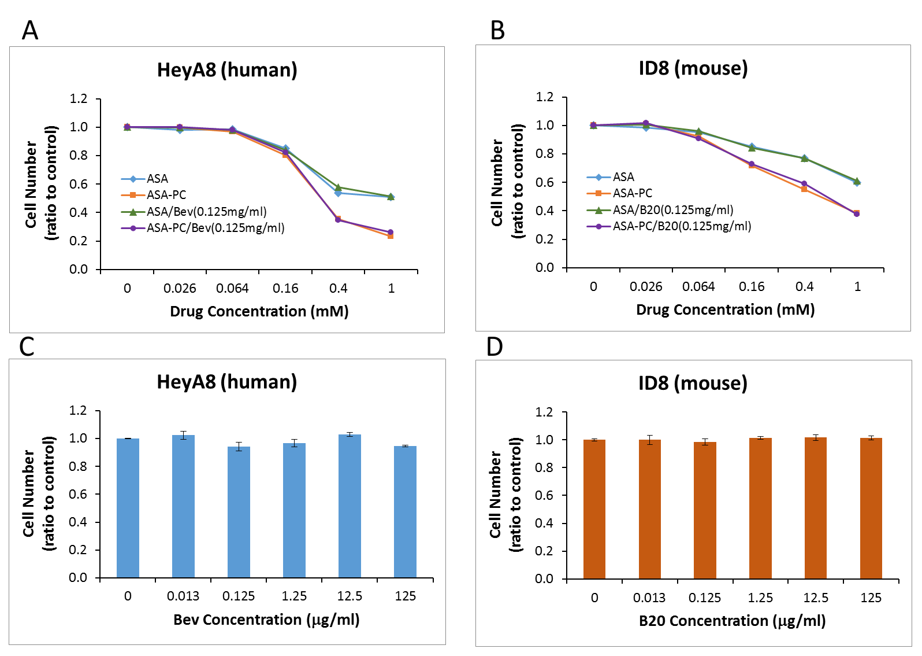

Figure S-3. In vitro evidence that the growth inhibitory activity of aspirin-PC and aspirin of ovarian cancer cell lines derived from: (A) human (HeyA8); and (B) mouse (ID8) are not affected by administering the aspirin formulations in combination with the VEGF inhibitors (bevacizumab/Bev) and B20, respectively. Drug concentration on x-axis refers to the final concentration of aspirin in the test formulations. We also performed a dose-response study with the two VEGF inhibitors on the growth of: (C) HeyA8; and (D) ID8 cells, which also demonstrated a lack of growth inhibitory activity on the ovarian cancer cells. These experiments used an MTT assay to assess cell growth over an 8 day culture period.

