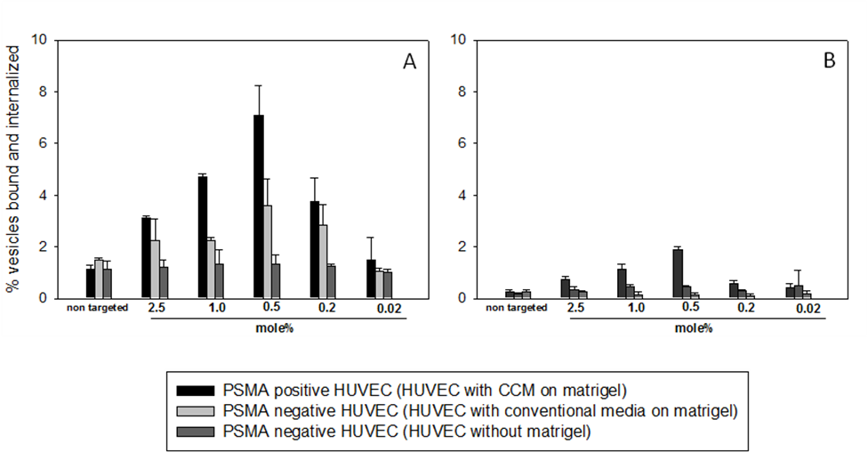
Figure S1_A and S1_B
Extent of lipid vesicles bound (A) and internalized (B) by PSMA+ HUVEC depends on the surface grafting density of the urea-based PSMA targeting ligand. In our studies, the fraction of 0.5 mole% of urea-based ligand is included in all lipid vesicle preparations. Error bars correspond to standard deviations of repeated measurements (3 independent construct preparations, 2 measurements per preparation).

Figure S1_C
Molecular structure of the non active lipid construct (top) and of the active urea-based targeting ligand (bottom).

