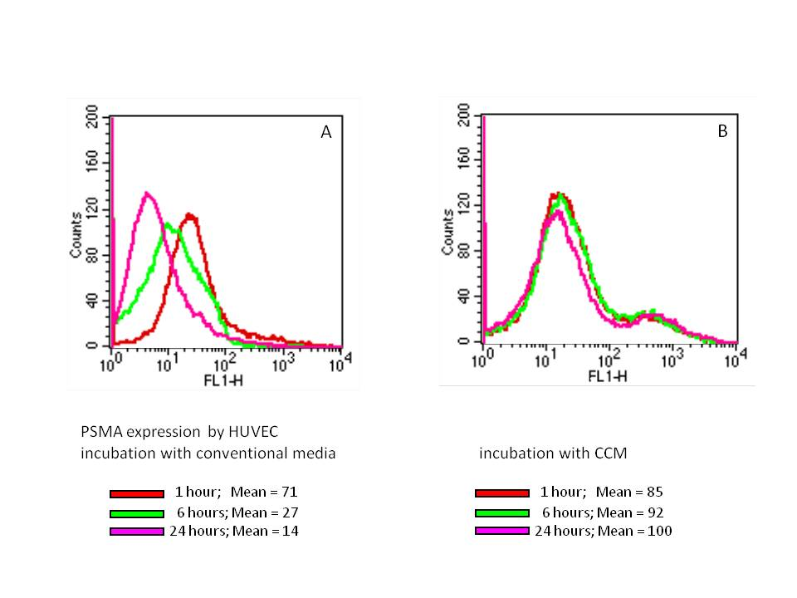

Figure S4
Upon removal of cell conditioned media (CCM) from HUVEC (A), PSMA expression decreases over time. All reported studies are conducted in the presence of CCM to ensure constant PSMA expression by HUVEC (B).

