Supplementary Data

Nucleic Topoisomerase 1 (TOP1) protein levels

TOP1 protein level was measured in the nucleic fraction of synchronized Caco-2 cells by Western blots.

Briefly, Caco2 cells from different Petri dishes were mechanically detached at 13 circadian times (0, 4, 8, 12, 16, 20, 24, 28, 32, 36, 40, 44 and 48 h), and centrifuged at 250 g for 5 min at 4°C in extraction medium. All the following procedures were performed at 4°C. Cell pellets were homogenized in a Potter homogenizer and centrifuged for 30 min at 10,000 g. Supernatants were transferred in new tubes and constituted the cytosolic fraction. Pellets were then re-suspended in extraction medium and represented the membrane fractions containing the nuclear extracts. Aliquots fraction containing 100 µg proteins were loaded onto a 4-20% polyacrylamide gel and allowed to migrate at 100 V for 1h using the inVitrogen system®. The proteins were then transferred to Immobilon P membrane (Millipore, Saint-Quentin-en-Yvelines, France) using an electroblotting system (iBlot, Invitrogen, France) for 8 min. The membranes were incubated at 4°C for 16 h with rabbit anti-human topoisomerase I antibody (TopoGen, Columbus, Ohio) diluted 1:2000, and for 1h with ProteinA-peroxidase (Sigma Aldrich, Paris, France) diluted 1/5000. Protein was detected using the peroxidase substrate Immun-star Western C chemoiluminescent kit (Biorad, France), and visualized by autoradiography. The chemoluminescence signals were analyzed using a video camera (Fuji, Las 4000) and quantified using the ImageJ software. Signal intensities were recorded and expressed in arbitrary units.

No statistically-validated circadian rhythm was observed (Figure S1).

Time 0 8 12 16 20 24 28 32 36 40 44 48 52 56 (h)
TOP1
β-ACTIN

Figure S1: Nucleic level of TOP1 protein in synchronized Caco-2 cells over 56 hours. The two first lines show the immunoblotting of TOP1 and β-actin at indicated time points. The third line shows the quantified amount of TOP1 protein normalized to β-actin level.

Circadian rhythms of mRNA expression of clock and pharmacology genes

The mRNA levels of three clock genes (PER2, REV-ERBα, BMAL1) and four genes involved in irinotecan pharmacology (CES2, ABCB1, UGT1A1, TOP1) were first fitted individually to a damped cosine model (equation (1) in main text). p-values for the test of null amplitude were below 0.0484 for all genes in clock-proficient cells but not in BMAL1 siRNA-transfected cells, thus confirming the existence of circadian rhythms in control conditions. As a second step, mRNA time series were simultaneously fitted to the same damped cosine model yet now assuming that all transcriptional patterns would remain synchronized with the same period. Best-fit parameter values of the dampening coefficient (λ), the mean value (M), the amplitude (A) and the phase (φ) are shown in Table S1. The statistical significance of the test of null amplitude was set to p<0.1 rather than p<0.05 when a common circadian period was assumed for all genes as this modeling constraint slightly increases the discrepancy between the data and the model as compared to individual fit.

 |  | λ (h⁻¹) | M (a.u.) | A (a.u.) | φ (h.min) | p (F-test)
BMAL1 | Control | 0.012 +/- 0.012 | 0.75 +/- 0.03 | 0.39 +/- 0.09 | 18h12 +/- 1h34 | 0.02
 | BMAL1 siRNA | 0.006 +/- 0.015 | 0.33 +/- 0.02 | 0.01 +/- 0.04 | - | 1
PER2 | Control | 0.033 +/- 0.011 | 0.92 +/- 0.03 | 0.52 +/- 0.12 | 2h44 +/- 1h37 | 0.036
 | BMAL1 siRNA | 0.009 +/- 0.014 | 0.48 +/- 0.02 | 0.09 +/- 0.05 | - | 1
REV-ERBα | Control | 0.017 +/- 0.012 | 0.48 +/- 0.03 | 0.38 +/- 0.1 | 4h57 +/- 1h53 | 0.087
 | BMAL1 siRNA | 0.006 +/- 0.014 | 0.35 +/- 0.02 | 0.01 +/- 0.03 | - | 1
TOP1 | Control | 0.001 +/- 0.006 | 0.96 +/- 0.05 | 0.49 +/- 0.15 | 14h30 +/- 2h03 | 0.018
 | BMAL1 siRNA | 0.009 +/- 0.018 | 0.7 +/- 0.05 | 0.06 +/- 0.09 | - | 0.65
CES2 | Control | 0.04 +/- 0.017 | 0.91 +/- 0.04 | 0.36 +/- 0.14 | 11h28 +/- 2h02 | 0.097
 | BMAL1 siRNA | 0.006 +/- 0.013 | 0.66 +/- 0.04 | 0.02 +/- 0.04 | - | 0.7
UGT1A1 | Control | 0.032 +/- 0.016 | 1.05 +/- 0.05 | 0.49 +/- 0.13 | 14h26 +/- 1h56 | 0.0748
 | BMAL1 siRNA | 0.006 +/- 0.014 | 0.74 +/- 0.04 | 0.02 +/- 0.04 | - | 0.99
ABCB1 | Control | 0.002 +/- 0.005 | 0.81 +/- 0.04 | 0.57 +/- 0.11 | 16h51 +/- 1h31 | 0.013
 | BMAL1 siRNA | 0.02 +/- 0.023 | 0.47 +/- 0.04 | 0.09 +/- 0.1 | - | 1

Table S1: Parameter estimates of circadian mRNA expressions in synchronized Caco-2 cells. Values correspond to mean ± SD. Estimation was obtained by fitting equation 1 to experimental data of Figure 2 through a bootstrap approach (see Methods), a.u. = arbitrary units.

Circadian activities of proteins involved in irinotecan pharmacology

The mathematical model of irinotecan PK-PD was fitted to all datasets of the current study resulting in a best-fit parameter set. Best-fit parameter values for circadian activities of proteins involved in irinotecan pharmacology are shown in Table S2. See main text for details.

 |  | M^{activity} | A^{activity} | A^{activity}/ M^{activity} | φ^{activity} | Δφ
Irinotecan bioactivation (CES) | Control | 0.62 ± 0.095 | 0.08 ± 0.04 | 0.127 ±0.054 | 12h52 ± 4h 22 | 1h24
 | BMAL1 siRNA | 0.42 ± 0.076
SN38 detoxification (UGT1As) | Control | 916.2 ± 166.5 | 733 ± 187.2 | 0.8 ±0.059 | 2h49 ± 39 min | 16h23
 | BMAL1 siRNA | 916.1 ± 162.7
Irinotecan efflux (ABC_CPT) | Control | 11.5 ± 2.57 | 6.4 ± 2.3 | 0.56 ±0.069 | 9h21 ± 5h09 | 20h30
 | BMAL1 siRNA | 11.4 ± 2.39
SN38 efflux (ABC_SN) | Control | 145.8 ± 35.38 | 100.6 ± 40.8 | 0.7 ±0.11 | 2h08 ± 1h56 | 15h36*
 | BMAL1 siRNA | 91.5 ± 32.4
DNA damage phenotype (k_{apop}) | Control | 351.1 ± 22.5 | 245.7 ± 22.3 | 0.68 ±0.02 | 21h03 ± 1h53
 | BMAL1 siRNA | 1002 ± 58.7

Table S2: Parameter estimates of circadian activity of proteins involved in CPT11 PK-PD. Δφ is the difference between the phase of the protein activity and that of the corresponding mRNA amount. The mRNA measurements of CES2, UGT1A1 and ABCB1 were compared to the activity of irinotecan bioactivation (CES), SN38 detoxification (UGT1As) and irinotecan efflux (ABC_CPT) respectively. For SN38 efflux (ABC_SN), the mRNA values of ABCG2 from (24) were utilized (*). M^{activity} and A^{activity} are expressed in μM.h⁻¹ for all protein activities except for the ones corresponding to k_{apop} which are in h⁻¹.

Irinotecan chrono-pharmacokinetics (chronoPK) in synchronized Caco-2 cells
Irinotecan (CPT11) extracellular concentrations differed slightly according to circadian timing (T), and this difference was poorly fit by the model, as shown in Figure 3. For this reason, an additional chronoPK experiment was undertaken, using a similar design (Figure S2). This replication study confirmed the model prediction of a lack of differences in parent drug extracellular concentrations and AUCs according to circadian timing (ANOVA, p=0.181). It further confirmed the influence of irinotecan timing for the intracellular pharmacokinetics of both irinotecan and SN38, with a similar magnitude of effect (ANOVA, CPT_{in} p = 0.456, SN_{in}
p = 0.096) (Figure S2).

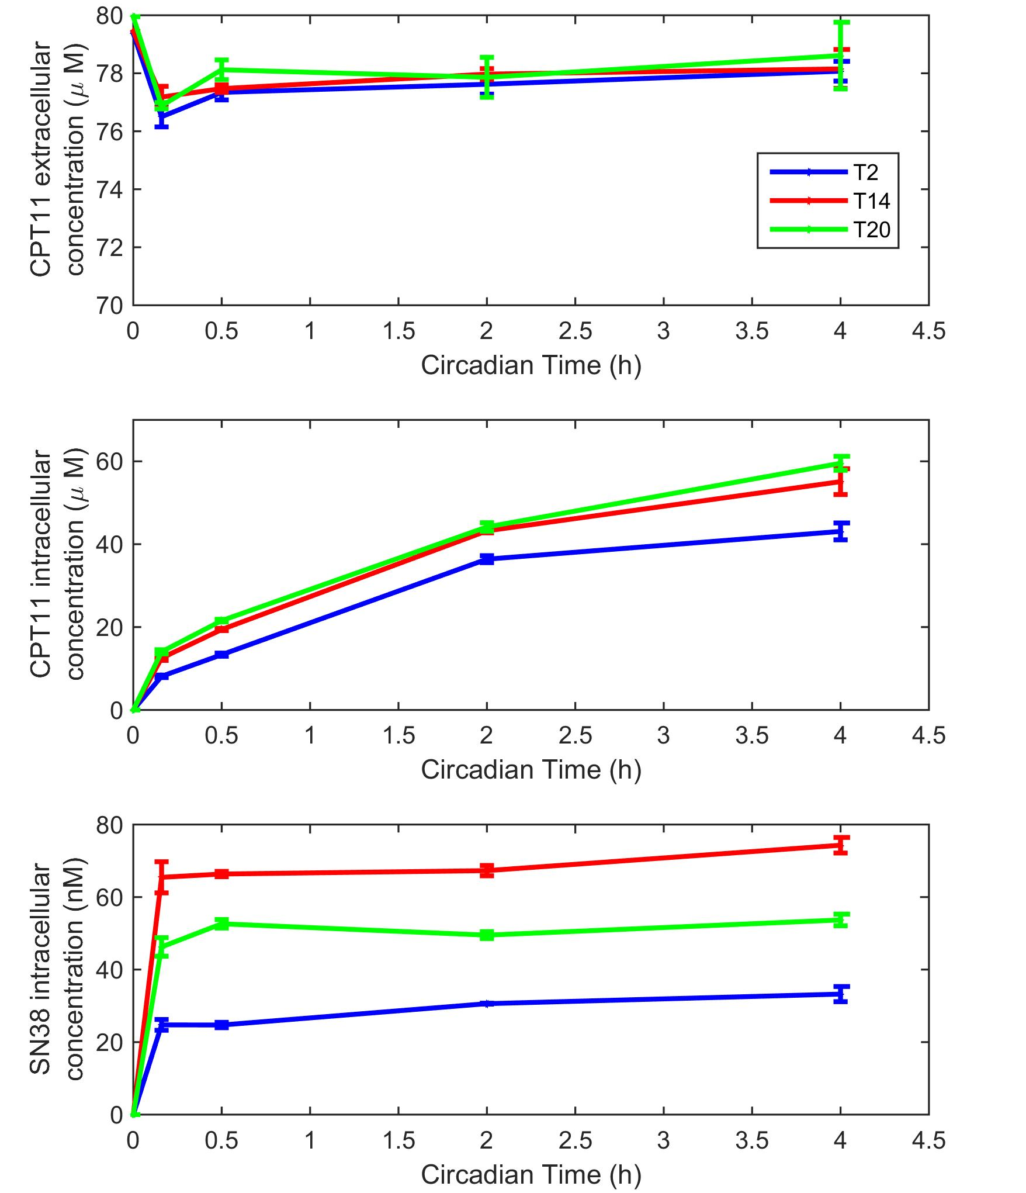

Figure S2: Irinotecan chronoPK in synchronized Caco-2 cells. Experimental results are the mean of 3 samples (± SEM). See Methods in the main text for experimental protocol.

Comparison of present results with those from former study (24).

Clock and pharmacology gene expression
The circadian rhythms in the mRNA expression of clock genes - BMAL1, PER2, and REV-ERBα - and irinotecan metabolism genes- TOP1, CES2, UGT1A1 and ABCB1- in the synchronized Caco-2 cell cultures from the current study were compared to those obtained in a separate experiment (24). The main endpoints for this comparison were the computed mean values and acrophases (Figure S3).

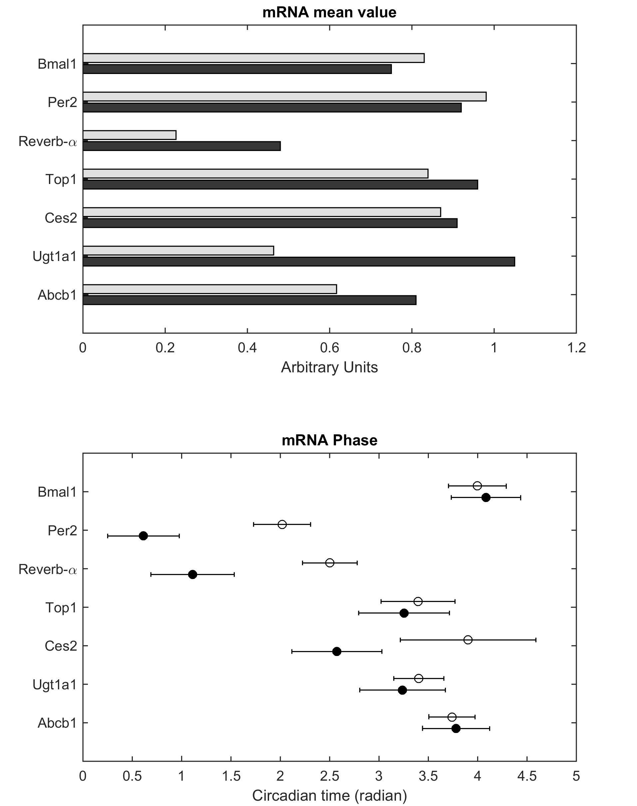

Figure S3: Comparison of the circadian phase of clock and irinotecan metabolism gene expressions in the present investigation (black) and in the prior study (grey, (24 in main text))

The mean values and acrophases of mRNA time series were similar in both investigations which were carried out 3 years apart, except the following. REV-ERBα and UGT1A1 average levels were twice as high in the current study compared to the former investigation. Moreover, the acrophases of PER2, REV-ERBα and CES2 differed by less than $\frac{π}{2}$ (0.447 π, 0.443 π and 0.423 π respectively) between studies.

Irinotecan PK-PD
In the prior Caco-2 cell study (24), a mathematical model of irinotecan PK-PD was designed and calibrated using (a) irinotecan pharmacokinetics in non-synchronized cells and (b) circadian patterns in clock and metabolism gene transcription and topoisomerase-1 complex formation in synchronized cells. The structure of the initial model was here used as such whereas new parameter estimates were obtained from fitting the current datasets in synchronized cell populations. The comparison of the two parameter sets allow to conclude to kinetics differences between both studies (Table S3).
Differences in SN38 PK were found as the metabolite accumulated in the extra- and intracellular compartments over 48h of exposure in the former study whereas it reached a plateau after few hours in the current study. SN38 average levels were also lower in the present investigation compared to previous experimental data. This led to differences between the two parameter sets as i) SN38 uptake rate was increased in the current study by several hundred-fold while SN38 efflux was slightly increased, ii) irinotecan bioactivation also had different kinetics in the present study with a smaller maximal velocity Vmax which was reached for lower CPT11 concentrations as indicated by a smaller Km value, iii) SN38 detoxification maximal velocity was increased by 4-fold while the corresponding Km was equivalent in the two studies, this estimation being consistent with the increased mean transcriptional level found for UGT1A1. PD parameters kf₁, kd₁, kf₂, kd₂, k_{Irr} were increased as compared to the former set while k_{entry} was decreased which resulted in faster formation and dissociation of all considered types of complexes on the DNA.

Reaction | Parameter (units) | Prior Study (24) | Present study | Ratio
CPT11 uptake | k_{upCPT} (h⁻¹) | 3.64 | 0.52 ± 0.12 | 7.0↓
CPT11 efflux (Vmax, Km) | V_{effCPT} (h⁻¹) | 594.35 | 11.46 ± 2.57 | 51.9↓
 | K_{effCPT} (μM) | 57.72 | 65.42 ± 19.93 | 1.1↑
CPT11 activation (Vmax, Km) | V_{CES} (h⁻¹) | 1.9 | 0.624 ± 0.095 | 3↓
 | K_{CES} (μM) | 147.34 | 0.5 ± 0.15 | 294.7↓
SN38 uptake | k_{upSN} (h⁻¹) | 27.01 | 7002 ± 2158 | 259.2↑
SN38 efflux (Vmax, Km) | V_{effSN} (h⁻¹) | 161.18 | 145.79 ± 35.38 | 0.9↑
 | K_{effSN} (μM) | 1.28 | 2.26 ± 0.76 | 1.8↑
SN38 glucuronidation (Vmax, Km) | V_{UGT} (h⁻¹) | 65.59 | 916.2 ± 166.5 | 14↑
 | K_{UGT} (μM) | 2.69 | 6.01 ± 1.59 | 2.2↑
DNATOP1 complex formation | k_{f1} (h⁻¹) | 0.75 | 4.09 ± 1.03 | 5.5↑
DNATOP1 complex dissociation | k_{r1} (h⁻¹) | 118.33 | 1510.7 ± 337.95 | 12.8↑
DNA/TOP1/SN38 complex formation | k_{f2} (h⁻¹) | 2432.42 | 99239 ± 39490 | 40.8↑
DNA/TOP1/SN38 complex dissociation | k_{r2} (h⁻¹) | 2.56 | 17.93 ±8.66 | 7↑
Irreversible complex formation | k_{Irr} (h⁻¹) | 0.0035 | 0.102 ±0.057 | 29.1↑
Entry sites on DNA for TOP1 binding | k_{entry} (pairs of bases) | 10.42 | 3.6 ±0.71 | 2.9↓

Table S3: Comparison of the kinetics model parameter values obtained in synchronized cell culture (current study) and in non-synchronized cell cultures ((24) in the main text). The ratio was computed as the minimum over the maximum value of the prior (24) and present parameter values, divided by the maximum and multiplied by 100.

