Supplementary methods
Glucose concentration and pH measurements. On days 0, 4, 7 and 10 of spheroid culture, media were harvested and pooled. Each sample contained media from 30 different wells from one plate. Measurements were performed for 3 different plates. Glucose concentration was measured by ARCHITECT c8000 Clinical Chemistry Analyzer (Abbott Diagnostics, Lake Forest, IL, USA) according to manufacturer’s directions. pH was measured using 826 pH mobile (Metrohm Ltd., Herisau, Switzerland) and the glass electrode Biotrode (Metrohm Ltd.).
Screening plates layout. Each screening plate contained 16 blank wells, 14 negative controls and 14 positive controls (containing 20 µM sorafenib, which was previously found to cause significant cytotoxicity in spheroids (data not shown)).
Formation of spheroids with medium change. 10000 HCT116 GFP cells/well were plated in 50 µl of fresh medium into 384-well U-bottom Ultra Low Attachment plates (Corning,) using Biomek 2000 (Beckman Coulter, Indianapolis, IN, USA). To decrease liquid evaporation, plates were covered with humidified MicroClime™ Environmental Microplate Lids (Labcyte, Sunnyvale, CA, USA). To induce cell aggregation, plates were spun at 1040 rpm for 30 s. Then, plates were incubated in 37°C, humidified atmosphere containing 5% CO₂ for 7 days. 35 µl of medium was aspirated after 4 and 7 days (just before drug treatment) of incubation and replaced with fresh medium.

Supplementary Table S1
Compound name | Indication
Nonoxynol-9 | Spermatocide, contraceptive
Bisacodyl | Cathartic
Hexachlorophene | Antiinfective (topical)
Pyrvinium pamoate | Anthelmintic
Niclosamide | Anthelmintic, teniacide
Nitazoxanide | Antiparasitic, anthelmintic
Clofazimine | Antibacterial, antilepretic, antituberculosis
Closantel | Anthelmintic
Salinomycin | Antibacterial
Chlormidazole | Antifungal
Acriflavine | Antiinfective, intercalating agent
Dichlorphen | Anthelmintic

Supplementary Table S2
Table S2. Chemical and biological properties of the final hit compounds

Name, Mw. XlogP | Formula | Registered for use in humans | Bioavailability  After oral administration | Reported effects on mitochondria | References
Nitazoxanide  190.2 g/mol  1.58 | 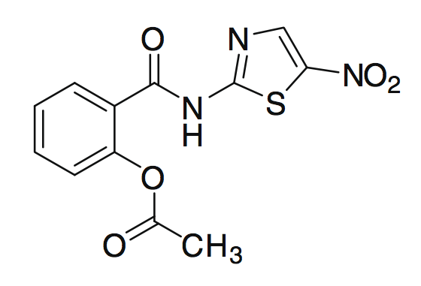 | Yes | High | Uncoupler | (25)
Tizoxanide*  265.3 g/mol  2.76 | 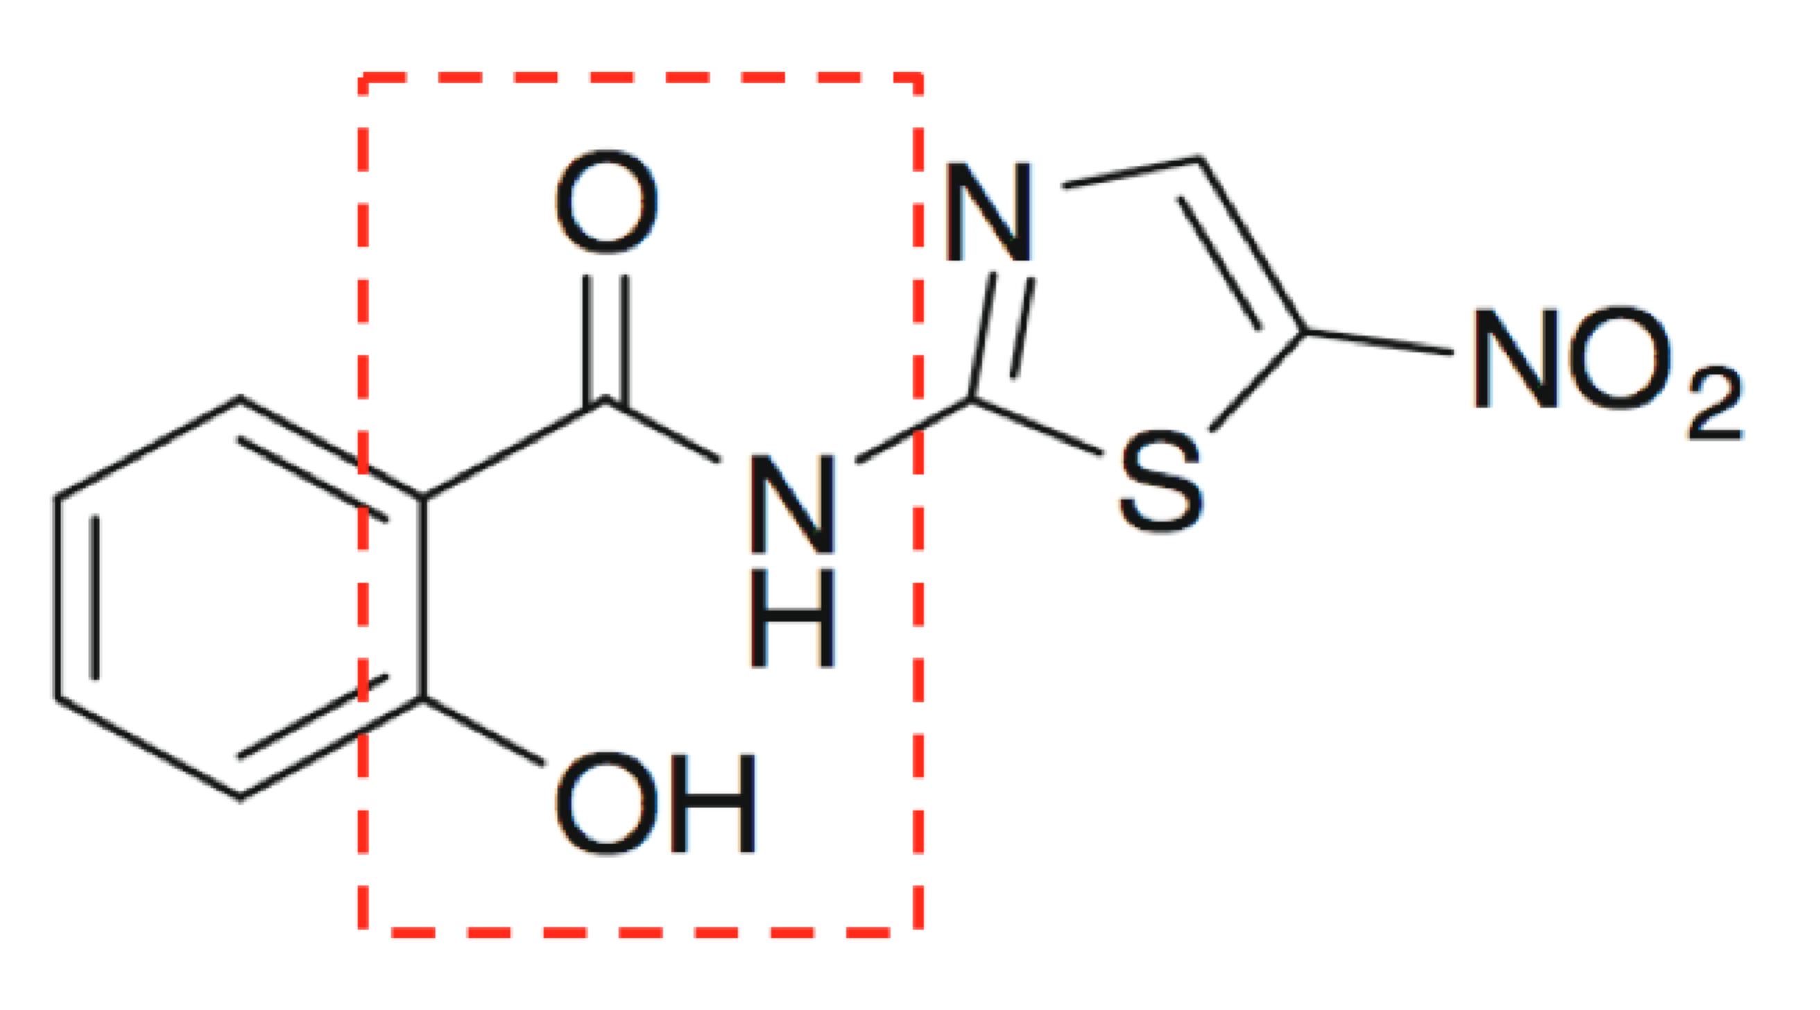 | NA | NA | Uncoupler | (25)
Niclosamide  275.2 g/mol | 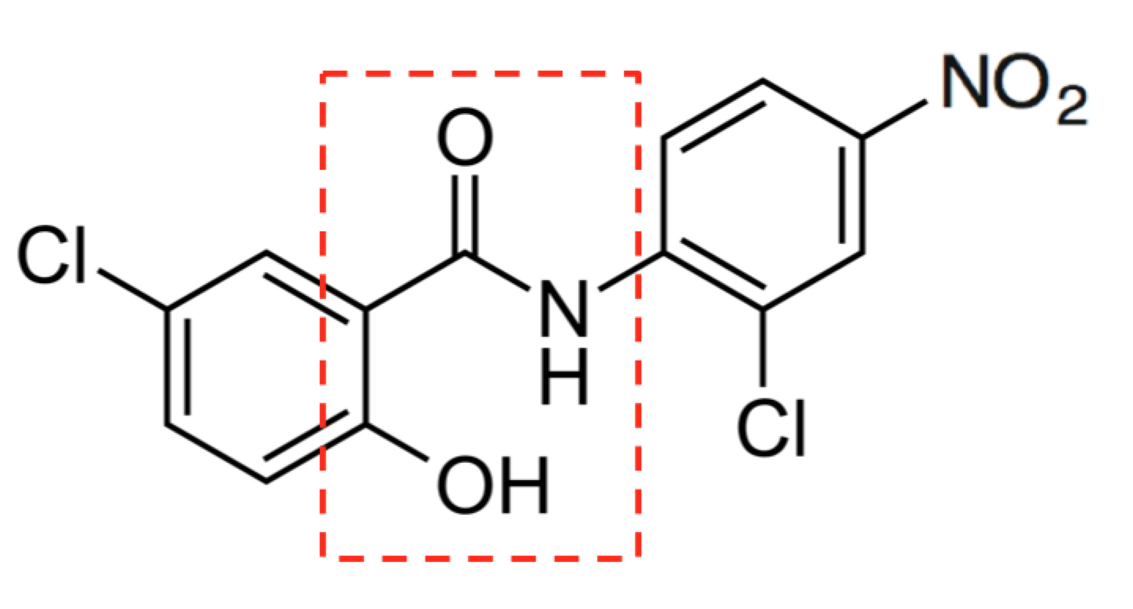 | Yes | Low | Uncoupler | (26-28)
Closantel  410.5 g/mol  1.18 | 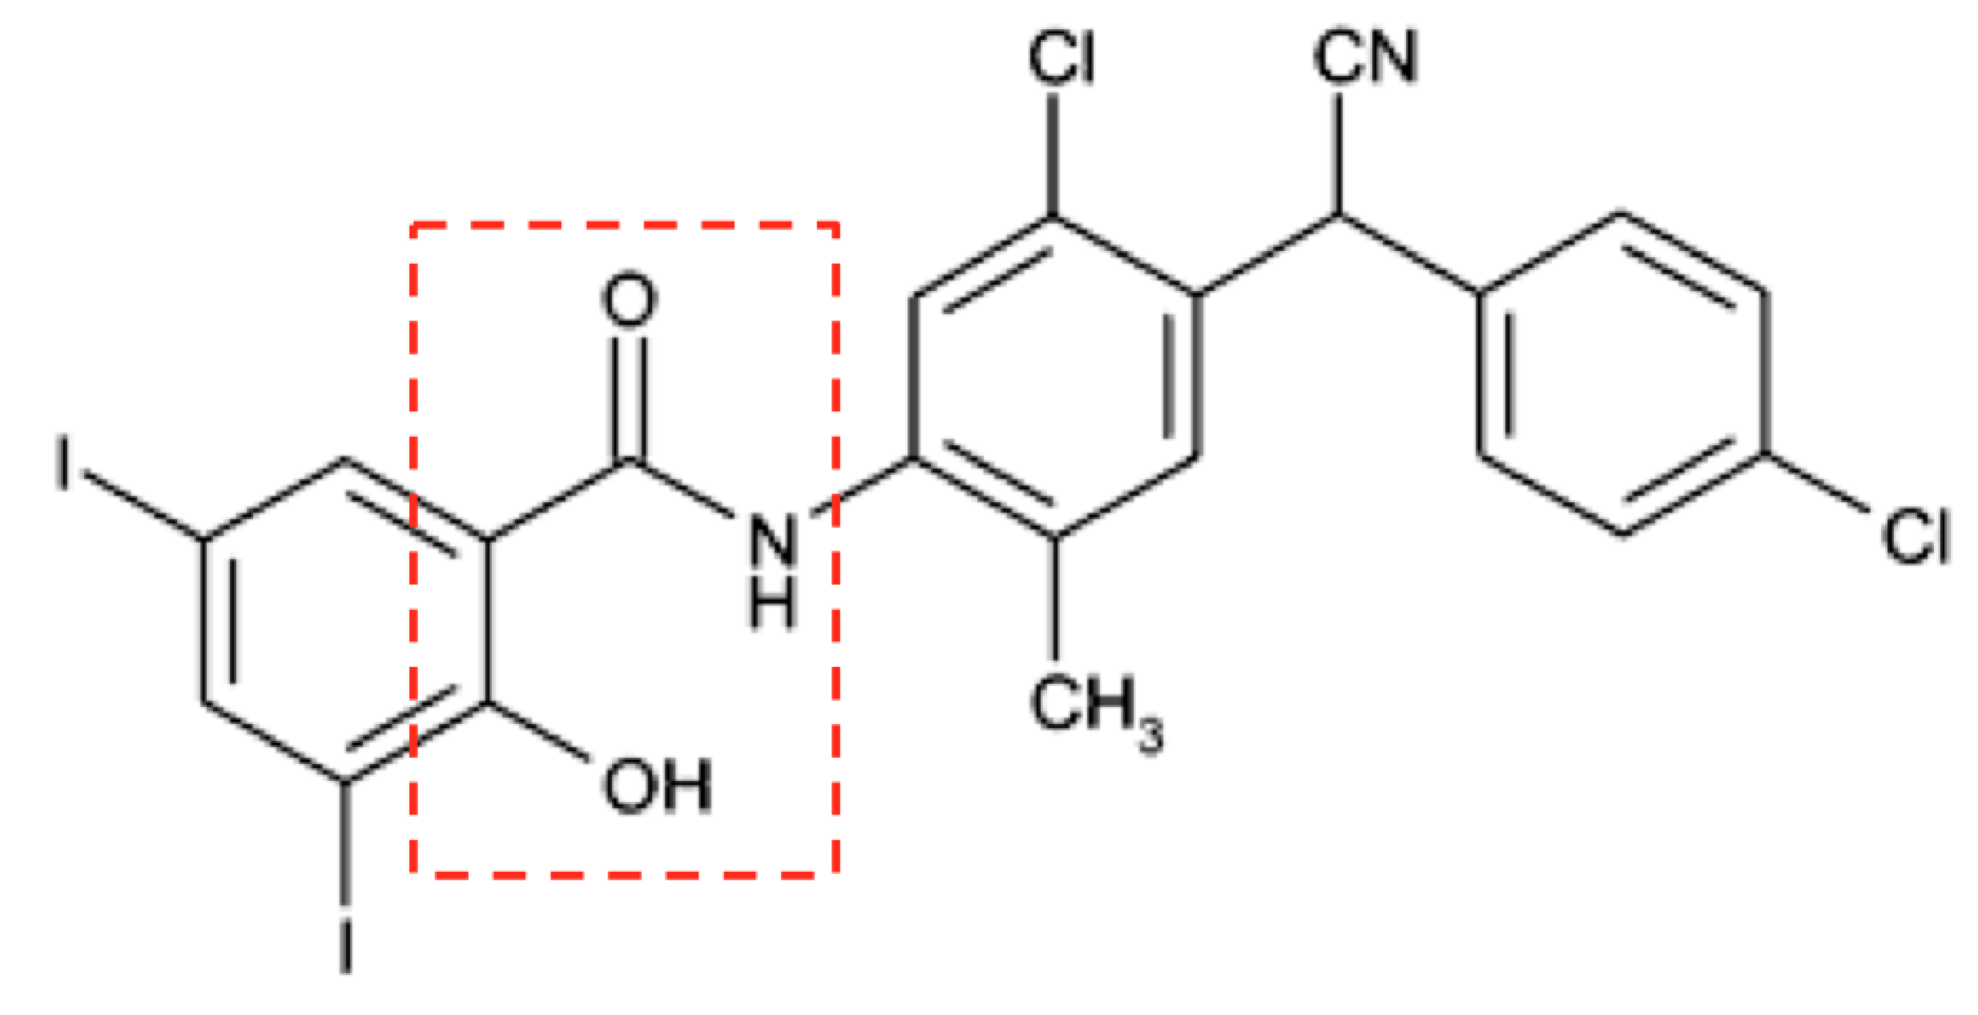 | No | NA | Uncoupler | (29,30)
Salinomycin  421.8 g/mol  2.96 | 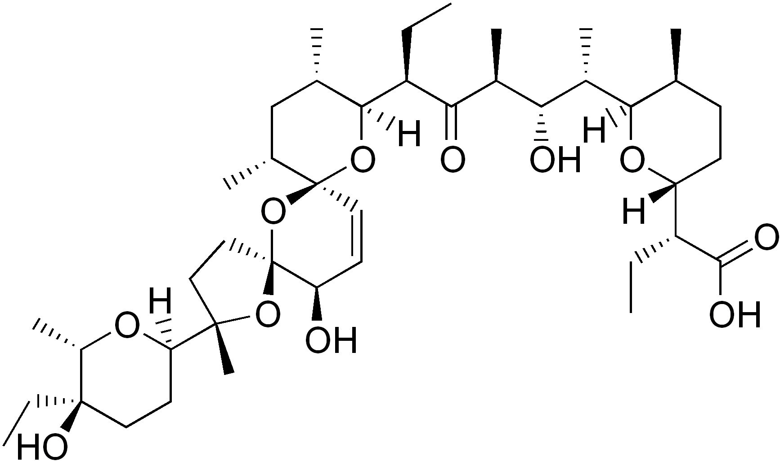 | No | NA | Ionophore,  Inhibitor of oxidative phosphorylation | (33)
Pyrvinium pamoate  475.0 g/mol  4.50 | 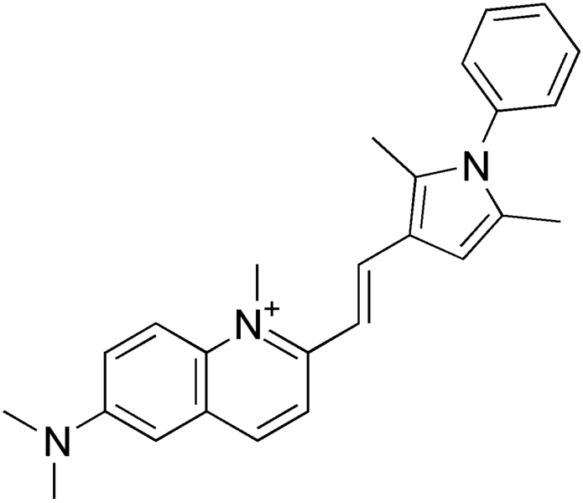 | Yes | Low | Inhibitor of NADH-fumarate reductase system | (31)
Shared pharmacophore highlighted with red rectangle.
* Tizoxanide is the active metabolite of nitazoxanide.

Supplementary Figure legends
Supplementary Table S1
List of 12 3D-selective compounds.
Supplementary Table S2
Chemical and biological properties of the final hit compounds.
Supplementary Figure S1
- Glucose concentration in the culturing medium over time of the spheroid culture. Measurements are shown as means ± s.d.; (n = 3).
- pH in the culturing medium over time of the spheroid culture. Measurements are shown as means ± s.d.; (n = 3).
Supplementary Figure S2
Spheroid-based dose-response experiment with time resolution.
Left: Dose-response curves for HCT116 GFP spheroids (started with 10000 cells/well and grown as spheroids for 7 days prior treatment) treated with nitazoxanide at various concentrations for 24, 48 or 72h. Cell viability was assessed with measurements of mean spheroid GFP fluorescence intensity (3D). Results are shown as means ± s.d.; (n = 3). Right: Bright-field/fluorescence composite images acquired with automated fluorescence microscope (magnification 5x) using identical settings.
All data and images presented are acquired from the same experiment.
This illustrates the possibility to test many different doses and perform sequential measurements from the same plate with our assay.
Supplementary Figure S3
Pearson correlation between two viability assays used for the screen. Data for GFP signal (horizontal axis) were acquired after 72h exposure of spheroids to library drugs. TOX8TM (resazurin-based assay) data were acquired after 7 days of drug exposure, at the end of screening part.
Supplementary Figure S4
Clonogenicity of cells from dissociated HT-29 spheroids after 72h incubation with screening hit compounds or doxorubicin at concentrations equal to 2D IC50 values in comparison with unexposed controls. Concentrations used: closantel 25 μM, niclosamide 17.5 μM, nitazoxanide 25 μM, salinomycin 6 μM, pyrvinium pamoate 0.5 μM, doxorubicin 3 μM.
Supplementary Figure S5
Medium-stressed spheroids are more sensitive to the final screening hits than spheroids formed with medium change.
- Dose-response curves for HCT116 GFP spheroids (10000 cells/well grown as spheroids for 7 days prior treatment) formed without (no medium change; blue) or with medium change (medium changed; red) treated with the final screening hit compounds. Cell viability was assessed with measurements of mean spheroid GFP fluorescence intensity. Results are shown as means ± s.d.; (n = 3).
- Viability of HCT116 GFP spheroids formed without or with medium change treated with the final hit compounds at the concentrations indicated. Cell viability was assessed every 24 h with measurements of mean spheroid GFP fluorescence intensity. Results are shown as means ± s.d.; (n = 3).
- Clonogenicity of all cells from dissociated HCT116 GFP spheroids formed without of with medium change after 72h exposure to nitazoxanide (5 μM), niclosamide (0.5 μM), closantel (15 μM), pyrvinium pamoate (0.5 μM) or salinomycin (2.5 μM) in comparison with unexposed controls. Note that all cells of each dissociated spheroid were seeded into wells (variation from other clonogenic assays presented in this paper). Outgrowth time was 10 days.
- Dose-response curves for HT-29 GFP spheroids (10000 cells/well grown as spheroids for 7 days prior treatment) formed without (no medium change; blue) or with medium change (medium changed; red) treated with the final screening hit compounds. Cell viability was assessed with measurements of mean spheroid GFP fluorescence intensity. Results are shown as means ± s.d.; (n = 3).
- Viability of HT-29 GFP spheroids formed without or with medium change treated with the final hit compounds at the concentrations indicated. Cell viability was assessed every 24 h with measurements of mean spheroid GFP fluorescence intensity. Results are shown as means ± s.d.; (n = 3).
- Clonogenicity of all cells from dissociated HT-29 GFP spheroids formed without of with medium change after 72h exposure to nitazoxanide (25 μM), niclosamide (17.5 μM), closantel (25 μM), pyrvinium pamoate (0.5 μM) or salinomycin (3 μM) in comparison with unexposed controls. Note that all cells of each dissociated spheroid were seeded into wells (variation from other clonogenic assays presented in this paper). Outgrowth time was 10 days.
Supplementary Figure S6
Tizoxanide causes the same effects as nitazoxanide.
- Dose-response curves for HCT116 (2500 cells/well grown as monolayer for 24h prior treatment; 2D; left) and HCT116 GFP (10000 cells/well grown as spheroids for 7 days prior treatment; 3D; right) cells treated with nitazoxanide or tizoxanide for 72 h. Cell viability was assessed with FMCA (2D) or measurements of mean spheroid GFP fluorescence intensity (3D). Results are shown as means ± s.d.; (n = 3).
- Clonogenicity of cells from dissociated HCT116 GFP spheroids after 72h exposure to nitazoxanide or tizoxanide at concentrations of 2 or 5 μM in comparison with unexposed controls. Outgrowth time was 10 days.
- Effects of nitazoxanide or tizoxanide at the concentration range 1-17 μM on oxygen consumption rate (OCR) in 70000 HCT116 cells, as measured by Seahorse XF analyser. Experimental compounds, oligomycin and FCCP were added as indicated with dotted lines. Results are shown as means ± s.d.; (n = 3).
- Left: Effects of nitazoxanide or tizoxanide at concentrations equal to their 2D IC50 values and FCCP (2.5 μM) on mitochondrial membrane potential in HCT116 cells (2500/well). Results in the graph are shown as means of JC-1 aggregates fluorescence per cell + s.d. (n≥7). Right: composite pictures from Cellomics Arrayscan VTI Reader of treated HCT 116 cells. Cell nuclei were stained with Hoechst 33342 and polarized mitochondria were stained with JC-1 probe. All pictures were acquired using identical settings. Magnification used was x20.
- Effects of nitazoxanide, tizoxanide or CCCP on hypoxia within HCT116 GFP spheroids. Spheroids were formed with 10000 cells/well for 7 days without medium change and treated with CCCP (2.5 μM), nitazoxanide (3 μM) or tizoxanide (3 μM) for 4 or 24 h. After 1 h pimonidazole treatment, spheroids were sectioned and hypoxia was visualized by staining for pimonidazole adducts. Scale bar, 250 μm.
- HCT116 GFP spheroids (formed from 10000 cells/well for 7 days without medium change) were treated with nitazoxanide or tizoxanide for 24h at concentrations indicated and analyzed for phospho-AMPK, AMPK and
- phospho-4EBP,1 4EBP1, phospho-p70, p70, C-Myc, phospho-GSK-3β, GSK-3β and β-actin by western blotting.
Supplementary Figure S7
- Proliferation rates in spheroid formed from 10,000 HCT116 GFP cells with medium change after 4 and 7 days of the culture. Staining for Ki-67. Scale bar, 250 μm.
- Clonogenicity of cells from dissociated HCT116 GFP spheroids (10000 cells/well grown as spheroids for 7 days prior treatment; medium was changed on day 4 of the culture and shortly before the treatment; 3D) after 72h exposure to nitazoxanide (10 μM), irinotecan (16 μM) or combination of both drugs in comparison with unexposed controls. Outgrowth time was 10 days.
- Number of colonies in each well from clonogenicity experiment presented in panel A was counted. Wells too dense to count were assumed to contain over 200 colonies. Results are shown as means ± s.d.; (n = 3).
Supplementary Figure S8
CD44 staining of spheroids
- Spheroid formed from 10000 HCT116 GFP cells. Staining for CD44. Scale bar, 250 μm.
- Spheroid formed from 10000 HT-29 GFP cells. Staining for CD44.
- Spheroid formed from 10000 HCT116 GFP cells. Staining without primary antibody (secondary antibody control).

