**Supplementary Tables and Figures**

**Table S1**



Apparent affinity (EC50) for antibodies binding to chimeric human:mouse HER2 ECD constructs where each HER2 domain was sequentially exchanged from human to murine sequence. EC50 values are expressed in µg/ml. (-) Not binding.

**Table S2 HER2 antibodies target distinct epitopes on HER2 ECD**



Epitope binning of antibodies as measured by BioLayer Interferometry (BLI) competition assay. Immobilized human HER2 ECD was saturated with each antibody from the HER2 panel (blocking mAb) and tested for competition with each of the same antibodies from the panel (Test mAb). Antibodies were grouped according to recognized HER2 domain. The percentage competition shown was calculated as the reduction in maximal binding of each antibody when tested on the antibody saturated antigen and is color coded as indicated. Antibody pairs binding overlapping epitopes were identified by an arbitrary set cut-off value of at least 50% inhibition (light red to dark red squares). Boxed squares indicate inhibition values for antibodies blocking their own binding. Negative inhibition values indicate binding enhancement.

**Figure S1 Comparison of Petuzumab analogue and Perjeta**



Comparison of the pertuzumab analogue used in throughout this work and commercially available Perjeta® (pertuzumab). Similar inhibitory activity was seen in the cell line MDA-MB-175-VII.

**Figure S2 Sensograms**

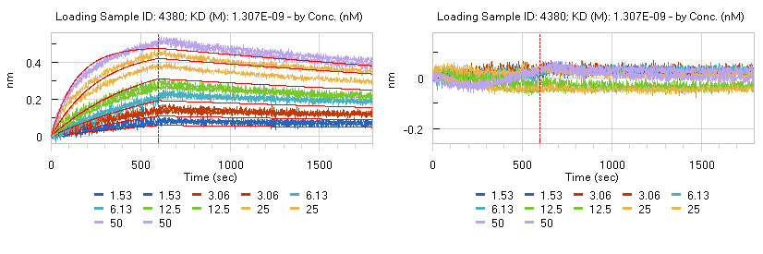

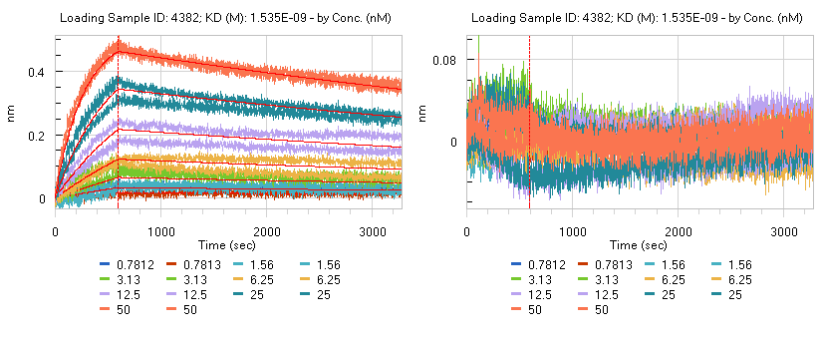

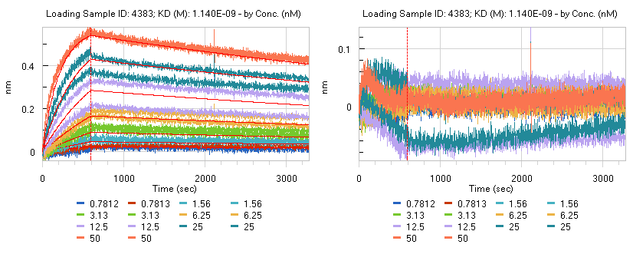

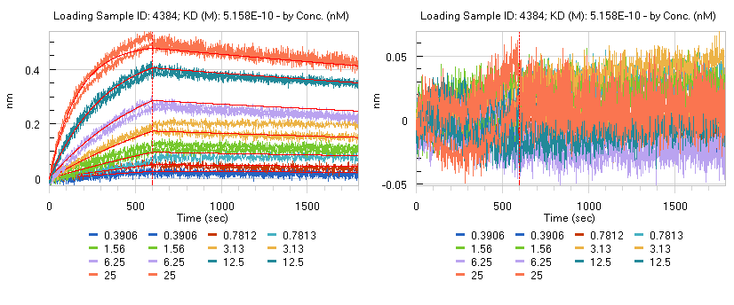

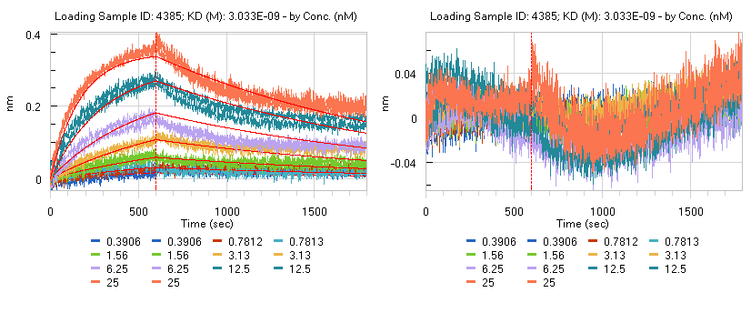

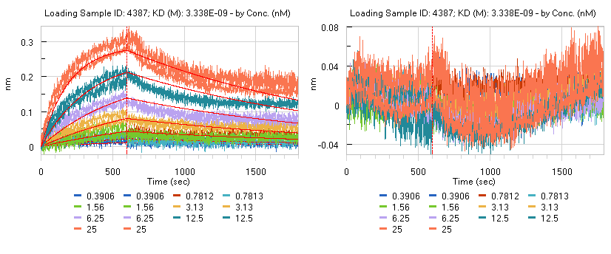

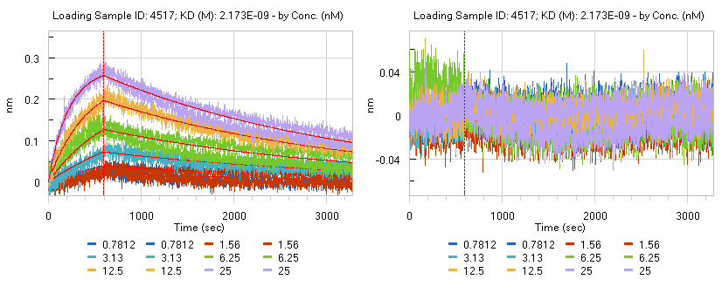

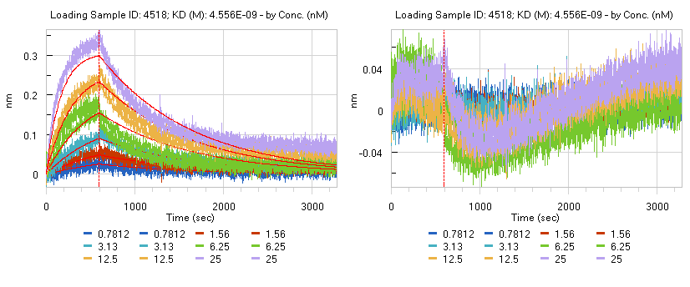

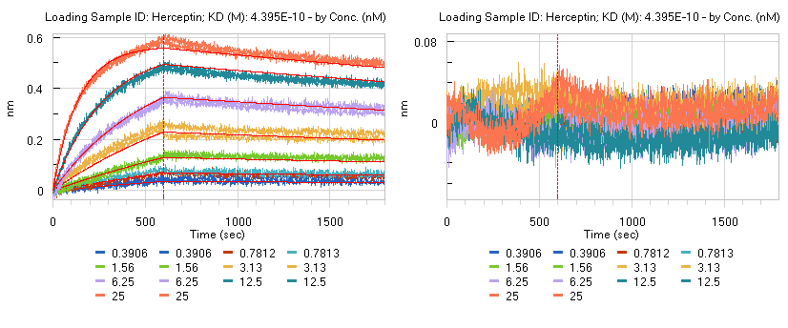

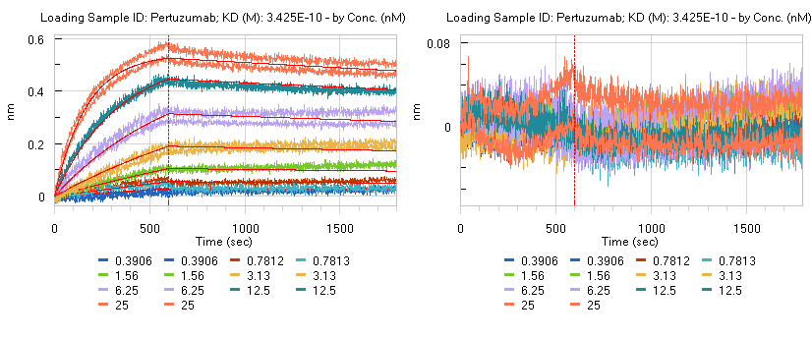

Sensograms for the antibodies 4380, 4382, 4383, 4384, 4385, 4387, 4517, 4518, trastuzumab (Herceptin) and the pertuzumab analogue.

**Figure S3 Dose-response curves for different anti-HER2 mixtures**

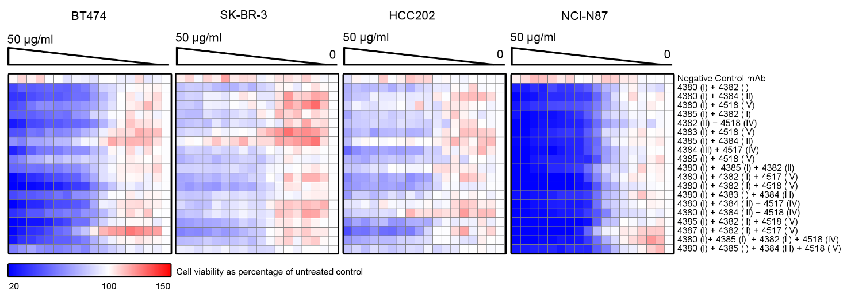

Heat map visualization of dose-response curves for selected anti-HER2 antibody mixtures in a panel of four HER2-driven cancer cell lines.

**Figure S4 Expression and activation status of HER family in cell line panel**

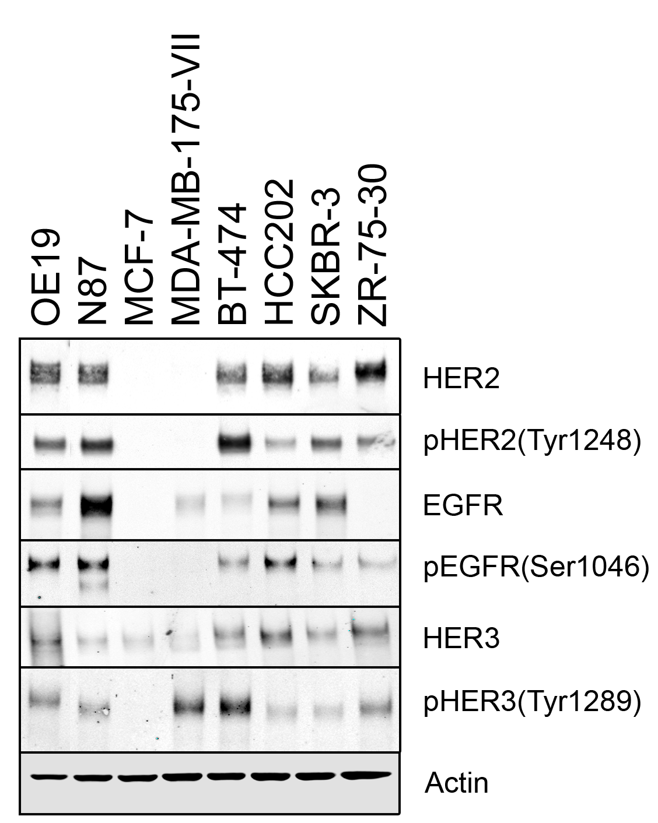

Western blot analyses of EGFR, HER2 and HER3 levels in the eight cancer cell lines used for lead selection studies

**Figure S5 ADCC and CDC**

**A)**

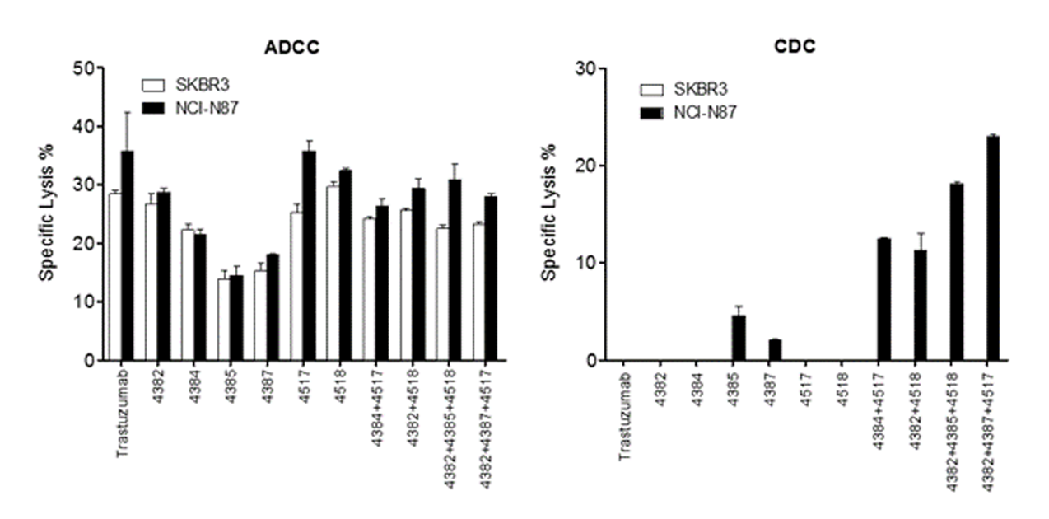

**B)**

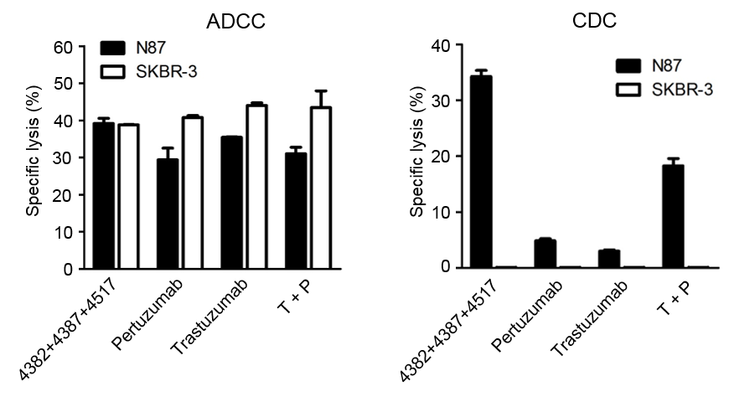

ADCC and CDC of anti-HER2 antibody mixtures against HER2 expressing tumor cell lines in the presence of human PBMCs (ADCC) or serum (CDC). Maximum lysis was measured as the amount of sodium chromate (51Cr) released into the medium by labeled SKBR-3 (white bars) or NCI-N87 (black bars) in the presence of 1 µg/ml (ADCC) or 20 µg/ml (CDC) antibody. Data were normalized to the minimum and maximum signal provided by PBMCs/serum alone and Triton X-100, respectively. Error bars represent SEM.

**Figure S6 Validation of mAb Synergy using Nonlinear Blending Method**



The figure shows blending synergy for the total dose amount of 25 µg/ml of the three two mAb mixtures 4382+4387, 4382+4517 and 4387+4517 as the proportion of mAbs is changed from 0 to 1. Blending synergy (grey area) was demonstrated for each of the possible two mixtures 4382+4387, 4382+4517 and 4387+4517. 4382 and 4387 had the strongest blending synergy. Strong blending synergy was also confirmed when adding a third antibody to each of the possible two-mixtures.

Blending synergy was not observed for the trastuzumab+pertuzumab combination in this cell line and trastuzumab was superior to the combination indicating antagonism of the two antibodies in this cell line.

**Figure S7 Western blot quantification**



Quantification of western blots from Figure 2D. HER2 levels were quantified using simple western as described in method section above. pHER2 (Y1248) levels were estimated from traditional western blots using Odyssey software package.

**Figure S8 Tripartite mixtures of trastuzumab and pertuzumab**



Dose response curves for various mAb mixtures as indicated in the figure.

**Reference list**

1. Peterson JJ. and Novick SJ.Nonlinear blending: a useful general concept for the assessment of combination drug synergy.Drug Synergy Journal of Receptors and Signal Transduction, 27:125-146.