**Supplementary figure 2 - Guichard *et al*.**

**Supplementary figure 2: Pharmacokinetics and PK/PD relationships for AZD2014**.

(A) Oral pharmacokinetics of AZD2014. Symbols are means, error bars are+/- standard errors of the means. Solid lines are fits of a linear two compartment model with first order absorption as described in the main text.

(B) PK/PD modelling (p-AKT) (C) PK/PD modelling (p-S6). Symbols are means with error bars being +/- standard errors of the means. Solid lines are model fit of a direct response model as described in the main text.

**(A)**

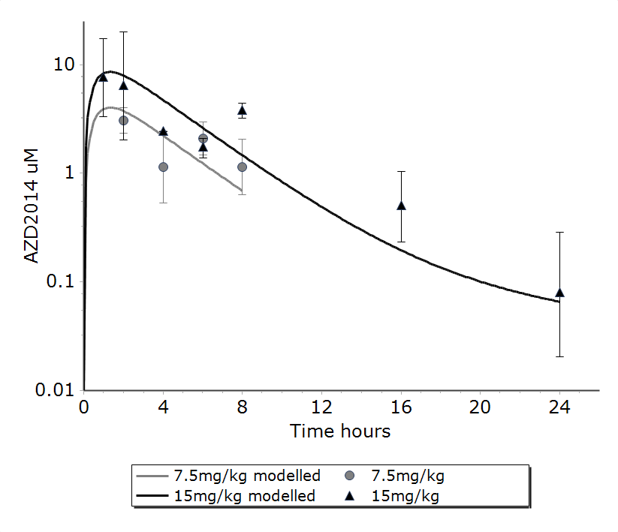

**(B)**



**(C)**

**C:\Users\ksmc298\AppData\Local\Microsoft\Windows\Temporary Internet Files\Content.Outlook\71XOU49D\Fig 2b pS6.tif**