Agents | 1 mg/mL | 2.5 mg/mL | 5 mg/mL | 7.5 mg/mL
Leelamine (Saline) | Insoluble | Insoluble | Insoluble | Insoluble
Liposomal leelamine | Soluble | Soluble | Soluble | Soluble
Supplemental Figure S1

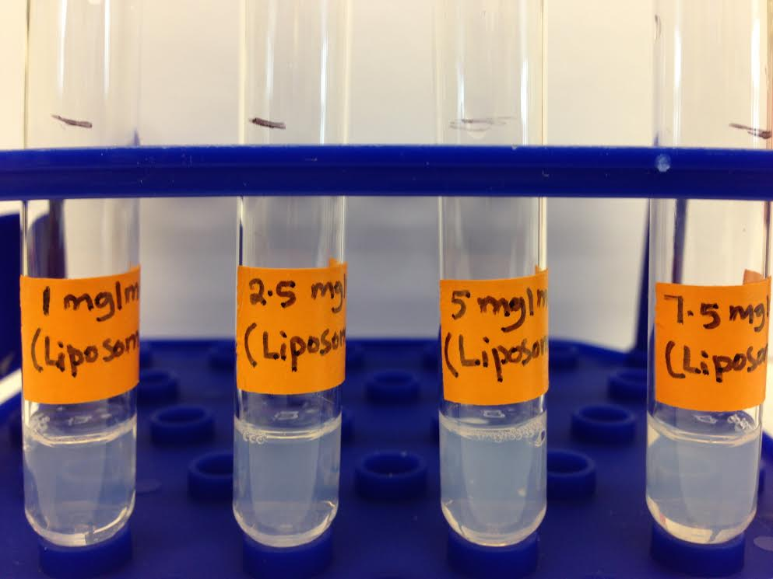
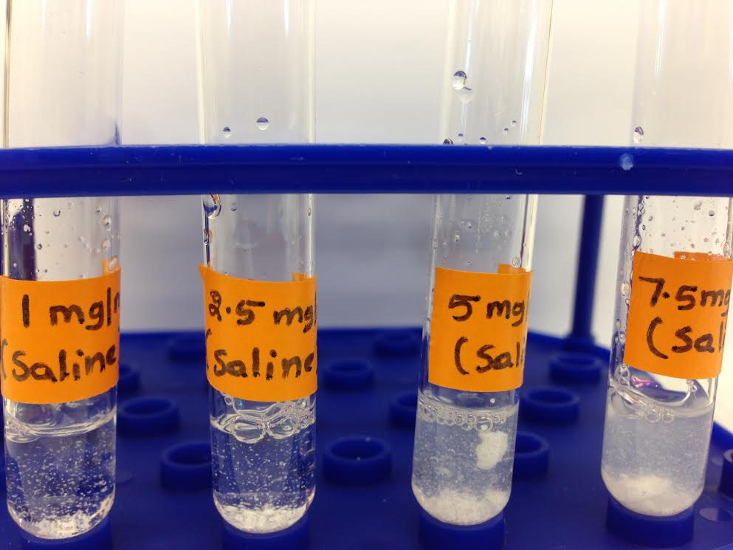
Leelamine in Saline Liposomal leelamine
*
*

