SUPPLEMENTARY FIGURES AND TABLES
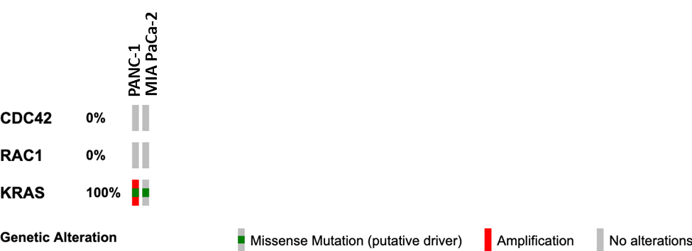
Supplementary Figure 1. Mutational profile for key genes in the cell lines studied. Oncoprint was generated using cBioportal.

Supplementary Figure 2. Volcano plot of proteins altered by mechanical stress. Values represent the log2-ratio (compressed/uncompressed) of expression level for each protein in each condition (n=3; 3 biological replicates). All proteins are depicted in this plot, with black color for no significant change, red for increase (>20%) and blue for decrease (<20%).
Supplement Figure 3. Immunoblotting showing activated JNK (Thr183/Tyr185) in control and compressed MIA PaCa-2 cells. Quantification of pJNK compared to β-tubulin, with fold changes indicated in grey font.
Supplement Figure 4. Mechanical stress upregulates the RAS/MAPK and downregulates the TSC/mTOR pathway. Heatmaps showing the expression level of each protein member in the selected pathways. Values in the heatmap represent the log2-ratio (compressed/uncompressed) of expression level for each protein in each condition (n=3; 3 biological replicates). Red: increase vs. blue: decrease.

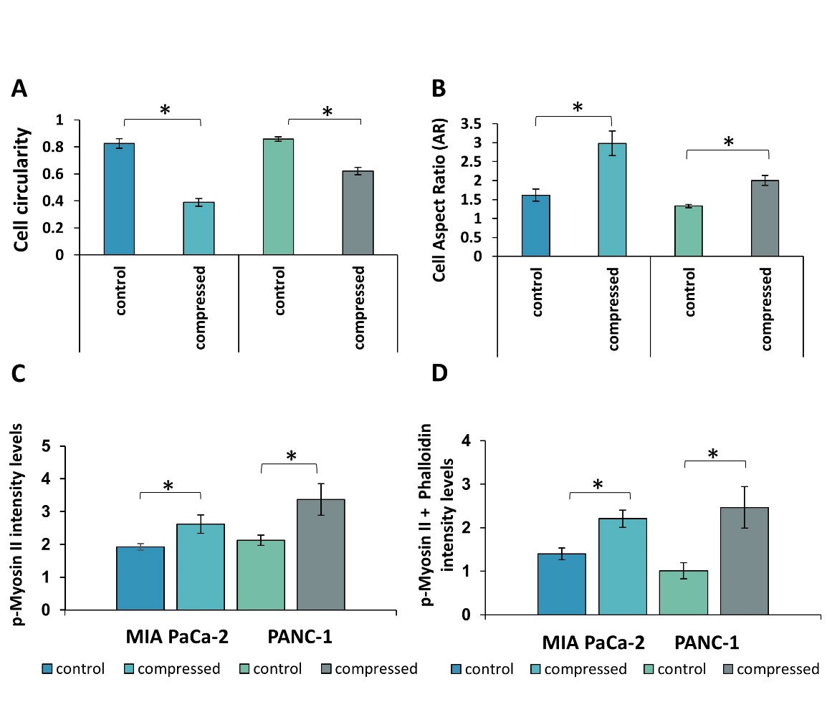
Supplementary Figure 5. A-B, The average cell circularity (A) and aspect ratio (B) (major/minor axis of the cell) was quantified using ImageJ. For cell circularity, a value of 1.0 indicates a perfect circle. Asterisk (*) indicates a statistically significant difference (p<0.05 in student’s t test, n≥25). C-D, The average of p-Myosin II (C) and p-Myosin II + phalloidin (D) area fraction normalized to DAPI fraction in control and compressed cells was quantified automatically using an in-house code in MATLAB. Asterisk (*) indicates a statistically significant difference (p<0.05 in student’s t test).

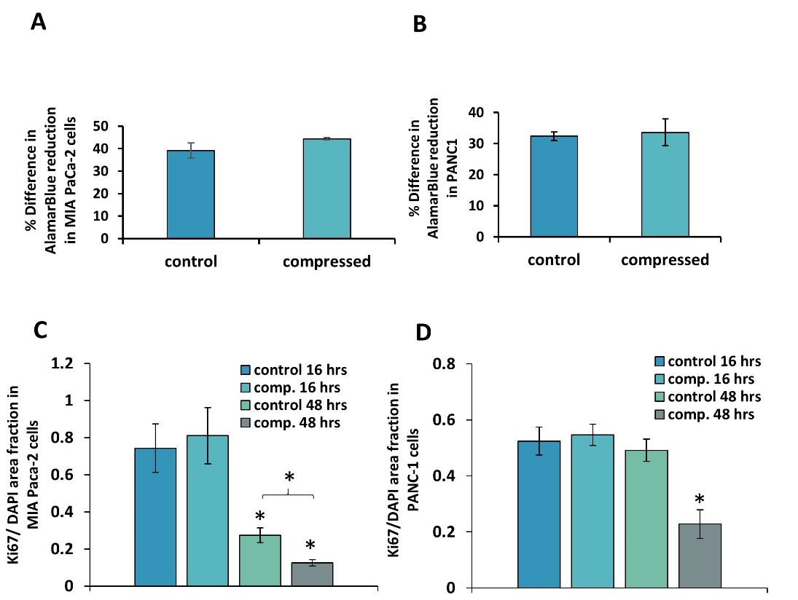
Supplementary Figure 6. The effect of mechanical stress on the viability and proliferation of pancreatic cancer cells. A-B, MIA PaCa-2 and PANC-1 cells were subjected to 0.0 (agarose cushion only) or 4.0 mmHg compressive stress for 16 hours, and AlamarBlue assay was performed pre- and post-compression. The absorbance measured by AlamarBlue reagent represents the metabolic activity of the cells, and thus it was used as an indicator for cell viability. Graphs represent the average % difference ±SE in AlamarBlue reduction pre-and post-compression in control and compressed cells. No statistically significant differences were observed in compressed cells as compared to the control (2 biological replicates; n=6, *p<0.05 in student’s t test). C-D, MIA PaCa-2 and PANC-1 cells were compressed for 16 and 48 hours and then were stained with Ki67, a marker for proliferation. The average Ki67 area fraction from at least 8 different fields/condition from two biological replicates was quantified automatically using an in-house code in MATLAB. Asterisk (*) indicates a statistically significant difference (p<0.05 in student’s t test).

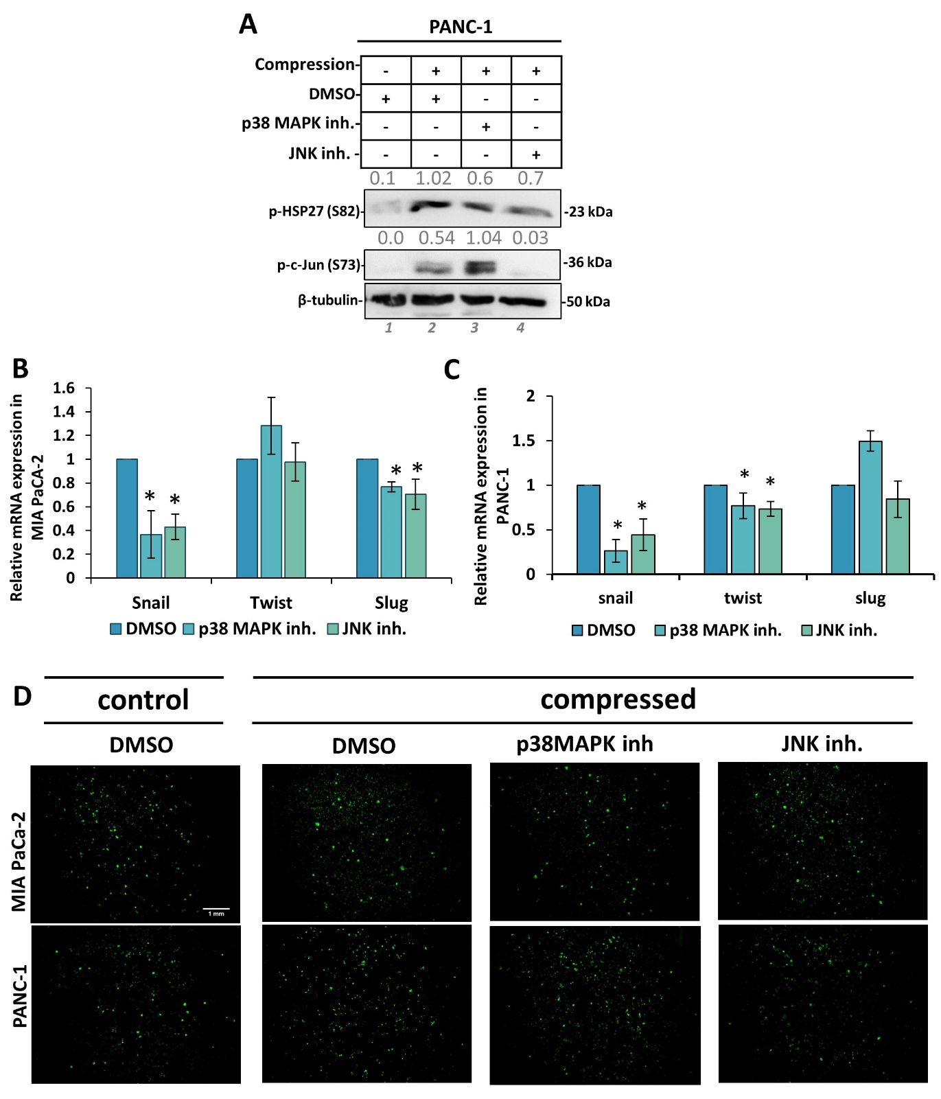
Supplementary Figure 7 A, Representative Immunoblotting showing phosphorylated HSP27 (Ser 82) and c-Jun (S73) in control and compressed PANC-1 cells treated with 15 μΜ of each inhibitor or equal volume of DMSO. Antibody against β-actin was used as a loading control. Quantification of each antibody compared to loading control was quantified by ImageJ and it is indicated by numbers in grey font. B-C, qPCR was used to quantify the mRNA levels of EMT markers in compressed MIA PaCa-2 (B) and PANC-1 (C) cells treated with 15 μΜ of each inhibitor compared to compressed cells treated with DMSO. ΔΔCt method was used to quantify the gene expression in each sample using as a reference the expression in compressed and treated with DMSO cells. Bar graphs represent the mean fold change ±SE of two biological replicates experiments (n=6) and statistical changes are indicated with an asterisk (*) (p<0.05 in student t test). D, Representative images of Ki67 staining in MIA PaCa-2 and PANC-1 uncompressed (DMSO) and compressed cells (DMSO+4 mmHg), and compressed cells treated with p38 MAPK or JNK inhibitors. Scale bar: 1mm.
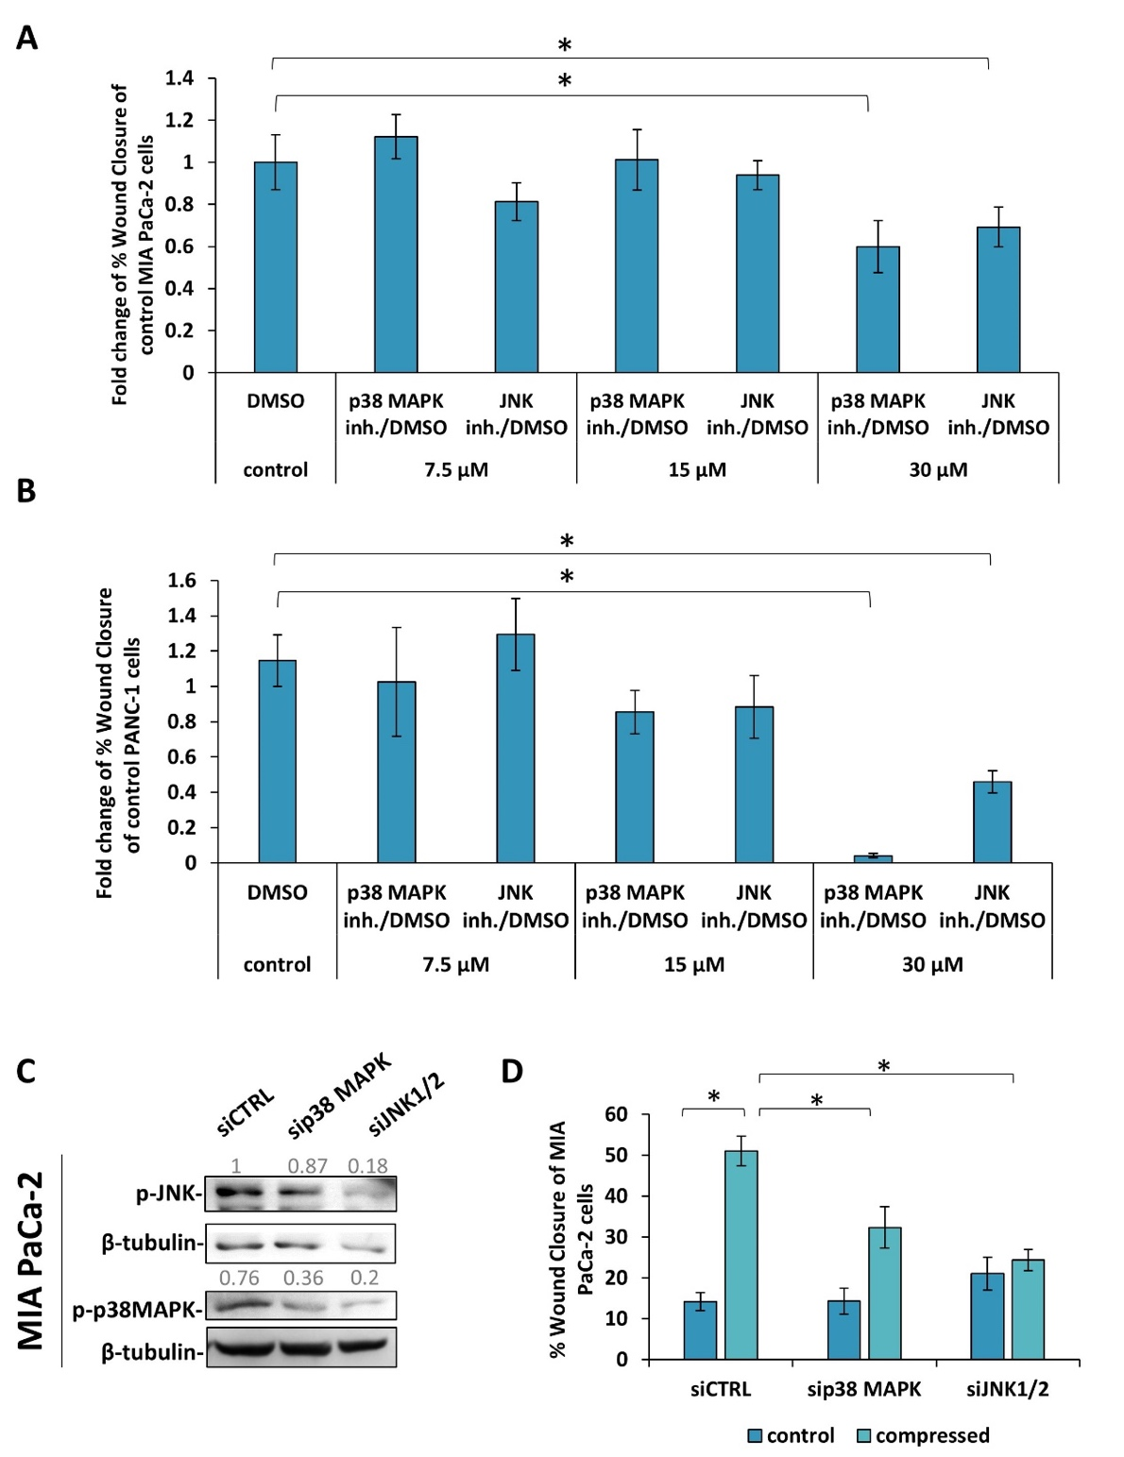
Supplementary Figure 8. A-B, MIA PaCa-2 and PANC-1 cells were treated with DMSO, p38 MAPK inhibitor (SB202190) or JNK inhibitor (SP600125) at 7.5-, 15- and 30 μΜ in low-serum- containing DMEM and then subjected to a scratch assay for 16 hours. Graphs showing the average percentage ±SE wound closure of MIA PaCa-2 (A) and PANC-1 (B) as quantified using ImageJ software. Statistically significant differences in wound closure of treated with inhibitors MIA PaCa-2 or PANC-1 cells compared to DMSO-treated cells is indicated with an asterisk (*) (2 biological replicates; n≥6; p<0.05 in student’s t test). C, Immunoblotting showing phosphorylated levels of JNK and p38 MAPK in MIA PaCa-2 cells treated with siCTRL-, sip38 MAPK- or siJNK1/2. Numbers in grey font represent the quantification of each protein normalized to β-tubulin. D, MIA PaCa-2 cells were treated with siRNA against p38 MAPK (sip38 MAPK) or co-treated with siRNA against JNK1 & JNK2 (siJNK1/2) and then subjected to a scratch wound healing assay for 16 hours under 0.0 or 4.0 mmHg of compression in 2 % FBS containing DMEM. Control cells were treated with stealth siRNA (siCTRL). Graph showing the average percentage ±SE of wound closure from a representative experiment of MIA PaCa-2 as quantified using ImageJ software. Statistically significant differences are indicated with an asterisk (*) (n≥4; p<0.05 in one-way ANOVA).
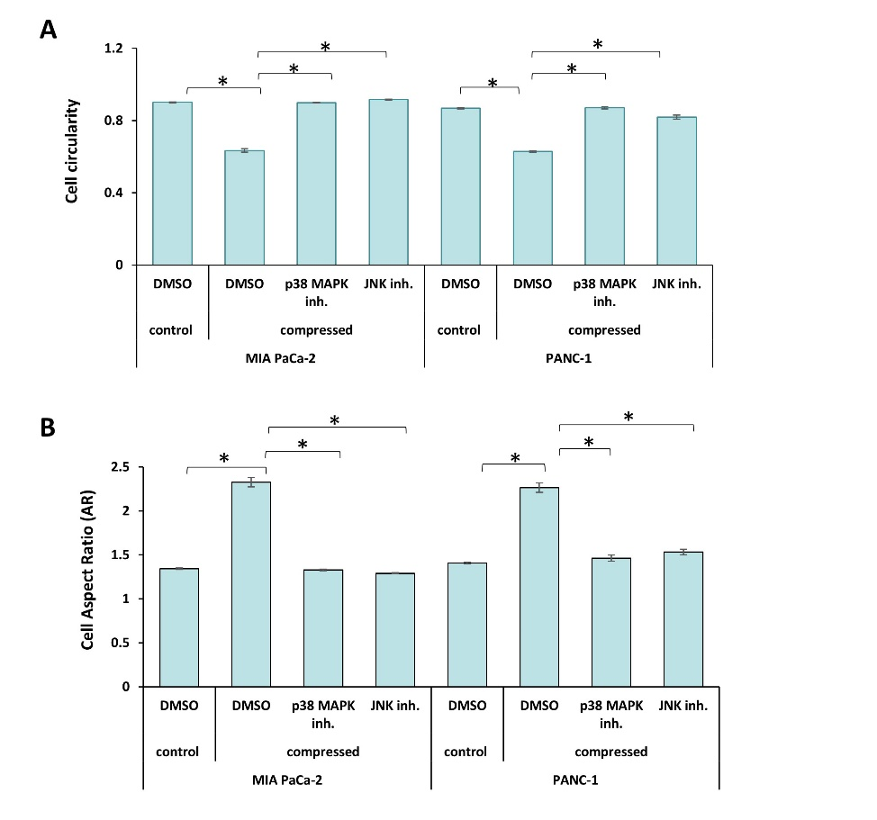
Supplementary Figure 9. The average of cell circularity (A) and aspect ratio (B) (major/minor axis of the cell) was quantified by ImageJ. For cell circularity a value of 1.0 indicates a perfect circle. Asterisk (*) indicates a statistically significant difference (p<0.05 in one-way ANOVA analysis; n≥25).

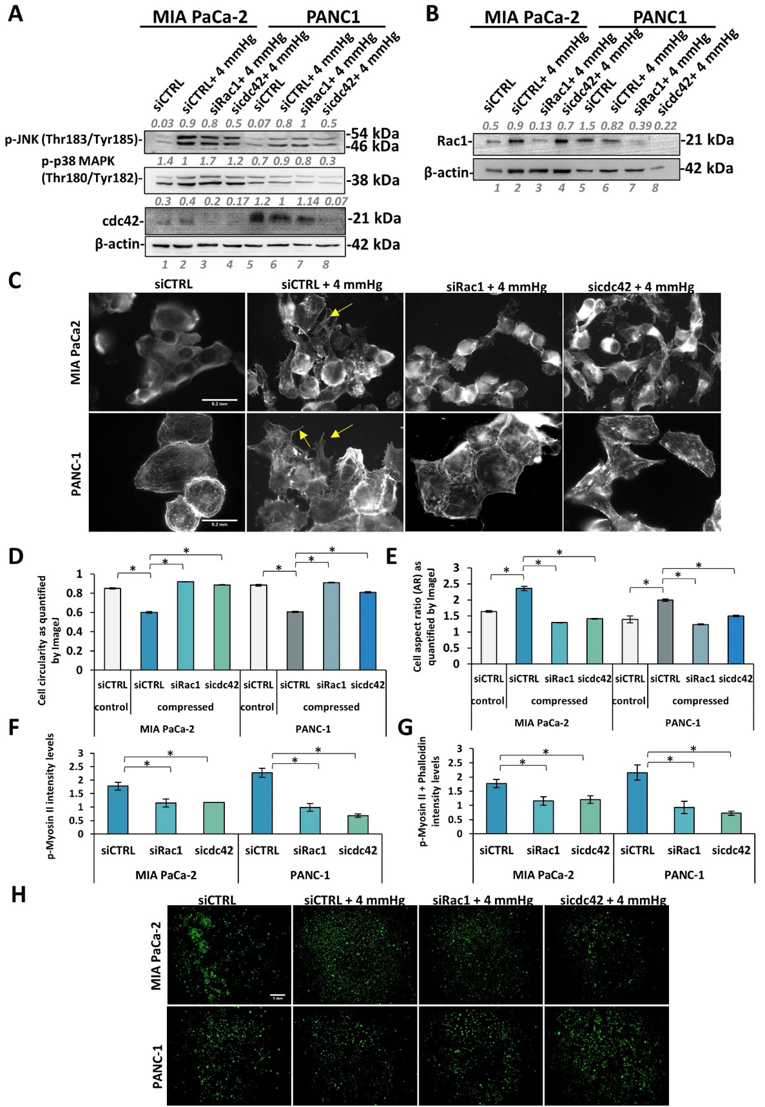
Supplementary Figure 10. A, Representative immunoblotting in control and compressed MIA PaCa-2 and PANC-1 treated with siCTRL, siRac1 or sicdc42 for the detection of the phosphorylated levels of JNK (Thr183/Tyr185), p38 MAPK (Thr180/Tyr182) and total levels of cdc42. Antibody against β-actin was used as a loading control. Quantification of each antibody compared to loading control was performed by ImageJ and it is indicated by numbers in grey font. B, Representative immunoblotting in control and compressed MIA PaCa-2 and PANC-1 treated with siCTRL, siRac1 or sicdc42 for the detection of total Rac1 levels. Antibody against β-actin was used as a loading control. Quantification of Rac1 antibody compared to loading control was quantified by ImageJ and it is indicated by numbers in grey font. C, Representative images of phalloidin staining in control and compressed MIA PaCa-2 and PANC-1 cells treated with siCTRL, siRac-1 or sicdc42. Red arrows indicate cell protrusions that facilitate cell migration. Scale bar 0.2 mm. D-E, The average cell circularity (D) and aspect ratio (E) (major/minor axis of the cell) was quantified by ImageJ. For cell circularity a value of 1.0 indicates a perfect circle. Asterisk (*) indicates a statistically significant difference (p<0.05 in one-way ANOVA analysis, n≥25). F-G, The average of p-Myosin II (F) and p-Myosin II+phalloidin (G) area fraction normalized to DAPI area fraction in control and compressed cells was quantified automatically using an in-house code in MATLAB. Asterisk (*) indicates a statistically significant difference (p<0.05 in one-way ANOVA analysis). H, Representative images of Ki67 staining in uncompressed MIA PaCa-2 and PANC-1 treated with siCTRL and compressed treated with siCTRL, siRac or sicdc42. Scale bar: 1mm.
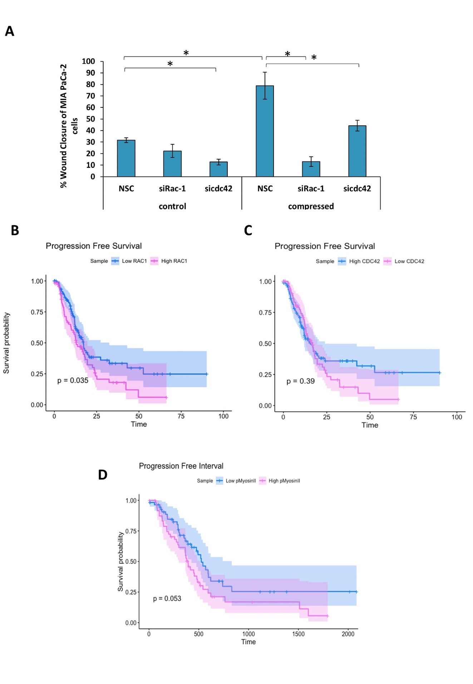
Supplementary Figure 11. A, MIA PaCa-2 pancreatic cancer cells were treated with siRNA against Rac1 (siRac1) or cdc42 (sicdc42) and then subjected to a scratch wound healing assay for 16 hours under 0.0 or 4.0 mmHg of compression in 2 % FBS containing DMEM. Control cells were treated with stealth siRNA (siCTRL). Graph showing the percentage ±SE wound closure of control and compressed MIA PaCa-2 cells treated with siRAC1 or sicdc42 normalized to siCTRL cells. Statistically significant differences are indicated with an asterisk (*) (1 biological replicate; n≥4; p<0.05 in one-way ANOVA analysis). B-D, Kaplan-Meier survival analysis for assessment of overall survival (0S) based on tumor Rac1 and cdc42 mRNA expression, and phospho-Myosin II protein expression in patients with pancreatic ductal adenocarcinoma.
Full-length Immunoblotting Images.
Figure 2A
-p-HSP27
b-tubulin

Figure 2C
p-p38 MAPK
48kD-
-b-tubulin
63kD-
Figure 2E
-c-Jun
48kD-

-b-tubulin
63kD-
Figure 2G
-pHSP27
35kD-
-pJNK
48kD-

-p-p38 MAPK
48kD-
-b-tubulin
63kD-

Supplementary Figure 3
-pJNK
48kD-

//////
-B-TUBULIN
63kD-

//////

Figure 4F
-pHSP27 -actin on HSP27
48kD-
35kD-
-p-c-Jun Actin on c-Jun
-48kD
-48kD

Supplementary Figure 6
-pHSP27
35kD-
-c-Jun
48kD-
-b-tubulin
3kD-

Supplementary Figure 9A
-pJNK
48kD-
-p-p38 MAPK
48kD-
-CDC42 TOTAL
28kD-

-b-actin
48kD-
Supplementary Figure 9B
-Rac1
-actin

Supplementary Table 1
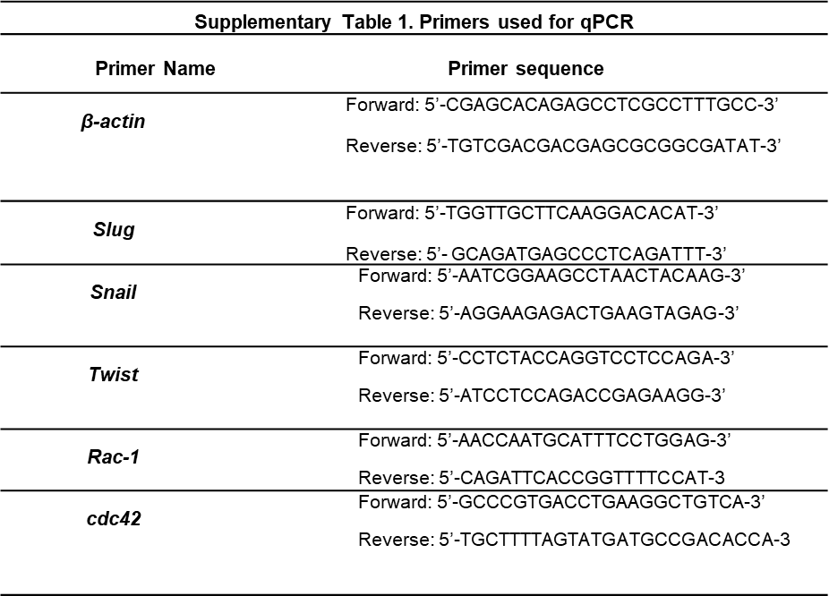

Supplementary Table 2: Gene ontology enrichment analysis in normal cell lines

SUPPLEMENTARY MATERIALS AND METHODS
AlamarBlue Assay
Cancer cells were subjected to a cell viability test prior- and post- compression using AlamarBlue reagent (Thermo), according to the manufacturer’s instructions. %Difference in AlamarBlue Reagent was calculated in triplicates for each condition.

