- Baseline (N=45), >40% cases had genomic gain
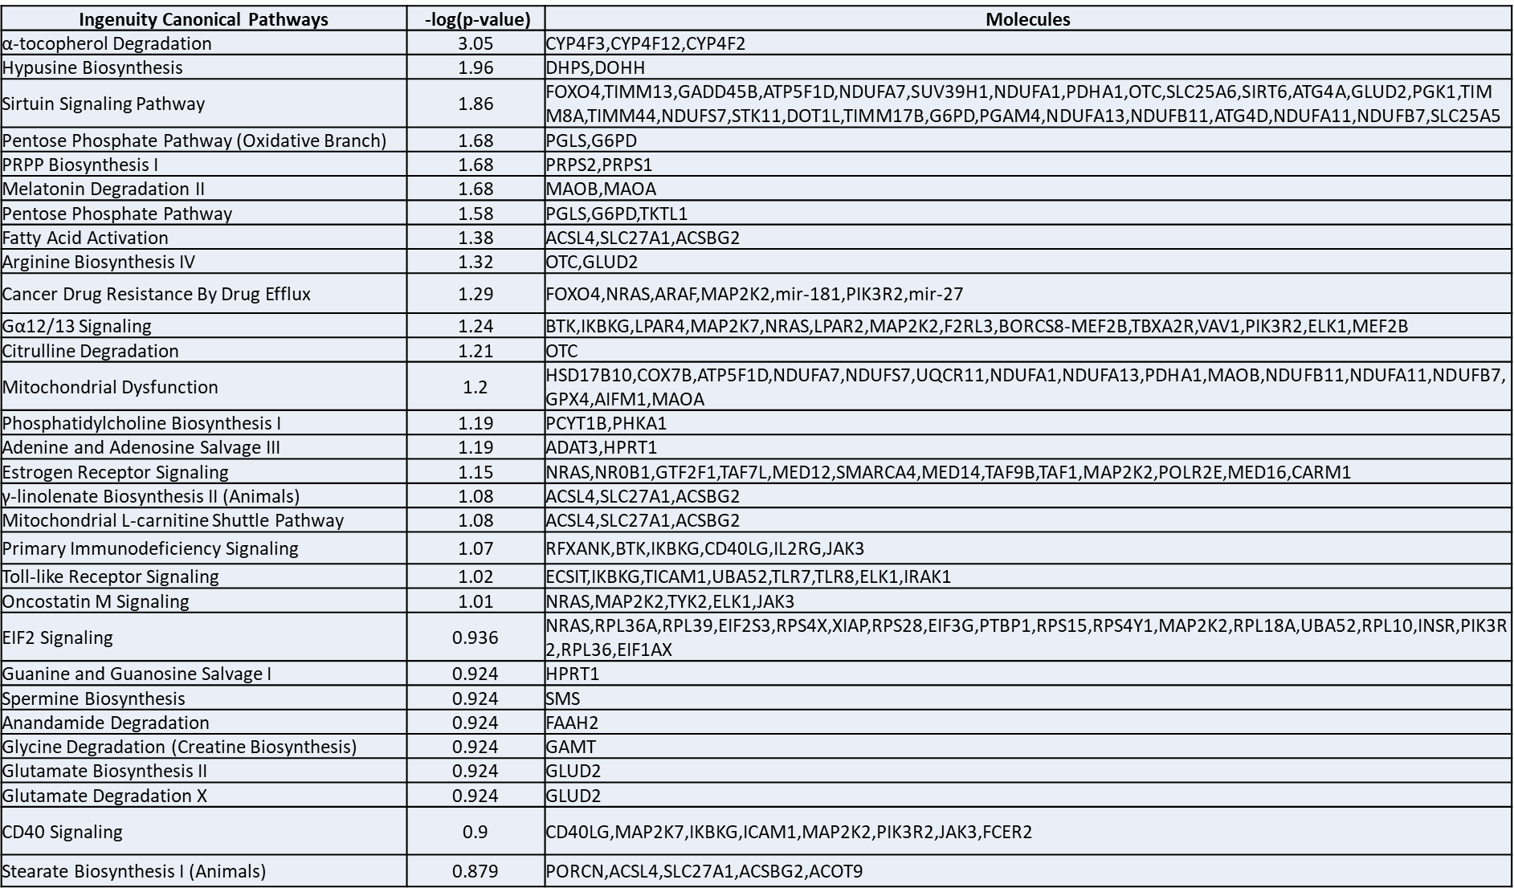
- Progression (N=28), >40% cases had genomic gain
