Supplementary Data for
Dual Regulation of Histone Methylation by mTOR Complexes Controls Glioblastoma Tumor Cell Growth via EZH2 and SAM
Mio Harachi, Kenta Masui, Hiroaki Honda, Yoshihiro Muragaki, Takakazu Kawamata, Webster K. Cavenee, Paul S. Mischel and Noriyuki Shibata
・Supplementary Figures S1-S7

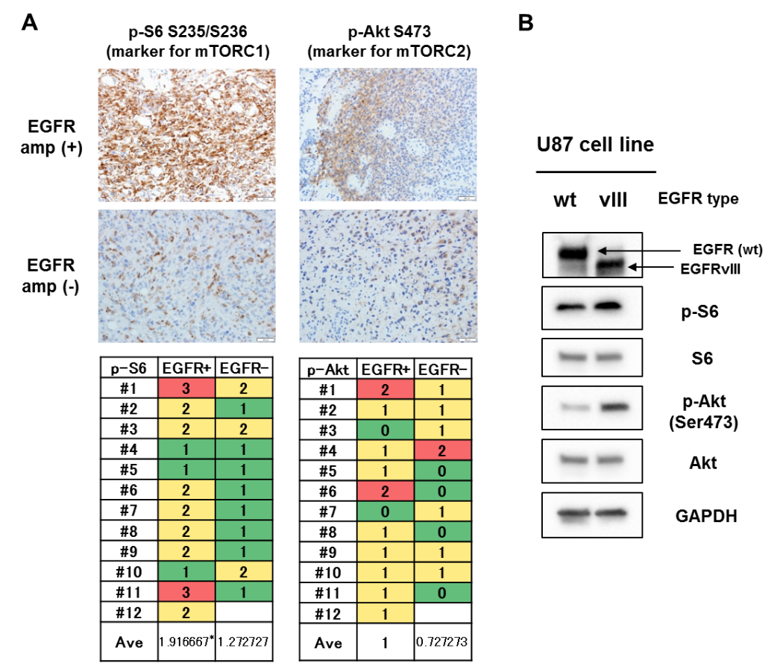
Figure S1. mTORC1 and mTORC2 are activated downstream of aberrant EGFR signaling in human GBM. A, Representative images for differential expression of p-S6 (mTORC1 activation marker) and p-Akt S473 (mTORC2 activation marker) in surgically resected GBM cases with (n = 12) or without (n = 11) EGFR amplification. B, Immunoblot detection of mTOR activation markers (p-S6 for mTORC1, p-Akt for mTORC2) in U87 cells with wild type (wt) EGFR and constitutively active form of EGFR (EGFRvIII).

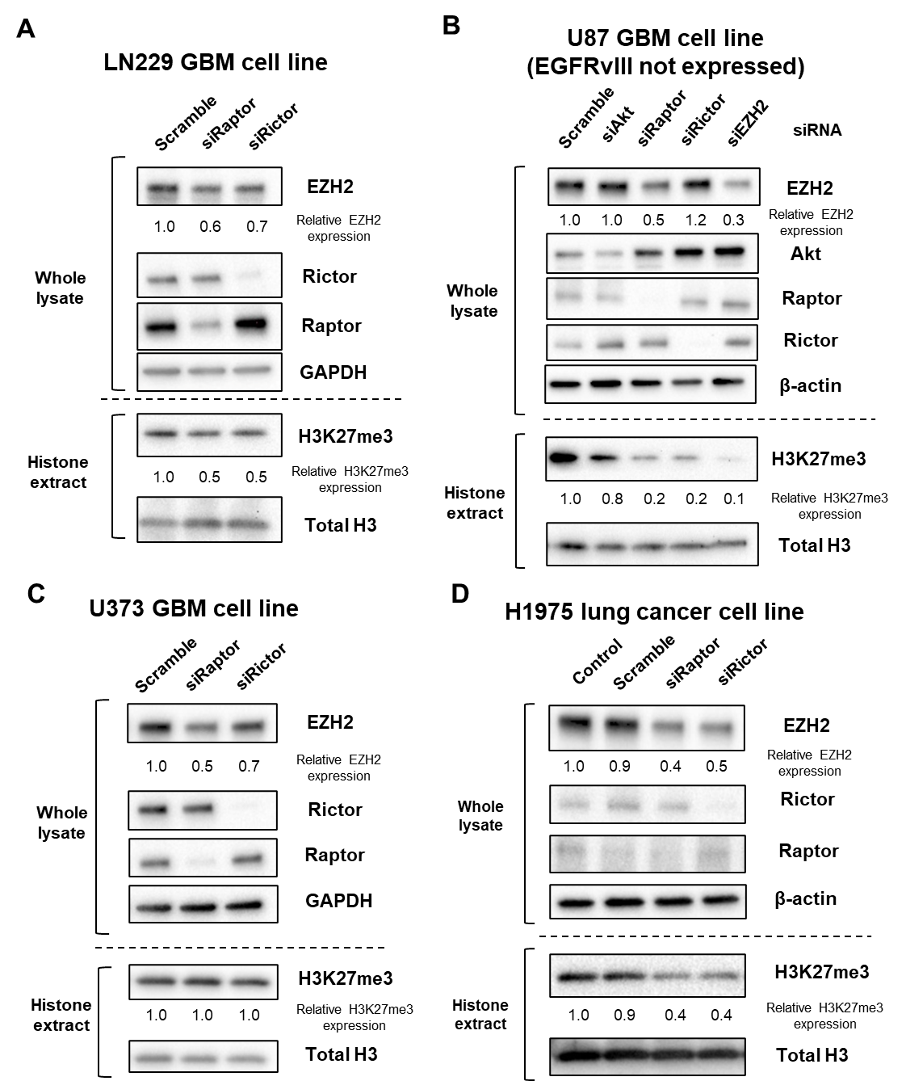
Figure S2. mTOR complexes regulate expression of EZH2 and H3K27me3 in GBM cell lines and other types of cancer cell lines. A-D, Knockdown of Raptor (mTORC1) or Rictor (mTORC2) reduces EZH2 and H3K27me3 expression at various levels in LN229, GBM cell line with EGFRvIII (tet-on EGFRvIII system) (A), U87 cell line without any known EGFR mutation (B), U373, GBM cell line with EGFRvIII (tet-off EGFRvIII system) (C), and H1975, lung cancer cell line with another EGFR mutation type (T790M) (D).
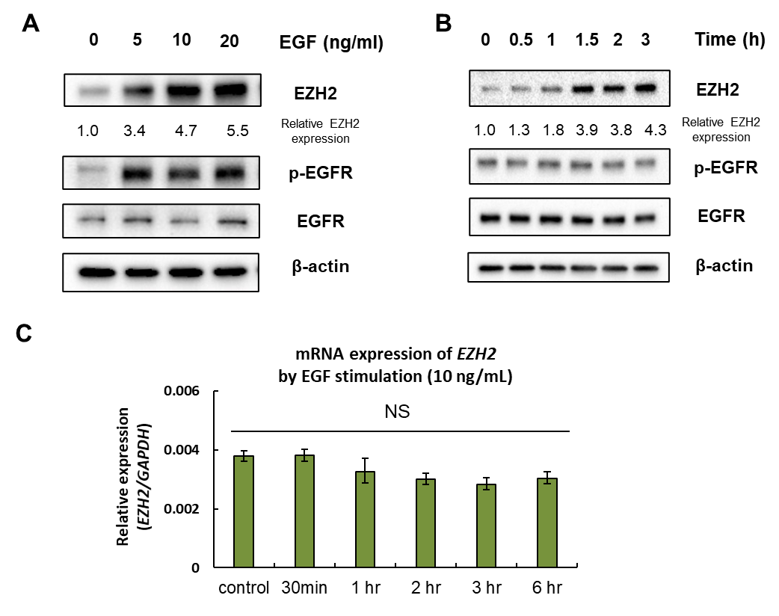
Figure S3. EGFR activation translationally increases the level of EZH2. A, Immunoblot detection of dose-dependent increase of EZH2 in U87-wild type EGFR with EGF stimulation (indicated dose) for 48 hours. B, Immunoblot detection of time-dependent increase of EZH2 in U87-wild type EGFR with EGF stimulation (EGF 10 ng/ml). C, Quantification of mRNA expression of EZH2 in U87-EGFRvIII cells with EGF stimulation in an indicated time frame. NS, not significant.

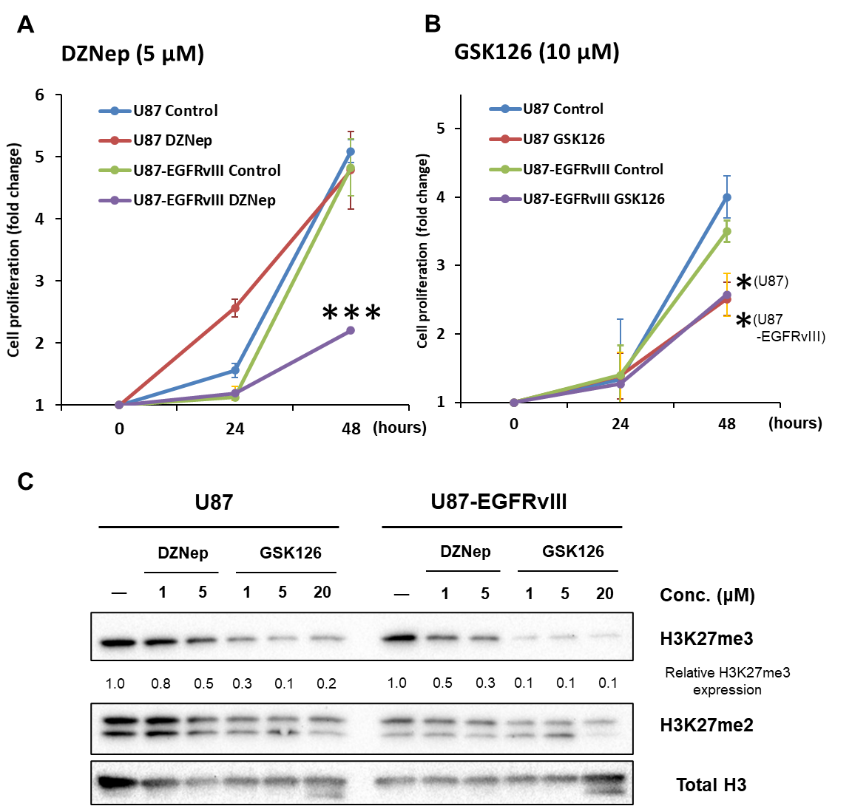
Figure S4. Aberrant EGFR signaling renders GBM cells sensitive to EZH2 inhibitors. A-C, Cell proliferation (A, B) and Western blotting (C) assays revealed that EGFR-mutated GBM cells (U87-EGFRvIII) were more sensitive to EZH2 inhibitors (DZNep and GSK126) over EGFR-wildtype GBM cells (U87). Note that the effect of DZNep on EGFR-mutated GBM cells was more potent than that of GSK126 in terms of cell proliferation.

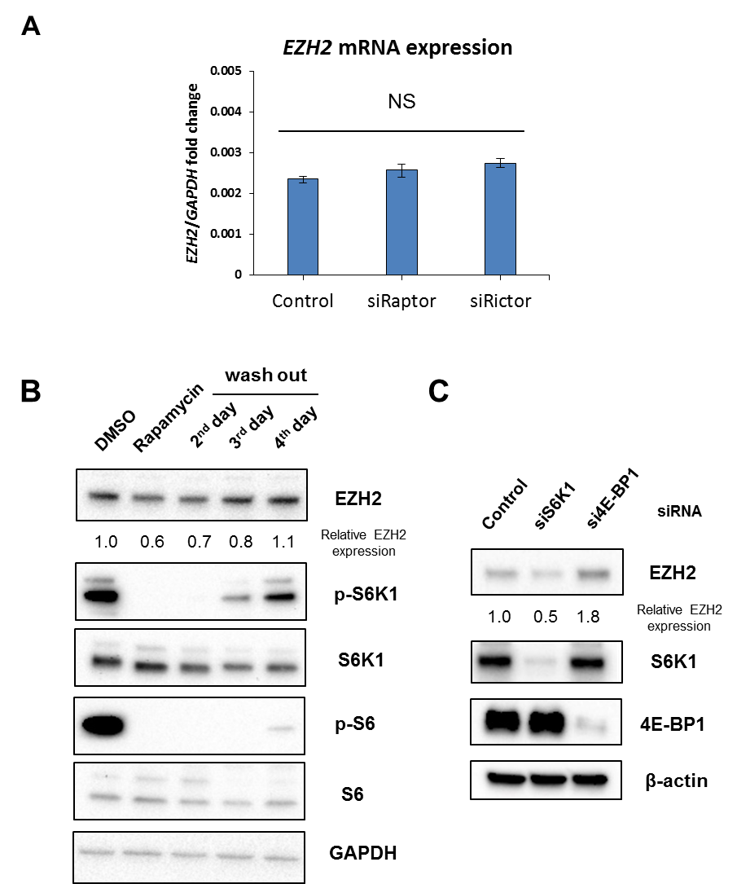
Figure S5. mTORC1 regulates the expression of EZH2 translationally. A, Quantification of EZH2 mRNA expression in U87-EGFRvIII cells transfected with siRNA against Raptor (mTORC1) or Rictor (mTORC2). The mRNA expression was normalized against GAPDH. NS, not significant. B, Immunoblot detection of EZH2 protein change in U87-EGFRvIII with an addition and subsequent wash-out treatment of Rapamycin (10 nM). C, Immunoblot detection of EZH2 in U87-EGFRvIII cells with siRNAs against the effector molecules downstream of mTORC1 including S6K1 and 4E-BP1.
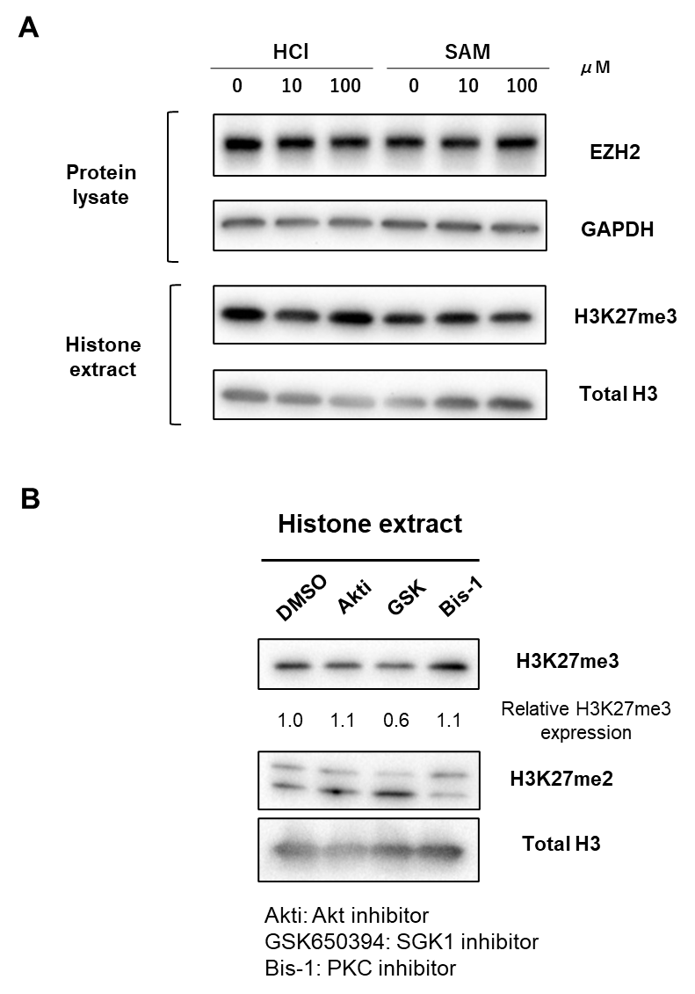

Figure S6. mTORC2 regulates the production of S-adenosylmethionine (SAM). A, Immunoblot detection of H3K27me3 in U87 cells with treatment of exogenous SAM or vehicle (HCl solution) in an indicated concentration for 24 hours. B, Immunoblot detection of H3K27me3 in U87-EGFRvIII cells with inhibitors against mTORC2 downstream substrates: Akti-1/2 (Akt inhibitor, 2.5 µM), GSK650394 (SGK1 inhibitor, 2.0 µM) or Bis-1 (PKC-alpha inhibitor, 10 µM) for 48 hours.

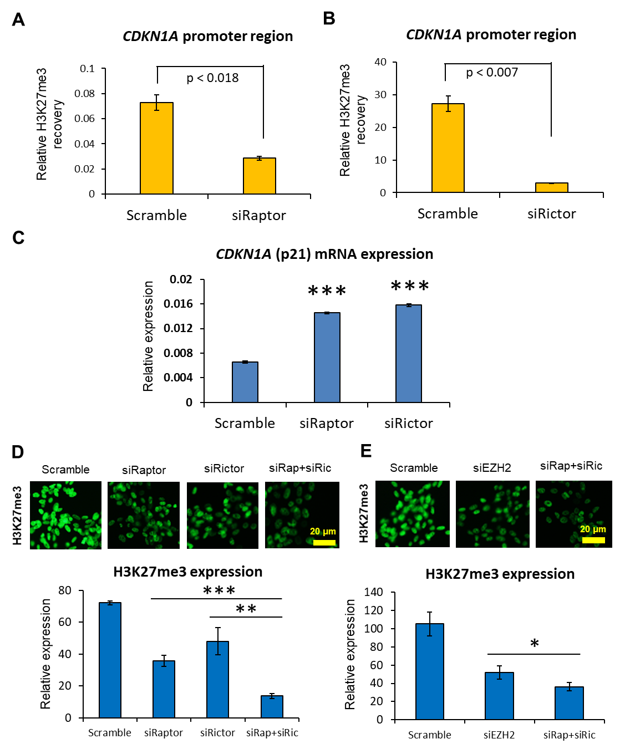
Figure S7. mTOR-dependent histone methylation epigenetically regulates tumor suppressor gene CDKN1A (p21) in GBM cells. A, B, ChIP-PCR analysis on H3K27me3 recovery in the promoter region of tumor suppressor CDKN1A in U87-EGFRvIII cells with siRNA against Raptor (A) or Rictor (B). Raptor knockdown experiment was normalized by input DNA, and Rictor knockdown one by negative control samples without any IP antibodies. C, mRNA expression of CDKN1A (p21) in U87-EGFRvIII cells with indicated siRNAs. mRNA expression was normalized against GAPDH. D, E, Immunocytochemisty revealed that double knockdown of Raptor (mTORC1) and Rictor (mTORC2) was more potent in decreasing H3K27me3 than knockdown of each gene (Raptor or Rictor) (D) or EZH2 (E).

