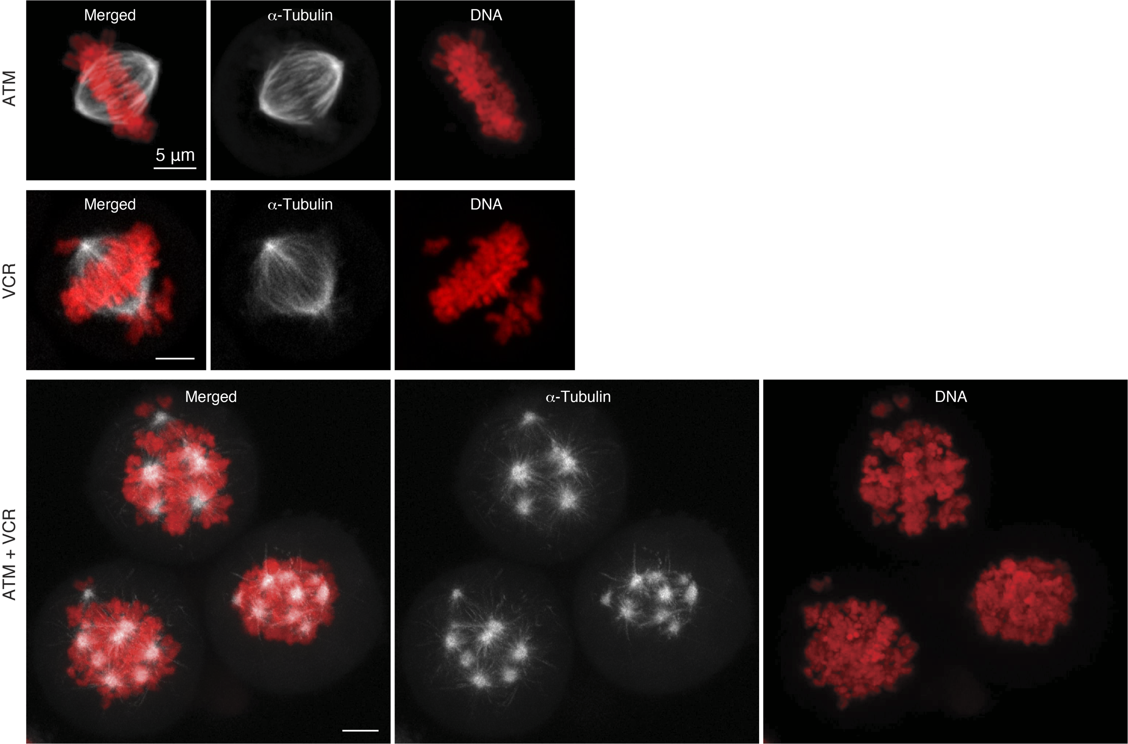
Supplementary Figure S7. Representative images of spindle phenotypes. The mitotic spindle phenotypes in cells treated with ATM 3 μM, VCR 1.5 nM or their combination (24 h-treatments) were visualized via live-cell imaging using HeLa cells expressing α-tubulin-GFP (white) and H2B-mCherry (red). Scale bar = 5 μm.

