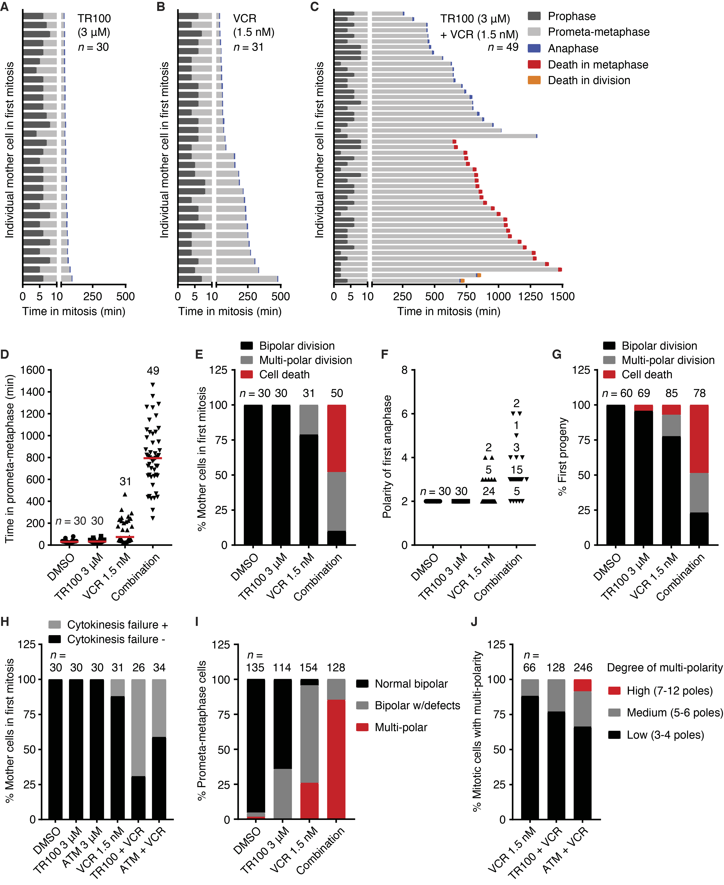
Supplementary Figure S6. The synergistic anti-cancer efficiency of the drug combinations is well correlated with the combinational impact on mitosis. A–C, A long-term live cell imaging (72 hrs) was performed to analyse the impact of drug treatments on the cell fate of individual cells. HeLa cells stably expressing α-tubulin-GFP and H2B-mCherry were used. The time durations that mother cells treated with TR100 (A), VCR (B) or TR100+VCR (C) spent in prophase, prometa-metaphase and anaphase were measured. The cell death during metaphase or division was highlighted in red or orange, respectively. D, The time that treated mother cells spent in prometa-metaphase was plotted. E, The percentage of mother cells that underwent bipolar division, multi-polar division or cell death was determined. F, The polarity of cell division during the first cell cycle was measured. G, The cell fate of the first generation of progeny was determined. H, The percentage of mother cells that experienced cytokinesis failure during first mitosis was determined. I, The phenotypes of mitotic spindles upon drug treatments were visualized via a live-cell imaging experiment using HeLa cells that express α-tubulin-GFP and H2B-mCherry. Cells were treated with TR100 (3 μM), VCR (1.5 nM) or their combination for 15 hrs. J, The polarity degree of multi-polar spindles from S6I was determined.

