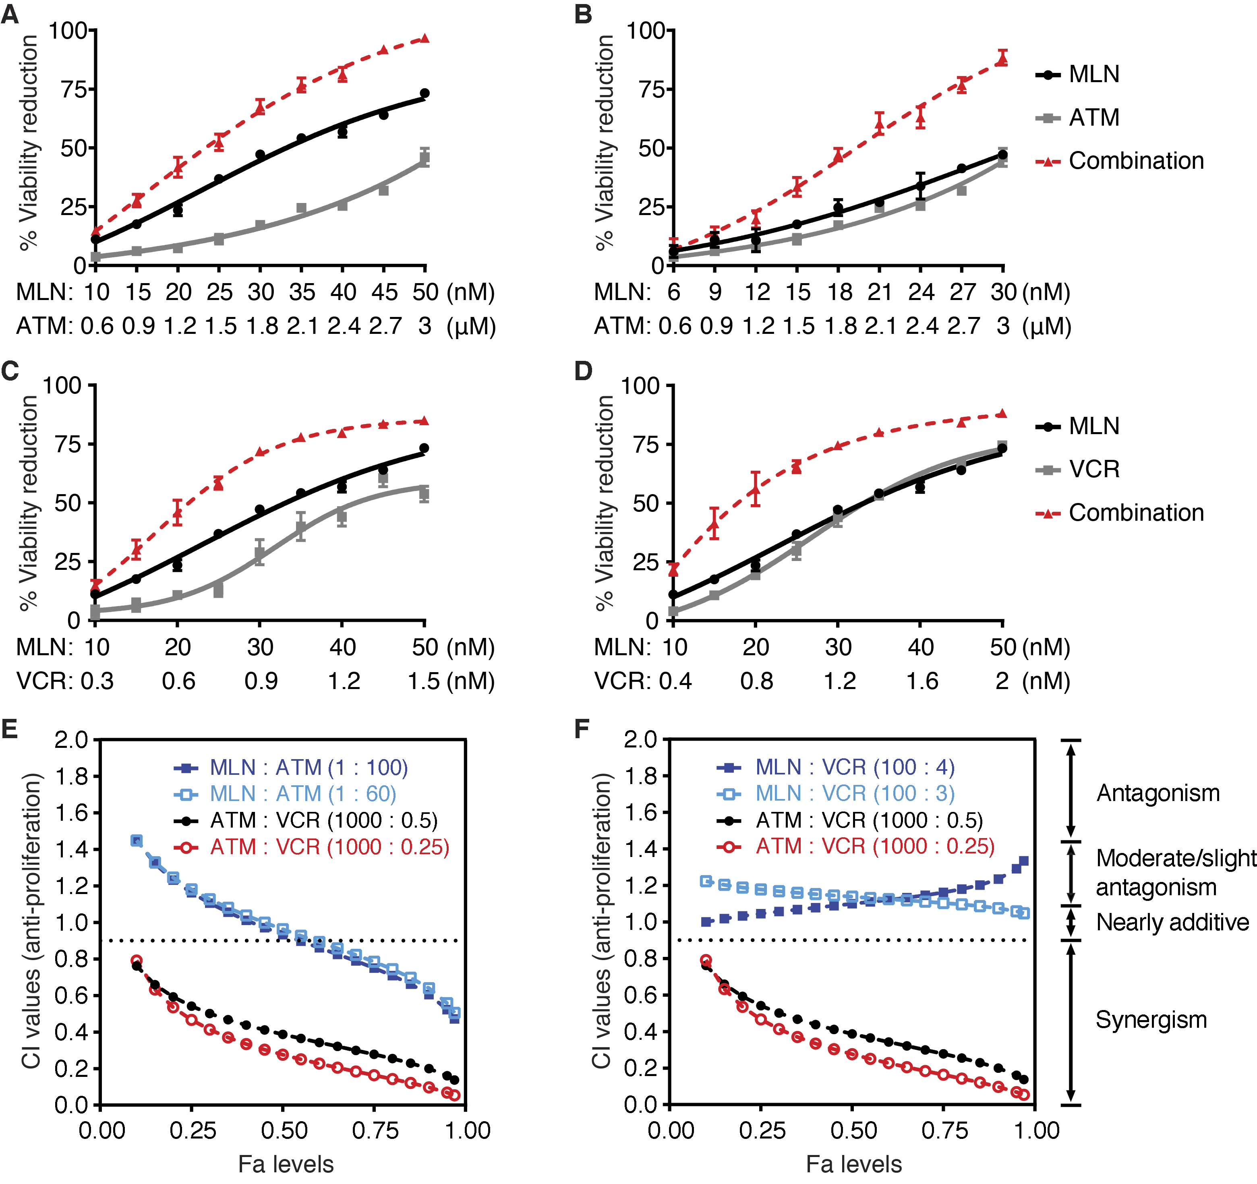
Supplementary Figure S4. Aurora-A inhibitor MLN8237 (MLN) shows no or low synergy with VCR or ATM. A–D, Fixed-ratio isobologram analysis was performed to quantitate the synergy levels of MLN+ATM combination at 1:60 (A) and 1:100 (B) dose ratios, and MLN+VCR combination at 100:3 (C) and 100:4 (D) dose ratios in reducing HeLa cell viability (72 h-treatments); error bars represent ± SEM (n > 3 tests). E and F, CI values at different Fa levels were calculated to determine the synergy levels of MLN+ATM (E) and MLN+VCR (F) combinations. The corresponding values for the ATM+VCR combination are shown for comparison.

