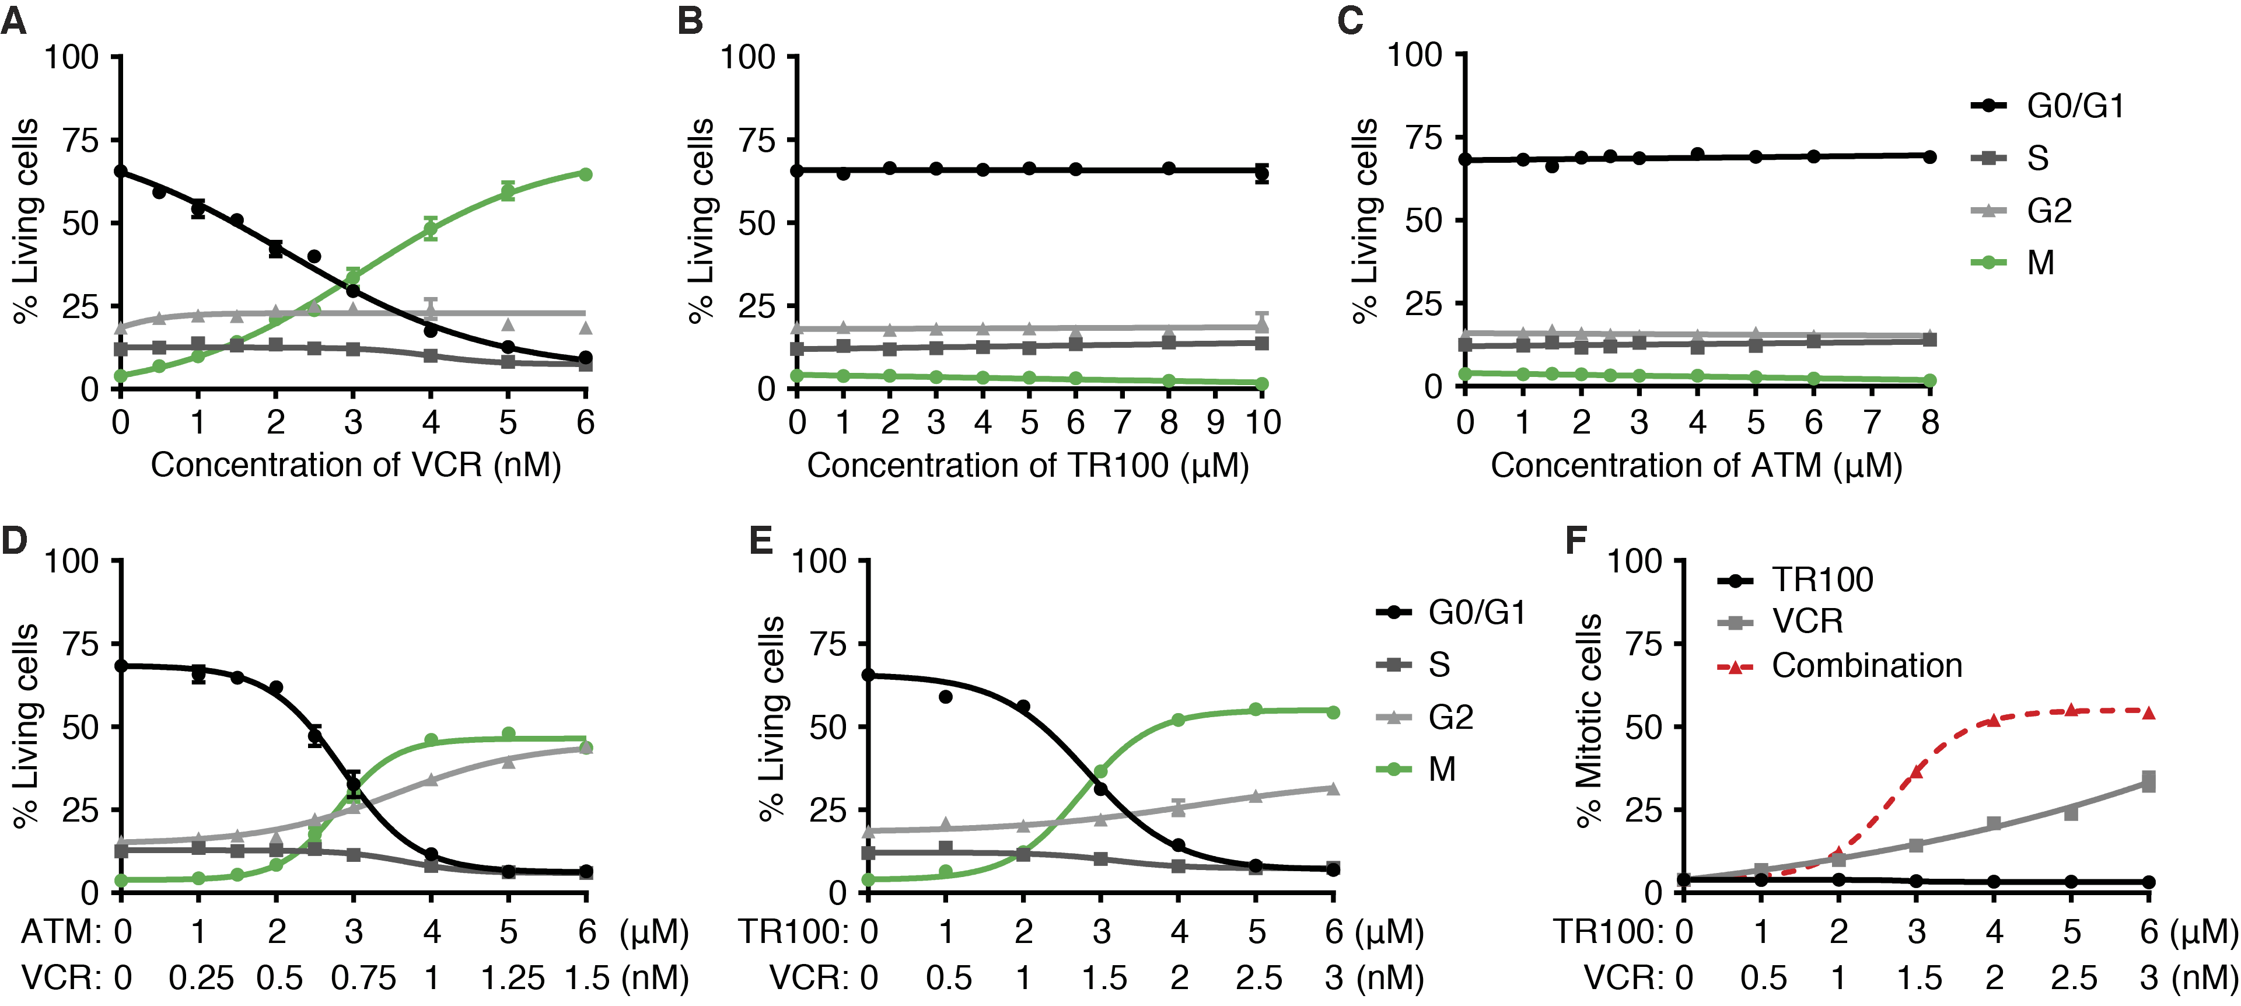
Supplementary Figure S3. The combinations of anti-Tpm3.1 compounds and VCR synergistically arrest HeLa cells in mitosis. A–C, The impacts of VCR (A), TR100 (B) and ATM (C) on cell cycle distribution (24 h-treatments). D and E, The combinational impacts of ATM+VCR at 1000:0.25 dose ratio (D) and TR100+VCR at 1000:0.5 dose ratio (E) on cell cycle distribution (24 h-treatments). F, The addition of TR100 strongly promoted the VCR-induced mitotic arrest (24 h-treatments). Error bars represent ± SEM (n > 3 tests).

