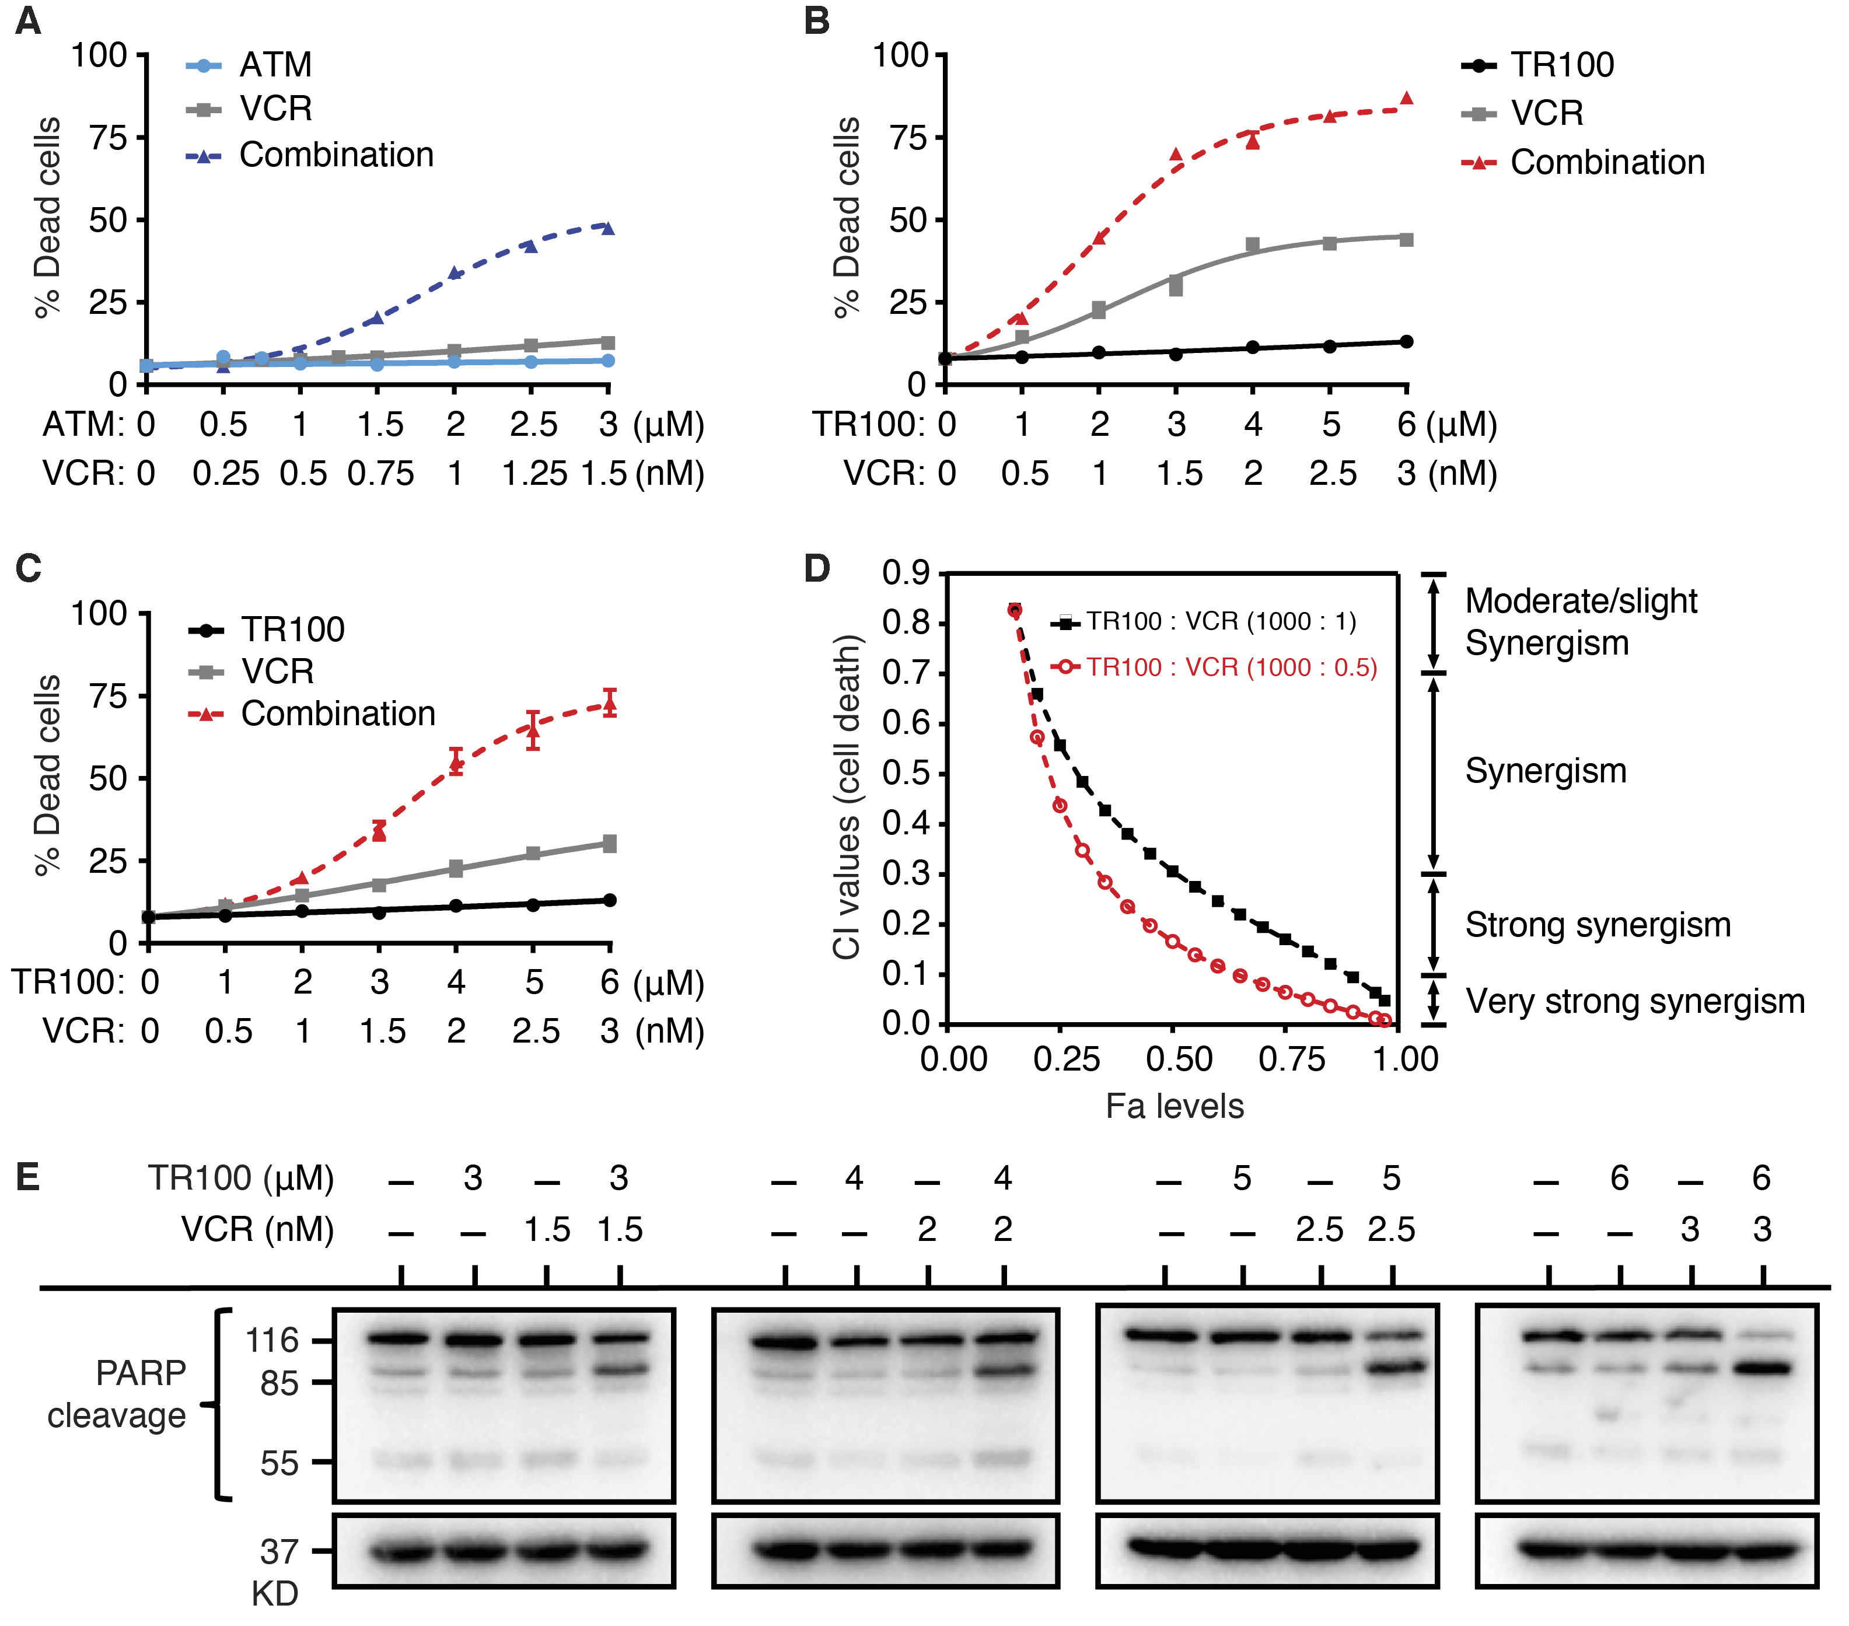
Supplementary Figure S2. The combinations of anti-Tpm3.1 drugs and VCR show strong synergy in inducing apoptosis. A, The combinational effect of ATM+VCR combination at dose ratio 1000:0.5 in causing cell death (early and late apoptosis/necrosis) was evaluated using the fixed-ratio isobologram method (24 h-treatments). B and C, The fixed-ratio isobologram curves of TR100+VCR combination at two dose ratios 1000:1 (B) and 1000:0.5 (C). D, CI values at different Fa levels were calculated to determine the synergy levels of TR100+VCR combinations at inducing cell death. CI values less than 0.9 demonstrate synergy. E, PARP cleavage pattern was detected by Western blot to determine the synergy of TR100+VCR in causing caspase-dependent apoptosis. Representative images were shown (n = 3 tests). Error bars represent ± SEM (n > 3 tests).

