**Fate of Ikaros on combining lenalidomide and proteasome inhibitor in myeloma: Potential therapeutic implication**

Saravanan Ganesan*, Hamenth Kumar Palani*, Nithya Balasundaram, Sachin David, Anup J Devasia, Biju George, Vikram Mathews.

Department of Haematology, Christian Medical College, Vellore, India.

*- equal contribution

**Supplementary files**

**Supplementary figure 1:**

Combination of lenalidomide (1uM) and bortezomib (different concentrations) induces apoptosis in myeloma cell lines (MM.1S and U266) compared to bortezomib alone treated cells (n=3) at the end of 48 hours.



**Supplementary figure 2:**

Representative Immunoblot showing induction of apoptosis in MM.1S cell line upon treatment with lenalidomide (1uM) and bortezomib (5nM), lysates were collected the end of 24 and 48 hours post treatment with drugs (n=3). The proteins analysed were mentioned in the image.

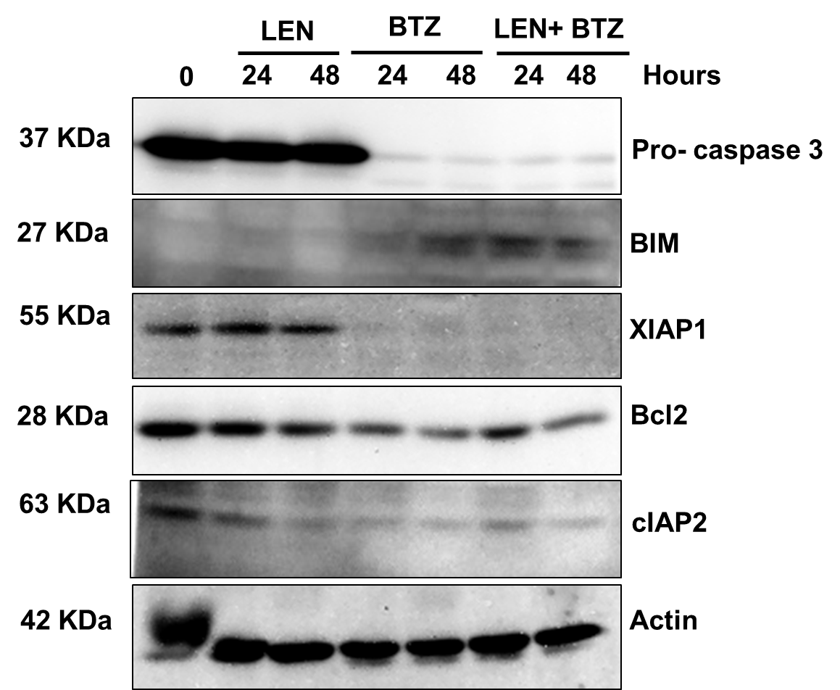

**Supplementary figure 3:**

a) Immunoblot showing that the combination of lenalidomide and bortezomib degraded IKZF1 in U266 cell line (n=3). b) Immunofluorescence assays showing degradation of IKZF1 in U266 cell line upon treatment with Lenalidomide and bortezomib (n=3).



**Supplementary figure 4:**

Immunoprecipitation of Ubiquitin after treatment with lenalidomide (1uM) and bortezomib (5nM) revealed an interaction with IKZF1 at 8 hours.



**Supplementary figure 5:**

Inhibition of autophagy by hydroxycholoroquine (HCQ) and bafilomycin A1 (BAFA1) in MM1.S cell line was confirmed using cyto-ID stain, where accumulation of autophagosome was observed (n=3) which was further confirmed by western blot (n=3).

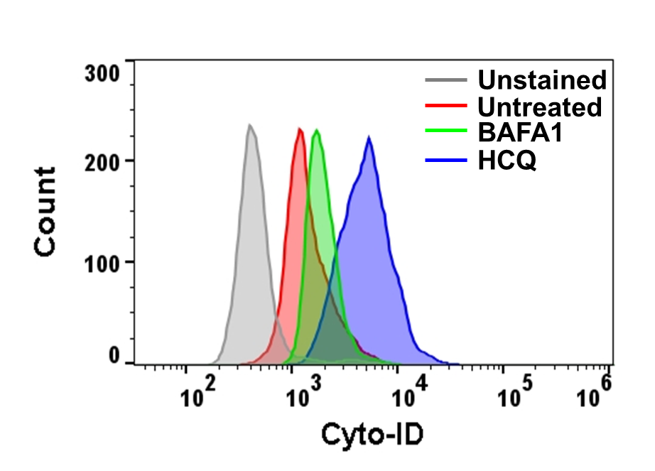 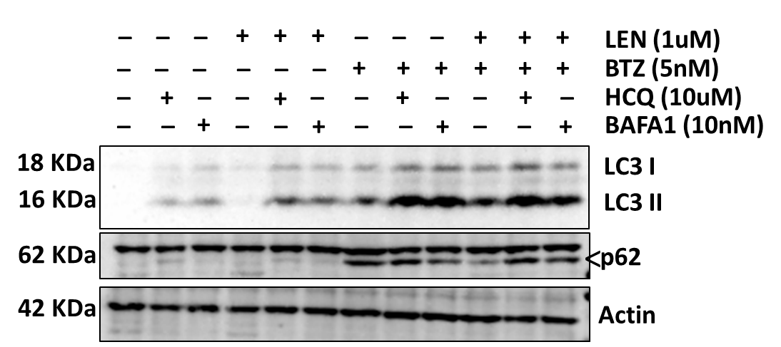

**Supplementary figure 6:**

Inhibition of autophagy by hydroxycholoroquine (HCQ) and bafilomycin A1 (BAFA1) did not inhibit the degradation of IKZF1 in U266 cell line (n=3).

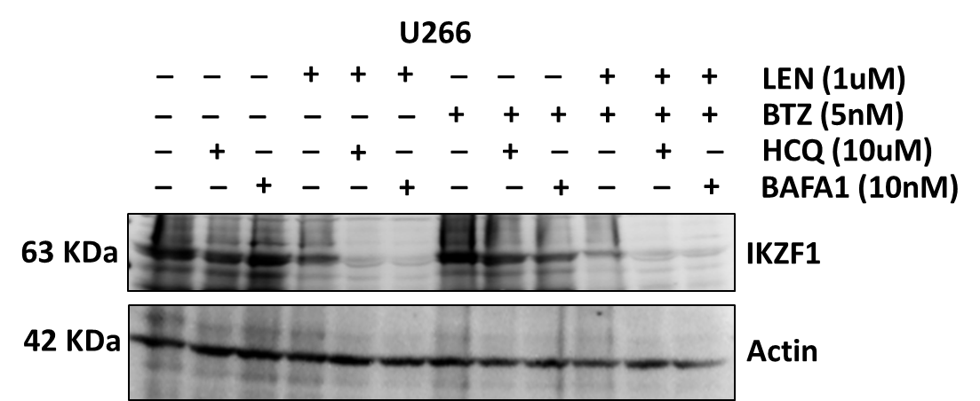

**Supplementary figure 7:**

Inhibition of calpain and caspase by PD150606 and zVAD.fmk inhibited the degradation of IKZF1 in U266 cell line (n=3).

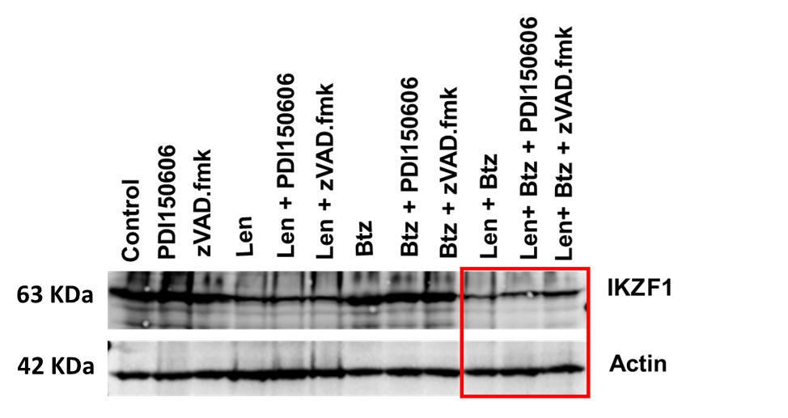

**Supplementary figure 8:**

Inhibition of calpain and chelation of calcium resulted in inhibition of PARP cleavage and IKZF3 degradation in MM1.S cell line (n=3) at the end of 24 hours of drug treatments.

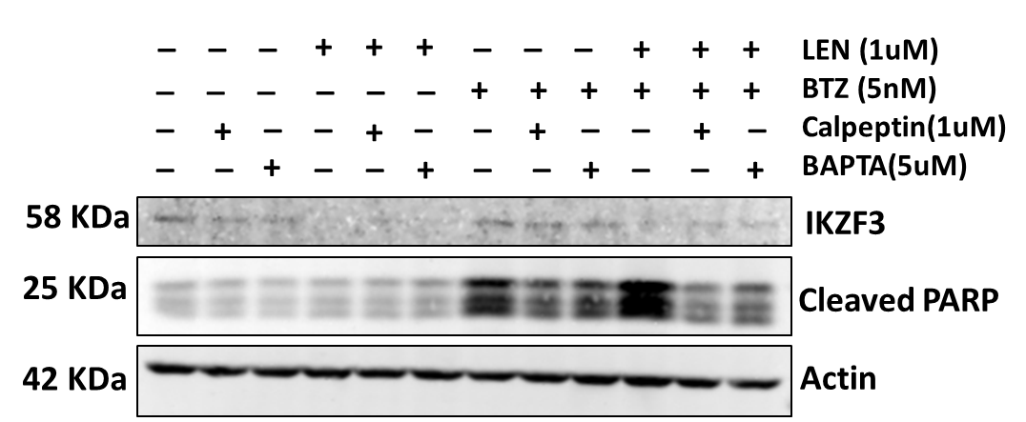

**Supplementary figure 9:**

Immunoblot representing modulation of calcium flux with ionomycin in MM.1S cell line enhanced IKZF1 degradation only in Ionomycin alone or in combination with LEN treated cells for 12 hours (n=3).

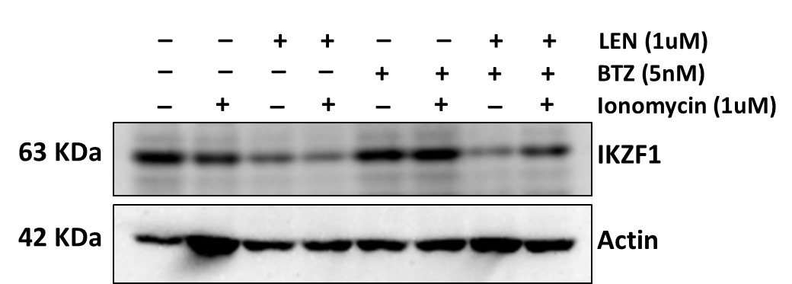

**Supplementary figure 10:**

Viability of MM1.S cell line at post LEN (1uM) and BTZ (5nM) treatment after 48 hours (n=3). Viability was assessed by Annexin V- and 7 AAD - viability assay.

