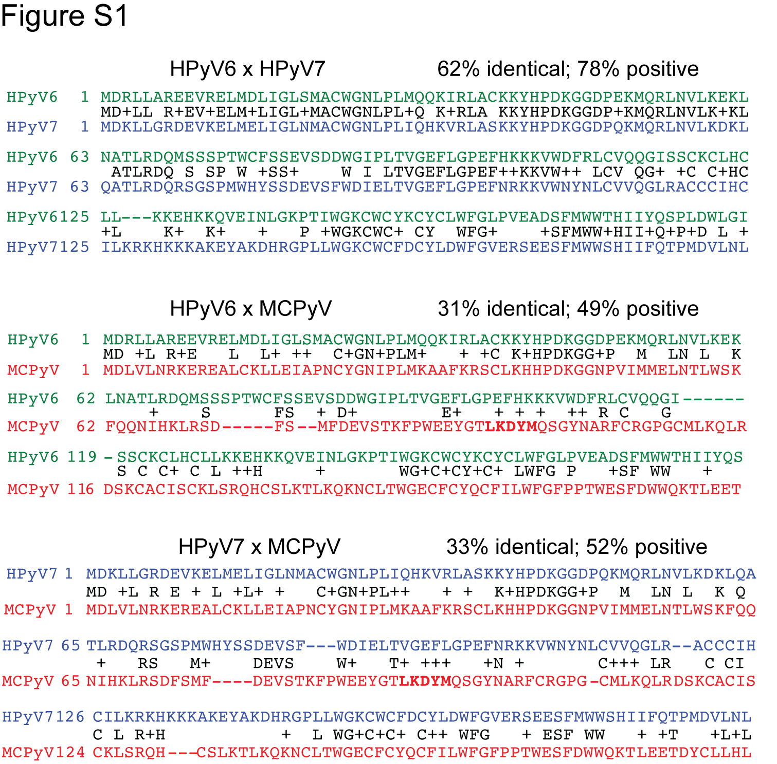

Figure S1. Protein sequence alignment of HPyV6, HPyV7 and MCPyV small T antigens.

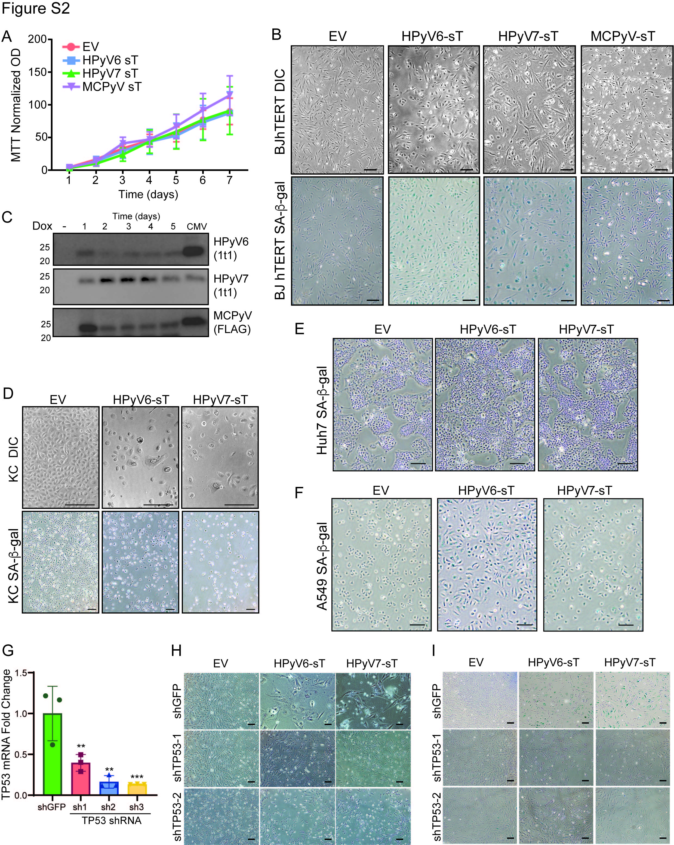

Figure S2. Expression of HPyV sT induces p53-dependent senescence in human fibroblasts.
(A) Rat2 fibroblasts were transduced with vector control or HPyV6, HPyV7 and MCPyV sT and proliferation assessed by MTT. 1,000 cell/well plated at Day 0. Each time point represents triplicates.
(B) Representative light microscopy (top) and SA-β-gal staining (bottom) of hTERT immortalized BJ fibroblasts (BJhTERT) transduced with HPyV6, HPyV7 and MCPyV small T antigens. HPyV 6/7 sT induce morphological senescence and SA-β-gal accumulation in BJhTERT cells. Scale bar = 200µm.
(C) BJ cell were transduced with the doxycycline-inducible HPyV6, HPyV7, and MCPyV sT. Western blot validation of expression after addition of doxycycline for indicated time. CMV indicates expression levels driven by the constitutive lentiviral expression construct.
(D) Representative light microscopy (top) and SA-beta gal staining (bottom) of hTERT immortalized human keratinocytes transduced with HPyV6/7 small T antigens. HPyV6/7 sT induces senescence in human keratinocytes. Scale bar = 200µm.
(E) Representative SA-β-gal staining of Huh7 (p53 mutant) cell transduced with HPyV6 and HPyV7 small T antigens. HPyV6/7 sT does not induce senescence in Huh7 cells. Scale bar = 200µm.
(F) Representative SA-β-gal staining of A549 (p53 WT) cell transduced with HPyV6/7 small T antigens. HPyV6/7 sT induces senescence in A549 cells. Scale bar = 200µm.
(G) RT-qPCR confirms TP53 shRNA knockdown in BJ fibroblasts (4 days) with three biological replicates of each shRNA.
(H) Representative light microscopy of BJ cells transduced HPyV6/7 sT transduced with the indicated shRNA (shTP53-1, shTP53-2, and shGFP control; 7 days) and then HPyV6/7 sT (3 days). Also see Fig. 1L-N.
(I) Representative light microscopy of SA-beta gal stained BJ cells transduced with the indicated shRNA (shTP53-1, shTP53-2, and shGFP control) and then HPyV6/7 sT. Also see Fig. 1L-N.
BJ cells were transduced with the indicated shRNA (7 days), then HPyV sT (3 days). Scale bar = 200µm.

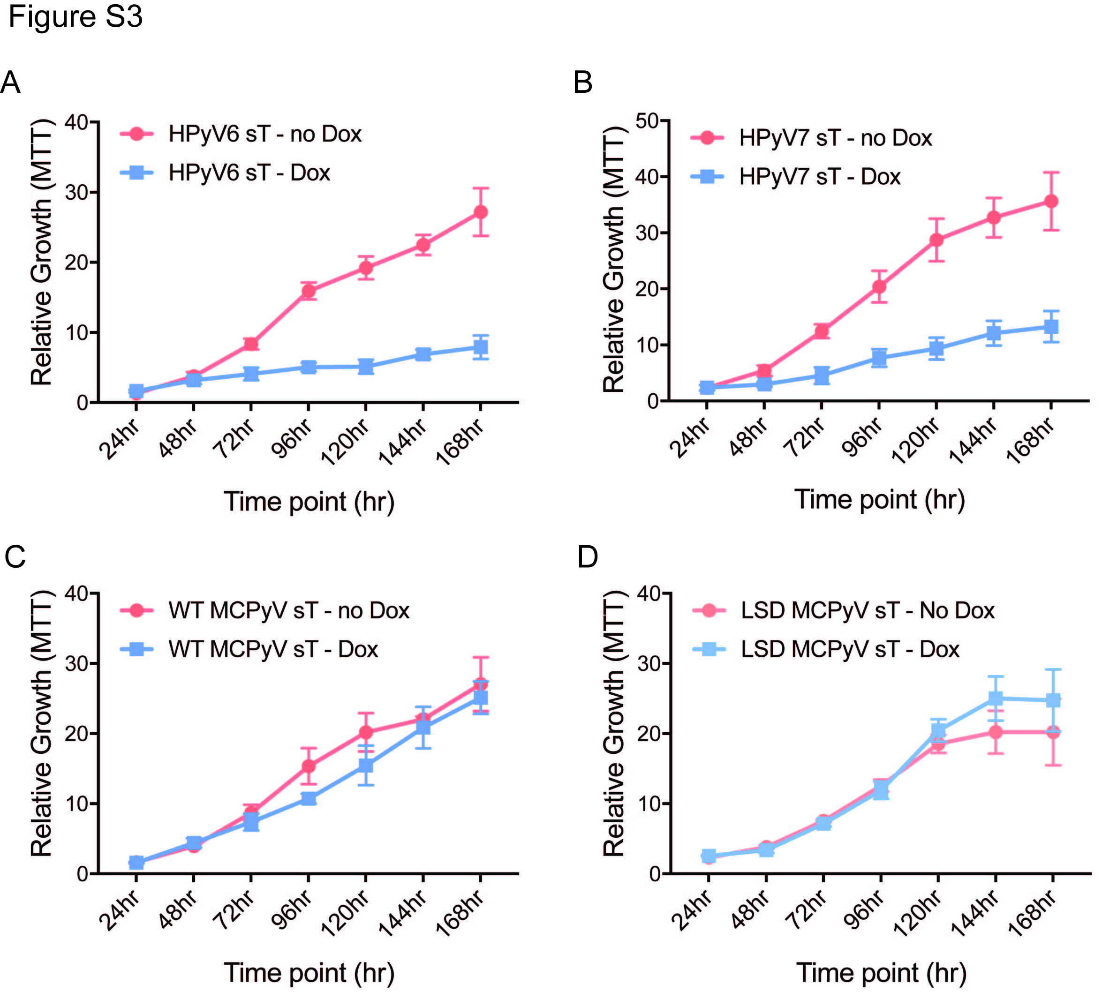

Figure S3. Proliferation of BJ fibroblasts with expression of HPyV sT.
(A-D) BJ fibroblasts were transduced with the HPyV6 sT (A), HPyV7 sT (B), wildtype MCPyV sT (C), or LSD mutant MCPyV sT (D) under a doxycycline inducible promoter. 1,000 cells/well were plated in triplicated in af 96 well plate. Proliferation was assessed by MTT every 24 hour as indicated. 1 µg/mL doxycycline or water (-no Dox) was added to all plates after 24 hrs.

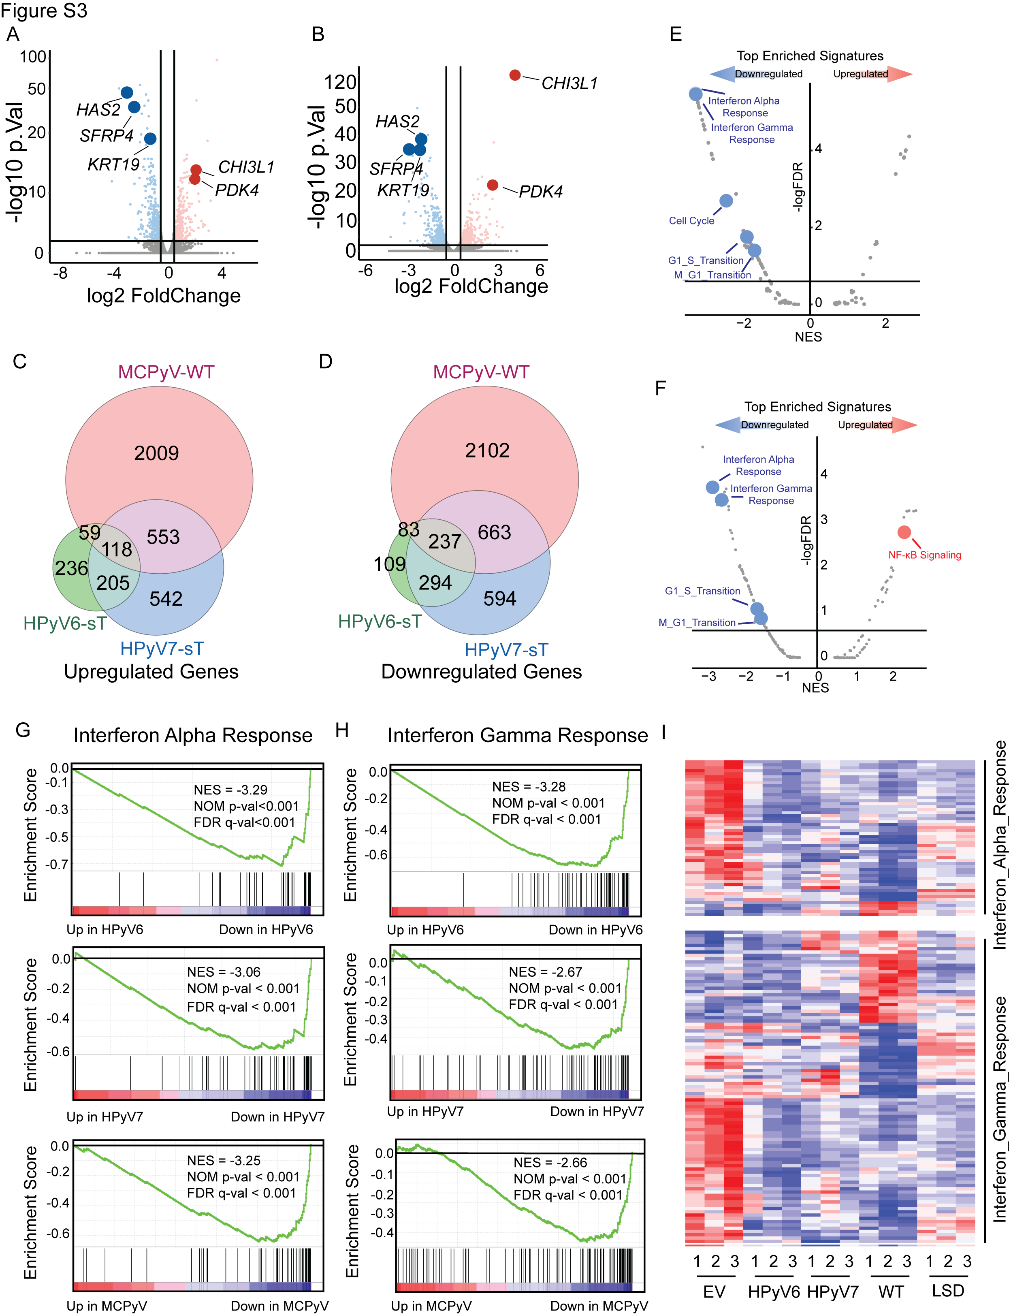

Figure S4. Analysis of RNA-Seq from HPyV6, HPyV7, and MCPyV sT expressing BJ fibroblasts.
(A) Volcano plot of HPyV6 sT compared to empty vector control (7 days). Log2 fold change threshold is set at ±0.5 and log10 adj.p-value threshold is set at 2.
(B) Volcano plot of HPyV7 sT compared to empty vector control (7 days). Log2 fold change threshold is set at ±0.5 and log10 adj.p-value threshold is set at 2.
(C) Venn diagram of upregulated genes in HPyV6, HPyV7, and MCPyV sT expressing BJ cells compared to vector control.
(D) Venn diagram of downregulated genes in HPyV6, HPyV7, and MCPyV sT expressing BJ cells compared to vector control.
(E) Volcano plot of enriched gene signatures of HPyV6 sT compared to empty vector control.
(F) Volcano plot of enriched gene signatures of HPyV7 sT compared to empty vector control.
(G) GSEA analysis of Interferon alpha response of HPyV6, HPyV7, and MCPyV sT expressing BJ cells compared to vector control (7 days).
(H) GSEA analysis of Interferon gamma response of HPyV6, HPyV7, and MCPyV sT expressing BJ cells compared to vector control (7 days).
(I) Heatmap of Interferon alpha response and Interferon gamma response genes in vector control, HPyV6, HPyV7 and MCPyV sT.

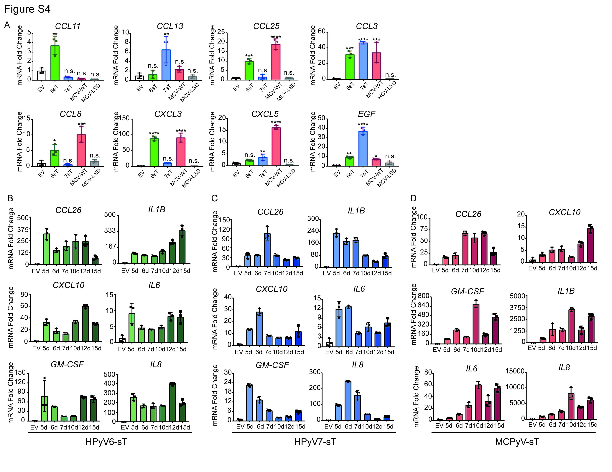

Figure S5. Time course and extended analysis of additional SASP gene expression in BJ cells after sT expression.
(A) RT-qPCR analysis of additional SASP genes—CCL3, CCL5, CCL11, CCL13, CCL25, CXCL3, CXCL5, EGF—in BJ cells transduced with HPyV6, HPyV7, and wildtype or LSD mutant MCPyV sT (7 days). Data are normalized by empty vector control. Each group ran as triplicates.
(B) Time course RT-qPCR analysis of SASP genes—CCL26, IL1B, CXCL10, IL6, GM-CSF, IL8—in HPyV6 sT transduced BJ cells at indicated time point. Data are normalized by empty vector control. See Fig. 2A.
(C) Time course RT-qPCR analysis of SASP genes—CCL26, IL1B, CXCL10, IL6, GM-CSF, IL8—in HPyV7 sT transduced BJ cells at indicated time point. Data are normalized by empty vector control. See Fig. 2A.
(D) Time course RT-qPCR analysis of SASP genes—CCL26, IL1B, CXCL10, IL6, GM-CSF, IL8—in MCPyV sT transduced BJ cells at indicated time point. Data are normalized by empty vector control. See Fig. 2A.

Figure S6. MCPyV sT shRNA confirms role of sT in SASP gene expression.
(A) BJ fibroblasts were first transduced with shRNA targeting MCPyV sT (shST) (4 days), then then transduced with MCPyV sT (7 days). RT-qPCR validation of MCPyV small T KD. Data are normalized by empty vector control. Each group ran as triplicates.
(B) Western blot validates knockdown of MCPyV sT in BJ fibroblast (7 days).
(C) RT-qPCR analysis of SASP genes in MCPyV sT transduced BJ cells (7 days). Data are normalized by shGFP control. See Fig. 2A.

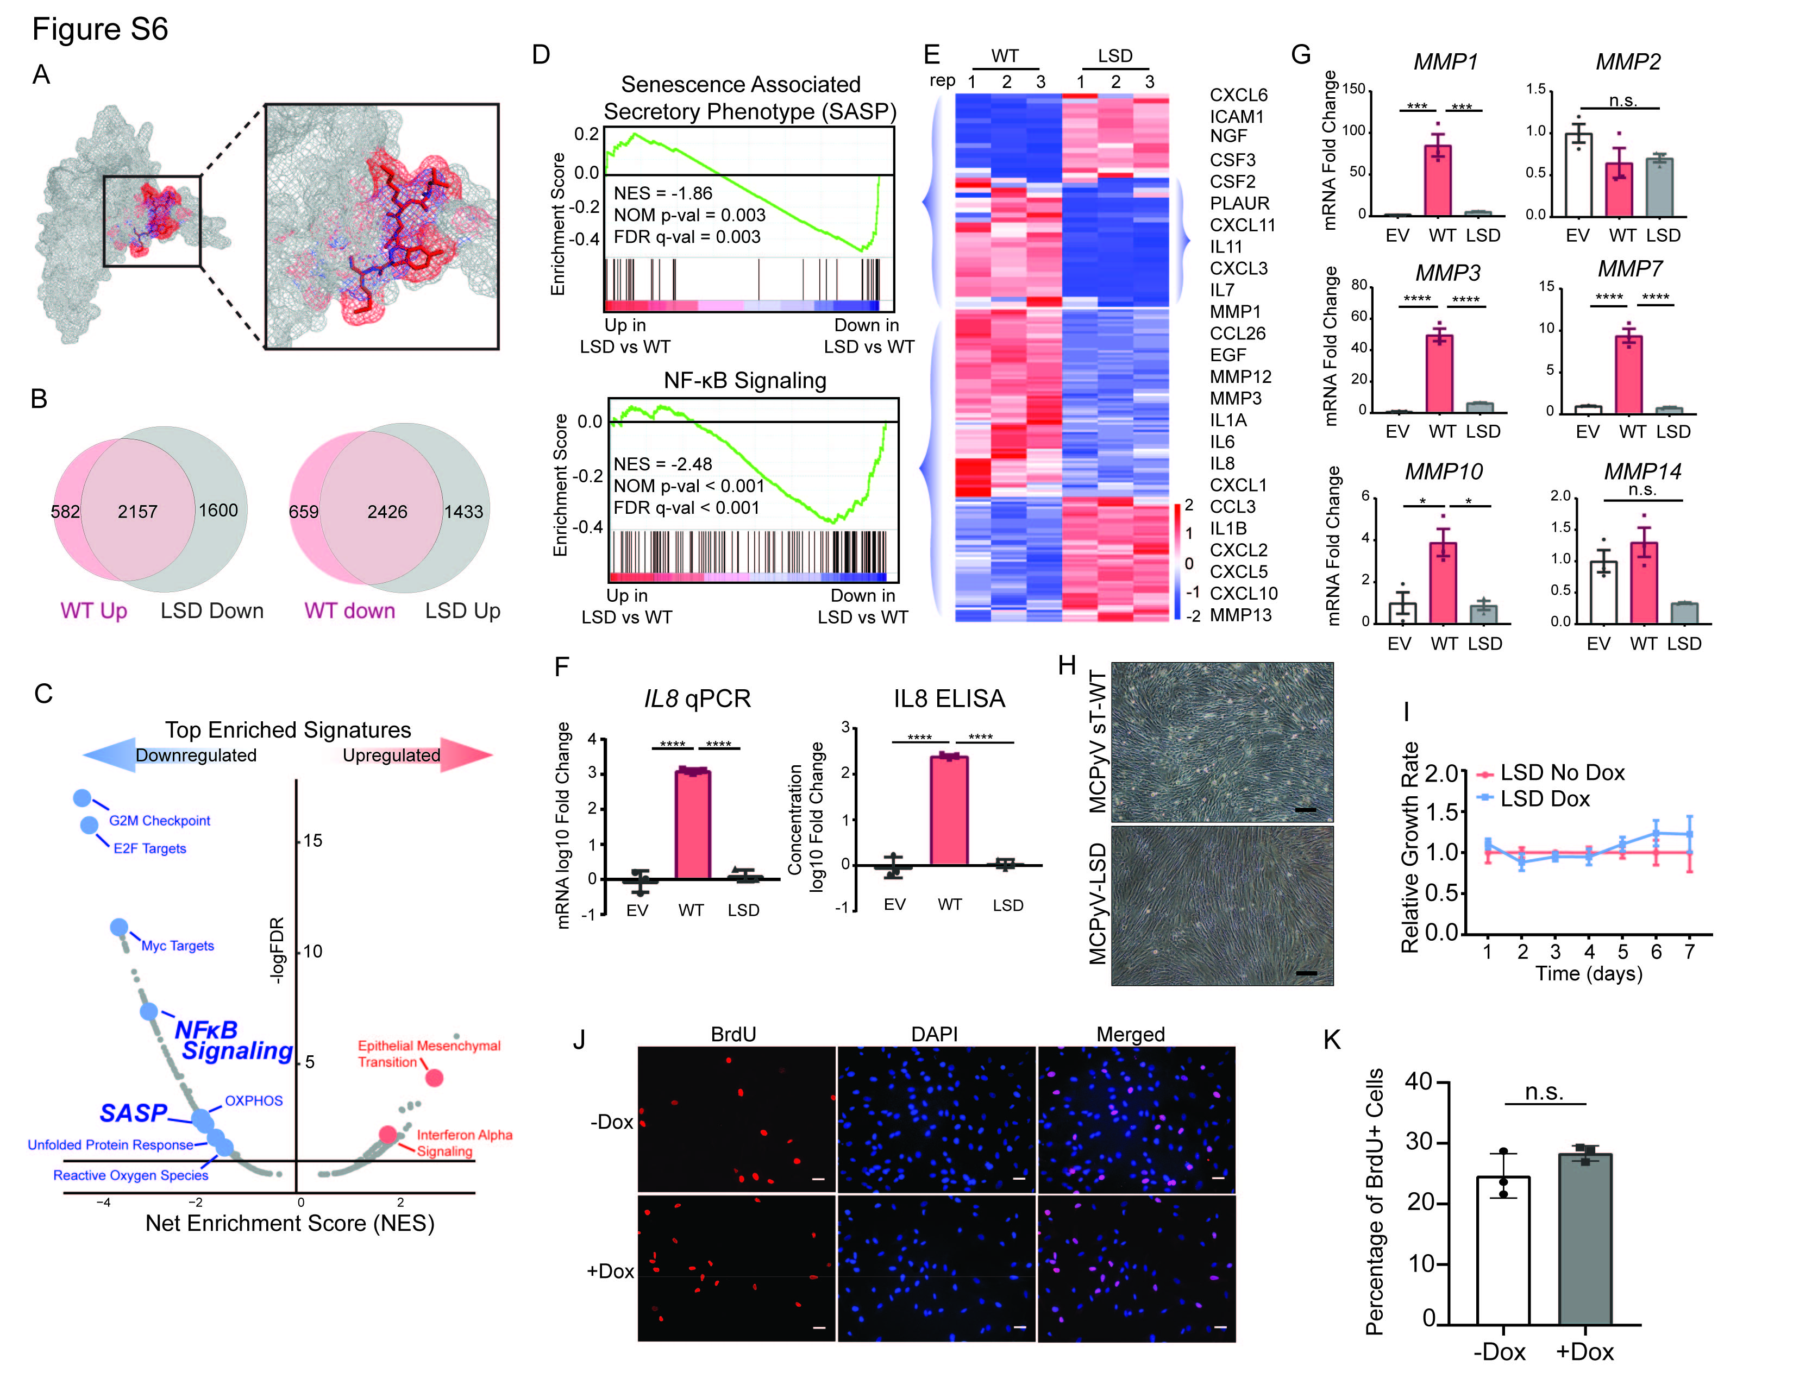

Figure S7. Impact of LSD motif of MCPyV sT on gene expression and proliferation.
(A) Simulated structures of wildtype and LSD mutant MCPyV sT highlighting the predicted location of the LSD motif.
(B) Venn diagram showing substantial overlap of genes regulated by wildtype MCPyV sT wildtype and the LSD mutant MCPyV sT.
(C) Volcano plot (gene signature) of wildtype and LSD mutant MCPyV sT. SASP and NF-κB signaling were notably downregulated in the LSD mutant compared to WT sT.
(D) GSEA analysis of SASP and NF-κB signaling of LSD mutant vs. wildtype MCPyV sT.
(E) Heatmap of significant genes in SASP and NF-κB signaling gene sets of LSD mutant vs. wildtype MCPyV sT.
(F) RT-qPCR and ELISA of IL8 in wildtype and LSD mutant MCPyV sT expressing BJ cells (7 days). The LSD mutant rescues the induction of IL8 by MCPyV sT.
(G) RT-qPCR analysis of MMP genes—MMP1, MMP2, MMP3, MMP7, MMP10, MMP14—by wildtype and LSD mutant MCPyV sT. Data are normalized by vector control. Each group ran as triplicates.
(H) Representative light microscopy of wildtype vs LSD mutant MCPyV sT. No changes consistent with morphological senescence were induced by either sT (3 days). Scale bar = 200µm.
(I) BJ cells were transduced with doxycycline-inducible wildtype or LSD mutant MCPyV sT. Proliferation was assessed at the indicated time point through MTT-mediated. Each time point ran as triplicates and normalized to the -dox control groups.
(J) Representative immunofluorescence images of BrdU incorporation assay on dox-inducible LSD mutant MCPyV sT BJ expressing cells. Cells were induced with doxycycline at 1µg/mL before the experiment and analyzed on Day 3. Scale bar = 50µm.
(K) Quantification of percentage of BrdU positive cells from (J) from three biological replicates of each group. There is no significant change in BrdU positive cells after dox induction.

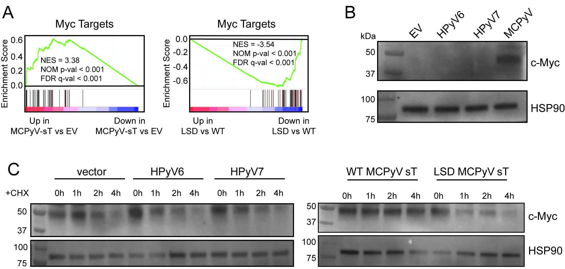

Figure S8. MCPyV st, but not HPyV6/7 sT, stabilizes and activates c-Myc in an LSD motif dependent manner.
(A) GSEA analysis of confirms the enrichment of Myc targets activation by MCPyV sT compared to vector control (left). Myc targets is reversed by the LSD motif mutation (right)
(B) BJ cells were stably transduced with pLEX vector, HPyV6 sT, HPyV7 sT, or MCPyV sT (5 days). c-Myc protein expression was detected by Western blot. c-Myc protein can only be detected after MCPyV, but not HPyV 6/7, sT expression. HSP90, loading control.
(C) 293T cells were co-transfected with pLEX vector, HPyV6 sT, HPyV7 sT, wildtype MCPyV sT, or LSD mutant MCPyV sT (48 hours) and pcDNA3.1-cMyc vector (48 hr). Cells were treated with cycloheximide (0.1 mg/ml) for the indicated time points. c-Myc protein turnover was slowed by MCPyV sT, but not HPyV 6/7 sT or LSD MCPyV sT, expression. HSP90, loading control.

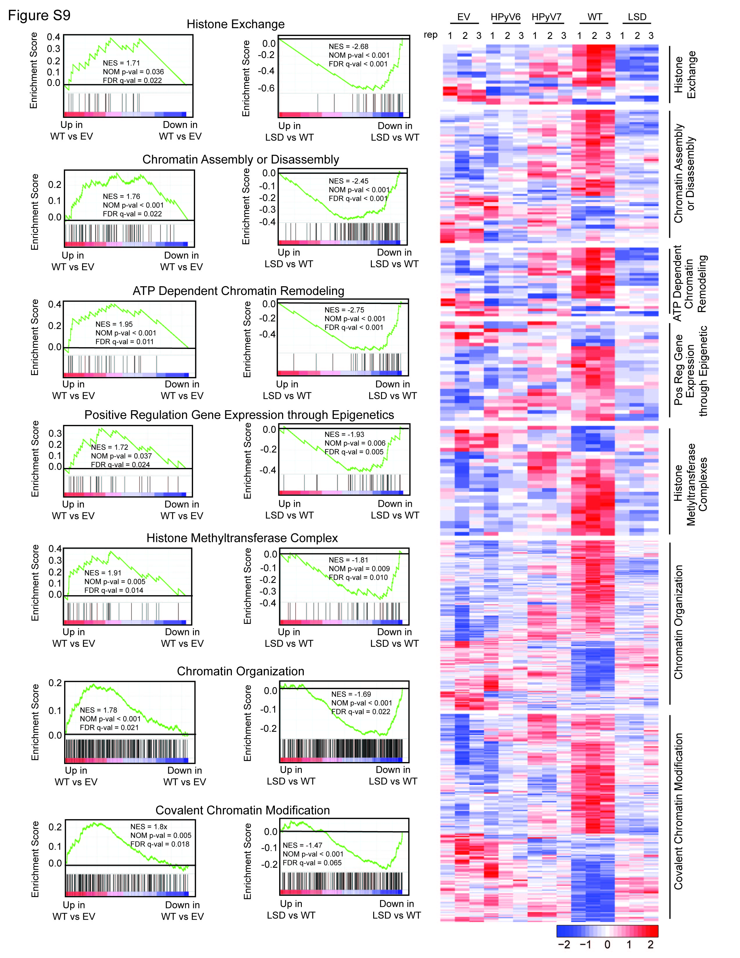
Figure S9. Chromatin remodeling signatures induced by MCPyV sT.
GSEA analysis and heatmap of epigenetics and chromatin remodeling signatures in MCPyV wildtype compared to vector control and wildtype vs LSD mutant MCPyV sT.
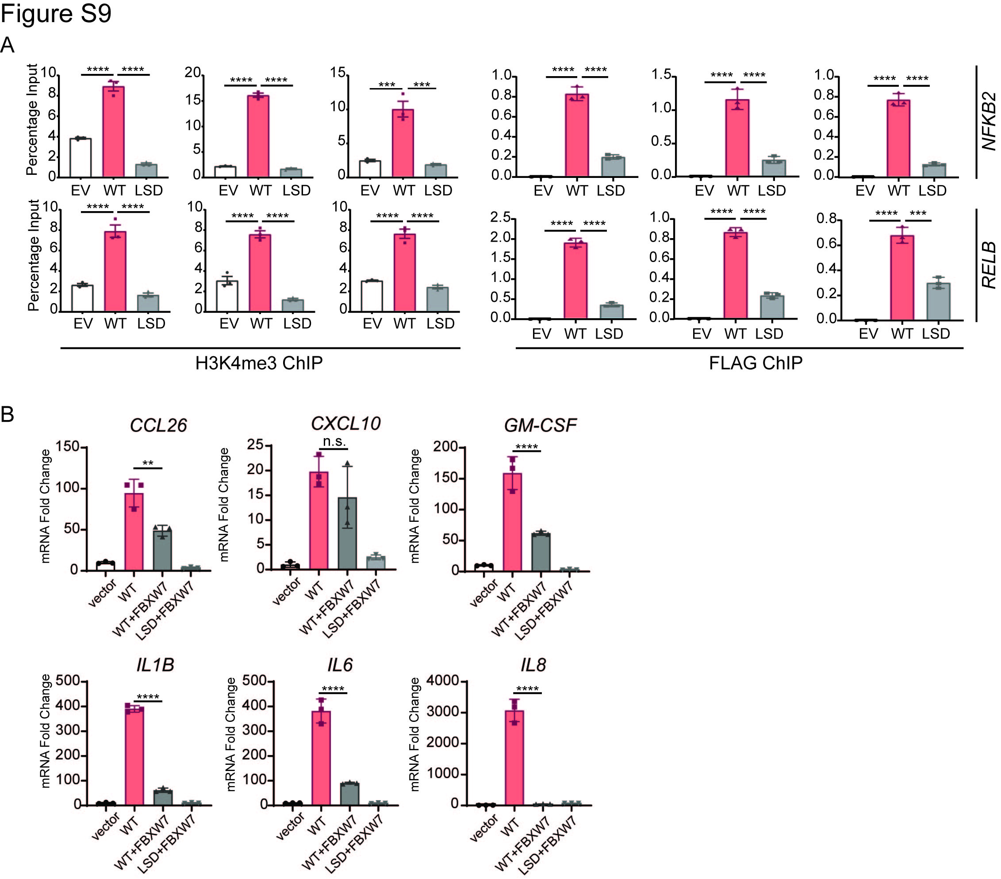

Figure S10. Mechanism of ncNF-κB and SASP induction by MCPyV sT.
(A) FLAG or H3K4me3 ChIP-qPCR analyses reveal the enrichment of NFKB2 and RELB promoter regions in wildtype, but not LSD mutant, MCPyV sT expressing BJ cells (5 days). Data are presented as percentage input and represent three biological replicates. See Fig. 3G-H.
(B) BJ Cells were first transduced with vector control or FBXW7 (5 day) and then vector, wildtype, or LSD mutant MCPyV sT (7 day). Data are normalized by empty vector control. Each group ran in triplicate.

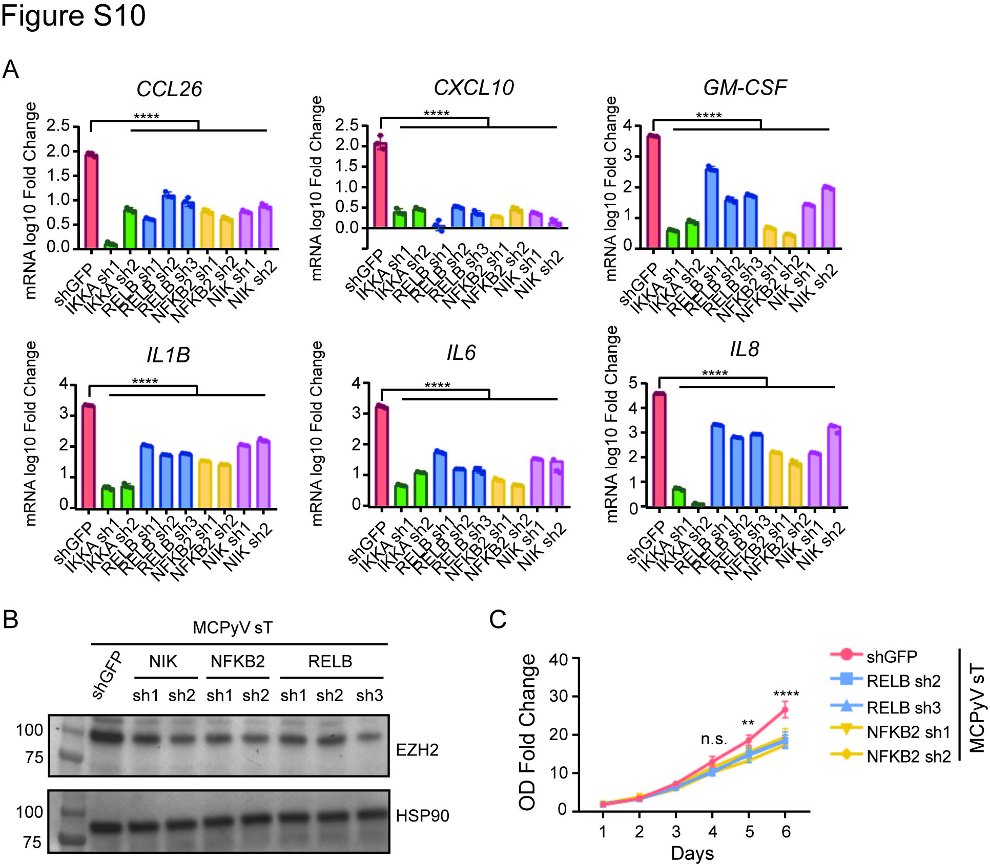

Figure S11. ncNF-κB signaling is required for SASP and EZH2 expression and affects cell proliferation.
(A) BJ cells were first transduced with MCPyV sT (5 days), then the indicated shRNA (7 days). RT-qPCR analysis of SASP gene expression in extended panel of ncNF-κB shRNA lines. Data are normalized by shGFP control and scaled to log10 fold change. See Fig. 4E-G. Data are presented as mean±SD ****p<0.0001. Significance assessed by One Way ANOVA followed by Tukey post hoc analysis.
(B) BJ cells were first transduced with MCPyV sT (5 days), then the indicated shRNA (7 days). Western blot reveals decreaed EZH2 expression after ncNF-κB signaling component shRNA. HSP90, loading control.
(C) BJ cells were first transduced with MCPyV sT (5 days), then the indicated shRNA (5 days). After selection, cells were plated in normal (10%) serum and proliferation assessed by MTT assays. Each time point represents triplicate platings.

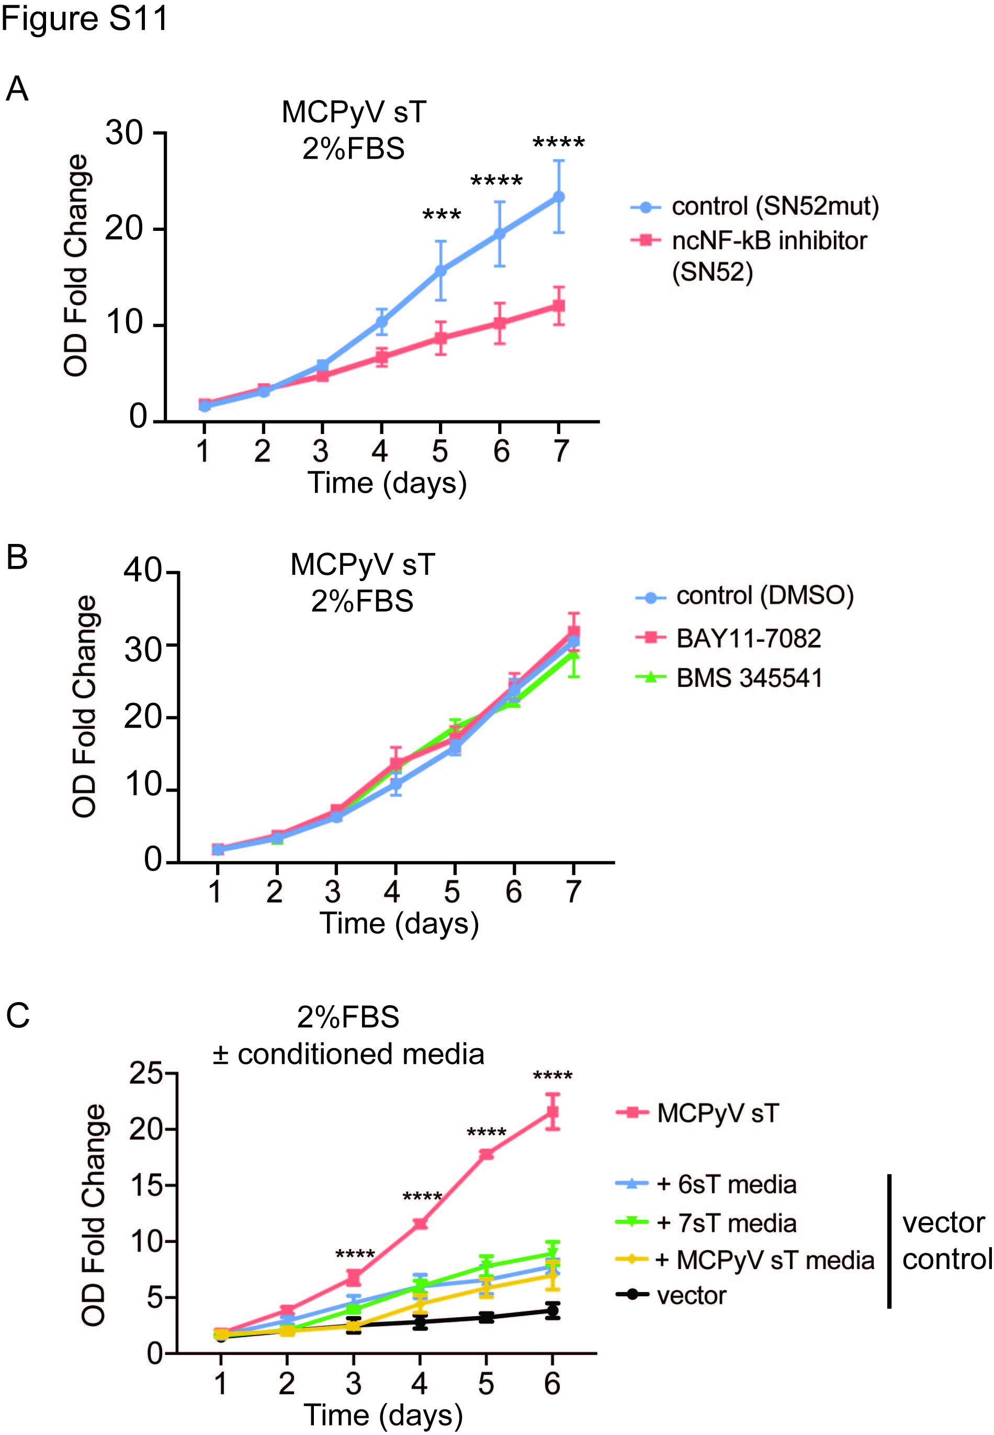

Figure S12. PyV sT conditioned media is not sufficient for growth in low serum.
(A) BJ fibroblasts were transduced with MCPyV sT (5 days). After selection, cells were plated in low serum (2% FBS) media in the presence of a peptide inhibitor of ncNF-κB (SN-52) or a control peptide (SN-52mut) and proliferation was assessed by MTT. Inhibition of ncNF-κB significantly inhibited growth.
(B) BJ fibroblasts were transduced with MCPyV sT (5 days). After selection, cells were plated in low serum (2% FBS) media in the presence of inhibitor of canonincal NF-κB or a vehicle (DMSO) control and proliferation was assessed by MTT.
(C) BJ fibroblasts were transduced with MCPyV sT or vector control (5 days). After selection, cells were plated in low serum (2% FBS) media. Vector expressing cells were supplemented with conditioned media from HPyV sT transduced fibroblasts. MCPyV sT expressing cells grew significantly faster than all vector expressing cells despite the supplementation of conditioned media from PyV sT expressing cells.

Figure S13. ST expression in VP-MCC lines and tumors.
(A) RT-qPCR analysis of relative expression of MCPyV sT normalized by β-actin in VP-MCC cancer cell lines and 7 patient samples. Each group ran as triplicates. MCPyV sT transduced BJ cells (5 days) (ST OE), positive control for sT expression.
(B) End-point PCR validation MCPyV sT expression by patient MCC tumors, but not normal skin.
(C) Sample identification and anatomic location of MCC tumors and normal skin controls.

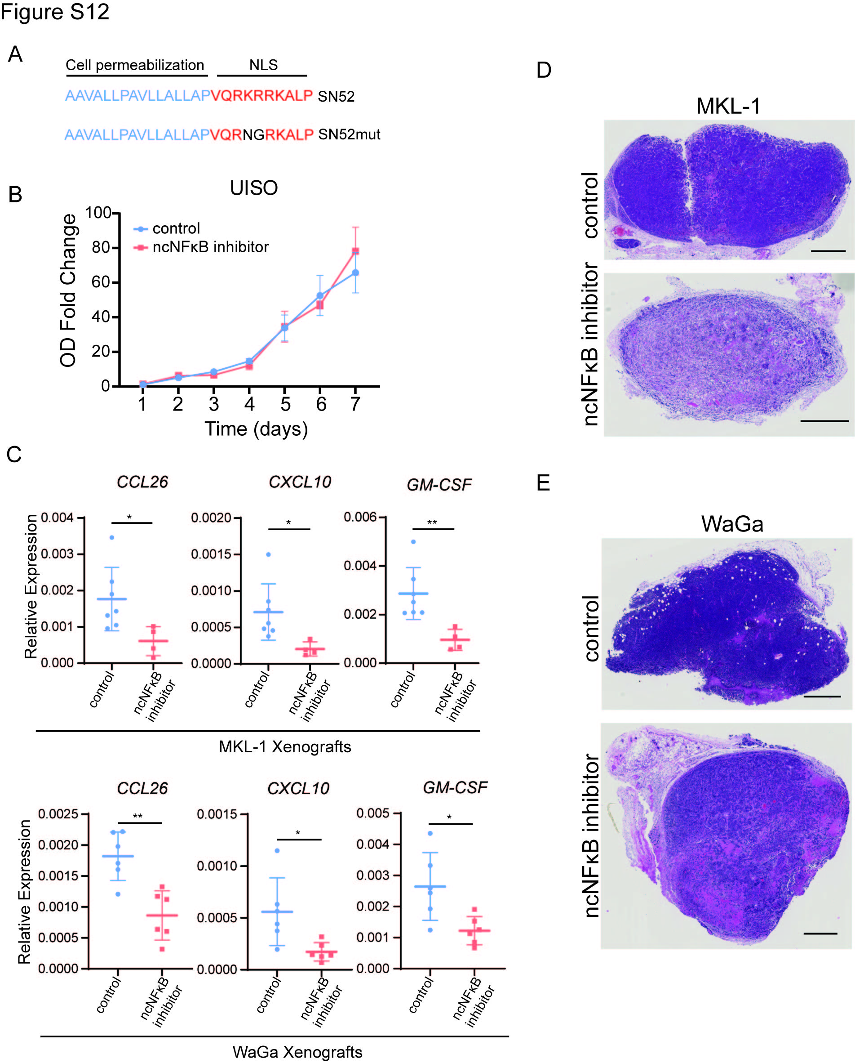
Figure S14. Impact of ncNF-κB inhibition on VP-MCC and VN-MCC.
(A) Sequence of ncNF-κB inhibitor (SN52) and control (SN52mut) peptides.
(B) Proliferation of VN-MCC UISO cells treated with ncNF-κB inhibitor (SN52) or control (SN52mut) peptides. Each time point ran as triplicate.
(C) RT-qPCR analysis of SASP genes—CCL26, CXCL10, GM-CSF—in MKL-1 and WaGa cells xenograft treated ncNF-κB inhibitor (SN52) or control (SN52mut) peptides. Each point represents one individual tumor.
(D) Representative H&E staining of MKL-1 xenograft tumor sections. Scale bar = 1mm.
(E) Representative H&E staining of WaGa xenograft tumor sections. Scale bar = 1mm.

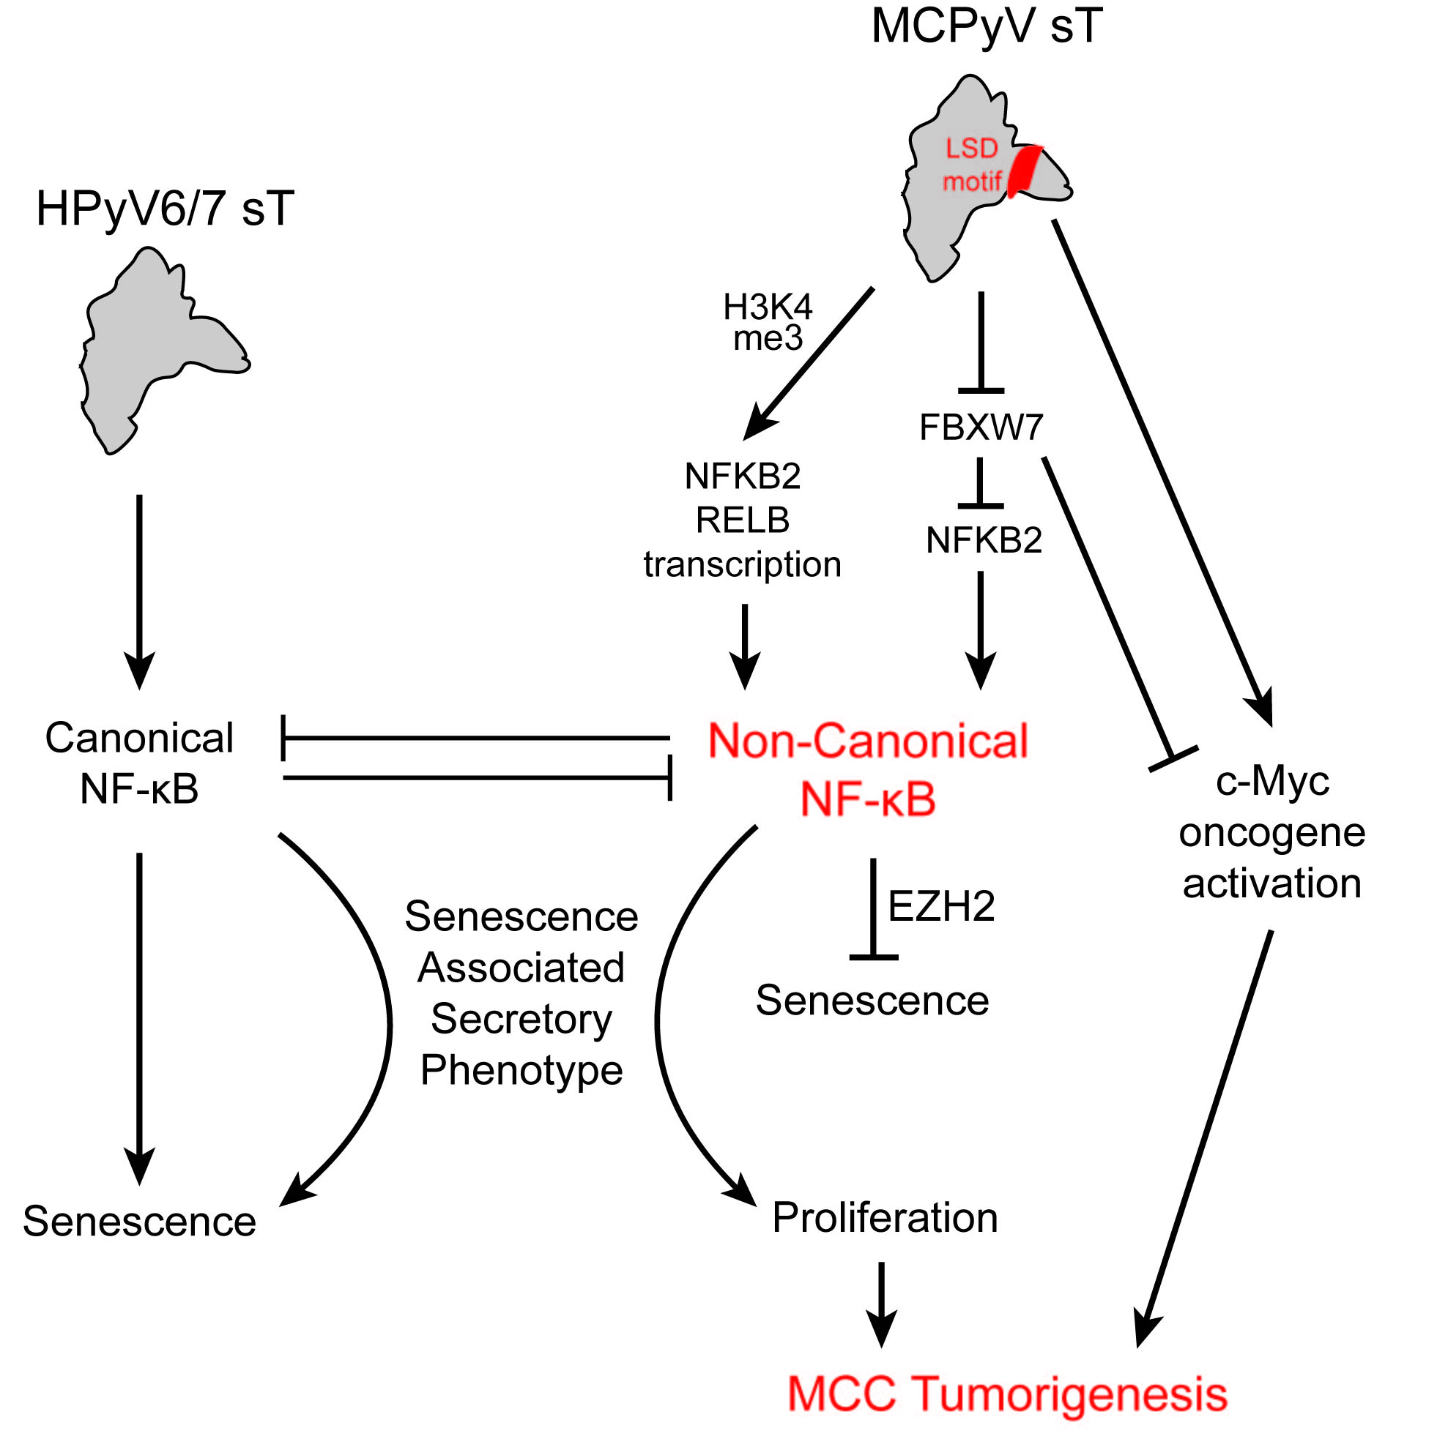

Figure S15. Summary Figure.
Expression of cutaneous HPyV sT antigens identifies unique activation of non-canonical NF-κB by Merkel Cell Polyomavirus (MCPyV) sT. Activation of ncNF-κB cooperates with Myc and additional reported mechanisms to promote MCC tumorigenesis.

