Cyclooxygenase-2 inhibition potentiates the efficacy of vascular endothelial growth factor blockade and promotes an immune stimulatory microenvironment in preclinical models of pancreatic cancer

Yuqing Zhang#, Amanda Kirane#, Huocong Huang, Noah B. Sorrelle, Francis J. Burrows, Michael T. Dellinger, Rolf A. Brekken

Supplementary Figures and Legends

Supplementary Figure 1. (a) Representative images of metastasis to the liver of control mice in Colo357 model was shown by H&E staining. Total magnifications are 100X and 200X. Scale bar, 50μm. (b) Colo357 human pancreatic cancer cells (1 $×$106) were injected orthotopically into the pancreas of SCID mice. Treatment began when the established tumor was visible by ultrasound, and consisted of control (saline, n = 6), gemcitabine 25 mg/kg twice weekly plus erlotinib 100 μg daily (standard of care, n = 6) as described in Kirane et al. (29), or mcr84 plus apricoxib (n = 10) and continued for 3 weeks. Tumor weight was normalized to the control and data from the treatment groups were compared. Data are displayed as mean ± SEM. *P < 0.05 vs. control, by ANOVA with Dunn’s MCT.

Supplementary Figure 2. Human pancreatic cancer cell lines, Colo357 (a) and AsPc-1 (b) were plated either under normal conditions or under conditions of forced EMT (treated with 20 ng/mL TGFβ on collagen I -coated plates for 72 hours). PGE₂ levels were measured by ELISA after 500 nM apricoxib treatment. (c) Colo357 and AsPC-1 cells were plated under normal conditions or conditions of forced EMT (50 ng/ml TGFβ on collagen I -coated plates for 24 hours). Lysates were probed for the indicated targets by Western blotting. The induced EMT conditions promoted loss of E-Cadherin, gain of Vimentin expression. In Colo357, the expression of N-Cadherin was also upregulated by collagen I and TGFβ stimulation. β-actin was used as a loading control.

Supplementary Figure 3. Microvessel density is not decreased by COX-2 inhibition. Paraffin-embedded tumor sections from Colo357 tumor-bearing mice were analyzed for endomucin (a, b) and NG2 (c) expression by immunofluorescence. Quantification of percentage area fraction for endomucin is shown (b). Data are displayed as mean ± SEM and represent 5 images per tumor with 3 animals per group. Representative images (endomucin, green; DAPI, blue) are shown for Colo357 tumors. Total magnification is 400X. *P < 0.05, **P < 0.01 vs. control, by ANOVA with Dunn’s MCT.

Supplementary Figure 4. KIC pancreatic tissues from the treated mice were subjected to immunohistochemistry for (A) CD11b and (B) F4/80. Images were analyzed using NIS Elements (Nikon) and Fiji software. Quantification of percentage area fraction for each target in each treatment group is shown. Data are displayed as mean ± SEM and represent 5 images per tumor with 3 animals per group analyzed. *P < 0.05 vs. control, by ANOVA with Dunn’s MCT.

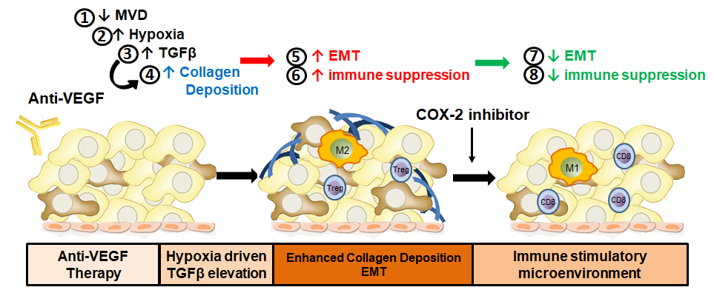
Supplementary Figure 5. Anti-VEGF therapy results in reduced microvessel density, hypoxia induced TGFβ expression, epithelial plasticity and enhanced collagen deposition (1-4). These changes drive a mesenchymal-like tumor cell phenotype (brown tumor cells). TGFβ and EMT contribute to an immune suppressive microenvironment (5-6). Inhibition of COX-2 in combination with anti-VEGF therapy reduces EMT and promotes an immune stimulatory microenvironment that includes increased infiltrating CD8⁺ T cells and decreased M2-like macrophages (7-8).

Table S1
Antigen | Antibody Clone or Catalog # | Vendor | Application
VEGF | ab52917 | Abcam | Immunofluorescence (IF)
COX-2 | ab23672 | Abcam | Immunofluorescence (IF)
E-cadherin | 3195 | Cell Signaling | Immunohistochemistry-Paraffin (IHC-P), Western blot (WB)
N-cadherin | 14215 | Cell Signaling | IHC-P, WB
Slug | 9585 | Cell Signaling | IHC-P
Snail | 3879 | Cell Signaling | IHC-P
CD3 | MCA11477 | Bio-Rad | IHC-P
CD8 | bs-0648R | Bioss | IHC-P
FoxP3 | 14-5773-80 | eBioscience | IHC-P
CD31 | DIA-310-M | dianova | IHC-P
FasL | NOK-1 | Santa Cruz | IHC-P
CD11b | Ab133357 | Abcam | IHC-P
iNOS | PA1-21054 | Thermo Fisher | IHC-P
Arginase 1 | PA5- 22009 | Thermo Fisher | IHC-P
Vimentin | 5741 | Cell Signaling | WB
endomucin | sc-65495 | Santa Cruz | IF
NG2 | ab5320 | Millipore | IF
F4/80 | NBP2-12506 | Novus Biologicals | IHC-P

Table S1: List of antibodies

