**SUPPLEMENTARY METHODS**

**mRNA Expression Profiling**

Gene expression was measured using the NanoString PanCancer Pathway Panel (NanoString Technologies, Seattle, WA, USA). The panel contains probes for 770 genes implicated in carcinogenic pathways, curated from data by The Cancer Genome Atlas (TCGA) (<https://cancergenome.nih.gov>). Thirty additional genes of interest were added for their potential involvement in ovarian cancer biology. The nCounter SPRINT Profiler (NanoString Technologies, Seattle, WA, USA) was used to run the reactions.

Each NanoString panel contains a number of pre-assigned genes, positive control probes and negative control probes for normalization purposes [1]. First, negative control probes are used to eliminate background signals. Second, positive control probes are used to adjust for technical variability. Finally, a number of probes against genes that are not supposed to vary across conditions are included to control for mRNA input (housekeeping genes). To optimize our normalization procedure, eight technical replicates were included. Six different normalization procedures are suggested by the NanoString bioinformatics team (Supplementary methods table 1), and each was tested on the eight pairs of technical replicates. The Pearson correlation between the gene expression of each pair was computed and can be found in Supplementary methods table 2. The low correlation between the replicates for sample 5 were attributed to mislabeling an removed from further evaluation. The mean concordance coefficient for the seven remaining samples was computed across all six normalization procedures. Method 3 was determined to be the optimal procedure.

First, no background subtraction was performed. Our data had very little noise and most negative control probes had a final count of zero. Second, no positive control noralization was performed. Positive controls are a set number of artificial probes spikes at defined levels within each sample to adjust for variations across lanes, samples, cartridges, and date. Since the positive controls and the endogeneous controls serve similar purpose, this step is often optional. Finally, the geometric mean of the housekeeping genes was used to control for sample input variability. Samples with a normalization outisde the 0.3-3 range were removed from further analyses. Notably, reference samples were run within each lot of samples to correct for batch effects using the built-in functionalities of the NSolver software.



**Supplementary methods table 1: Parameters for normalization methods for NanoString**



**Supplementary methods table 2: Concordance Correlation Coefficients of six recommendation methods for NanoString data**

**SUPPLEMENTARY FIGURES**

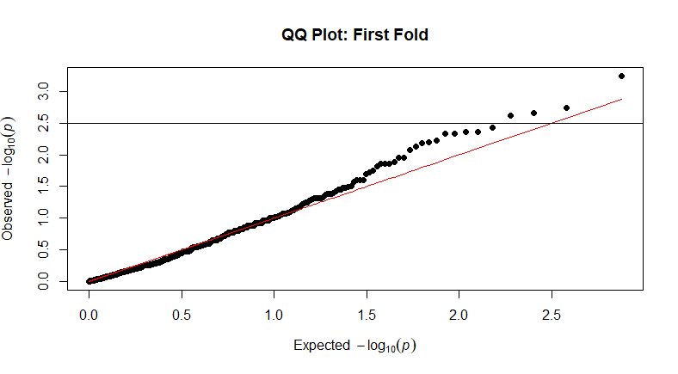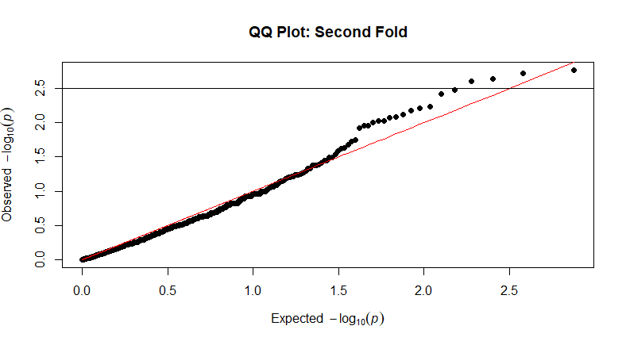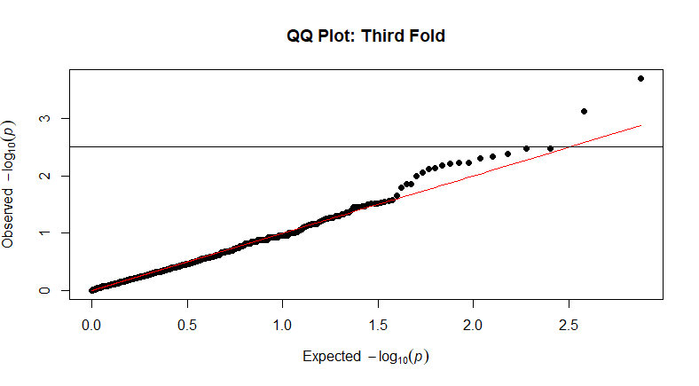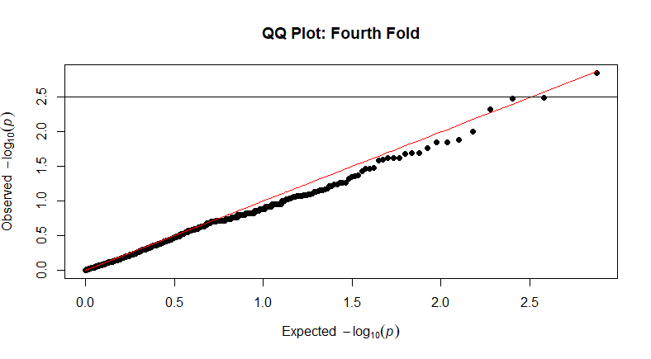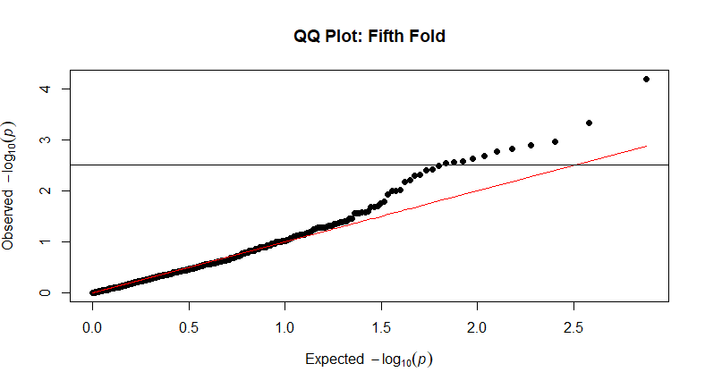

**Supplementary Figure 1: Log-transformed Quantile-Quantile plots of the Univariate Survival Analysis p-values.** P-values derived from the univariate survival analysis of the effects of each individual gene was plotted for each fold in which the analysis took place. The horizontal line at 2.52 represents -log(0.003), which was the cutoff for variable selection in the final modeling of survival in the test cohort.

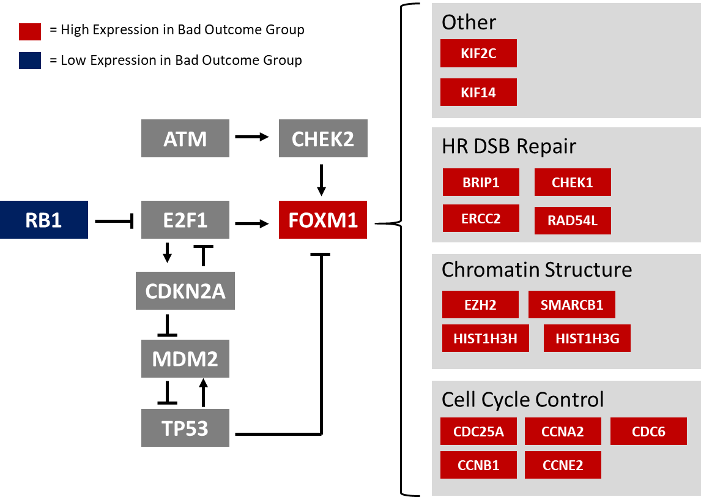

**Supplementary Figure 2: Abridged representation of the FOXM1 regulatory network.** See references [2–5]

**Supplementary Material References**

1. Veldman-Jones MH, Brant R, Rooney C et al. Evaluating Robustness and Sensitivity of the NanoString Technologies nCounter Platform to Enable Multiplexed Gene Expression Analysis of Clinical Samples. Cancer Res. 2015; 75(13):2587–2593.

2. Chen X, Müller GA, Quaas M et al. The Forkhead Transcription Factor FOXM1 Controls Cell Cycle-Dependent Gene Expression through an Atypical Chromatin Binding Mechanism. Mol. Cell. Biol. 2013; 33(2):227–236.

3. Raychaudhuri P, Park HJ. FoxM1: A Master Regulator of Tumor Metastasis. Cancer Res 2011; 71(13):4329–4333.

4. Tan Y, Chen Y, Yu L et al. Two-fold elevation of expression of FoxM1 transcription factor in mouse embryonic fibroblasts enhances cell cycle checkpoint activity by stimulating p21 and Chk1 transcription. Cell Prolif. 2010; 43(5):494–504.

5. Tan Y, Raychaudhuri P, Costa RH. Chk2 Mediates Stabilization of the FoxM1 Transcription Factor To Stimulate Expression of DNA Repair Genes. Mol. Cell. Biol. 2007; 27(3):1007–1016.