Supplementary Figures

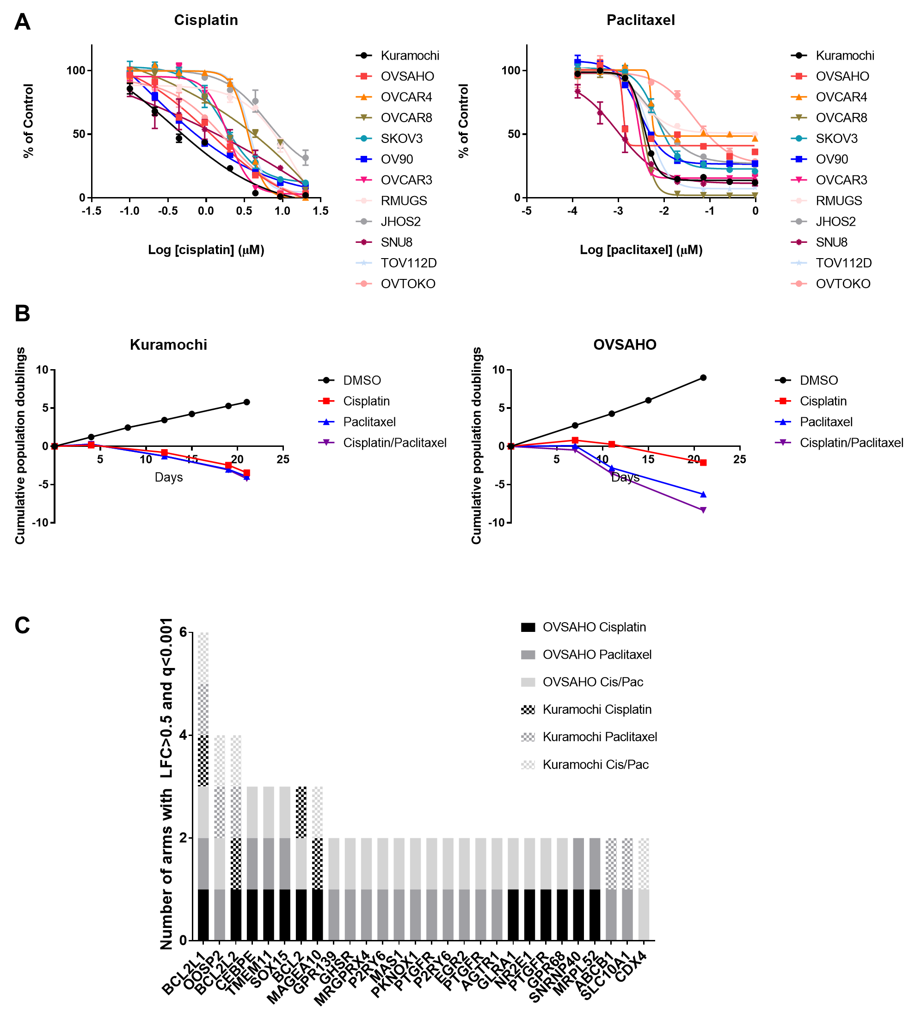
Figure S1A. Cisplatin and paclitaxel sensitivity in ovarian cancer cell lines
Dose-response curves for a panel of ovarian cancer cell lines (various histologic subtypes) treated with cisplatin or paclitaxel at indicated doses (x-axis, log₁₀ µM). Viability, measured by CellTiterGlo reagent which detects ATP, was normalized to vehicle controls (y-axis). Average +/- standard deviation of 3 replicates; representative of two or more experiments.

Figure S1B. Cell line growth curves in ORF screen
Cumulative population doublings (y-axis) over time (x-axis) for ORF library-infected cell lines Kuramochi and OVSAHO. Negative population doublings indicates cell death. Average +/- standard deviation of four replicates.

Figure S1C. Candidate resistance genes scoring in ≥2 conditions in primary ORF screen
Top candidate genes whose overexpression promoted survival in ≥2 cell line plus drug conditions in the primary screen; y-axis shows number of conditions in which each gene satisfied criteria of log₂-fold change>0.5 and q-value <0.0001.

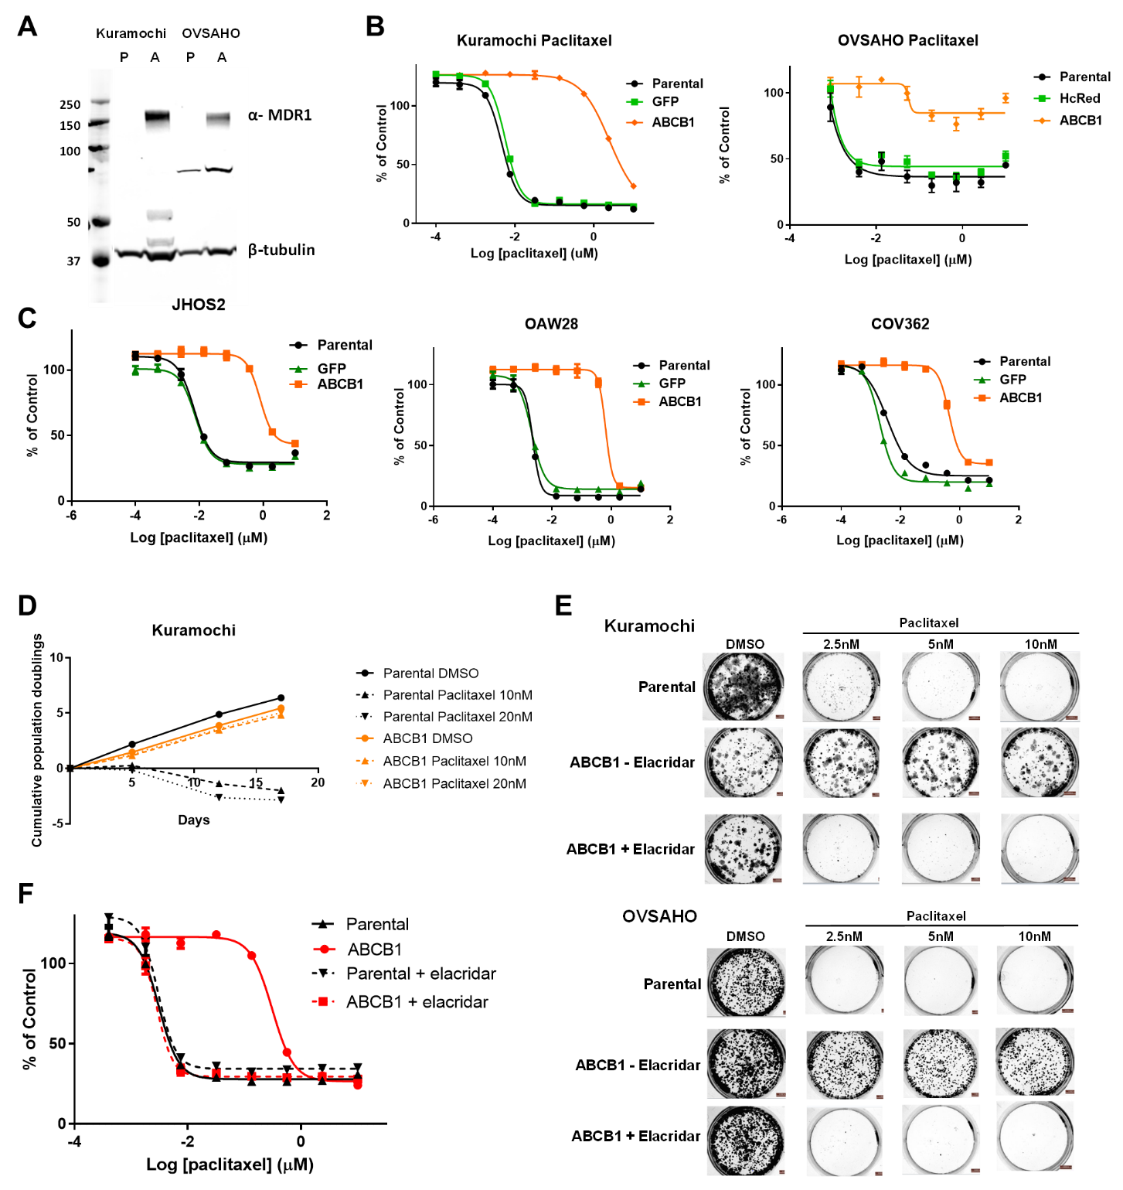
Figure S2A. Expression of MDR1, encoded by ABCB1
Western blot of MDR1 and tubulin (loading control) in parental cells (P) and cells overexpressing ABCB1 (A).

Figure S2B. Overexpression of ABCB1 and paclitaxel response
Dose-response curves for Kuramochi and OVSAHO parental cells, cells expressing green fluorescent protein (GFP) or HcRed control, or cells overexpressing ABCB1, treated with paclitaxel once (x-axis, log₁₀ µM) followed by measurement of viability 5 days later by a luminescent assay, normalized to vehicle controls (y-axis). Mean +/- standard deviation of 3 replicates; representative of at least two experiments. Two-tailed t-test of AUC of ABCB1 vs parental: Kuramochi p<0.0001; OVSAHO p<0.0001.

Figure S2C. Overexpression of ABCB1 and paclitaxel response in HGSOC cell lines
Dose-response curves for additional HGSOC cell lines not used in the ORF screen: parental cells or cells overexpressing ABCB1, treated with paclitaxel once (x-axis, log₁₀ µM) followed by measurement of viability 5 days later by a luminescent assay, normalized to vehicle controls (y-axis). Mean +/- standard deviation of 3 replicates; representative of at least two experiments.
Two-tailed t-test of AUC of ABCB1 vs parental: OAW28, JHOS2, COV362 p<0.0001.

Figure S2D. Effect of ABCB1 overexpression on cell growth with paclitaxel treatment
Cumulative population doublings (y-axis) over time (x-axis) for Kuramochi cells (parental or overexpressing ABCB1) treated with paclitaxel at the indicated doses every 3-4 days for 17 days. Mean +/- standard deviation of 2 replicates; the experiment was performed twice.

Figure S2E. Effect of MDR1/P-glycoprotein inhibitor elacridar on paclitaxel response
Dose-response curves for parental or ABCB1-overexpressing cell lines treated with paclitaxel once with or without addition of elacridar (1 µM), followed by measurement of viability at 5 days by a luminescent assay. Mean +/- standard deviation of 3 replicates; the experiment was performed twice. Similar results were observed with OVSAHO cell line (not shown). Two-tailed t-test of AUC of parental vs. ABCB1, p<0.0001; parental vs. ABCB1 + elacridar, p=0.76 (NS).

Figure S2F. Overexpression of ABCB1 and colony formation with paclitaxel treatment and effect of elacridar on colony formation
Kuramochi cell lines (parental or overexpressing ABCB1) were seeded at low density in 12-well plates and treated weekly with paclitaxel at the indicated concentrations, in the presence or absence of elacridar (1 µM). At 3 weeks the cells were fixed and stained with crystal violet. Representative images are shown from one of three replicates; the experiment was performed twice.

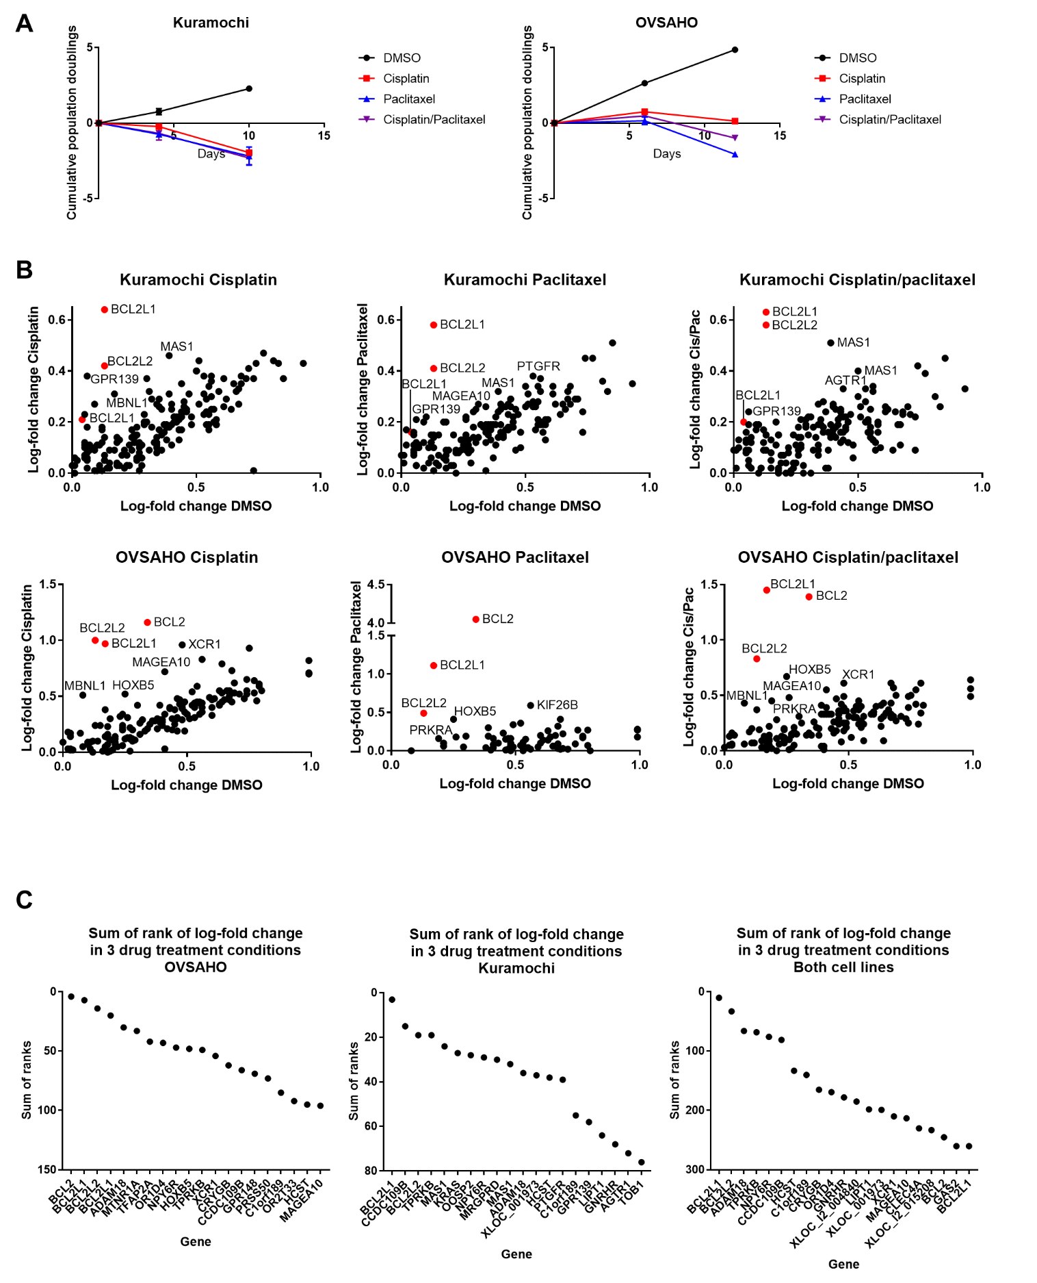
Figure S3A. Cell line growth curves in mini-pool overexpression secondary screen
Cumulative population doublings (y-axis) over time (x-axis) for ORF mini-pool library infected cell lines Kuramochi (left) and OVSAHO (right). Negative population doublings indicates cell death. Average +/- standard deviation of 2 replicates.

Figure S3B. Mini-pool overexpression secondary screen
Scatterplot of log₂-fold change (LFC) in DMSO (x-axis) versus log₂-fold change in drug treatment (y-axis) for each cell line and drug in the ORF mini-pool screen. Data points are limited to ORFs with LFC>0 compared to the early time point, indicating enrichment following drug treatment (putative resistance genes). Anti-apoptotic genes are highlighted in red. ABCB1 was excluded from the mini-pool screen.

Figure S3C. Top-ranked genes by LFC in mini-pool overexpression secondary screen
The ORFs in the mini-pool were ranked by LFC from positive to negative (e.g. Rank 1 indicates the highest positive LFC and thus the greatest enrichment following drug treatment compared to the early time point). ORFs were ranked by LFC in each drug condition, and the ranks were summed to generate plots of the highest-ranked genes across all three drug conditions for each cell line, individually (left two plots) and combined (right). The lowest sums correspond to the most consistently enriched ORFs following drug treatment.

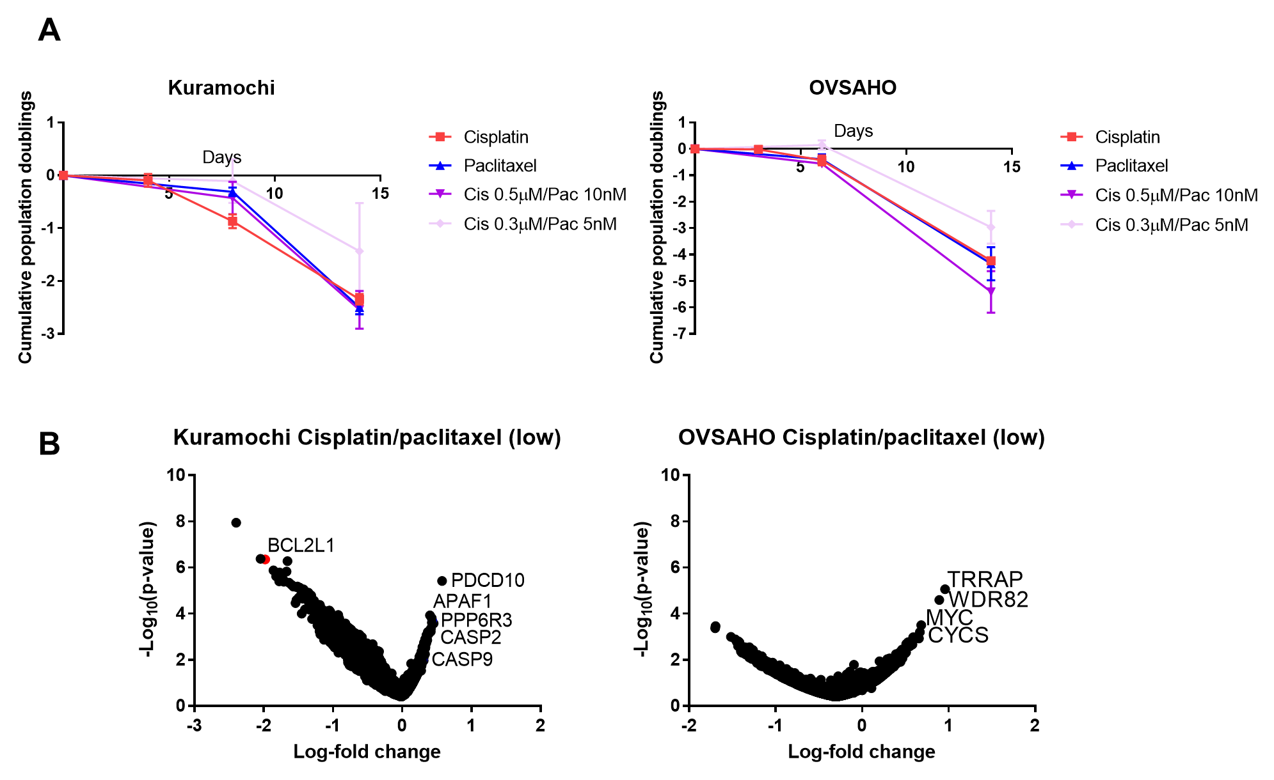

Figure S4A. Cell line growth curves in CRISPR-Cas9 screen
Cumulative population doublings (y-axis) over time (x-axis) for sgRNA library-infected cell lines Kuramochi and OVSAHO. Negative population doublings indicates cell death. Average +/- standard deviation of four replicates. No DMSO arm was included in the CRISPR screen.

Figure S4B. CRISPR-Cas9 screen data from cisplatin+paclitaxel “low-dose” combination
Data from an additional combination cisplatin+paclitaxel drug arm in CRISPR-Cas9 screen using lower doses of each drug (cisplatin 0.3 µM + paclitaxel 5 nM). Average log₂-fold change (x-axis) of the guide RNAs representing each gene, compared to the early time point, versus the average p-value (-log₁₀ p-value) (y-axis) representing statistical significance compared to the entire pool. Negative average log₂-fold change indicates depletion of cells with the sgRNA, whereas positive average log₂-fold change indicates enrichment of cells with the sgRNA, compared to the early time point.

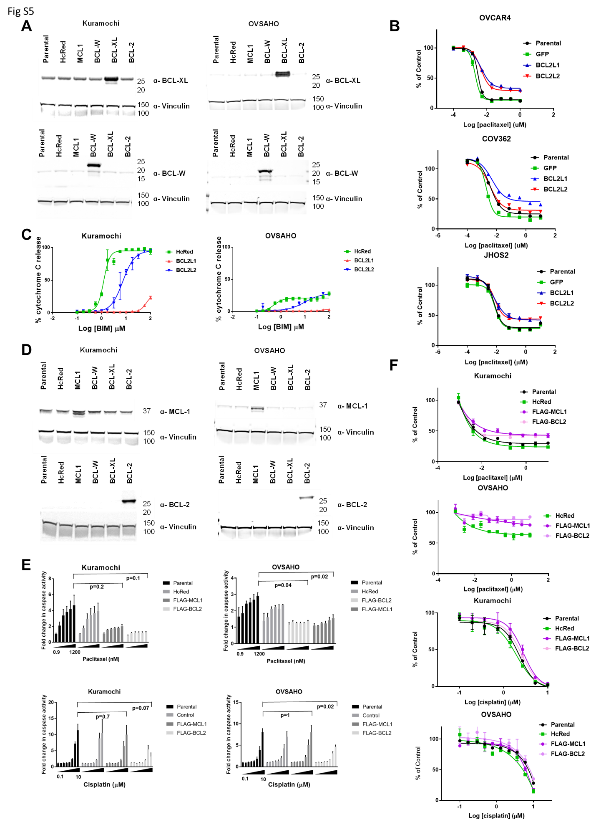
Figure S5A. Expression of BCL-XL and BCL-W
Representative Western blot of BCL-XL (top) or BCL-W (bottom) and vinculin (loading control) in parental cells (P) and cells overexpressing HcRed (control), MCL1, BCL-W, BCL-XL, or BCL-2.

Figure S5B. Overexpression of BCL2L1 (BCL-XL) or BCL2L2 (BCL-W) and paclitaxel response in HGSOC cell lines
Dose-response curves for additional HGSOC cell lines not used in the ORF screen: parental cells or cells overexpressing BCL2L1 (BCL-XL) or BCL2L2 (BCL-W), treated with paclitaxel once (x-axis, log₁₀ µM) followed by measurement of viability 5 days later by a luminescent assay, normalized to vehicle controls (y-axis). Mean +/- standard deviation of 3 replicates; representative of at least two experiments. Two-tailed t-test of AUC: BCL2L1 (BCL-XL) vs parental: COV362 p<0.0001; JHOS2 p=0.0036; OVCAR4 p=0.0003; BCL2L2 (BCL-W) vs. parental: COV362 p=0.1073 (NS); JHOS2 p=0.0038; OVCAR4 p=0.0047.

Figure S5C. Effect of overexpressing anti-apoptotic proteins on apoptotic priming
BH3 profiling measurement of apoptotic priming in Kuramochi and OVSAHO cells with overexpression of HcRed (control), BCL2L1 (BCL-XL) or BCL2L2 (BCL-W), treated with increasing concentrations of BIM peptide (x-axis, log₁₀ µM) in the absence of drug treatment. Cytochrome C release (y-axis) was determined by the percent cytochrome C negative cells as measured by flow cytometry, normalized to DMSO control. Representative results of at least two independent experiments.

Figure S5D. Expression of BCL-2 and MCL1
Western blot of BCL-2 (top) or MCL1 (bottom) and vinculin (loading control) in parental cells (P) and cells overexpressing HcRed (control), MCL1, BCL-W, BCL-XL, or BCL-2, using N-terminal FLAG-tagged constructs of MCL1 and BCL2.

Figure S5E. Overexpression of BCL2 or MCL1 and apoptosis induction
CaspaseGlo assay for caspase 3/7 activity in parental cells or cells overexpressing HcRed (control), BCL2, or MCL1 treated with vehicle, paclitaxel, or cisplatin for 48 hours. Luminescence units were normalized to vehicle controls and expressed as fold change in caspase activity. Mean +/- SEM of 3 biological replicates. Values for parental cells were compared to cells overexpressing BCL2 or MCL1 at the highest drug dose within each figure by two-sample t-test.

Figure S5F. Overexpression of BCL2 or MCL1 and paclitaxel or cisplatin response
Dose-response curves for Kuramochi and OVSAHO parental cells or cells overexpressing BCL2 or MCL1, treated with paclitaxel or cisplatin once (x-axis, log₁₀ µM) followed by measurement of viability 5 days later by a luminescent assay, normalized to vehicle controls (y-axis). Mean +/- standard deviation of 3 replicates; representative of at least two experiments. Paclitaxel: two-tailed t-test of AUC: BCL-2 vs parental or HcRed control: Kuramochi p=0.0004, OVSAHO p <0.0001; MCL1 vs. parental or HcRed control: Kuramochi p=0.0002, OVSAHO p=0.0001. Cisplatin: two-tailed t-test of AUC: BCL-2 vs parental or HcRed control: Kuramochi p=0.14 (NS), OVSAHO p=0.1 (NS); MCL1 vs. parental or HcRed control: Kuramochi p=0.025, OVSAHO p=0.62 (NS).

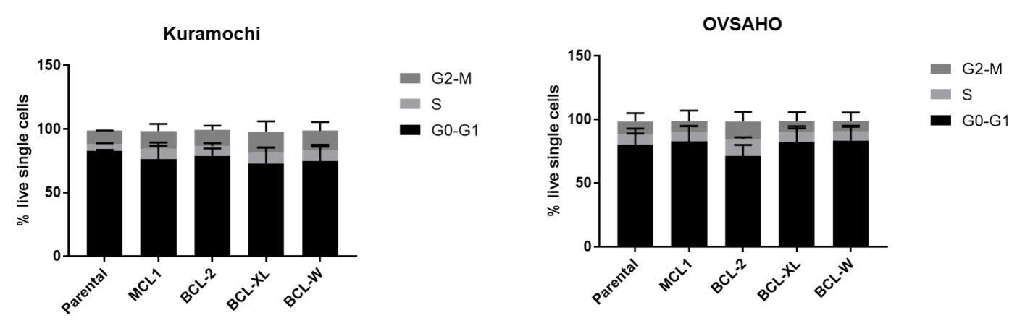

Figure S6. Cell cycle analysis of HGSOC cells overexpressing anti-apoptotic proteins
Estimated fraction of cells in each phase of the cell cycle (G0/G1, S, G2/M) in Kuramochi and OVSAHO cells stably overexpressing indicated anti-apoptotic proteins, as measured by propidium iodide staining and flow cytometry. Stacked bars represent mean +/- SEM of three biological replicates.
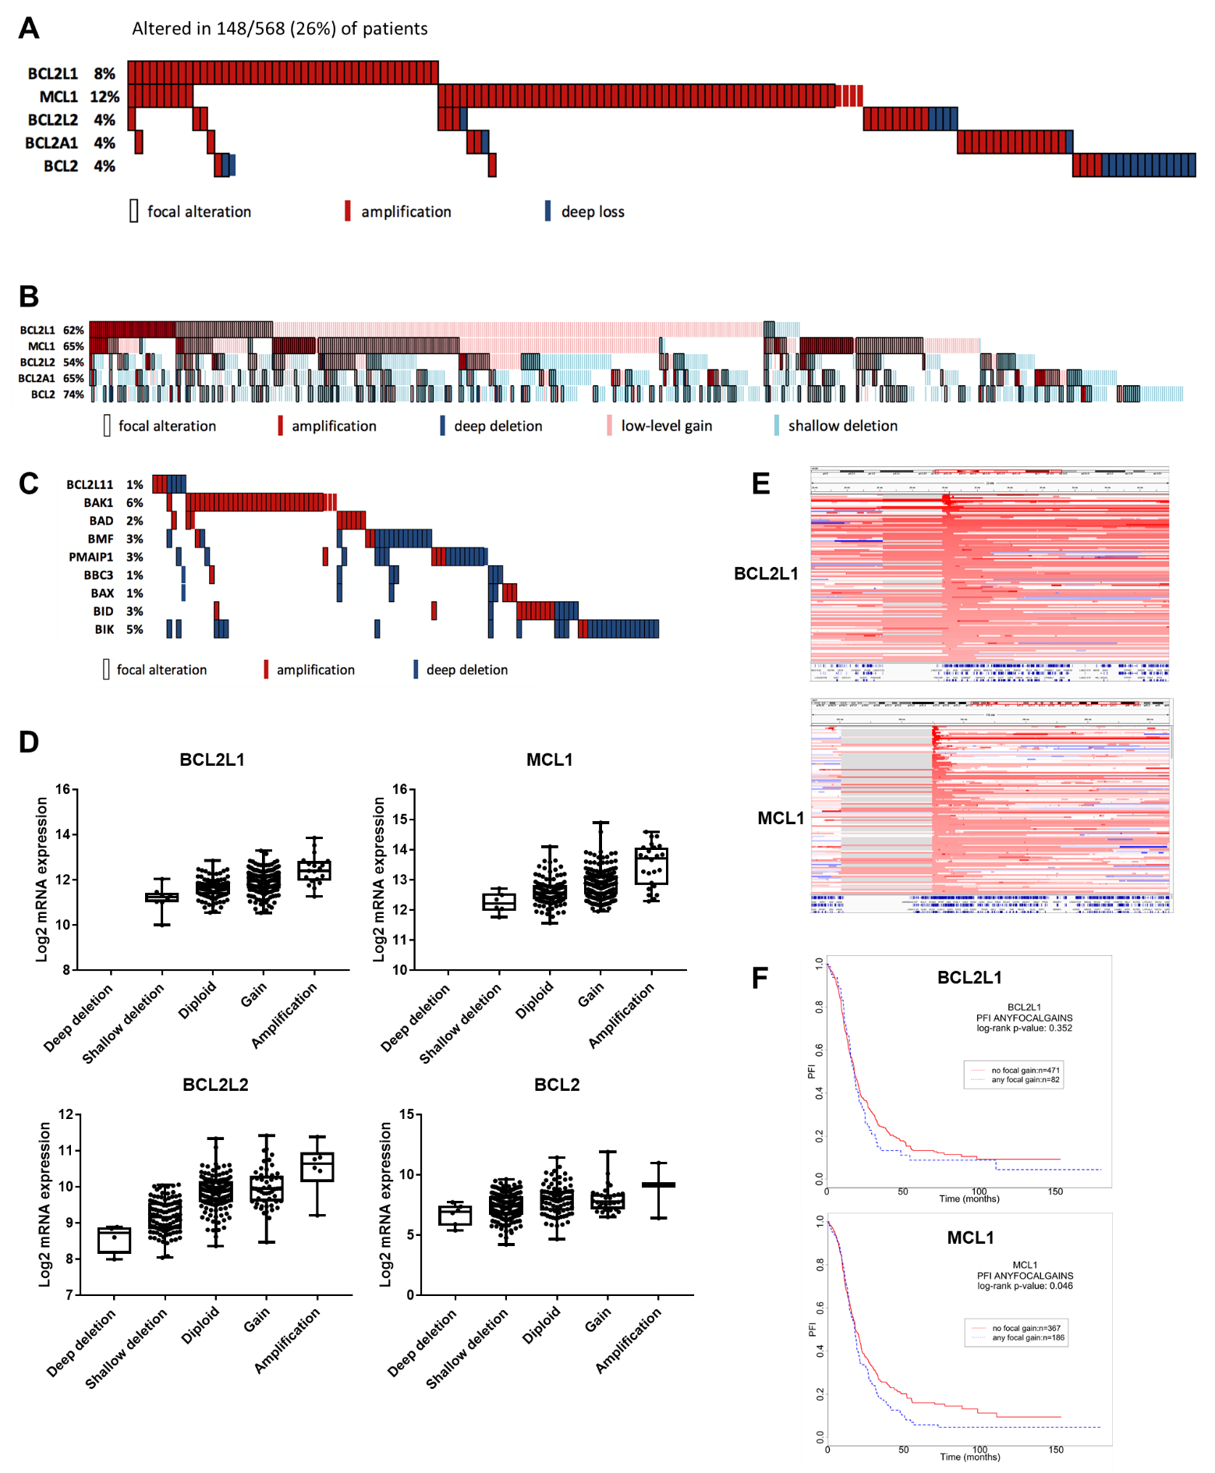
Figure S7A. Genomic alterations in anti-apoptotic genes in primary ovarian cancer
Frequency of copy number alterations in anti-apoptotic genes from the Cancer Genome Atlas study of primary HGSOC. Red indicates high-level amplification and blue indicates deep loss. Focal amplifications are outlined. (BCL2A1 is a minor BCL-2-family anti-apoptotic protein not included in our screens.)

Figure S7B. Copy-number alterations of anti-apoptotic genes in primary HGSOC
Amplifications, copy gains, deep deletions, and shallow deletions of anti-apoptotic genes in primary HGSOC from the Cancer Genome Atlas Pan-Cancer dataset. Focal alterations are outlined.

Figure S7C. Copy-number alterations of pro-apoptotic genes in primary HGSOC
Amplifications and deep deletions of pro-apoptotic genes in primary HGSOC from the Cancer Genome Atlas Pan-Cancer dataset. Focal alterations are outlined.

Figure S7D. Copy number and expression of anti-apoptotic genes in primary HGSOC
Box plot of copy number alterations (x-axis) and mRNA expression (mRNA Expression Batch Normalized/Merged from Illumina HiSeq_RNASeqV2) (y-axis) of anti-apoptotic genes in primary HGSOC from the Cancer Genome Atlas Pan-Cancer dataset. Data accessed via cBio Portal.

Figure S7E. MCL1 and BCL2L1 are focally amplified in HGSOC
Local copy number profiles showing region of amplification (red) of BCL2L1 and MCL1 in primary HGSOC.

Figure S7F. Progression-free interval of patients with primary HGSOC with focal amplifications of BCL2L1 or MCL1
Kaplan-Meier curves showing progression-free intervals of patients with primary HGSOC from the Cancer Genome Atlas Pan-Cancer dataset either with (blue) or without (red) focal gain of BCL2L1 or MCL1. P-values for significance by log-rank test: BCL2L1 = 0.352 (NS), MCL1 = 0.046.

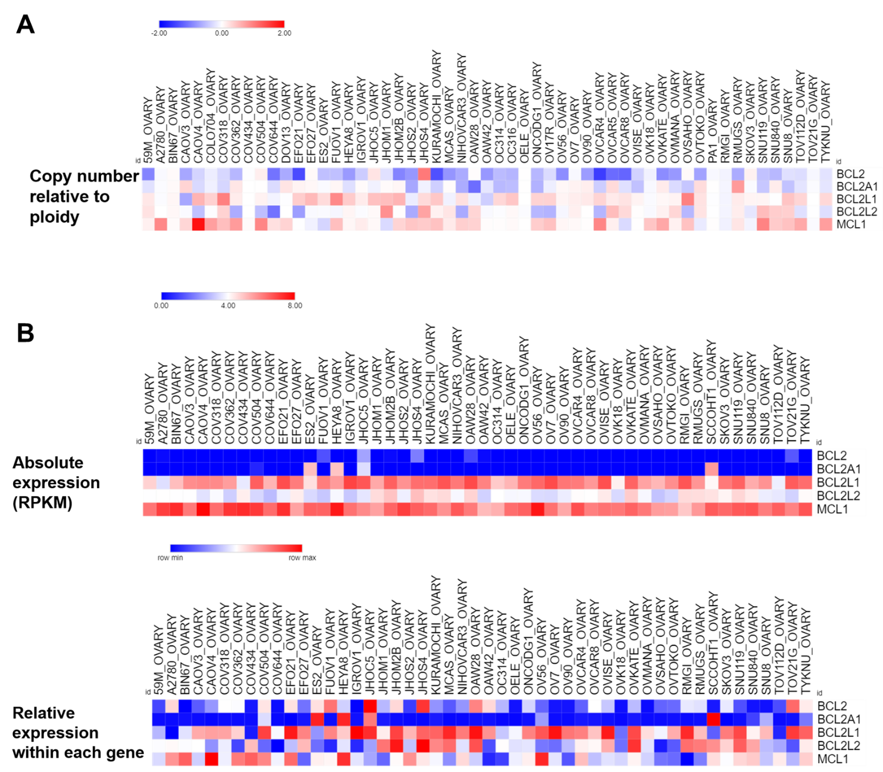

Figure S8A. Copy number alterations of anti-apoptotic genes in ovarian cancer cell lines
Heatmap of relative copy-number of anti-apoptotic genes in CCLE cell lines (all histologic subtypes), -2 to 2 on scale, with copy-number gains in red and losses in blue. Heatmap was generated in Morpheus (https://software.broadinstitute.org/morpheus).

Figure S8B. Expression of anti-apoptotic genes in ovarian cancer cell lines
Heatmap of mRNA expression of anti-apoptotic genes in CCLE ovarian cancer cell lines (all histologic subtypes), with absolute expression (RPKM, 0-8 on scale) at top and relative expression within each gene at bottom, with higher expression in red and lower in blue. Heatmap was generated in Morpheus (https://software.broadinstitute.org/morpheus).

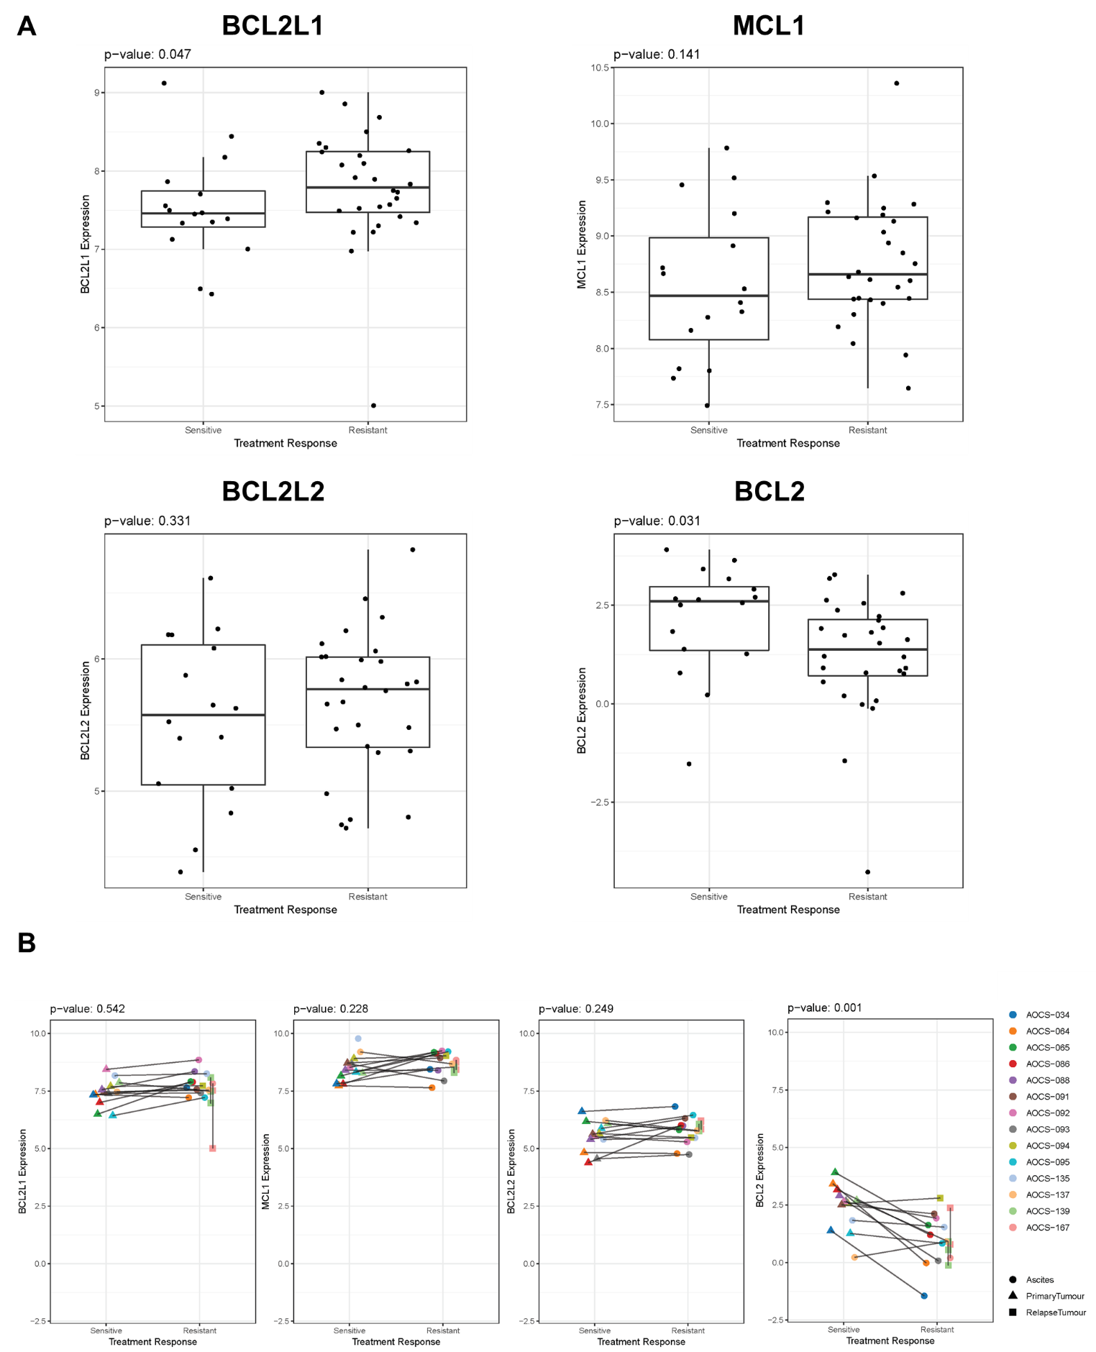

Figure S9A. Expression of anti-apoptotic genes in platinum-sensitive and -resistant HGSOC
Box plot of gene expression levels (counts per million, y-axis) in samples from HGSOC patients with platinum sensitivity (left in each plot) or acquired platinum resistance (right) from the Australian Ovarian Cancer Study cohort. Differences are statistically significant between groups for BCL2 (t-test, p-value 0.03), and borderline for BCL2L1 (p-value 0.047).

Figure S9B. Expression of anti-apoptotic genes in paired platinum-sensitive and- resistant HGSOC
Expression of anti-apoptotic genes (counts per million, y-axis) in paired platinum-sensitive and acquired platinum-resistant samples from individual HGSOC patients in the Australian Ovarian Cancer Study cohort. P-values for significant differences between sensitive and resistant groups by t-test are indicated. No significant differences in copy number alterations between sensitive and resistant samples were observed (data not shown). Across the entire dataset, BCL2L1, BCL2L2, and MCL1 showed a significant correlation between copy number and expression levels (data not shown).

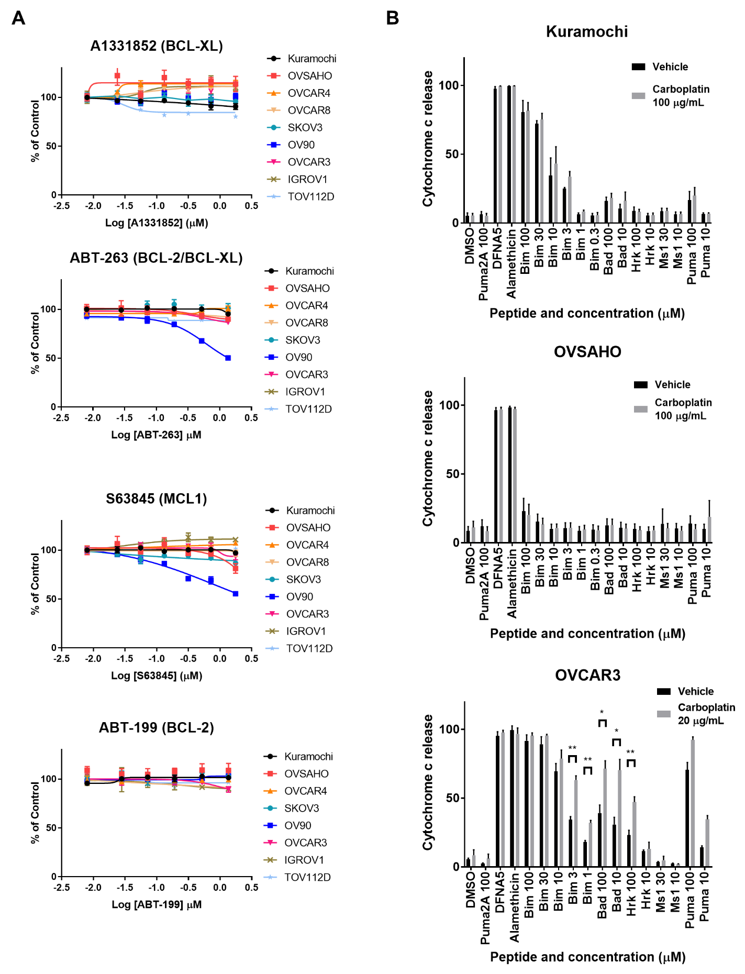

Figure S10A. Effects of single-agent anti-apoptotic protein inhibitors on ovarian cancer cell lines
Dose-response curves for ovarian cancer cell lines (HGSOC and non-HGSOC subtypes) treated once with single-agent anti-apoptotic protein inhibitors (A1331852 (BCL-XL), S63845 (MCL1), ABT-263 (BCL-2/BCL-XL), ABT-199 (BCL-2)), followed by measurement of viability at 5 days by a luminescent assay. Mean +/- standard deviation of 2 replicates; representative of at least two experiments.

Figure S10B. BH3 profiling of HGSOC cell lines with a panel of pro-apoptotic peptides
BH3 profiling of Kuramochi, OVSAHO, and OVCAR3 HGSOC cell lines with a panel of pro-apoptotic peptides (x-axis; concentration in µM). Percent cytochrome C release (x-axis) was measured by flow cytometry after treatment with vehicle or with carboplatin (20 or 100 µg/mL as indicated) for 24 hours prior to BH3 profiling. Mean +/- SEM of 3-4 independent experiments. For OVCAR3, statistical significance determined using the Holm-Sidak method to correct for multiple comparisons, with alpha = 0.05. Each row was analyzed individually, without assuming a consistent SD. * = adjusted p-value <0.05; ** = adjusted p-value <0.005.

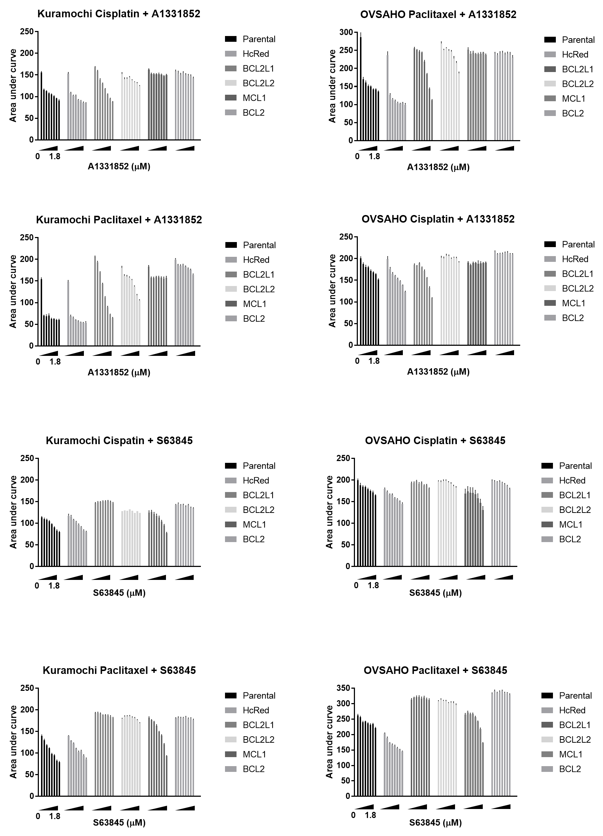
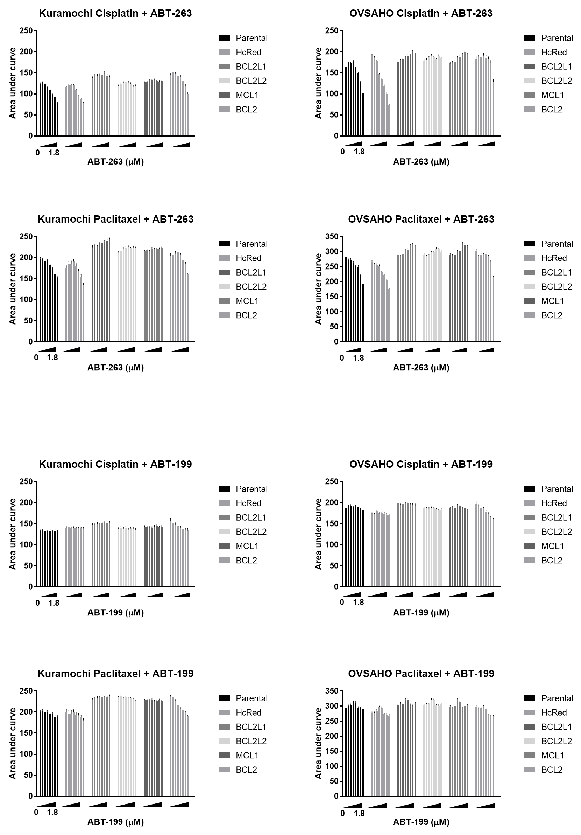
Figure S11. Combinations of cisplatin or paclitaxel plus anti-apoptotic protein inhibitors with overexpression of anti-apoptotic genes
Area under the curve (AUC, y-axis) of dose-response curves for parental cells or cells overexpressing different anti-apoptotic proteins treated with a fixed dose range of cisplatin (0.1 to 10 µM) or paclitaxel (0.0001 to 0.1 µM) plus increasing doses (bars) of anti-apoptotic protein inhibitors A1331852 (BCL-XL), S63845 (MCL1), ABT-263 (BCL-2/BCL-XL), or ABT-199 (BCL-2), followed by measurement of viability at 5 days. AUC +/- standard error of the mean of 2 replicates; each experiment was performed at least twice.
Note: For Kuramochi cisplatin/S63845 BCL2L2 only one replicate is shown from this experiment.

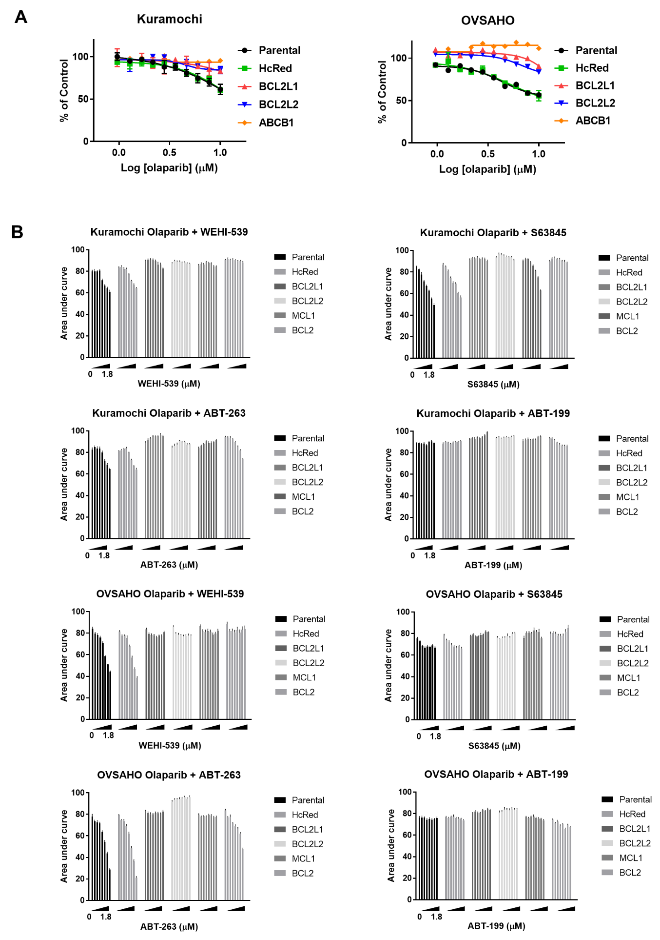
Figure S12A. Overexpression of anti-apoptotic proteins and olaparib response
Dose-response curves for Kuramochi and OVSAHO parental cells or cells overexpressing anti-apoptotic proteins, treated with olaparib once (x-axis, log₁₀ µM) followed by measurement of viability 5 days later by a luminescent assay, normalized to vehicle controls (y-axis). Mean +/- standard deviation of 2 replicates; each experiment was performed at least twice. Two-tailed t-test of AUC: BCL-XL vs parental: Kuramochi p=0.055, OVSAHO p<0.0001; BCL-W vs. parental: Kuramochi p=0.041, OVSAHO p=0.0002; ABCB1 vs. parental: Kuramochi p=0.012, OVSAHO p<0.0001.

Figure S12B. Combinations of olaparib and anti-apoptotic protein inhibitors
Area under the curve (AUC, y-axis) of dose-response curves for parental cells or cells overexpressing different anti-apoptotic proteins treated with a fixed dose range of olaparib (1-10 µM) plus increasing doses (bars) of anti-apoptotic protein inhibitors WEHI-539 (BCL-XL), S63845 (MCL1), ABT-263 (BCL-2/BCL-XL), or ABT-199 (BCL-2), followed by measurement of viability at 5 days. AUC +/- standard error of the mean of 2 replicates; each experiment was performed at least twice.

Supplementary Table Legends
Supplementary Table 1. ORF screen barcode sequencing reads
Total number of sequencing reads corresponding to the indicated barcode at the early time point (ETP) or at the end of the screen for each treatment regimen and replicate (rep = replicate, A-D; Cis/Pac = cisplatin + paclitaxel combination)
Column A indicates the unique barcode for the ORF construct.
Column B indicates the ORF construct ID.
Column C shows the gene symbol representing the best sequence match to the ORF sequence.
Columns D-S show the total sequencing reads for each barcode in each condition.

Supplementary Table 2. ORF screen analysis of statistical enrichment
Log-fold change (LFC) and q-value for statistical significance of individual ORF clones in each drug treatment arm of the ORF screen.
Tab 1 is Kuramochi and Tab 2 is OVSAHO.
Column A is the ORF construct barcode.
Column B is the ORF construct ID. Sequencing information and other details of constructs are available at Broad Institute TRC Portal: https://portals.broadinstitute.org/gpp/public/
Column C is the gene symbol representing the best sequence match to the ORF sequence.
Column D is the gene name corresponding to the symbol.
Column E, F, and G are the gene family, Entrez ID and Ensembl ID annotation of the gene.
Columns H-M are the log-fold-change and q-value of each treatment arm. See methods for details of the calculation of each parameter.
NA indicates data not available.

Supplementary table 3. ORF constructs included in mini-pool secondary screen
List of ORF construct IDs and corresponding genes included in the mini-pool secondary screen.
Criteria for each category are detailed in the methods section and in each sheet in the table.

Supplementary Table 4. Secondary mini-pool overexpression screen data
Log-fold change (LFC) in reads per million (log₂RPM) in each condition compared to the early time point (ETP) and corresponding Z-scores for significance. Each tab represents a cell line.
Column A and B indicate barcode and construct ID identifying each ORF construct.
Column C is the average log₂RPM of the ETP.
Column D-K show the Log-fold change (LFC) of each individual replicate compared to the ETP.
(rep = replicate, A-B; Cis/Pac = cisplatin + paclitaxel combination)
Column L shows the gene name corresponding to the ORF construct.
Column M is the average LFC of the DMSO arm compared to the ETP.
Column N-P show the average LFC of each drug arm compared to the ETP.
Column Q-T show the Z-scores of the average LFC of each drug arm.

Supplementary Table 5. CRISPR-Cas9 screen log-fold-change (LFC) and p-value data
Average of log₂-fold change (compared to the early time point) for 4 sgRNAs per gene, and negative log₁₀ of the p-value for significance compared to the entire pool.

Supplementary Table 6. CRISPR-Cas9 screen data, STARS analysis
STARS scores providing a gene-level ranking of the enrichment of genes in the CRISPR-Cas9 screen. Genes passing a threshold of the top 2% of genes in each treatment arm were included in the table. Each tab represents a cell line and drug treatment arm. Documentation of the methodology is available at http://portals.broadinstitute.org/gpp/public/software/stars.
Column A is the gene symbol.
Column B is the number of sgRNAs (perturbations) in the pool corresponding to the gene.
Column C is the rank of each perturbation among all perturbations in that arm.
Column D is the barcode sequence of the perturbations, in the same order as column C.
Column E is the most enriched perturbation, i.e., the within-gene rank of the least probable perturbation.
Column F is the STARS score: -log₁₀(least probable perturbation).
Column G is the average of –log₁₀ of values of all perturbations ranking above the threshold.
Column H is the p-value calculated using a null distribution.
Column I is the false discovery rate (FDR).
Column J is the q-value corrected FDR.

