SUPPLEMENTARY INFORMATION

Suppression of Breast Cancer Stem Cells and Tumor Growth by the RUNX1 transcription factor

Deli Hong^{1,2}, Andrew J. Fritz¹, Kristiaan H. Finstad¹, Mark P. Fitzgerald¹, Adam L. Viens¹, Adam Weinheimer¹, Jon Ramsey¹, Janet L. Stein¹, Jane B. Lian¹, Gary S. Stein¹

¹Department of Biochemistry and University of Vermont Cancer Center, University of Vermont College of Medicine, 89 Beaumont Avenue, Burlington, VT, 05405, USA. ² Graduate Program in Cell Biology, University of Massachusetts Medical School, 55 Lake Avenue North, Worcester, MA 01655, USA
*Corresponding author:
Gary S. Stein
Department of Biochemistry and University of Vermont Cancer Center
University of Vermont College of Medicine
89 Beaumont Avenue
Burlington, VT 05405, USA
P: 802-656-4874
F: 802-656-2140
E: gary.stein@uvm.edu
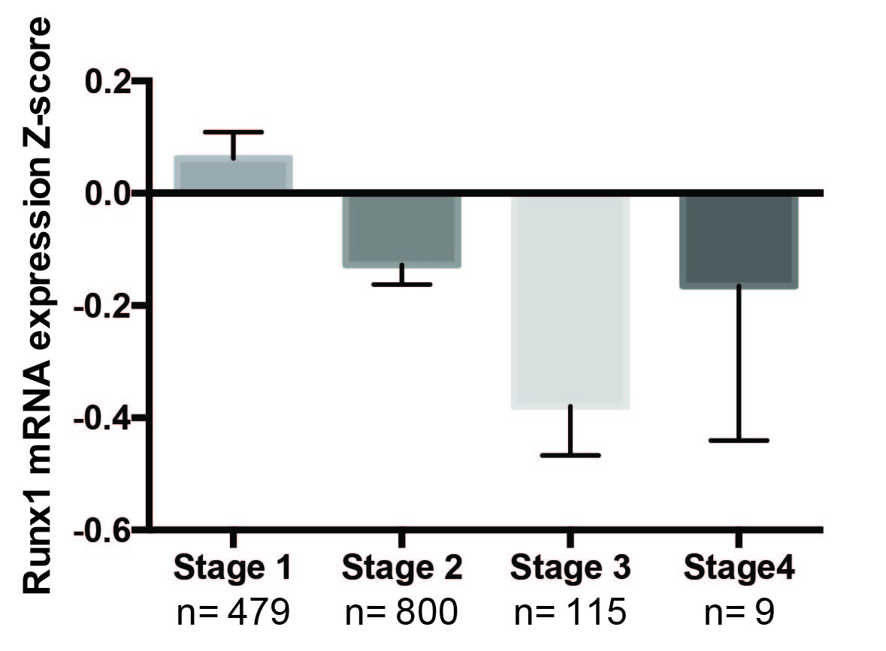
Supplementary Figure 1. RUNX1 mRNA is decreased during breast cancer progression. TCGA data show that RUNX1 mRNA is decreased in Stage 2 and Stage 3 tumors.

Supplementary Figure 2. RUNX1 does not change cell proliferation. Growth curves for MCF10AT1 cells (A.) or MCF10CA1a cells (B.) expressing either empty vector (black) or RUNX1 (blue). Line graph represents mean ±SEM from two experiments each with a technical replicate (N=4). No statistical difference was found (*, p>0.05).

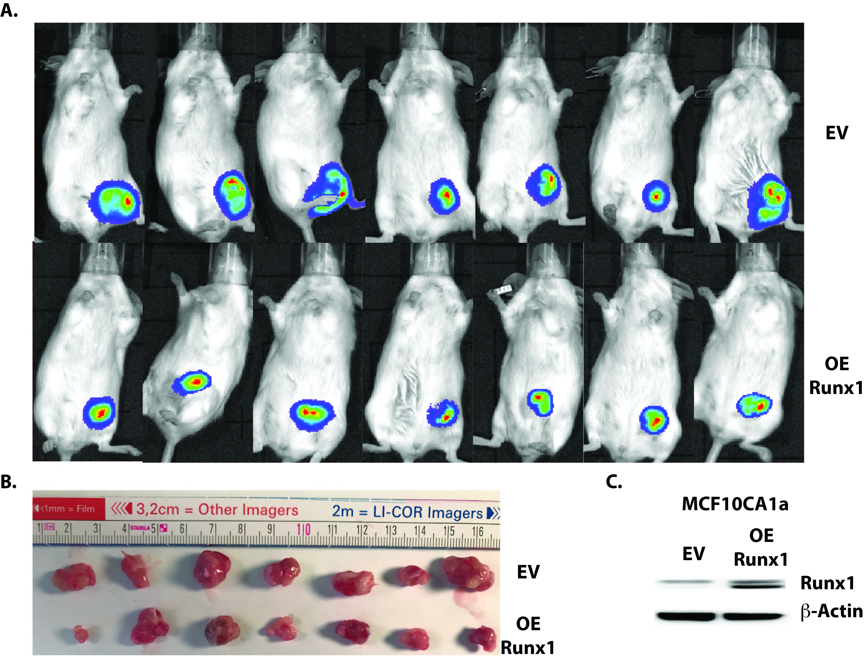
Supplementary Figure 3. RUNX1 represses tumor growth in mammary fat pad. A. Luminescence images at 4 weeks after mammary fat pad injection. B. Photograph of excised tumors shows that MCF10CA1a cells with RUNX1 overexpression formed smaller tumors in mice mammary fat pad. C. Western Blot for MCF10CA1a cells shows RUNX1 is overexpressed.

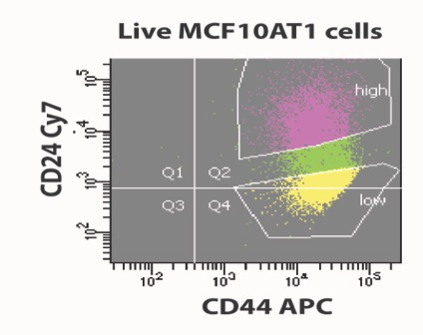

Supplementary Figure 4. Gate for MCF10AT1 sorting. Gating for BCSC and Bulk sub-population in MCF10AT1 cells. B. Overexpression RUNX1 in MCF10CA1a cells does not change BCSC population.

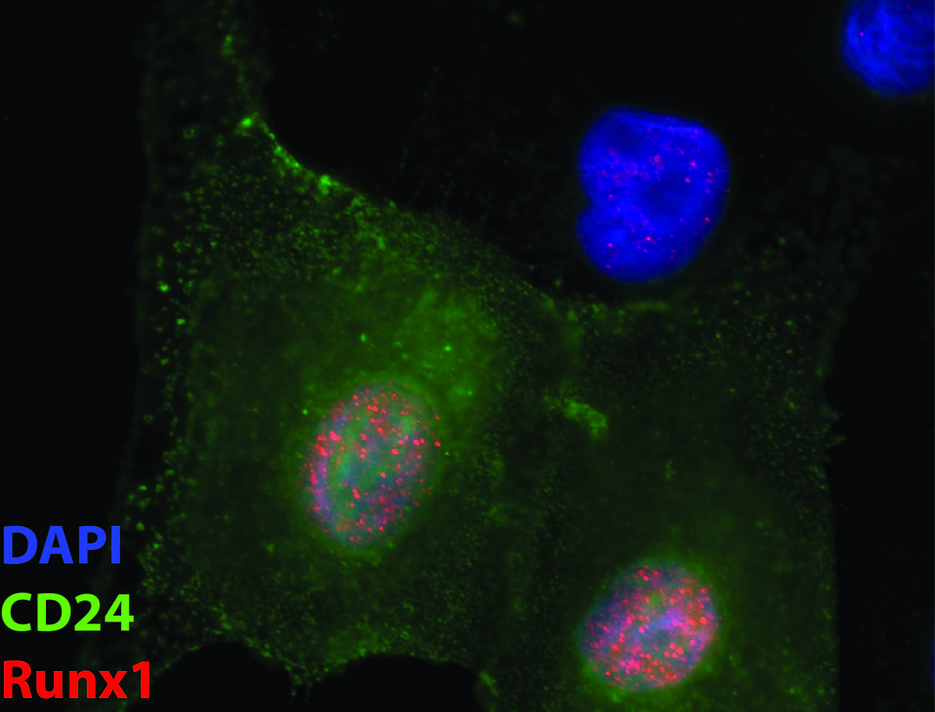
Supplementary Figure 5. CD24^{high} Cells have high RUNX1 expression in MCF10AT1 cells.
Immunostaining shows the cells with CD24 (Green) expression have high RUNX1 (Red) expression.

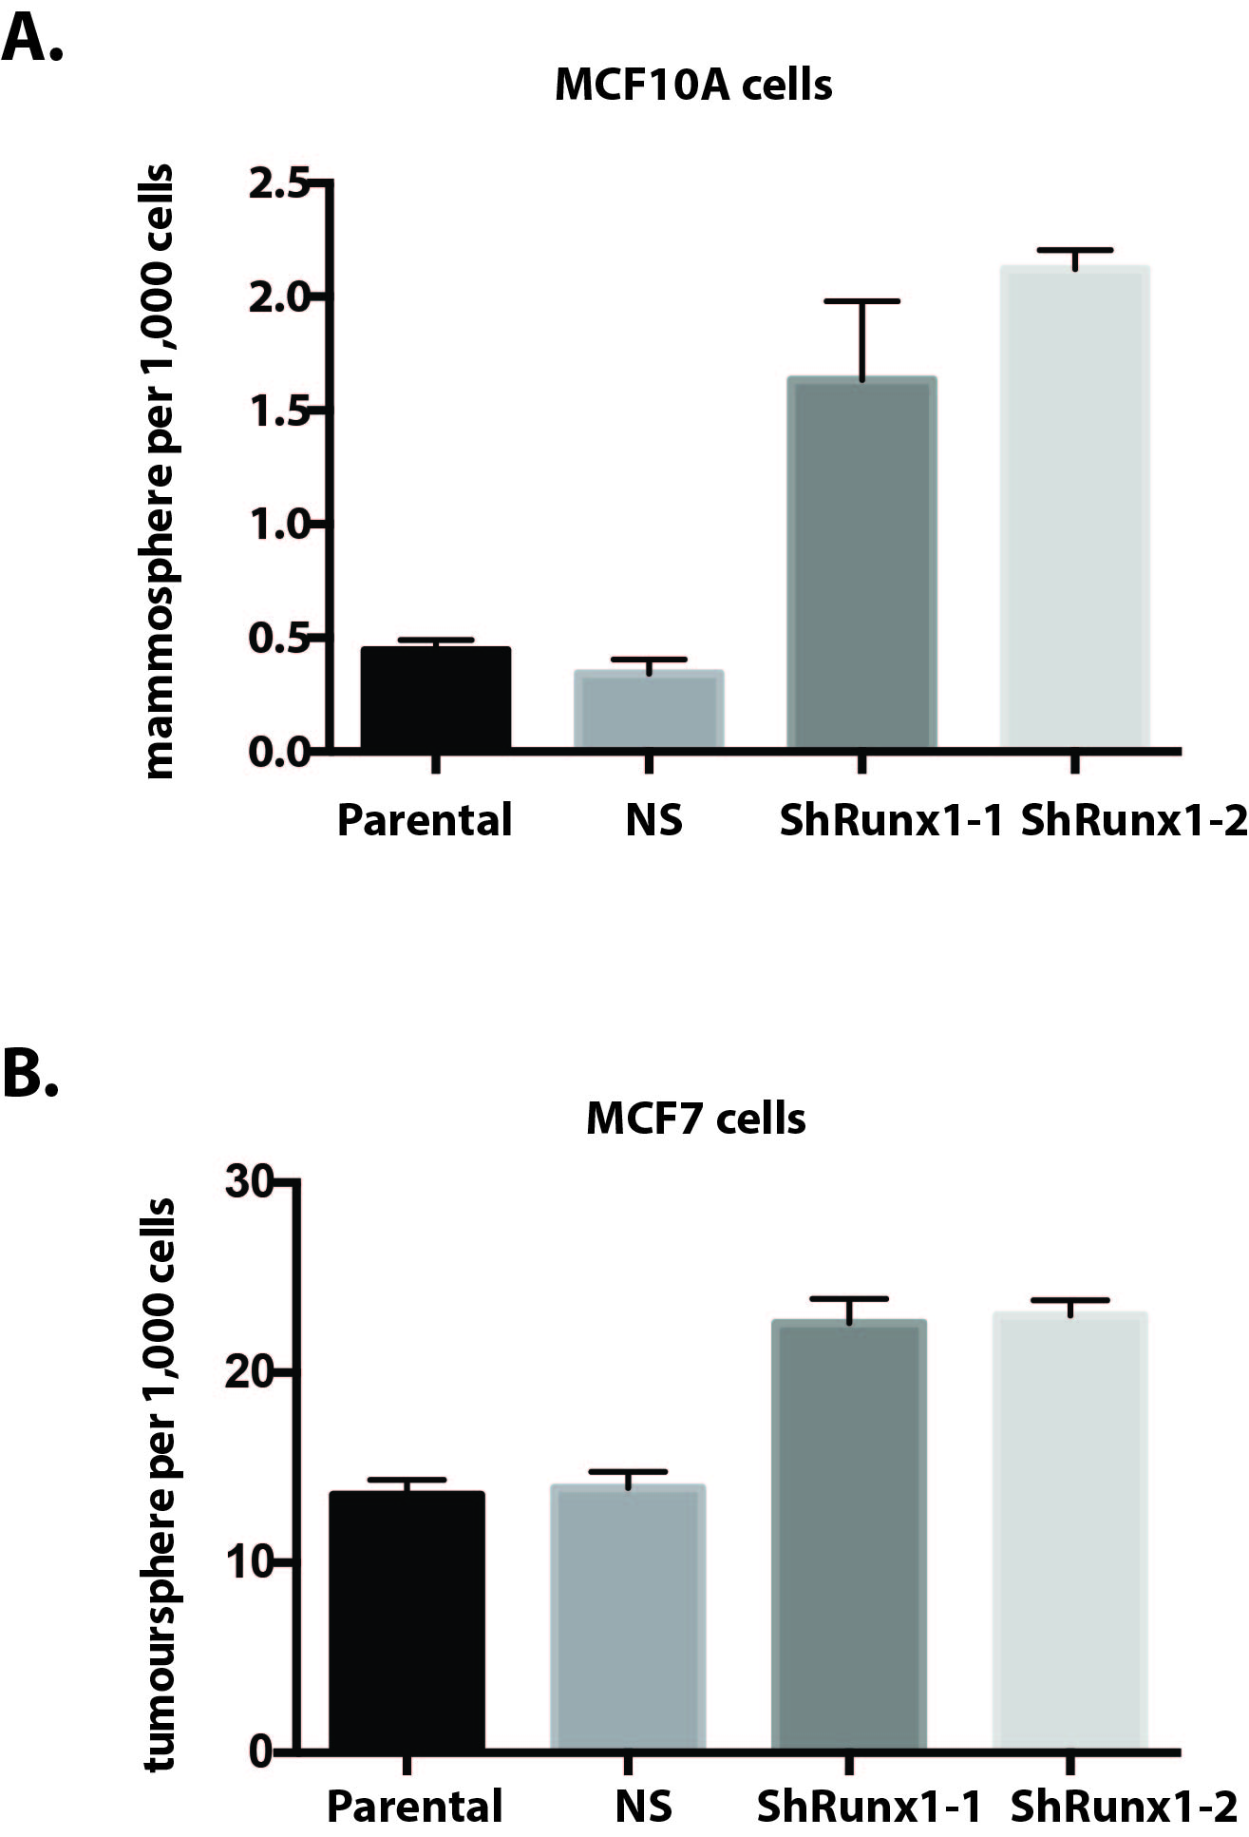
Supplementary Figure 6. Loss of RUNX1 promotes stemness in MCF10A and MCF7 cells. A. RUNX1 knockdown in MCF10A cells activates tumorsphere formation efficiency. B. RUNX1 knockdown in MCF107 cells activates tumorsphere formation efficiency.
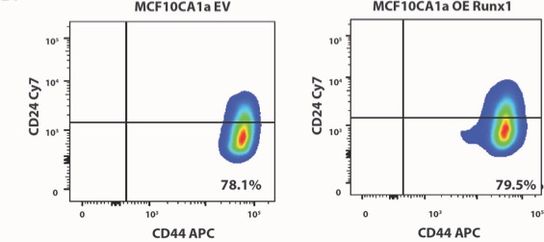
Supplementary Figure 7 Overexpression RUNX1 in MCF10CA1a cells does not change BCSC population. Flow cytometric analysis of CD44 and CD24 expression in MCF10AT cells stably expressing non-silencing (Left) or RUNX1 (Right) shRNA. All the experiments are performed 3 times (N=3).

Supplementary Figure 8. Zeb1 is expressed at low level in MCF10CA1a cells.
Zeb1 RNA expression by RT-qPCR of normal mammary-like MCF10A cells, MCF10A-derived tumorigenic cell line MCF10AT1, and metastatic MCF10CA1a cells shows Zeb1 is expressed at a low level in MCF10CA1a cells.

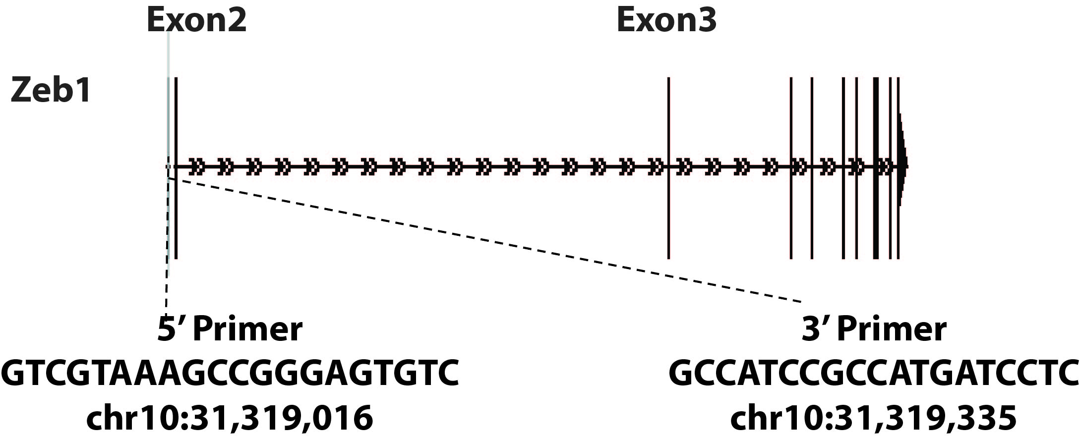
Supplementary Figure 9. Schematic diagram of ChIP qPCR primers and amplicons over Zeb1 for ChIP-qPCR.

Supplementary Figure 10. Knockdown Zeb1 in MCF10AT1 ns cells does not change cancer stem cell phenotypes. (A) Western blot analyses show Zeb1 knockdown by siRNA in MCF10AT1 ns cells. (E) Flow cytometric analysis of CD44 and CD24 expression in MCF10AT1 ns control and Zeb1 knockdown cells. (F) Zeb1 knockdown in MCF10AT1 control cells does not effect tumorsphere formation efficiency.

