Supplementary Figures:
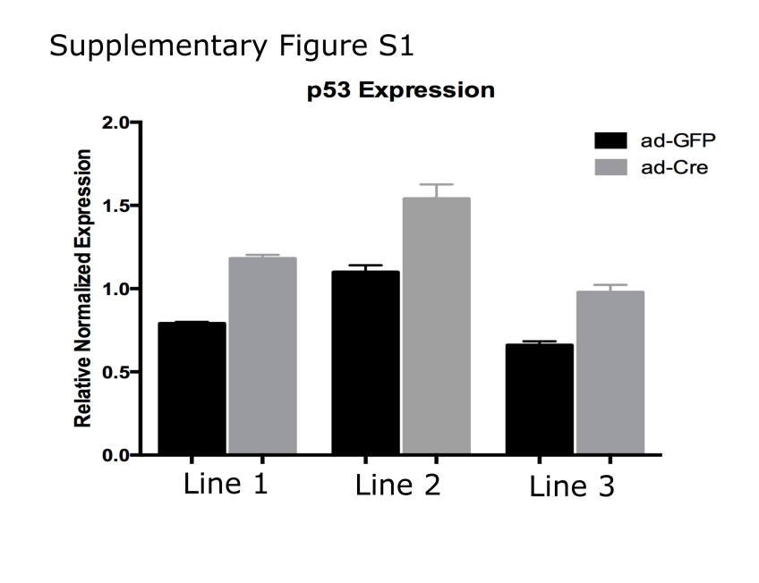
Pirozzi Supplementary Fig. S1
Supplementary Figure S1: p53 is upregulated in response to mutant IDH1 induction. q-RT-PCR of p53 in three independent mouse NSC lines of the genotype IDH1^{LSL:R132H/WT}. NSC lines were transduced with either ad-GFP (control) or ad-Cre to induce expression of the mutant IDH1 allele.

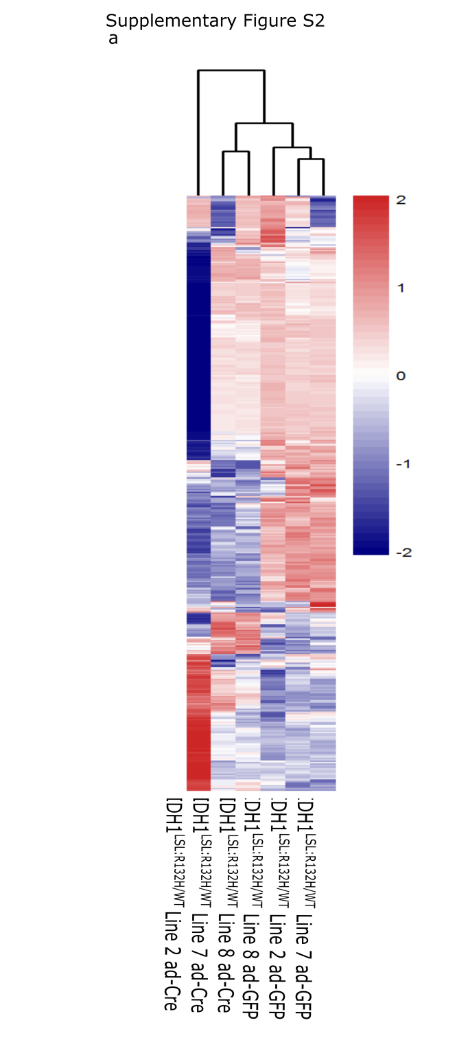
Pirozzi Supplementary Fig. S2
Supplementary Figure S2: Hierarchical clustering of top 1% variant genes. Three independent IDH1^{LSL:R132H/WT} NSC lines were transduced with either ad-GFP or ad-Cre. Hierarchical clustering was performed on the top 1% variant genes (n=414).

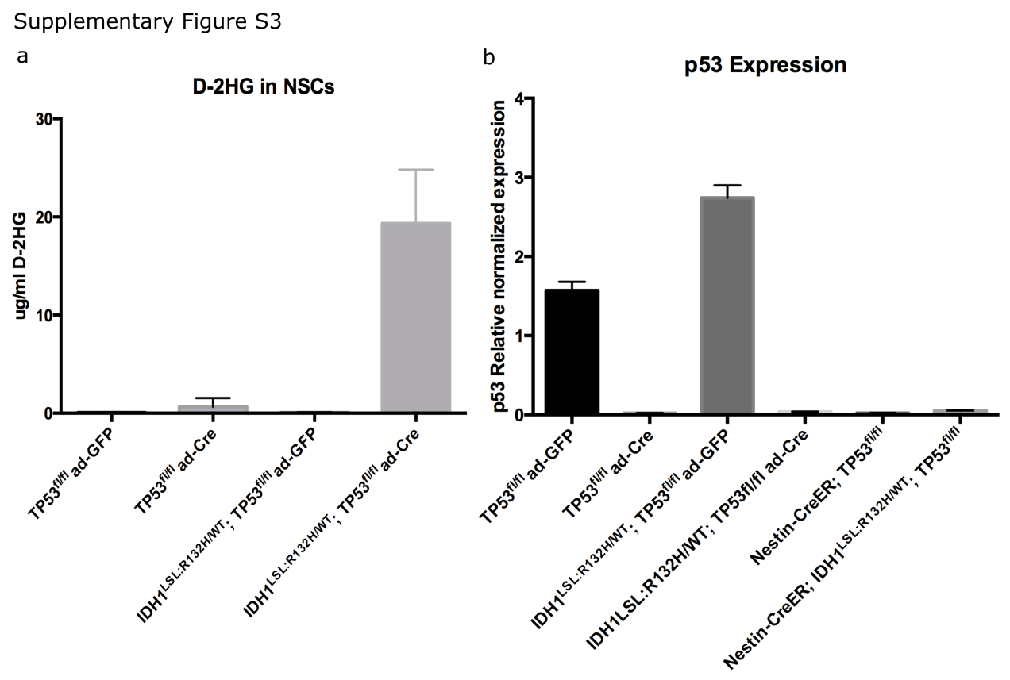
Pirozzi Supplementary Fig. S3
Supplementary Figure S3: Further characterization of NSC and brain tumor cell lines. (a) D-2HG detection of NSC lines of the genotype TP53^{fl/fl} and IDH1^{LSL:R132H/WT}; TP53^{fl/fl} transduced either with ad-GFP or ad-Cre. (b) q-RT-PCR of p53 in TP53^{fl/fl} and IDH1^{LSL:R132H/WT}; TP53^{fl/fl} NSC lines transduced with either ad-GFP or ad-Cre. Additionally, cell lines derived from brain tumors from Nestin-CreER^{T2}; TP53^{fl/fl} and Nestin-CreER^{T2}; IDH1^{LSL:R132H/WT}; TP53^{fl/fl} animals are deficient for p53 and suggests these cells are derived from the initial recombination following tamoxifen treatment.
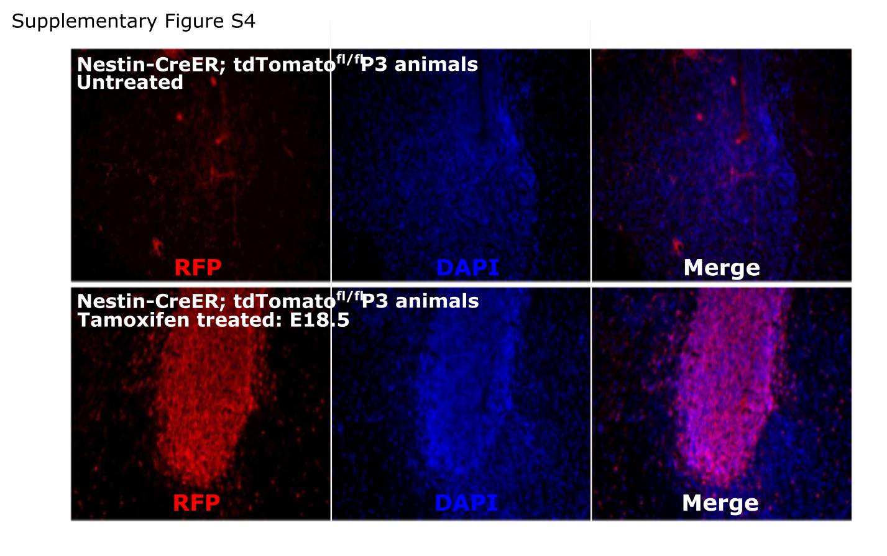
Pirozzi Supplementary Fig. S4
Supplementary Figure S4: E18.5 tamoxifen treatment of pregnant dams promotes robust recombination in embryos. Nestin-CreER^{T2}; tdTomato^{fl/fl} animals were mated and either were or were not treated with tamoxifen at E18.5. Neonates were sacrificed at P3 and the brains were harvested, sectioned, and stained with a Red Fluorescent Protein (RFP) antibody. Untreated animals are shown in the top row and treated animals are shown on the bottom row. Robust recombination can be seen in the SVZ of these animals. Additionally, sporadic RFP positive cells can be seen in untreated animals, suggesting Nestin-CreER^{T2} may be mildly leaky.

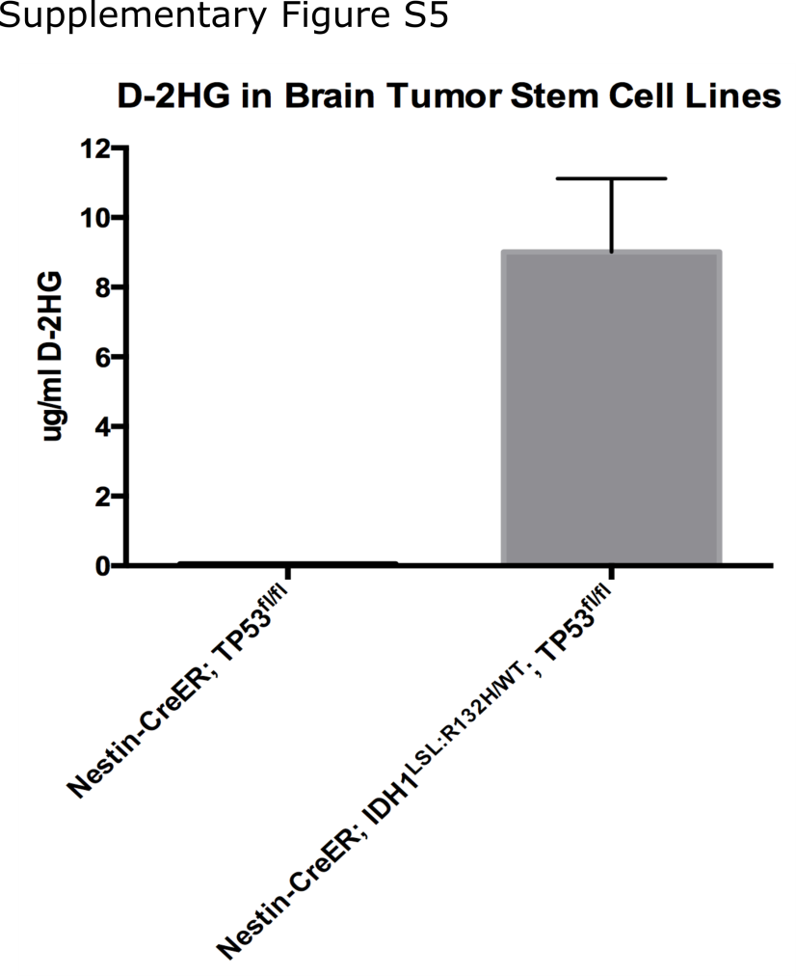
Pirozzi Supplementary Fig. S5

Supplementary Figure S5: D-2HG detection in brain tumor cell lines. D-2HG is expressed in cell lines derived from mutant IDH1-expressing brain tumors, but not in IDH1-wildtype brain tumors, suggesting these cells are derived from the original recombined cells following tamoxifen treatment.

