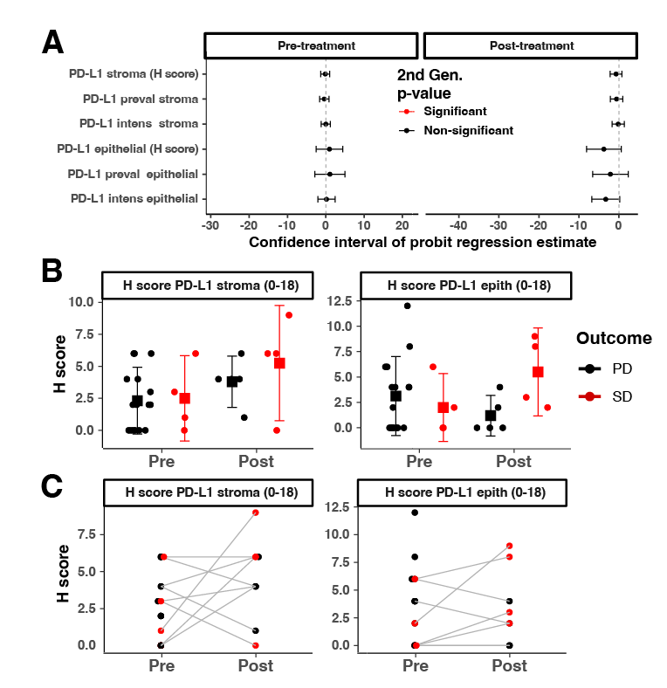
Supplementary Figure 8: PD-L1 levels in tumor or tumor microenvironment does not associate with tumor progression or control. A. Cumulative probit ordinal mixed-effects regressions with second generation p-values testing for association between tumor progression and PD-L1 levels in epithelial or stroma compartments. B. Histology scoring (H score) of epithelial or stromal P D-L1 levels in PD and SD tumors. Error bars represent means +/- Gini mean difference (a nonparametric measure of dispersion/spread). C. H scores comparing the change in epithelial or stromal PD-L1 levels in PD and SD tumors after combination therapy.

