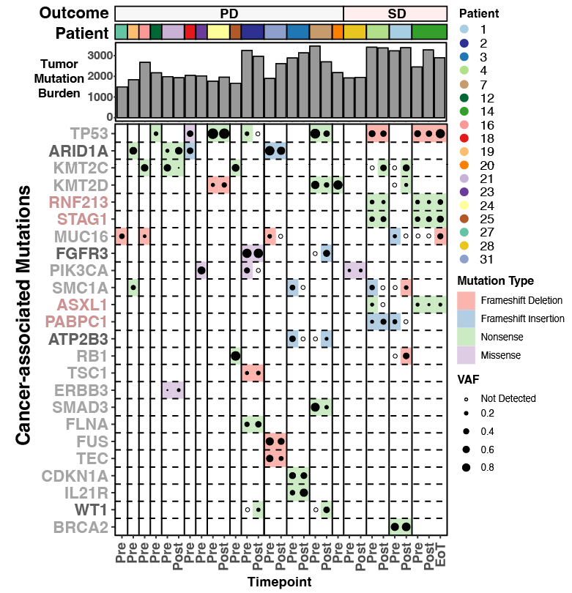
Supplementary Figure 5: Overall tumor mutation burden and frequency of mutations in cancer-associated genes in UC tumors.

