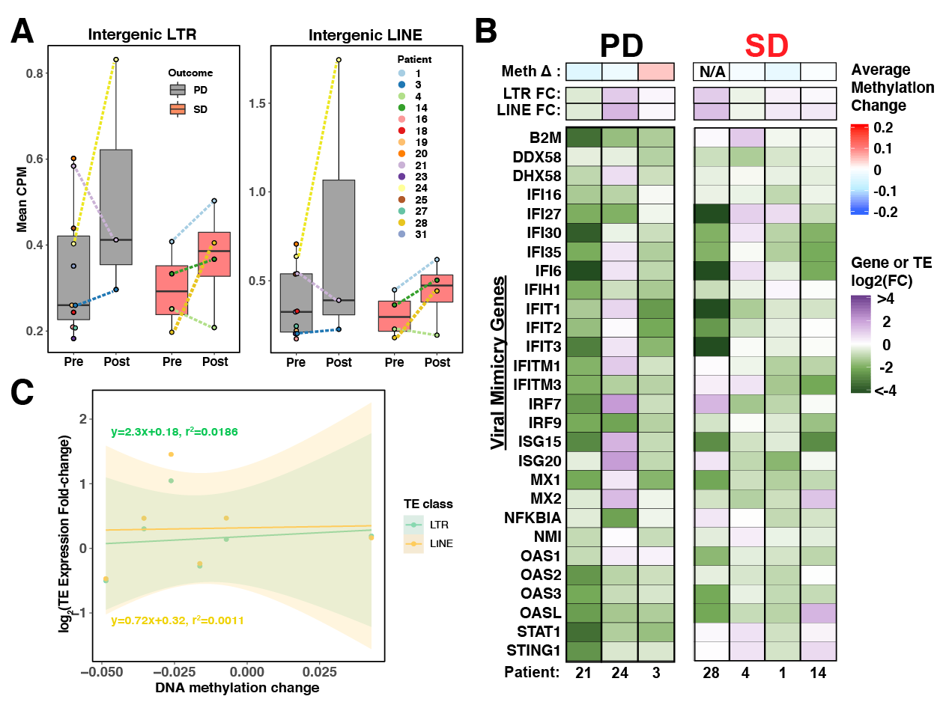
Supplementary Figure 4: Weak correlation of TE expression induction with DNA methylation change and viral mimicry activation. A. Boxplot illustrating the average TE expression (counts per million) in tumor samples. Dotted lines connect tumor pairs from same patient. B. Heatmaps representing the average DNA methylation change, intergenic LTR/LINE expression fold-change and viral mimicry gene expression fold-change comparing pre-treatment and post-treatment UC tumors from this study. C. Correlation between TE expression fold-change and DNA methylation change induced by combination therapy.

