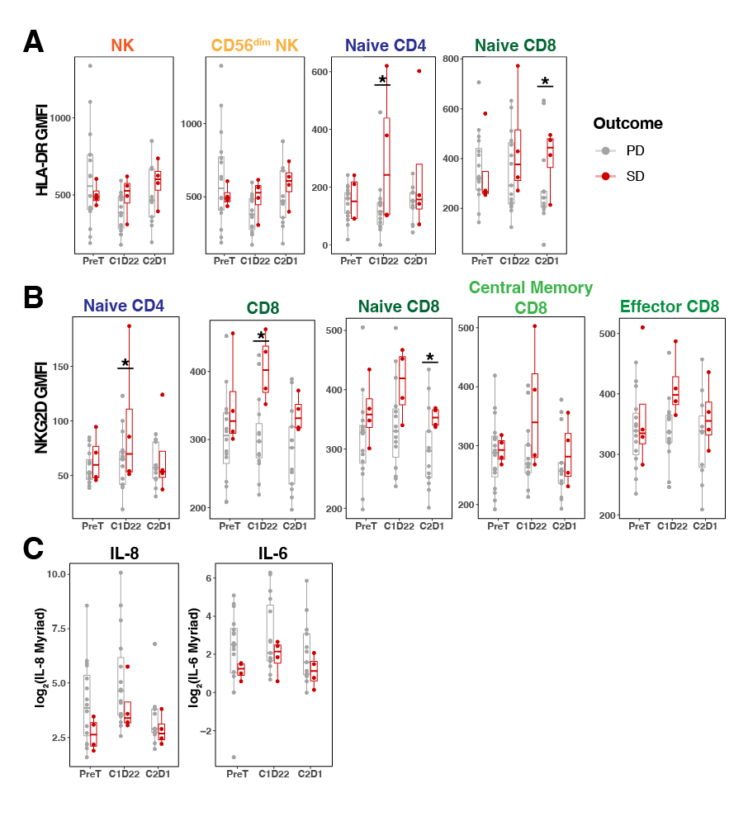
Supplementary Figure 12: HLA-DR and NKG2D abundance on peripheral lymphocytes associate with longer progression free survival. A-B, Geometric mean fluorescence intensity (GMFI) comparison of HLA-DR (A) or NKG2D (B) on particular immune subtypes from SD or PD patient blood across various treatment timepoints. C. Expression distribution of IL-8 and IL-6 cytokines detected in patient plasma by Myriad RBM platform. Statistical significance tested with cumulative probit mixed-effects ordinal regressions and SGPVs were used to determine if there was significant evidence of a difference where the null interval was set at +/- 5% difference in regression estimates. *SGPV = 0; there were no SGPVs = 1.

