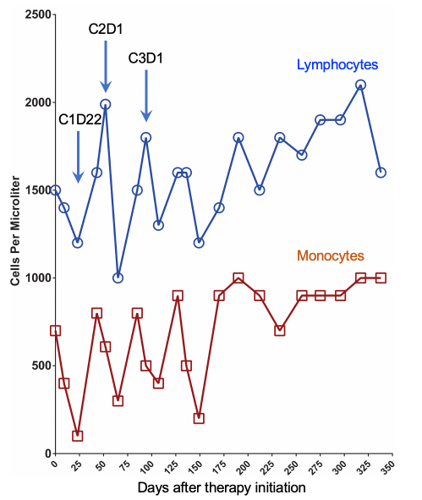
Supplementary Figure 10: Peripheral immune cell dynamics induced by combination therapy

