Supplementary Figure 9. Drug combination studies in MCF7, T47D and T47D-FPR cells.
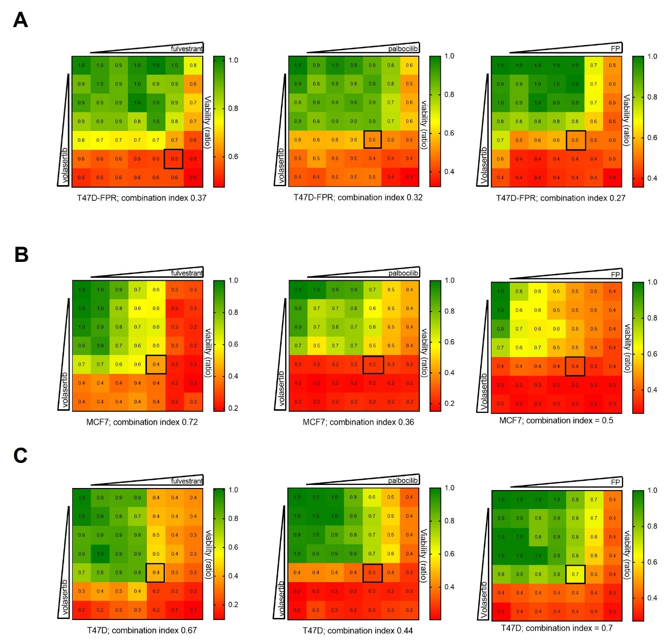

Viability assay to assess pharmacological synergy between fulvestrant, palbociclib alone or in combination and volasertib. T47D-FPR (A), MCF7 (B), T47D (C) were treated with increasing doses of each drug alone or in combination (up to 100nM fulvestrant and 300nM palbociclib for parental cells, and up to 1000nM fulvestrant, 1000nM palbociclib and/or 100nM volasertib for T47D-FPR) every 72 hours for 1 week. Cell were stained with crystal violet; staining intensities were quantified, and combination indices were determined using the Chou-Talalay test by CompuSyn software. Numbers inside each box indicate the ratio of viable treated cells to untreated cells, from two independent experiments.

