Supplementary Figure 7. Generation and characterization of ER+ breast cancer cell lines resistant to palbociclib alone or in combination with fulvestrant.
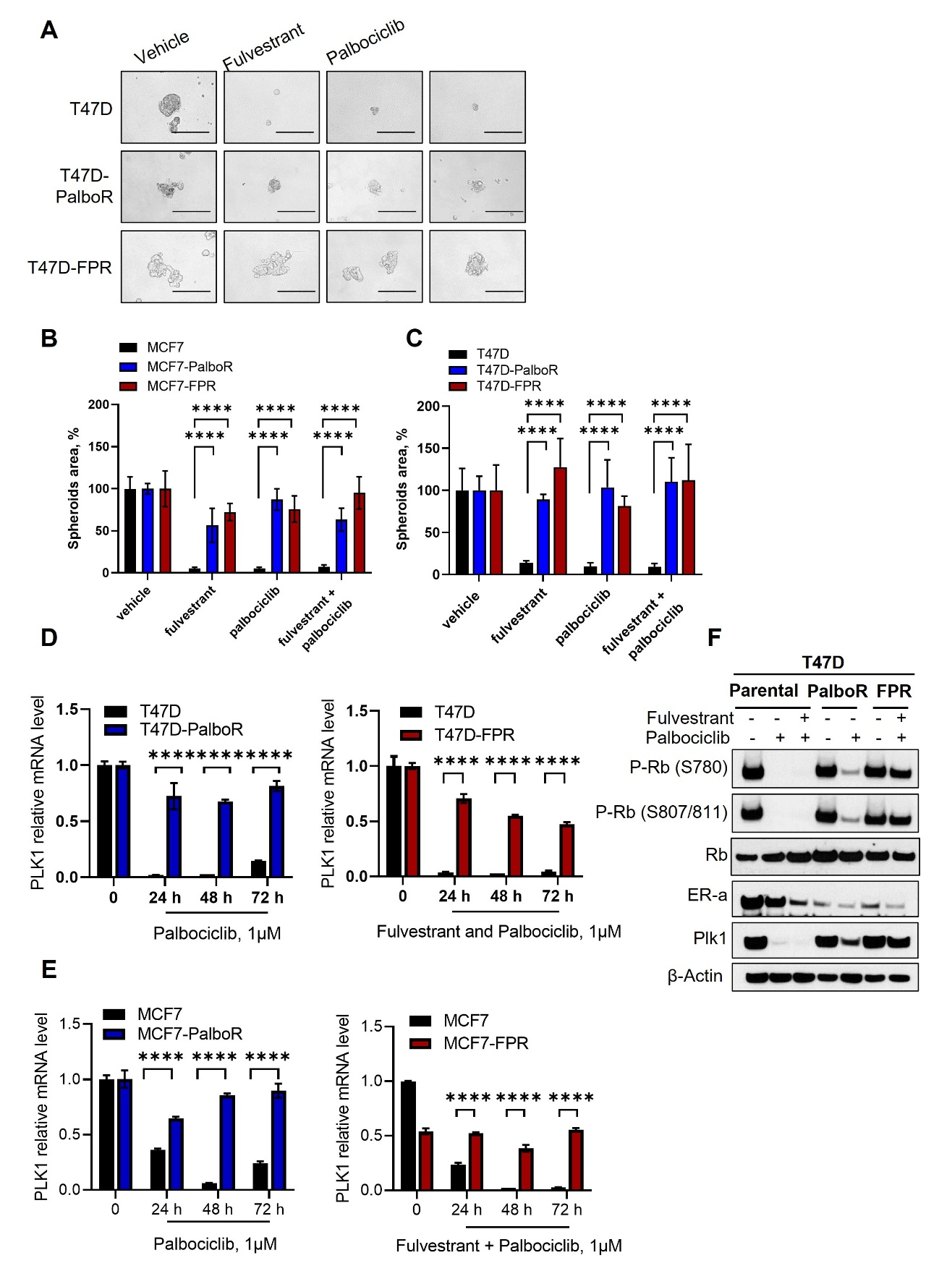

A) Representative images of breast tumor spheroids from T47D, -PalboR (palbociclib resistant) or -FPR (fulvestrant - palbociclib resistant) treated with the indicated drugs at 250nM final concentration, every 72 hours for 10 days. Spheroids area was calculated by ImageJ software for both MCF7 cells (B) and T47D (C). Values were expressed as percentage relative to vehicle-treated controls. Data are expressed as mean ± standard deviation of the representative experiment, indicated by error bars, performed in quadruplicate (****p<0.0001, 2way ANOVA Bonferroni’s multiple comparisons). D) Relative quantification (qPCR) of PLK1 mRNA T47D parental or resistant cells treated with 1µM palbociclib alone (left) or in combination with fulvestrant (right) at 1µM final concentration for the indicated times. Data are expressed as mean ± standard deviation of two separate experiments conducted in triplicate (****p<0.0001, 2way ANOVA Bonferroni’s multiple comparisons). E) Relative quantification (qPCR) of PLK1 mRNA in MCF7 parental or resistant cells treated with 1µM palbociclib alone (upper panel) or in combination with fulvestrant at 1µM final concentration (bottom panel) for the indicated times (Data are expressed as mean ± standard deviation of two separate experiments conducted in triplicate, ****p<0.0001, 2way ANOVA Bonferroni’s multiple comparisons). F) Western blot analysis for p-Rb (Ser780), p-Rb (Ser807/811), Rb, ER-α, Plk1 of whole cell lysates from T47D parental or resistant cells treated with vehicle, palbociclib alone or in combination with fulvestrant at 1µM final concentration for 72 hours. β-actin was used as a loading control. Images are representatives from three independent experiments.

