Supplementary Figure 6. PALOMA-3 study as validation dataset.
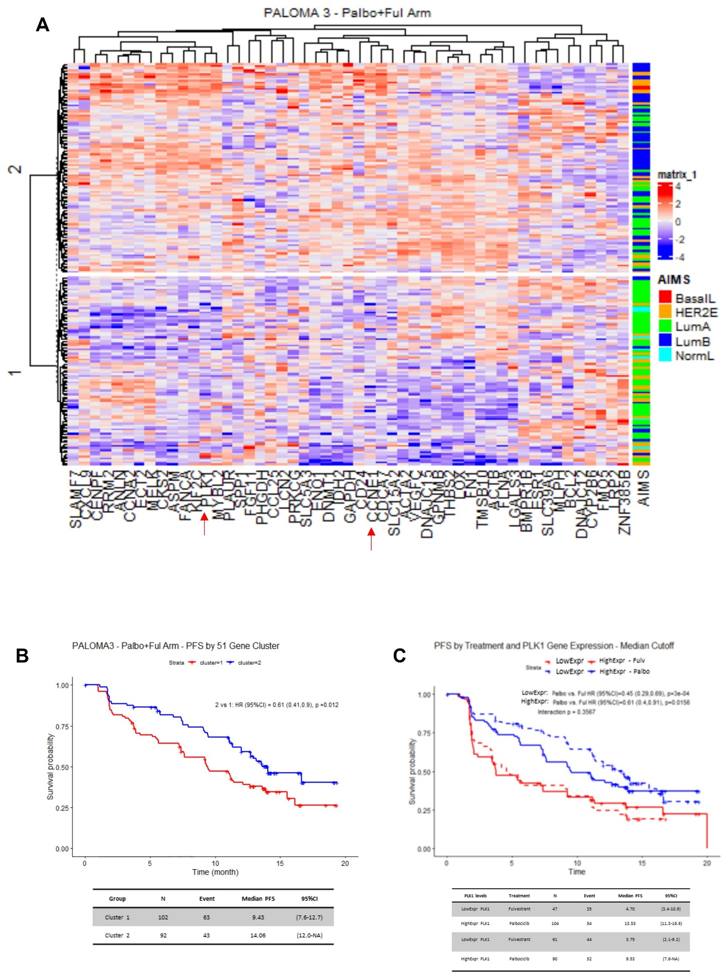

A) Unsupervised hierarchical clustering complete linkage and euclidean distance of n=194 patients, treated with palbociclib plus ET according to 51 differentially expressed significant genes by SAM analysis (FDR<0.05), in refractory vs sensitive tumors (each row represents a patient, and each column a gene). It includes the clinical subtype classification of patients in Luminal A, Luminal B, Basal, HER2 enriched and Normal. B) Progression Free Survival analysis (PFS) analysis on cluster 1 and 2. C) PFS on PLK1 expression levels.
In PFS curves, Kaplan-Meier plots are used to represent the survival curves, while Cox models, adjusted by prognosis variables, are used to represent the values.
LowExpr PLK1 (below median value); HighExpr PLK1 (above median value).

