Supplementary Figure 5. Analysis of gene expression associated with treatment benefit.
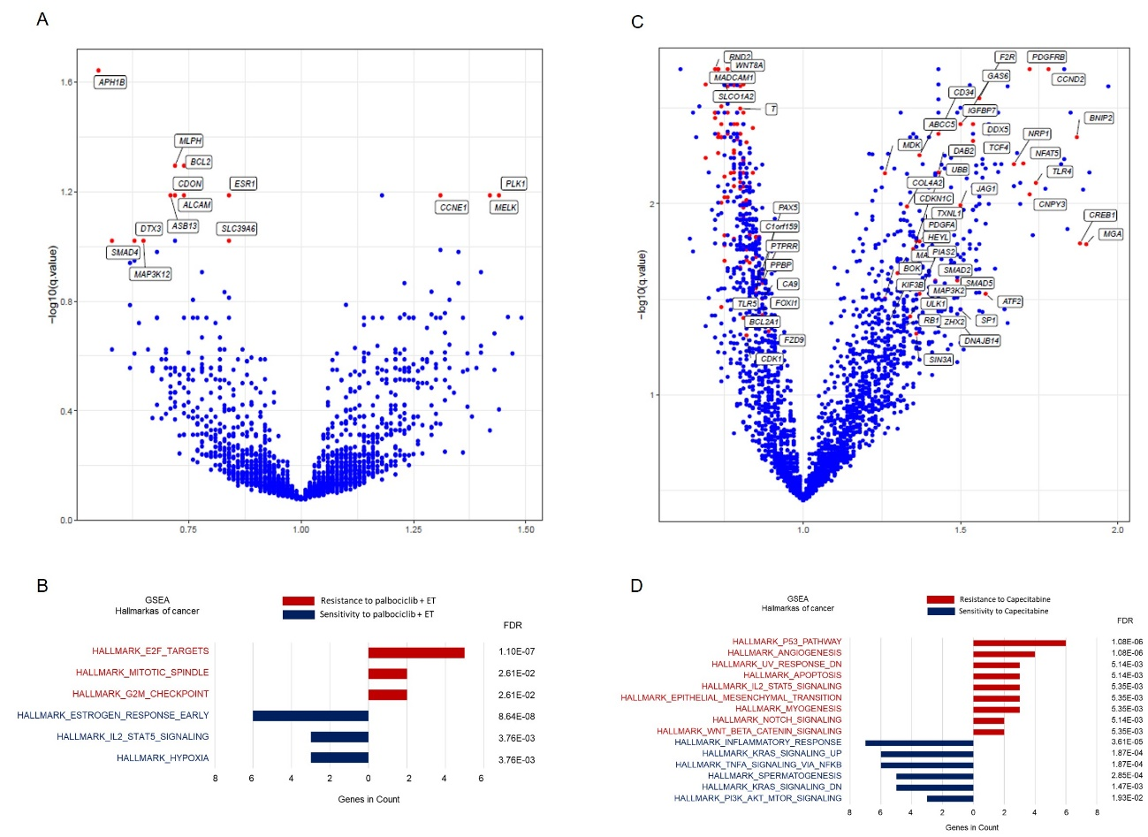

A) Volcano plot showing genes whose expression is associated with either resistance or sensitivity to palbociclib plus ET. The Hazard ratio (HR) is represented in the x-axis, with a HR>1 indicating resistance and a HR<1 sensitivity. The Y-axis shows the adjusted –log10(q-value) of the association and highlighted red points indicate 11 genes with an FDR<0.1 in the cross-arm treatment interaction test. B) Gene set enrichment analysis using MsigDB Hallmarks of Cancer of the 11 genes associated with response to palbociclib plus ET.
C) Volcano plot showing genes whose expression is associated with either resistance or sensitivity to capecitabine. The Hazard ratio (HR) is represented in the x-axis, with a HR>1 indicating resistance and a HR<1 sensitivity. The Y-axis shows the adjusted –log10 (q-value) of the association and highlighted red points indicate some of the 139 genes with an FDR<0.1 in the cross-arm treatment interaction test. D) Gene set enrichment analysis using MsigDB Hallmarks of Cancer of the 139 genes associated with response to capecitabine

