Supplementary Figure 3. Progression Free Survival analysis on intrinsic subtypes.
Stratified by treatment arms (capecitabine vs palbociclib plus ET) and by source of tumor tissue (primary vs metastatic).
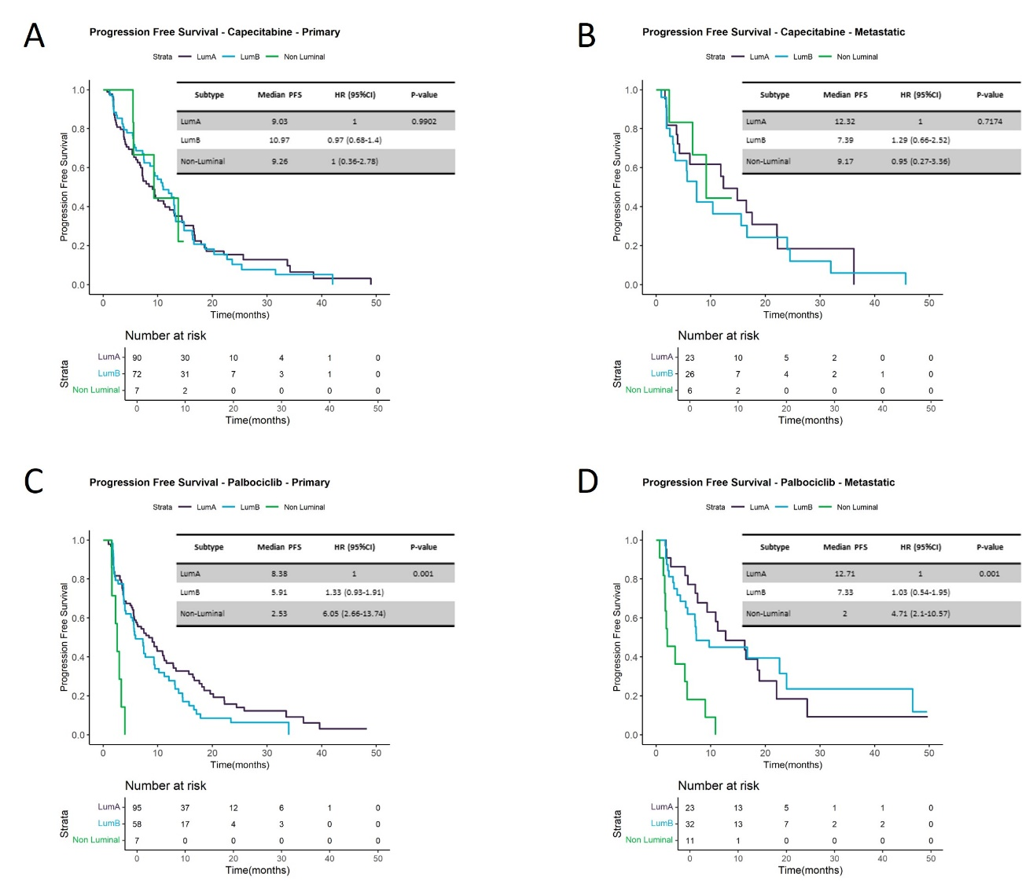

Capecitabine treatment arm, in A) primary tumor tissue, or B) metastatic tumor tissue.
Palbociclib plus ET treatment arm in, C) primary tumor tissue, or D) metastatic tumor tissue.
In PFS curves, Kaplan-Meier plots are used to represent the survival curves, while Cox models, adjusted by prognosis variables, are used to represent the values.

