Supplementary Figure 2. Patients’ characteristics and Progression Free Survival comparison. Biomarker Cohort and PEARL Study Population.
Patient characteristics and treatment outcome in the whole PEARL study population compared against the biomarker cohort.
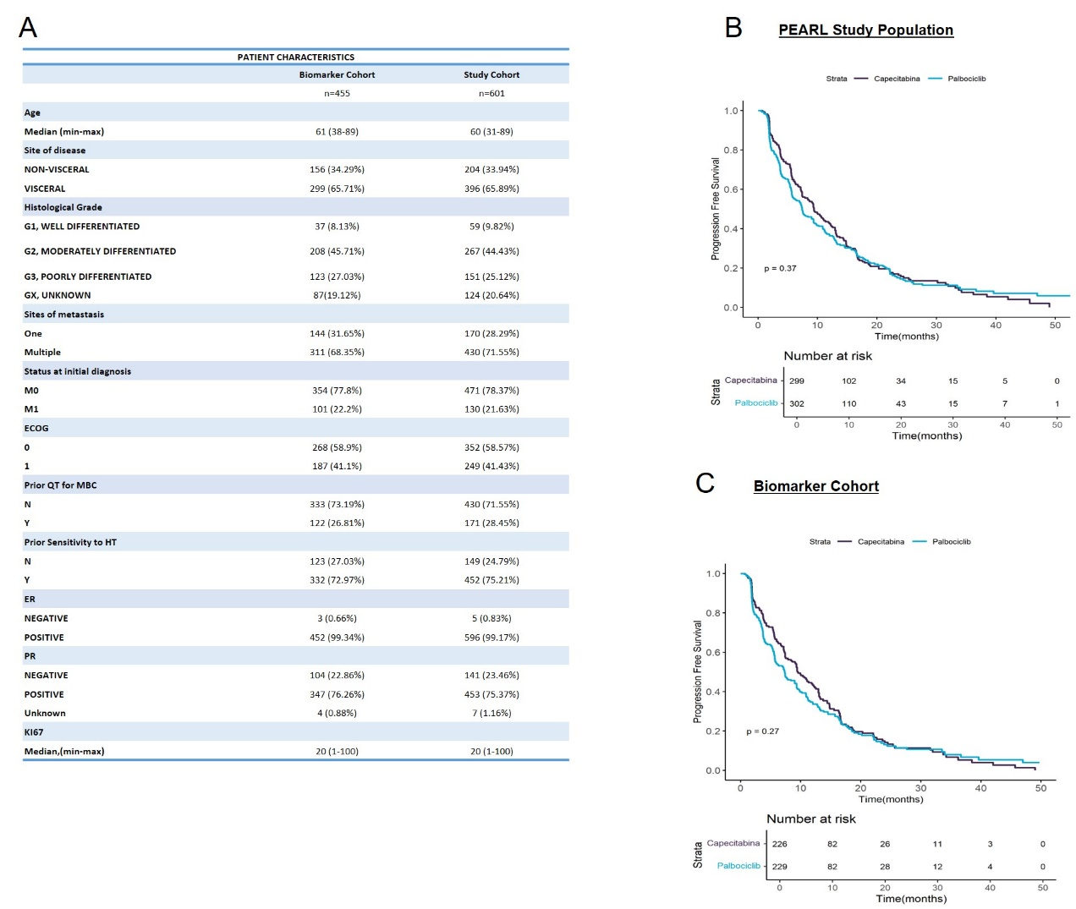

A) Clinicopathologic characteristics in the whole PEARL study population and the biomarker cohort. PFS in the (B) whole PEARL study cohort and the (C) biomarker cohort. In PFS curves, Kaplan-Meier plots are used to represent the survival curves, while Cox models, adjusted by prognosis variables, are used to represent the values.

