Supplementary Figure 10. Evaluation of volasertib effects on tumor spheroid growth and on the activation of signal transduction pathways in PalboR and FPR cells.
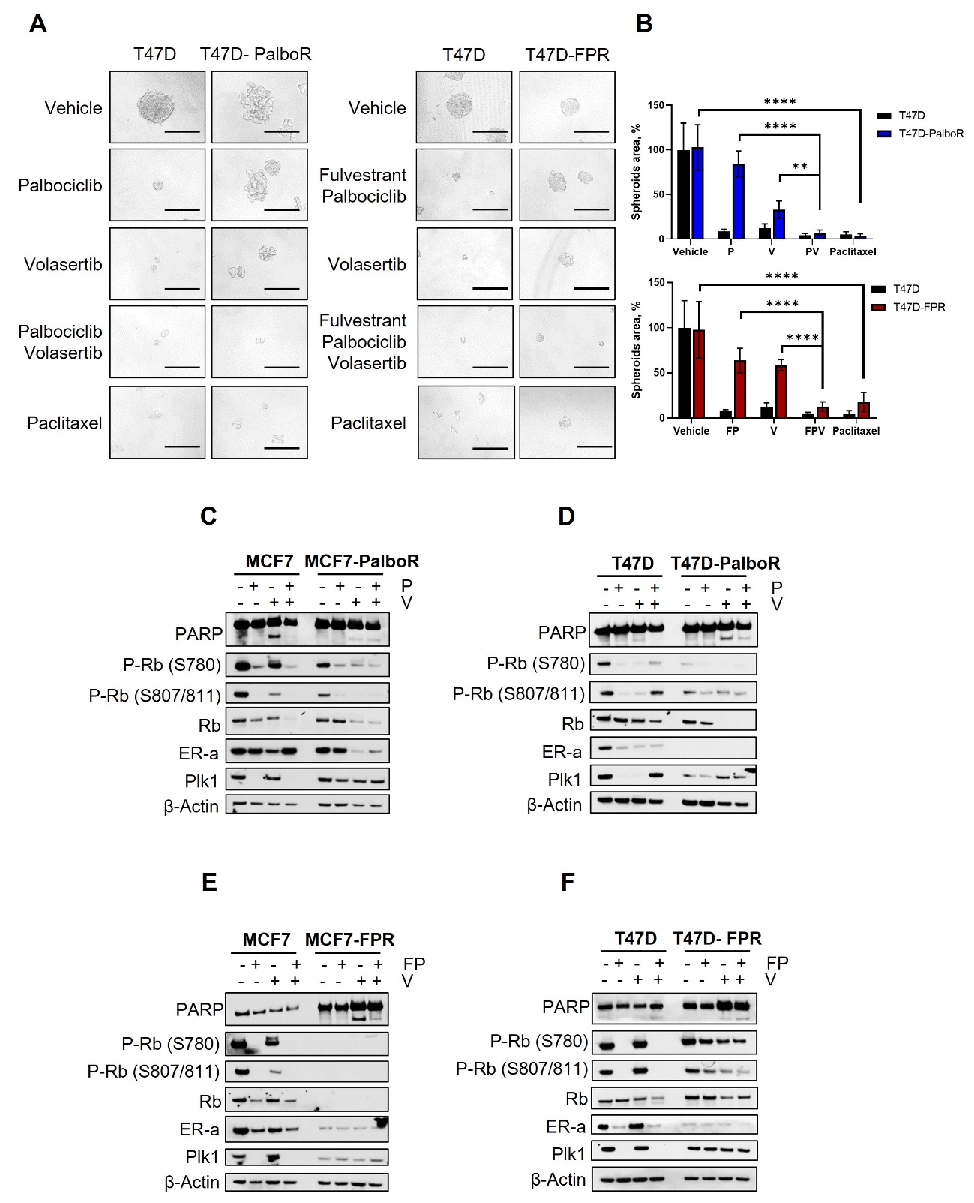

A) Representative images of breast tumor spheroids from T47D, T47D-PalboR or -FPR treated with vehicle (DMSO), 500 nM fulvestrant (F), 500 nM palbociclib (P), 10 nM volasertib (V), alone or combined, 10nM paclitaxel for 6 days, every 72 hours. All images were capture at 20X magnification (Bars = 200 µm). B) Spheroids area was calculated by ImageJ software. Values were expressed as percentage relative to vehicle-treated controls. Data are expressed as mean ± SD of three separate experiments, indicated by error bars, performed in quadruplicate. Differences between data sets were determined by 2way ANOVA Bonferroni’s multiple comparisons (**p<0.01; ****p<0.0001).
MCF7 or MCF7-PalboR (C) or T47D or T47D-PalboR (D) were treated with 1µM palbociclib or 0.1µM volasertib, alone or in combination, for 72 hours as indicated in the figure. Whole lysates were collected and subjected to immunoblot analysis for the indicated antibodies. Western blot analysis of whole cell lysates from MCF7 or MCF7-FPR (E) or T47D or T47D-FPR (F) treated with 1µM palbociclib + 1 µM fulvestrant ± 0.1µM volasertib for 72 hours as indicated in the figure. For panels C, D, E, F: β-actin was used as a loading control. Images are representatives from three independent experiments.

