Supplementary Figure S2. The effect of covariates, body weight, baseline albumin level, and combination therapy, on tremelimumab exposure metric C_{min1} (PK analysis population)
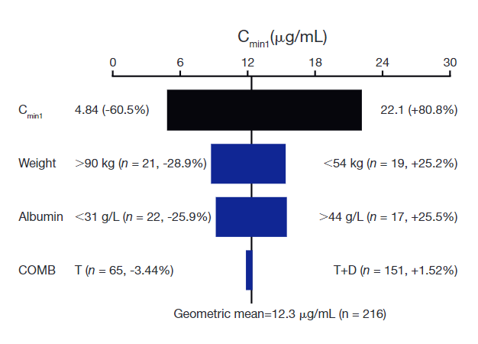
The black vertical line refers to the geometric mean of the predicted exposure (C_{min1}) of tremelimumab across the entire population which serves as the reference value. All percentage values shown in each plot are the relative changes in exposure compared with the reference value. The black shaded bar with values at each end shows the 2.5th to 97.5th percentile exposure range across the entire population. Each blue shaded bar represents the magnitude of influence of the respective covariate on the exposure. The length of each bar represents the magnitude of change in predicted exposure caused by changing the covariate from its reference to the low or high values, or other possible values (indicated on the two sides of the bars). The covariates shown in each plot are ordered from the most influential covariate at the top to the least influential covariate at the bottom.
C_{min1}, minimum tremelimumab concentration at day 28; COMB, combination therapy (pooled STRIDE and T75+D); PK, pharmacokinetics; STRIDE, Single Tremelimumab Regular Interval Durvalumab (single dose of tremelimumab 300 mg with durvalumab 1500 mg, followed by durvalumab 1500 mg Q4W); T, tremelimumab monotherapy; T+D, pooled STRIDE and T75+D; T75+D, tremelimumab 75 mg plus durvalumab 1500 mg Q4W for a total of 4 doses, followed by durvalumab monotherapy Q4W.

