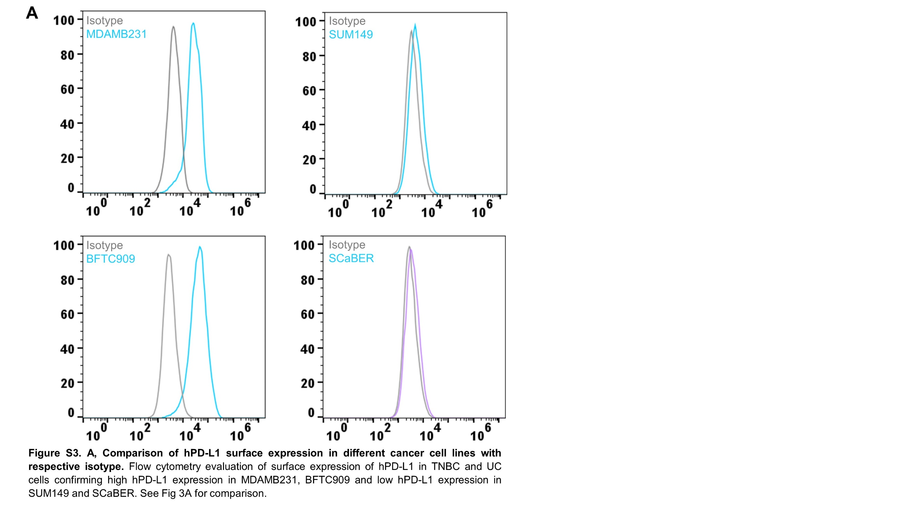

**Figure S3. A,** **Comparison of hPD-L1 surface expression in different cancer cell lines with respective isotype.** Flow cytometry evaluation of surface expression of PD-L1 in human TNBC and UC cells confirming high PD-L1 expression in MDAMB231, BFTC909 and low expression in SUM149 and SCaBER.

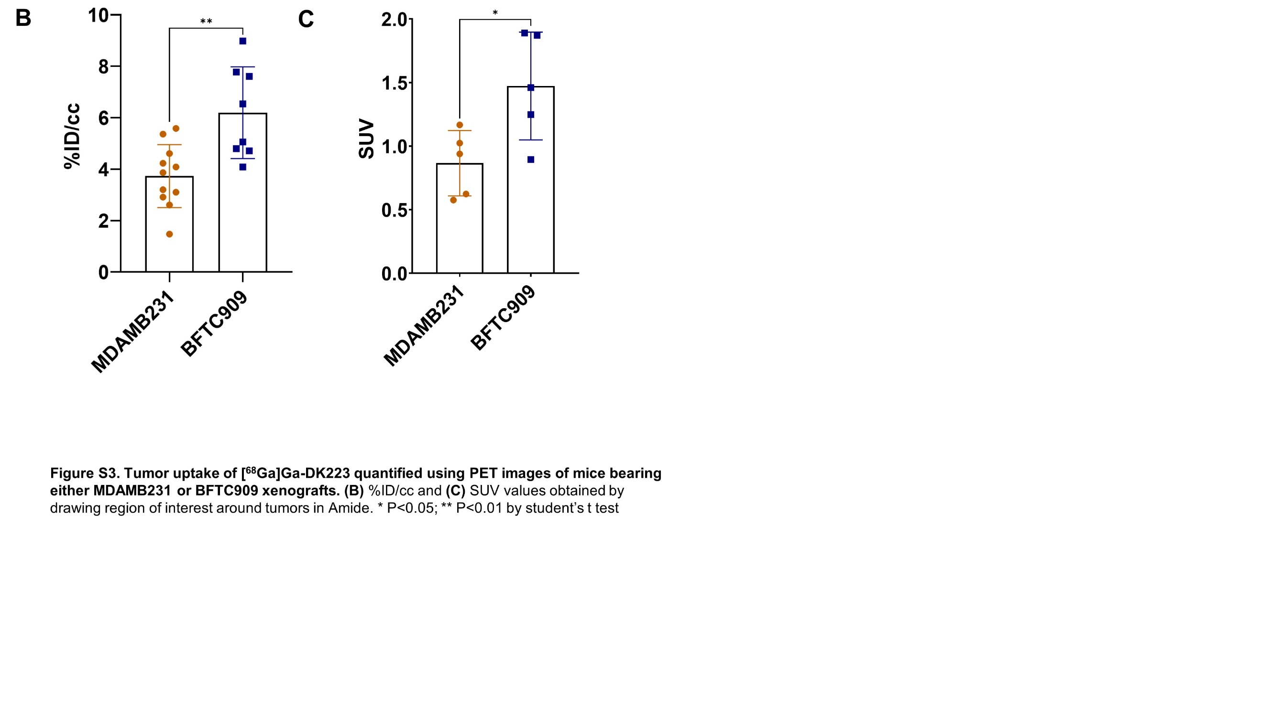

**Figure S3. Tumor uptake of [68Ga]Ga-DK223 quantified using PET images of mice bearing either MDAMB231 or BFTC909 xenografts. (B)** %ID/cc and **(C)** SUV values obtained by drawing region of interest around tumors in Amide. * P<0.05; ** P<0.01 by student’s t test

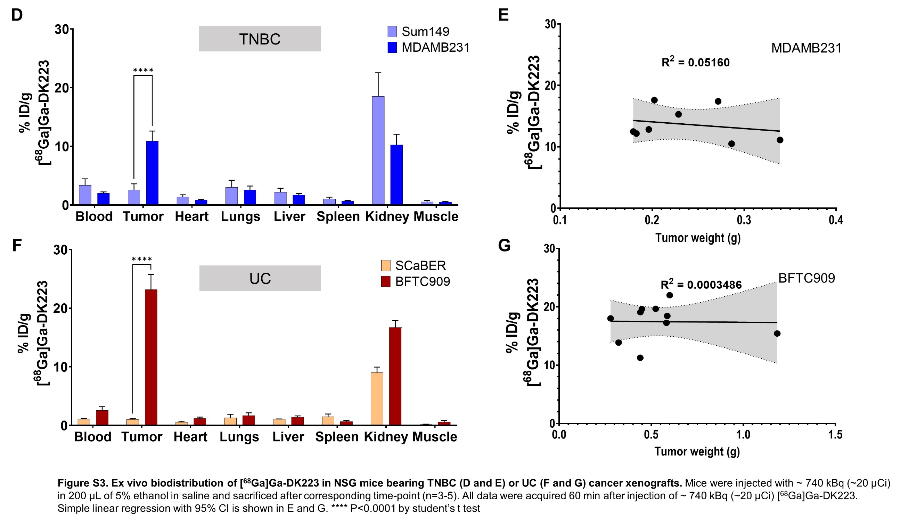

**Figure S3. Ex vivo biodistribution of [68Ga]Ga-DK223 in NSG mice bearing TNBC or UC xenografts.** TNBC in **D and E** and UC in **F and G.** Mice were injected with ~740 kBq (~20 µCi) in 200 µL of 5% ethanol in saline and sacrificed after corresponding time-point (n=3-5). All data were acquired 60 min after injection of ~740 kBq (~20 µCi) [68Ga]Ga-DK223. Simple linear regression with 95% CI is shown in E and G. **** P<0.0001 by student’s t test

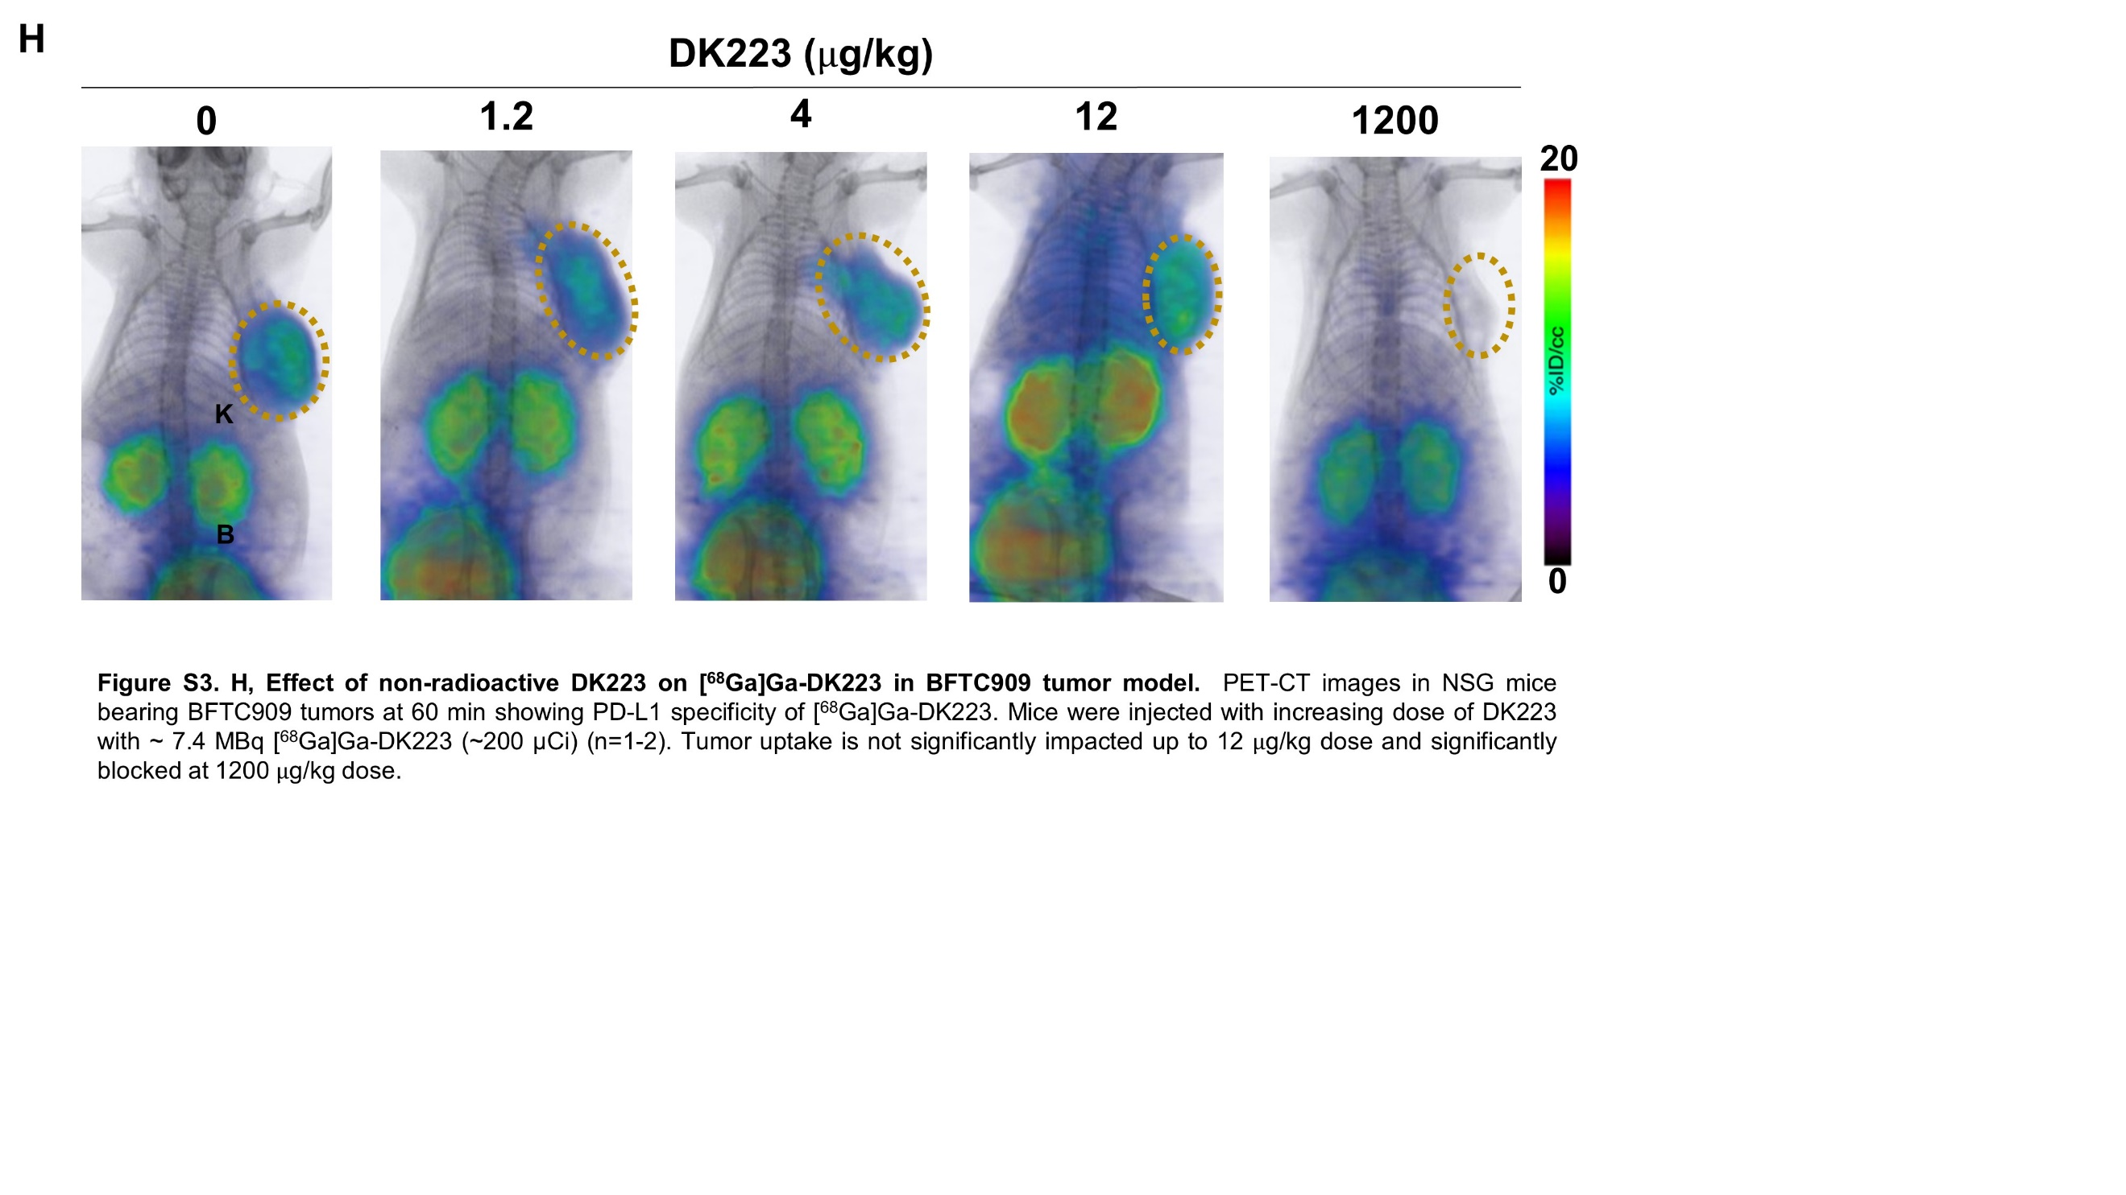

**Figure S3. H,** **Effect of non-radioactive DK223 on [68Ga]Ga-DK223 uptake in BFTC909 tumor model.** PET-CT images in NSG mice bearing BFTC909 tumors at 60 min. Mice were injected with increasing dose of DK223 with ~7.4 MBq [68Ga]Ga-DK223 (~200 µCi) (n=1-2). Co-injection of 12 ug/kg of DK223 had minimal effect on tumor uptake, whereas, 1200 g/kg dose significantly blocked.