**Supplementary Figures**

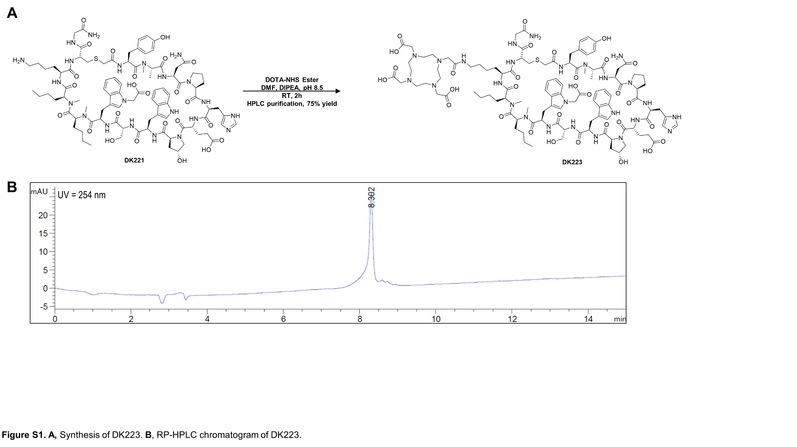

**Figure S1. A,** Synthesis of DK223. **B**, RP-HPLC chromatogram of DK223.

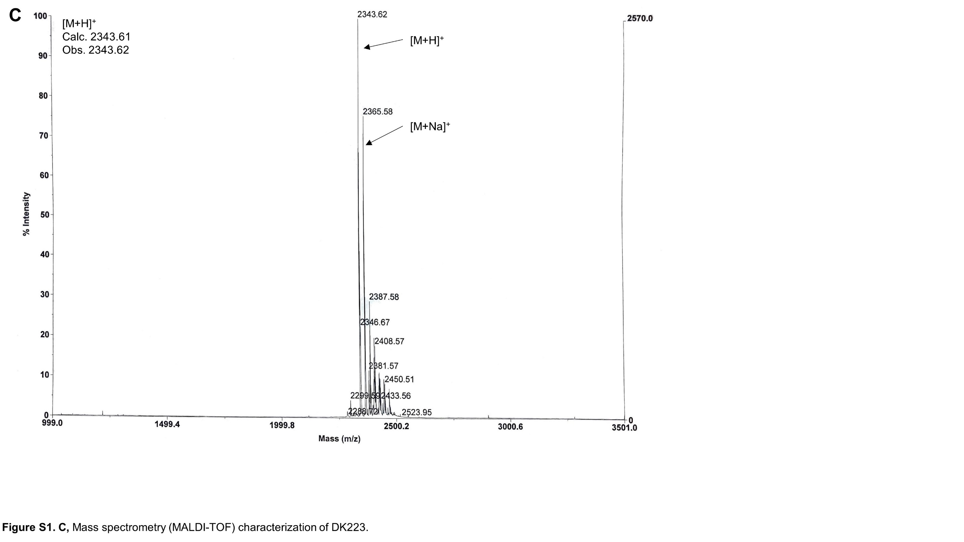

**Figure S1. C,** Mass spectrometry (MALDI-TOF) characterization of DK223.

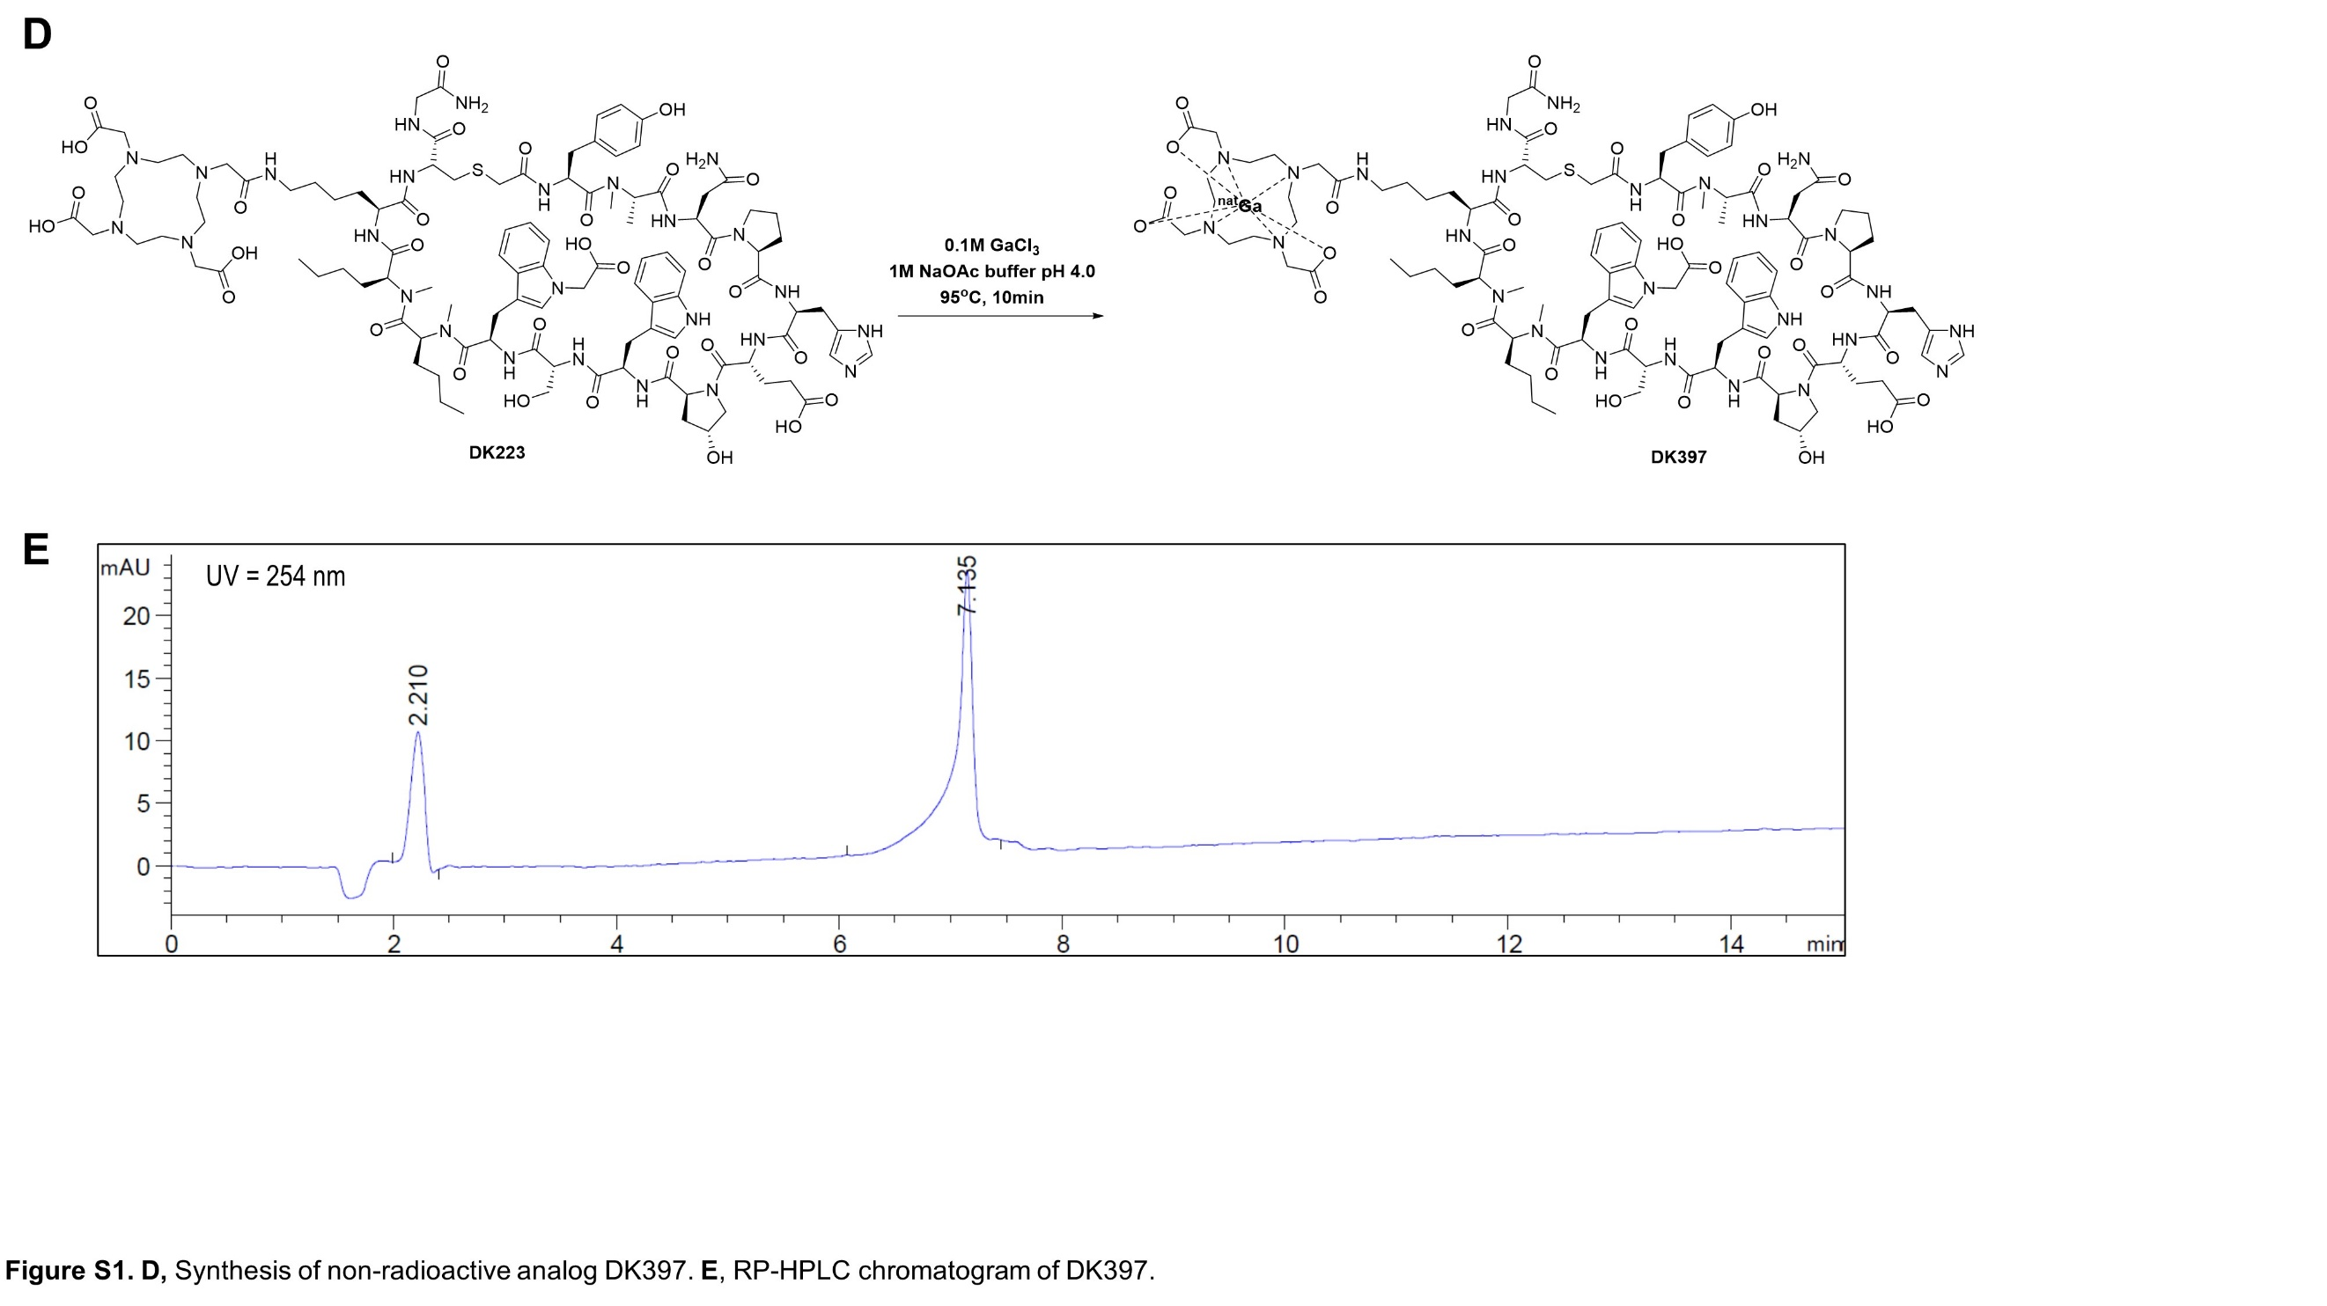

**Figure S1. D,** Synthesis of non-radioactive analog DK397. **E**, RP-HPLC chromatogram of DK397.

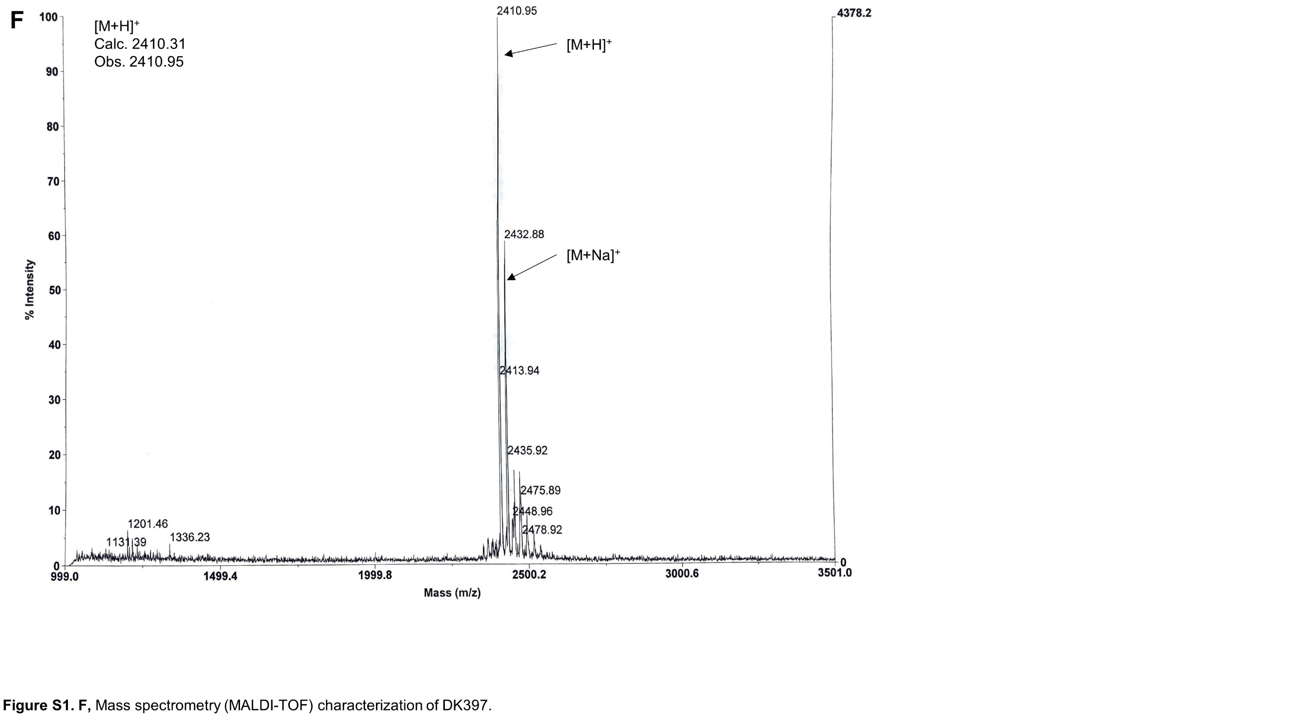

**Figure S1. F,** Mass spectrometry (MALDI-TOF) characterization of DK397.

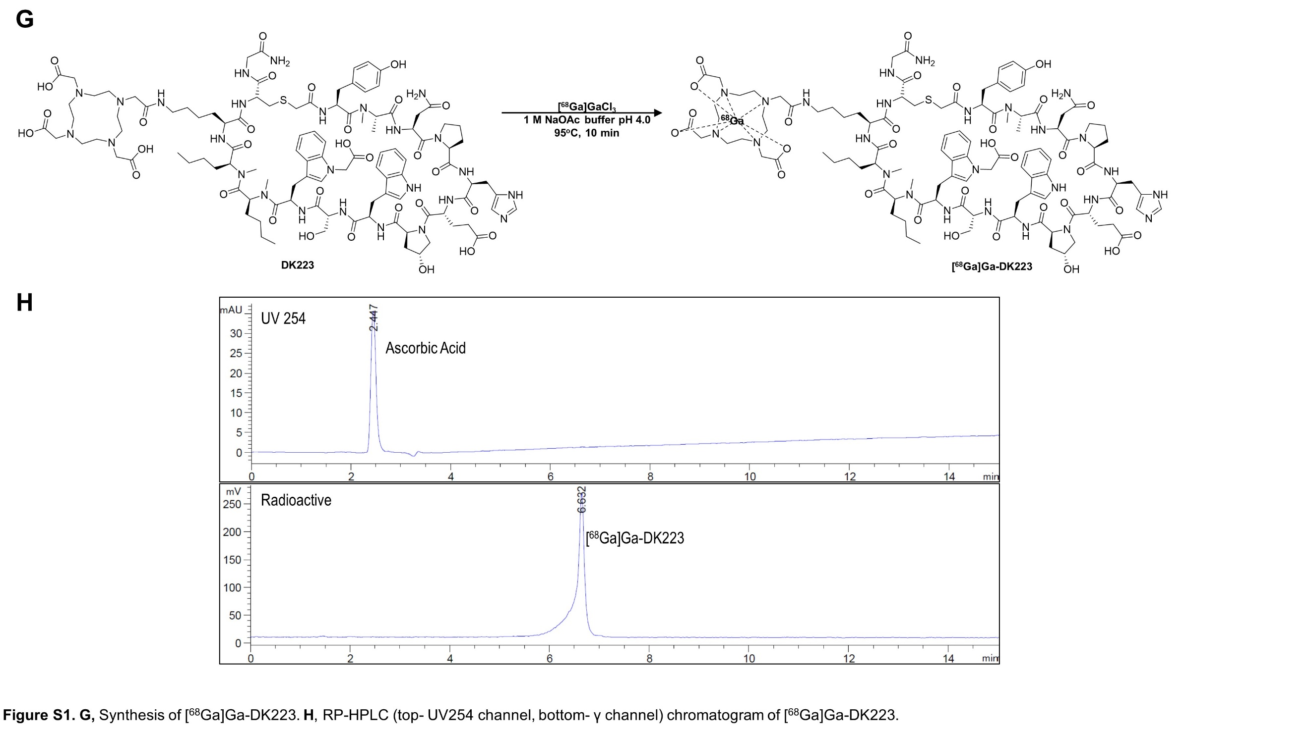

**Figure S1. G,** Synthesis of [68Ga]Ga-DK223. **H**, RP-HPLC chromatogram of [68Ga]Ga-DK223.

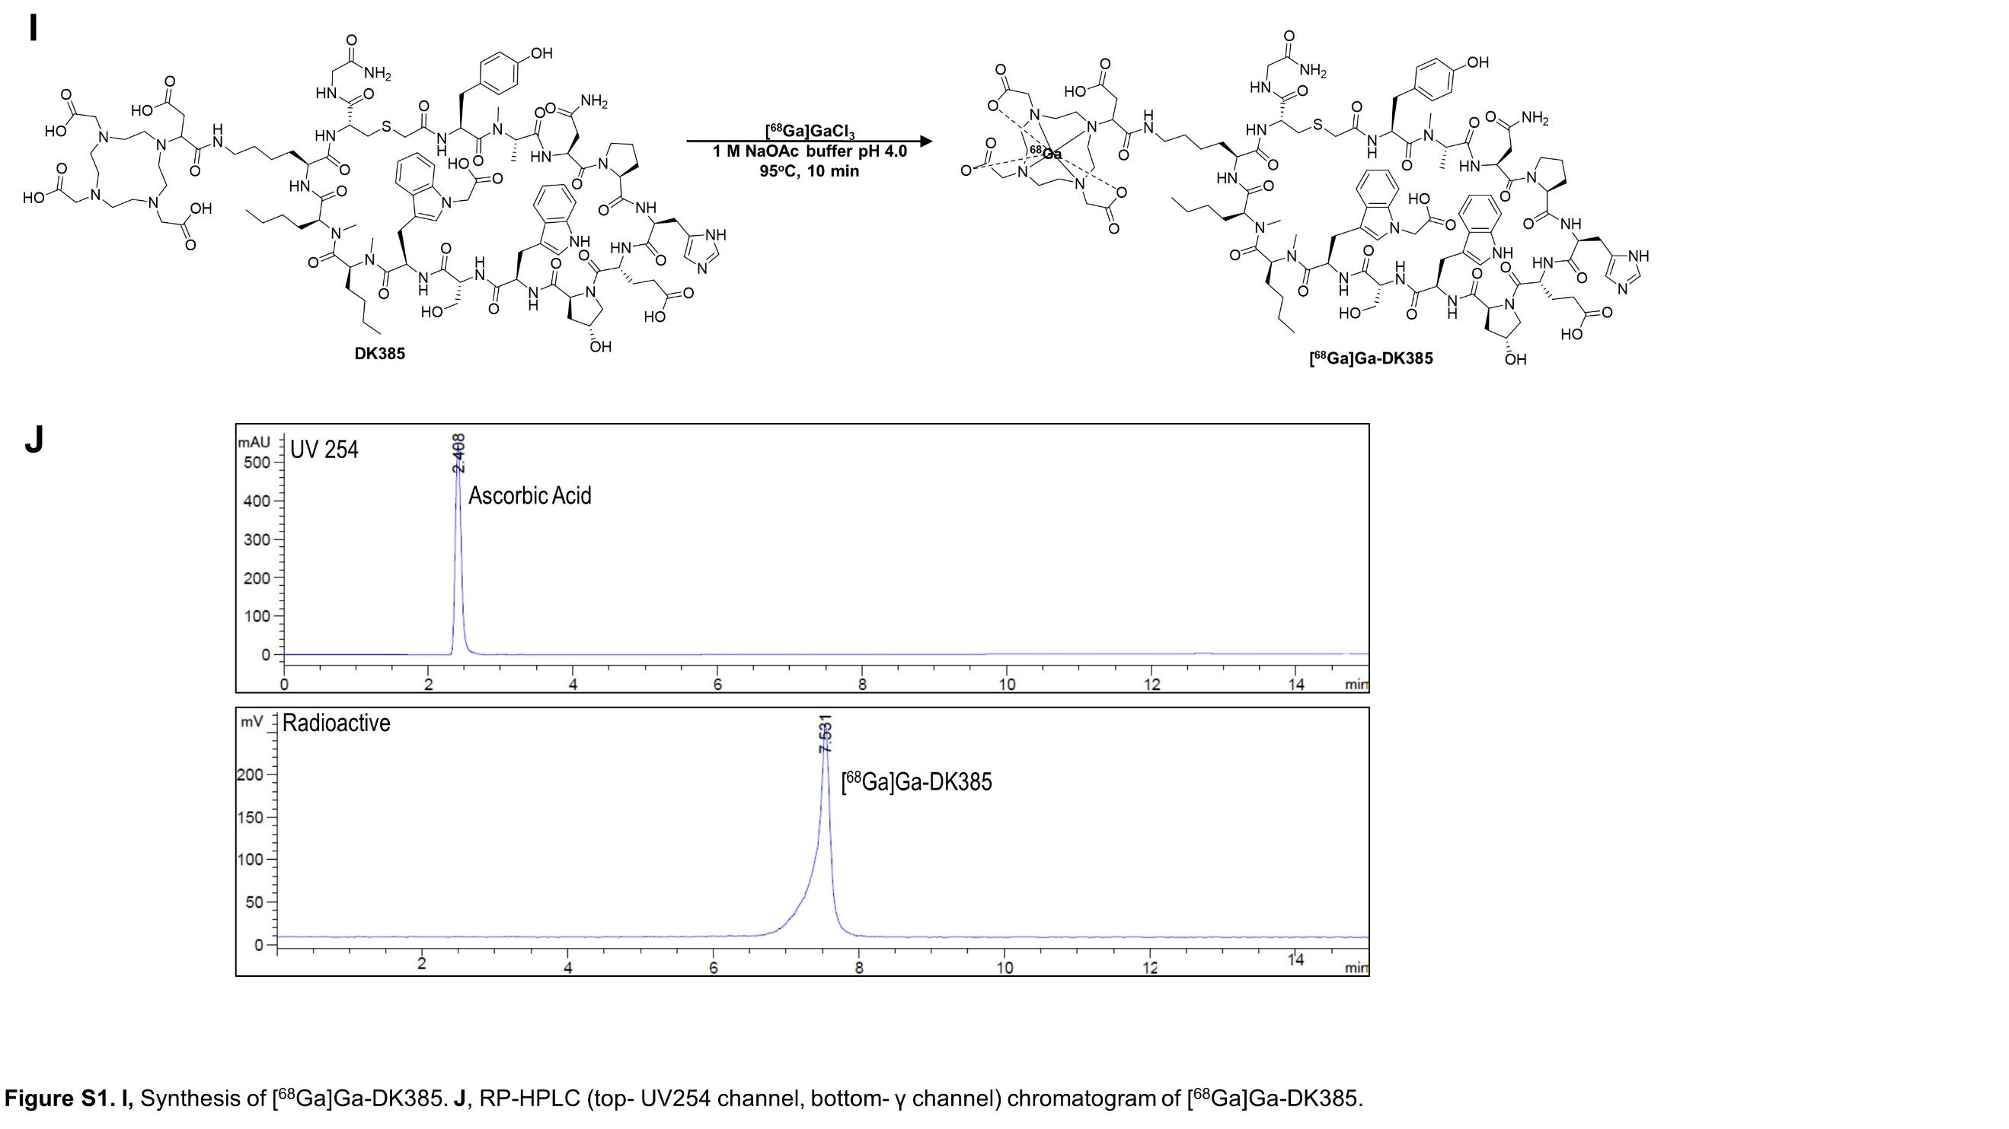

**Figure S1. I,** Synthesis of [68Ga]Ga-DK385. **J**, RP-HPLC chromatogram of [68Ga]Ga-DK385.

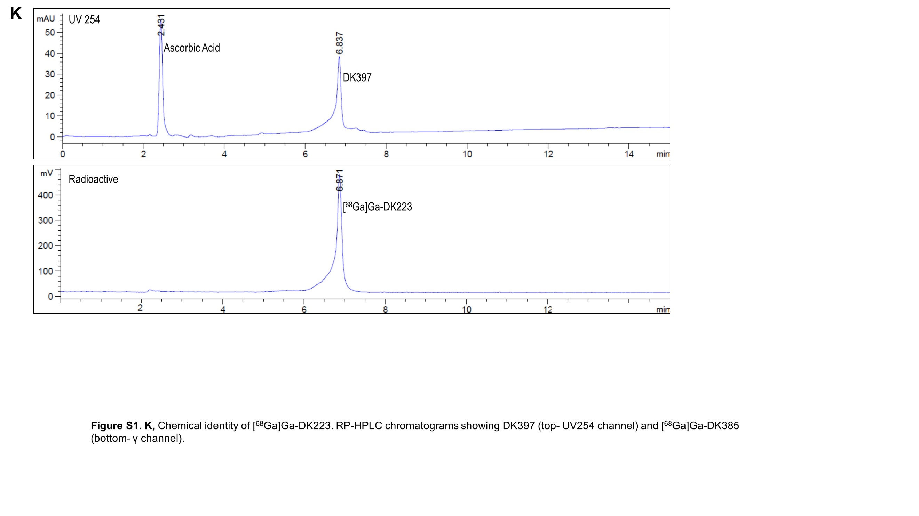

**Figure S1. K,** Chemical identity of [68Ga]Ga-DK223. RP-HPLC chromatogram of [68Ga]Ga-DK223 co-injected with DK397.

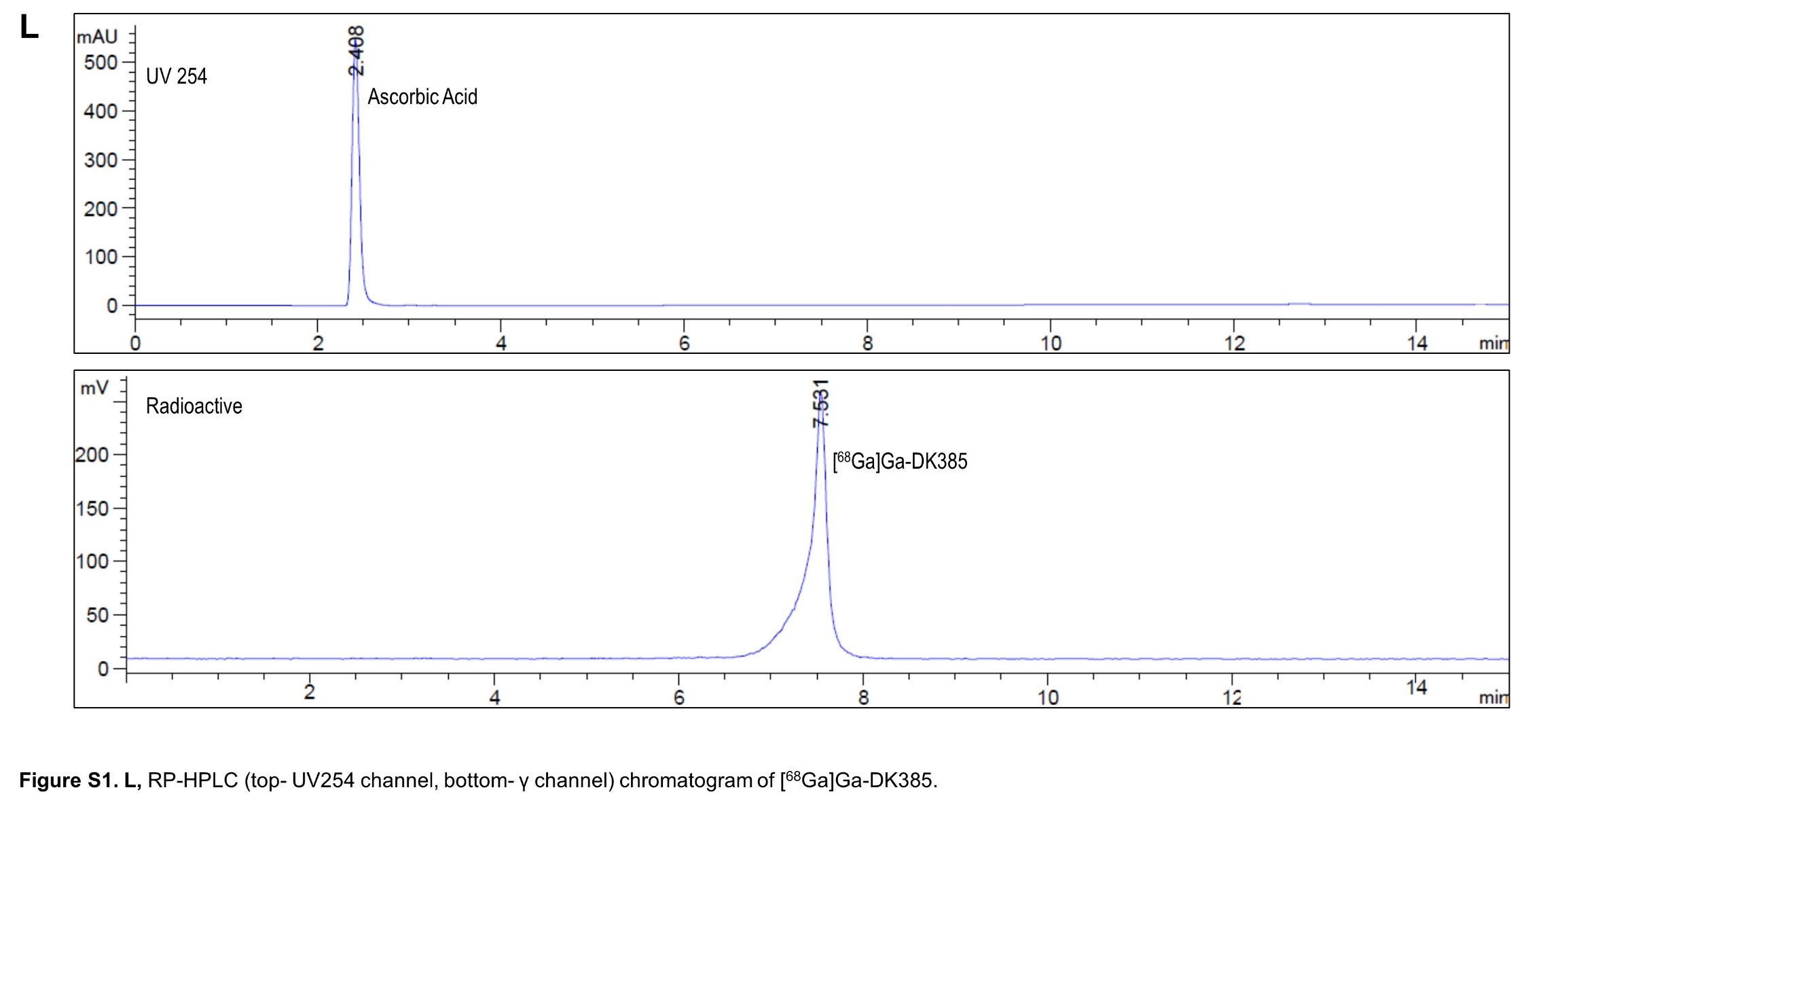

**Figure S1. L,** RP-HPLC chromatogram of [68Ga]Ga-DK385.

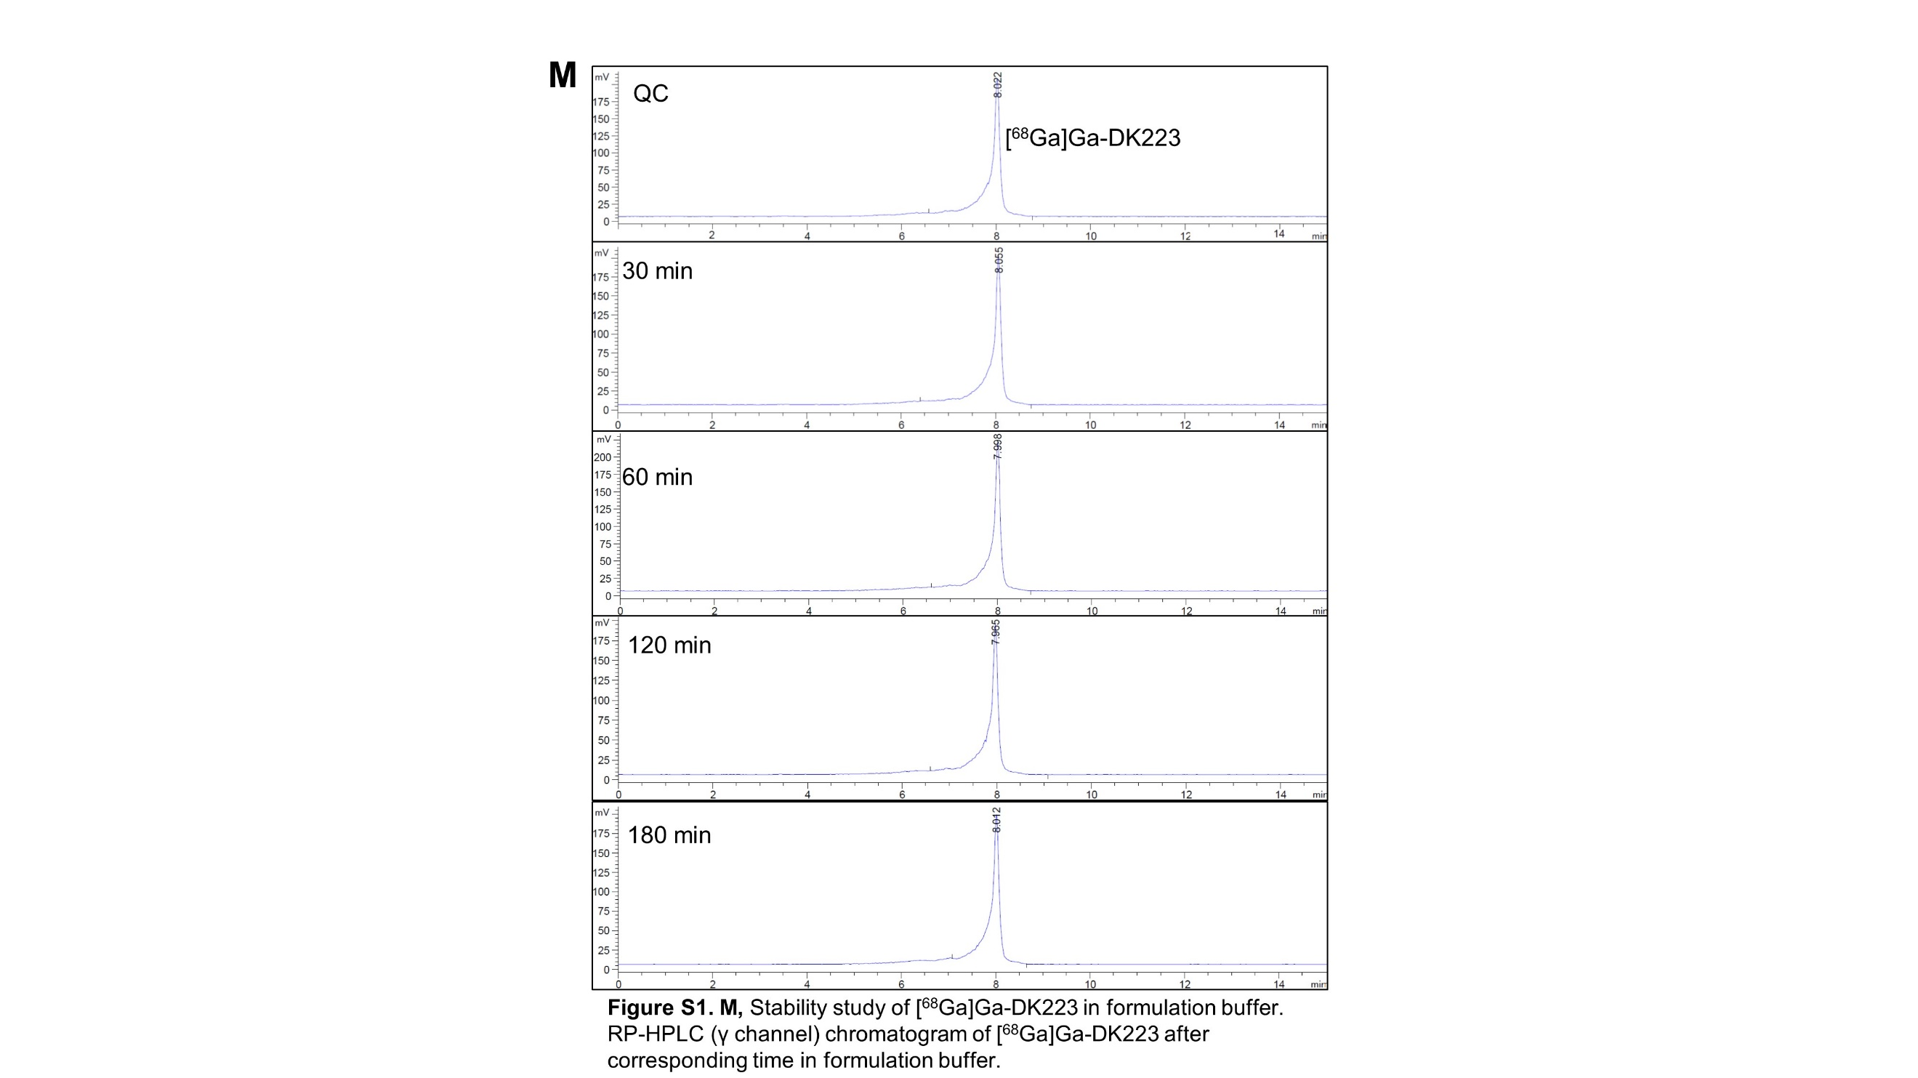

**Figure S1. M,** Stability study of [68Ga]Ga-DK223 in formulation buffer. RP-HPLC chromatogram of [68Ga]Ga-DK223 at the corresponding time-point.