SUPPLEMENTAL MATERIAL
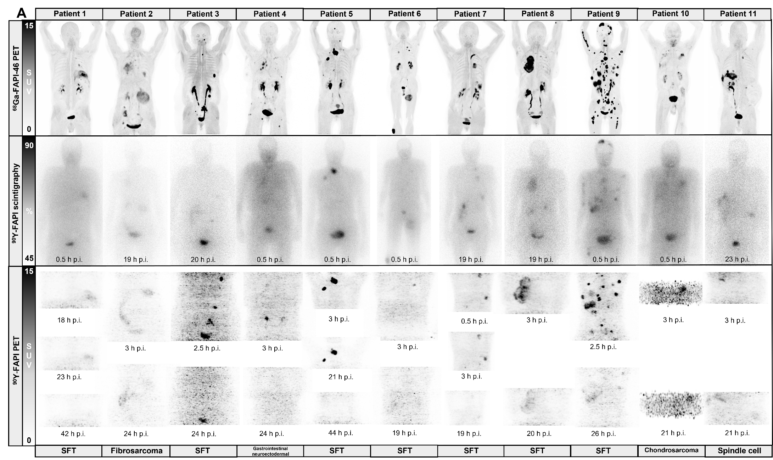

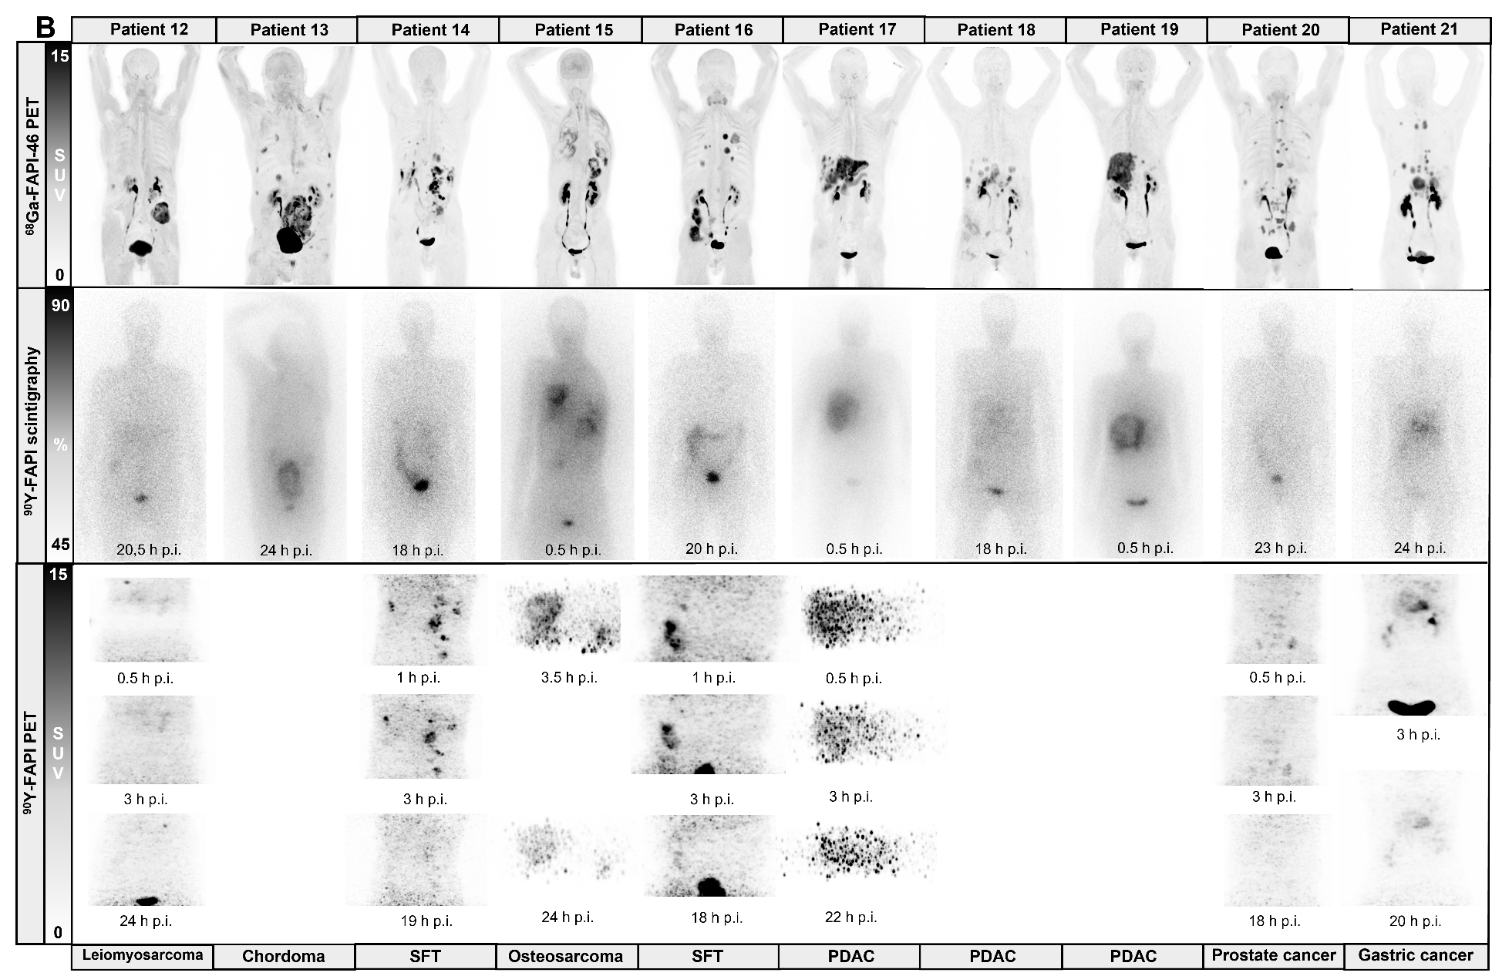
Supplemental Figure 1: Pre-therapeutic ⁶⁸Ga-FAPI-46 PET and post-treatment ⁹⁰Y-FAPI-46 imaging after the first cycle of ⁹⁰Y-FAPI-46 radioligand therapy for patients 1 to 11 (A) and 12 to 21 (B). ⁹⁰Y-FAPI-46 PET is shown for patients with diagnostic quality scans. SFT, solitary fibrous tumor.

