Supplementary Figure S2. Summary of all adverse events according to NCI-CTCAE version 4.0.3.

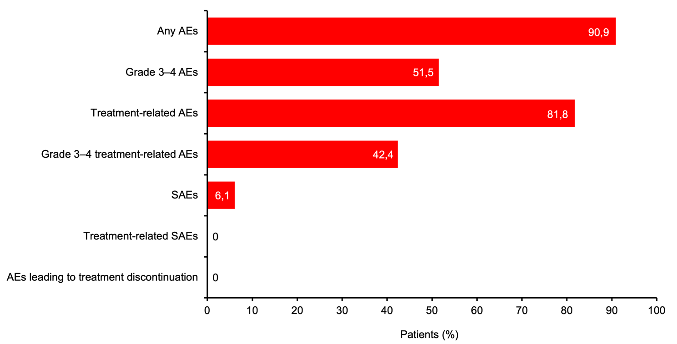
Abbreviations: AE, Adverse events; NCI-CTCAE, National Cancer Institute-Common Terminology Criteria for Adverse Events; SAE, Serious adverse events

