Supplementary Figure S2. Distribution of Response Categories Between RCTs and RWD. Response category distributions comparing RCT vs RWD in the (A) IMpower150-WT, (B) IMpower130-WT, (C) IMpower131, and (D) IMpower132 RCTs.
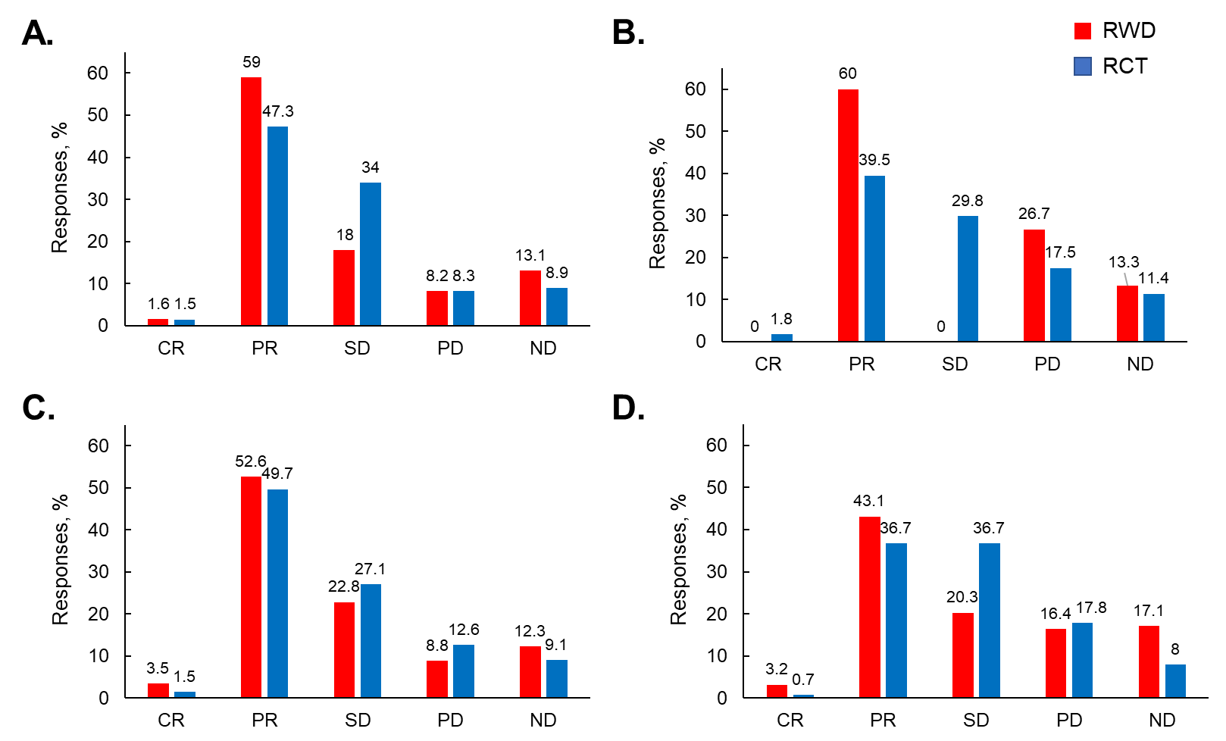
CR, complete response; ND, not determined; PD, progressive disease; PR, partial response; RCT, randomized controlled trial; RWD, real-world data; SD, stable disease; WT, wild type.

